

Oregon Environmental Quality Commission Meeting

Sept. 10-11, 2026

Temporary Rulemaking Action Item G

Recycling Modernization Act: Temporary rules (2026)

DEQ recommendation to the EQC
DEQ recommends the Environmental Quality Commission:
- Determine that failure to act promptly would result in serious prejudice to the public interest or the interests of the parties concerned as provided under the Justification section of this staff report.
- Adopt TEMPORARY rules as proposed in Attachment A1 as part of chapter 340 of the Oregon Administrative Rules to be effective on filing with the Oregon Secretary of State.
- Adopt TEMPORARY rules as proposed in Attachment A2 as part of chapter 340 of the Oregon Administrative Rules to be effective July 1, 2027.

Overview
DEQ is proposing that two elements of the Recycling Modernization Act (RMA) Rulemaking 3, scheduled for review and action by the commission in January 2027 for permanent rulemaking, be considered in fall 2026 for temporary rulemaking. Both elements relate to proposed changes that would modify regulatory requirements used in the fee-setting process by Circular Action Alliance, the Producer Responsibility Organization that implements the structures of Oregon’s modernized recycling system. Bringing the proposed rules as temporary in fall 2026 would allow CAA to consider the regulatory changes as part of its fee-setting processes for the 2027 fees, allowing for potential reduction or elimination of fees in 2027.
The first proposed amendments would exempt garbage bags from the definition as a covered product under Oregon’s Recycling Modernization Act rules. The proposed exemption means the producers would not be required to pay annual fees to the RMA Producer Responsibility Organization for these products. In the proposed amendments, DEQ further clarifies that the exemption would not apply to any plastic bag sold into Oregon that is labeled or marketed for recycling purposes, labeled or marketed as a storage item, intended to be used primarily for the purposes of containing or presenting a consumer product, or primarily for any purpose other than containing landfill-bound garbage.

The second proposed amendment would modify the collection requirements for glass packaging intended for recycling in Oregon. The amendments would add glass packaging to the Local Government Recycling Acceptance List and treat it akin to motor oil and large appliances. As a result, local governments, except for 10 counties described below, would be required to provide depot or drop-off collection opportunities for glass packaging at sites that currently accept solid waste from the public, such as transfer stations. All local governments would retain the ability to voluntarily provide for on-route collection of glass packaging if they desire. DEQ is not proposing a new requirement for on-route glass packaging collection.

The proposed amendments for glass packaging would maintain a current exemption for very small transfer stations/depot sites, as described in OAR 340-093-0160(4). The proposed amendments would also exempt the local governments of 10 lower-population counties from the amended collection requirements. Those counties are: Curry, Grant, Harney, Lake, Malheur, Morrow, Sherman, Wallowa, Gilliam and Wheeler. In only those areas, glass packaging would remain on the PRO Acceptance List, which means the PRO would retain the current obligation to provide glass packaging collection services as outlined in OAR 340-090-0640(2) for those 10 counties. The proposed amendments are designed to result in a reduction of at least 40 percent of the current base fees paid to the PRO by the producers of glass packaging. In 2026, the producers of glass packaging paid a base fee of $0.10 per pound of glass packaging sold in or into Oregon, per Circular Action Alliance’s published fee schedule.
The proposed rules are informed by discussions with, and input provided by, DEQ’s
RMA Rulemaking Advisory Committee. More information about the advisory committee and its members begins on page 9 of this report.

Statement of need
- Amendments to OAR 340-090-0040 and OAR 340-090-0630
OAR 340-090-0630 describes the collection requirements for local governments and the Producer Responsibility Organization for a variety of materials intended for recycling in Oregon. OAR 340-090-0040 refers to the relevant amendments related to glass packaging in OAR 340-090-0630(2)(p) and 340-090-0630(4)(c) and (d).

What need is DEQ trying to address?
DEQ’s proposal responds to concerns from the producers of glass packaging who are seeking fee relief.

How would the proposed rule address the need?
If adopted, the amended rules would reduce the financial and logistical obligations related to the collection and responsible recycling of glass packaging by the Producer Responsibility Organization. The impact would lower operating costs for that material and, subsequently, reduces the base fee to be paid to the Producer Responsibility Organization by the producers of glass packaging. The amended rules would eliminate the specific collection obligations of the Producer Responsibility Organization for glass packaging in all but 10 lower-population counties of Oregon. Those reductions in obligations mean reduced costs for the PRO to operate the statewide collection and responsible recycling of glass packaging. Costs for the operations of the program are a major determinant in the PRO’s calculation of fees for any material.

The proposed rules also allow for the near-total reduction of an incentive fee currently paid by the PRO to local governments across Oregon. The incentive fee is part of the costs associated with the current collection obligations of the PRO for glass packaging collection. As seen in the chart below, the incentive fee is approximately 53 percent of the total costs included in the fees that glass packaging producers currently pay.

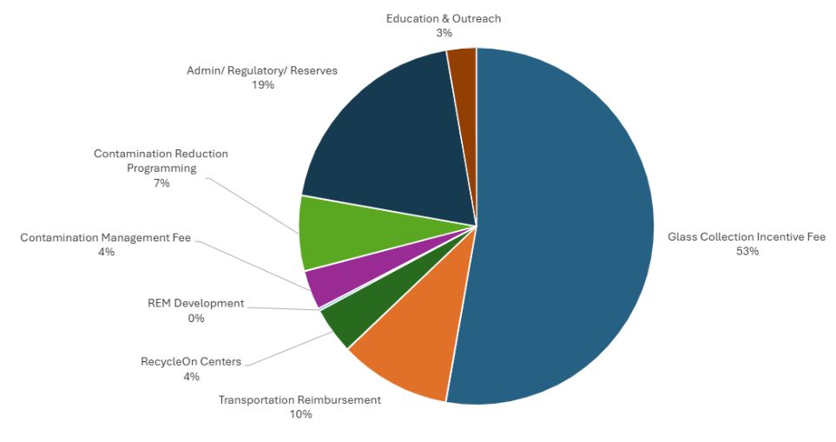
Figure 1: 2026 Glass Packaging Fees by Category. Data provided by Circular Action Alliance

DEQ cannot specify the precise amount of the expected reductions. The base fees for any material are set annually by the Producer Responsibility Organization and include many factors, including recycling market conditions, that are out of the control of the State of Oregon. However, based on conversations with the Producer Responsibility Organization, Glass Packaging Institute, the Oregon Winegrowers Association and Rulemaking Advisory Committee members, DEQ expects a reduction of at least 40 percent from the annual base fees paid by the producers of glass packaging in 2026. The proposed effective date of July 1, 2027, means that potential fee relief would be partial for 2027, as the changes would only apply to six of 12 months.

- Amendments to OAR 340-090-0840
This rule describes the inclusions and exemptions related to covered products under RMA.

What need is DEQ trying to address?
Currently, garbage bags are designated as a covered product. The producers of garbage bags are obligated to fulfill all requirements of ORS 459A.869, including payment of an annual fee determined by the Producer Responsibility Organization. Initial fee setting methods were based on modeled or other estimated data when no actual data was available yet. The annual fees that have been paid by garbage bag producers were based on modeled and estimated data. Since program implementation began July 1, 2025, DEQ has been provided with updated data that shows the fees charged to garbage bag producers were inaccurate and resulted in vast overpayment. There is a need to correct this inaccuracy by exempting garbage bags, with some qualifying requirements, from being covered products starting in 2027.

How would the proposed rule address the need?
If adopted, the amended rules would exempt garbage bags from being a covered product. The producers of garbage bags would not be subject to the obligations of a producer within the RMA for those materials and would not be required to pay an annual fee to the Producer Responsibility Organization for those materials in 2027.

Justification

Finding of serious prejudice
DEQ found failing to act promptly would result in serious prejudice to the interests of the affected parties.

Consequences of not taking immediate action
DEQ determined that not immediately adopting the proposed rule amendments would cause harm to the affected parties by delaying the potential for fee relief by at least one year, resulting in potential overpayment into the system and financial burden to the affected parties.

Affected parties
The parties who would be harmed if EQC did not take this action are the producers of garbage bags and the producers of glass packaging as categorized in Oregon’s Recycling Modernization Act and related rules.

Why or how failing to act immediately would cause the harm described above
The harm described above would occur if EQC does not act immediately because the annual fee-setting process occurs in the fall for the next calendar year. Immediate action in fall 2026 would result in the 2027 fees being set based on the temporary rules, which amend the current rules.

How the temporary rule would avoid or mitigate consequences
If EQC adopts the proposed temporary rule amendments, this will prevent the harm described above because the fee-setting process would be able to incorporate the information and regulatory requirements as amended by the temporary rule.

Rules affected, authorities, supporting documents

Land Quality Division

Materials Management Program, Product Stewardship, Recycling Modernization Act

Chapter 340 action

Amend OAR:
- 340-090-0040
- 340-090-0630
- 340-090-0840

Statutory authority
Statutory Authority – ORS
- 468.020
- 468.065
- 459A.975

Statute implemented
Statutes Implemented – ORS
- 459A.005
- 459A.007
- 459A.010
- 459A.863
- 459A.866
- 459A.896
- 459A.914

Legislation
The Oregon Legislature approved the Plastic Pollution and Recycling Modernization Act in 2021, which is the basis of ORS 459A.860 through ORS 459A.975.

Documents relied on for rulemaking
Document | Location
Technical Workgroup on Glass Collection, Various background papers prepared for April 15 and April 28, 2026, workgroup meetings | RMA Rulemaking 2026 webpage: Department of Environmental Quality : Recycling Modernization Act Updates 2026 : Rulemaking at DEQ : State of Oregon

Housing costs
As ORS 183.534 requires, DEQ evaluated whether the proposed rules would have an effect on the development cost of a 6,000-square-foot parcel and construction of a 1,200-square-foot detached, single-family dwelling on that parcel.
DEQ determined the proposed rules would have no new effect on development costs because the proposed rules are primarily clarifications and amendments to current requirements and do not modify costs associated with development or construction activities.

Racial equity
ORS 183.335(2)(b)(F) requires state agencies to provide a statement identifying how adoption of this rule will affect racial equity in this state. DEQ expects that the proposed rulemaking will not significantly modify the racial equity outcomes previously described in the 2023 and 2024 RMA rulemakings.

Environmental justice considerations

ORS 182.545 requires natural resource agencies to consider the effects of their actions on environmental justice issues. Environmental justice is the fair treatment and meaningful involvement of all people regardless of race, color, national origin, culture, education or income with respect to the development, implementation and enforcement of environmental laws, regulations and policies. DEQ is committed to incorporating environmental justice best practices into its programs and decision-making, to ensure all people in Oregon have equitable environmental and public health protections.

Environmental justice analysis

In evaluating the proposed temporary rules, DEQ notes that the proposed amendments related to the collection of glass packaging could result in some inconsistency in recycling services for these materials. While many communities have shown a strong commitment to collecting glass packaging regardless of financial incentives, the proposed changes could result in some local governments reducing their on-route collection services or making other changes based on local operational needs. In many instances, the communities that discontinue or reduce service are likely to be those that are likely more rural or farther from the end markets for glass packaging, which also tend to be lower income than the state average.

In addition, there is potential for a small increase in costs to the ratepayers in communities that would no longer receive a glass packaging collection incentive payment from CAA but choose to maintain on-route collection for glass packaging at the same frequency as currently provided. As an example, the City of Portland provided estimates to DEQ that the monthly cost of glass packaging collection is approximately $3.20 per residential customer. During the first program plan year in 2025, a glass incentive payment from CAA reduced that monthly per-residential-customer cost of glass packaging collection by $0.20. As proposed, that $0.20 cost would no longer be offset by the incentive payment from CAA and would likely be borne by the residential customer if the City of Portland did not change its on-route glass packaging collection. Since the cost is equal across all residential customers, and not a proportional element of overall recycling and garbage bills, there is a possibility of disproportionate effects to people with lower incomes.

Advisory committee
The proposed temporary rules are part of a permanent rulemaking process for which DEQ appointed an advisory committee. The 11-member committee met five times from November 2025 to July 2026 and included representatives from organizations and communities likely to be affected by the rulemaking outcomes. The committee approved its charter at the first meeting, on Nov. 13, 2025. The committee discussed rule concepts related to the proposed temporary rules at several meetings.
Roster
Name | Organization | Interest or group represented
Kim Holmes | Circular Action Alliance | RMA Producer Responsibility Organization
Will Grassle | Consumer Brands Association | Producers of RMA-covered products*
Tom Egleston | Metro | Local governments (1 of 2)
Paul Seitz | Lincoln County | Local governments (2 of 2)
Kristin Leichner | Pride Disposal | Recycling Service Providers
Scott Jenkins | EFI Recycling | Recycling Facilities/Processors
Dan Felton | Flexible Packaging Association | Topic-specific expert (1 of 2): Responsible End Markets (plastic)
Jay Simmons | North Pacific Paper Company | Topic-specific expert (2 of 2): Responsible End Markets (paper)
Dr. Anja Brandon | Ocean Conservancy | At-large member (1 of 3): Environmental advocacy
Jamie Pang | Oregon Just Transition Alliance | At-large member (2 of 3): Environmental justice, equity
Adam Rack | Revino | At-large member (3 of 3): Small business focused on reuse
*Amanda Nelson, New Seasons, represented producers of RMA-covered products from November 2025 to March 2026. Will Grassle was appointed in May 2026 for the duration of the rulemaking process.

As ORS 183.33 requires, DEQ asked for the committee’s recommendations on:
  - Whether the proposed rules would have a fiscal impact
  - The extent of the impact
  - Whether the proposed rules would have a significant impact on small businesses and complies with ORS 183.540
The committee reviewed the draft fiscal and economic impact and racial equity statements on July 20, 2026, and provided verbal and written feedback to DEQ. The committee determined the proposed rules would not have a significant adverse impact on small businesses in Oregon. DEQ compiled a memo of the feedback, which is included as Attachment C to this report.

EQC prior involvement
DEQ shared information about this temporary rulemaking with the EQC through an information item on the July 9, 2026, EQC agenda.

Implementation

Notification
The proposed rules would become effective on two separate dates. The proposed amendments for garbage bags would become effective upon filing with the Oregon Secretary of State. The proposed amendments related to glass packaging would become effective July 1, 2027.
DEQ would notify affected parties by email, using established lists of parties interested in the RMA Rulemaking and the specific topics of garbage bags and glass packaging. DEQ would also publish information on its RMA Rulemaking 2026 website, as noted below, to document the EQC action.

Compliance and enforcement
  - Affected parties - No changes needed
  - DEQ staff - No changes needed

Measuring, sampling, monitoring and reporting
  - Affected parties - No changes needed
  - DEQ staff - No changes needed

Systems
  - Website – RMA Rulemaking 2026: To be updated with the documented EQC action.
  - Invoicing – No changes needed

Training
  - Affected parties - No changes needed
  - DEQ staff - No changes needed

Non-discrimination statement
DEQ does not discriminate on the basis of race, color, national origin, disability, age, sex, religion, sexual orientation, gender identity, or marital status in the administration of its programs and activities.
For translation or other formats, visit DEQ’s Civil Rights and Environmental Justice page.

