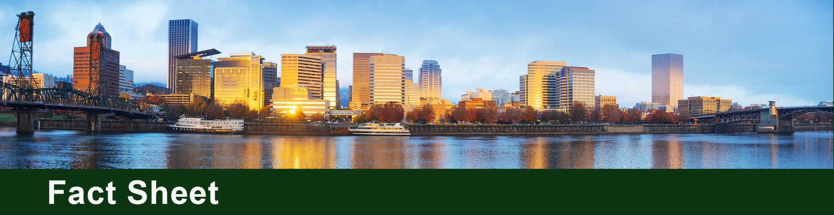

Arkema In-Situ Stabilization Cleanup
Arkema Inc. is carrying out a major interim cleanup action under DEQ oversight at its former chemical manufacturing facility at 6400 NW Front Ave. in Portland. The cleanup action is treating the primary source of chlorobenzene (also known as monochlorobenzene) contamination in the former acid plant area to reduce migration into groundwater and toward the Willamette River. The company is paying for this work as the responsible party.

Cleanup action at a glance
Cleanup method: In-situ stabilization.
Construction: Began in summer 2026. Expected to last about nine months.
Objective: Contain the source of contamination and reduce migration of contaminants.
What’s next: Additional sampling to fill data gaps, performance monitoring to evaluate the in-situ stabilization effectiveness, additional interim cleanup actions to address other sources of contaminants and preparation of a revised feasibility study.

Why the interim cleanup action is needed
The facility produced chemicals from 1941 until operations ended in 2001. Chlorobenzene was used to manufacture the insecticide dichlorodiphenyltrichloroethane (DDT) at the facility from 1947 to 1954. Historical handling and disposal of process residues left concentrated chlorobenzene in soil and groundwater near the former manufacturing process residue pond and overflow trench.
Contamination extends from the upland property toward the Willamette River. The adjacent in-water area is part of the River Mile 7 West segment of the Portland Harbor Superfund Site under U.S. Environmental Protection Agency oversight.

How in-situ stabilization works
In-situ stabilization/solidification treats contaminated soil in place. Equipment mixes the soil with amendments like cement, slag and biochar. The treated soil becomes a monolith that isolates contaminated soil from groundwater by substantially reducing permeability and leaching of contamination.
This is accomplished using two methods:
- Bucket mixing for shallow soil using an excavator.
- A large auger treats deeper soil by rotating in the subsurface while soil amendments are injected.
This method does not remove the contamination. Instead, the method treats and binds contaminated soil in a solid, significantly less permeable material, to greatly reduce the ability for contamination to move into groundwater.

DEQ oversight and monitoring
This interim action is being taken to accelerate cleanup of the highest-priority source area of upland contamination while broader cleanup planning continues. DEQ reviewed and approved the final design of this in-situ cleanup action and is overseeing implementation.
- Construction testing will confirm the stabilized soil meets design requirements.
- Arkema will submit a construction completion report documenting the work and test results.
- DEQ will review groundwater monitoring after construction to evaluate the remedy's effectiveness.

How this interim action fits into the broader site cleanup
This interim cleanup action is not the final cleanup for the entire property. This action addresses the largest upland source of chlorobenzene now to reduce migration of contamination before a final sitewide cleanup plan is selected and prior to the implementation of the in-water remedial action overseen by EPA.
Additional work will address remaining contamination in the upland areas. In-water cleanup of river sediment and the riverbank will proceed through the EPA-led Portland Harbor Superfund cleanup process.

Connection to the Portland Harbor Superfund cleanup
Arkema is a Portland Harbor upland source control site overseen by DEQ. DEQ’s responsibility in the Portland Harbor Superfund cleanup involves working with property owners to investigate and clean up upland sources of contamination in soil, groundwater and stormwater that could reach the Willamette River. EPA is leading the overall Portland Harbor Superfund cleanup process and is responsible for cleaning up contaminated river sediment. This in-situ stabilization project is part of DEQ’s upland source-control work and is coordinated with the adjacent River Mile 7 West in-water sediment cleanup overseen by EPA.

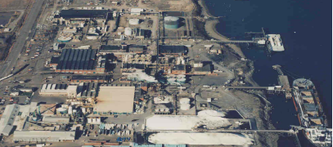
DDT process area
Arkema facility along the Willamette River in the 1990s

Non-discrimination statement
DEQ does not discriminate on the basis of race, color, national origin, disability, age, sex, religion, sexual orientation, gender identity, or marital status in the administration of its programs and activities. For translations or alternate formats, visit DEQ's Civil Rights and Environmental Justice page.

