2026-April-30 Jim Orr review of Apex Auto, ECSI 3766 Phase II Report October 21, 2025
Summary:
Results indicate that arsenic concentrations in five deeper soil samples were greater than ODEQ’s background levels or RBCss for dermal contact with, inhalation of, or ingestion of soil by occupational or construction workers. Total PCBs in the solids in a steam cleaning vault were greater than ODEQ’s RBCss for dermal contact with, inhalation of, or ingestion of soil by current and reasonably likely future occupational workers. A surface sample collected from the dry well contained an elevated concentration of lead above the ODEQ RBCss for dermal contact with, inhalation of, or ingestion of this material by current and reasonably likely future occupational, construction and/or excavation workers. The detected concentration of diesel-range hydrocarbons in B10 at 9 feet below ground surface also exceeded the ODEQ’s RBCss for dermal contact with, inhalation of, or ingestion of soil by current or future construction workers. Exceedances of RBCs may trigger additional characterization or cleanup requirements from ODEQ. RBDM VOCs were not detected in groundwater samples collected from temporary wells TW1 and TW3, and the method detection limits were less than the ODEQ RBCwe for construction and excavation worker exposure to groundwater in excavations. No ACM was identified in building materials.

Trinity evaluated the results of the Phase II ESA investigation and presents the following conclusions:

Soil Results
- Arsenic concentrations in four (4) deep samples in REC-2 (B3, B5, B6, and B7) and one deep sample under a former residence (B9) were greater than ODEQ’s background levels or RBCss for occupational or construction worker exposures. Given the depth and undisturbed appearance of these deposits (i.e., native deposits at 10 ft), the elevated detected concentrations are considered naturally occurring and do not require additional characterization or removal.
- Total PCB concentration in the steam cleaning vault (TW3) (REC 2) was greater than ODEQ’s RBCss for occupational worker exposures and may require additional characterization and/or removal.
- Lead concentrations in a surface sample collected from the dry well exceeded the ODEQ RBCss for occupational, construction and/or excavation worker exposures and may require additional characterization and/or removal.
- The diesel-range hydrocarbon concentration in B10 (dry well) at 9 ft bgs exceeded the ODEQ RBCss for construction worker exposure and may require additional lateral characterization and/or removal.
- Soil sampling and analysis address the concerns in the ODEQ’s preliminary assessment (REC-4).

Groundwater Results
- RBDM VOCs were not detected in groundwater samples collected from temporary wells TW1 and TW3, and the MDLs were less than the ODEQ RBCwe for construction and excavation worker exposures to groundwater in excavations.
- Groundwater sampling and analysis address the concerns in the preliminary assessment completed by ODEQ (REC-4).

Asbestos Containing Materials Survey
- No ACM was identified in the building
.

Table 5-1 Soil Results RBC for Lead 800 PPM?? Occ, Construction Worker and Excavation Worker

Soil Resultseslts
Arsenic concentrations in four (4) deep samples in REC-2 (B3, B5, B6, and B7) and one deep sample under a former residence (B9) were greater than ODEQ’s background levels or RBCss for occupational or construction worker exposures. Given the depth and undisturbed appearance of these deposits (i.e., native deposits at 10 ft), the elevated detected concentrations are considered naturally occurring and do not require additional characterization or removal.
- Total PCB concentration in the steam cleaning vault (TW3) (REC 2) was greater than ODEQ’s RBCss for occupational worker exposures and may require additional characterization and/or removal.
- Lead concentrations in a surface sample collected from the dry well exceeded the ODEQ RBCss for occupational, construction and/or excavation worker exposures and may require additional characterization and/or removal.
- The diesel-range hydrocarbon concentration in B10 (dry well) at 9 ft bgs exceeded the ODEQ RBCss for construction worker exposure and may require additional lateral characterization and/or removal.
- Soil sampling and analysis address the concerns in the ODEQ’s preliminary assessment (REC-4).

Groundwater Results
- RBDM VOCs were not detected in groundwater samples collected from temporary wells TW1 and TW3, and the MDLs were less than the ODEQ RBCwe for construction and excavation worker exposures to groundwater in excavations.
- Groundwater sampling and analysis address the concerns in the preliminary assessment completed by ODEQ (REC-4).

Were is vapor screening and TCE PCE testing

Need to abandon dry well

RG stamp?

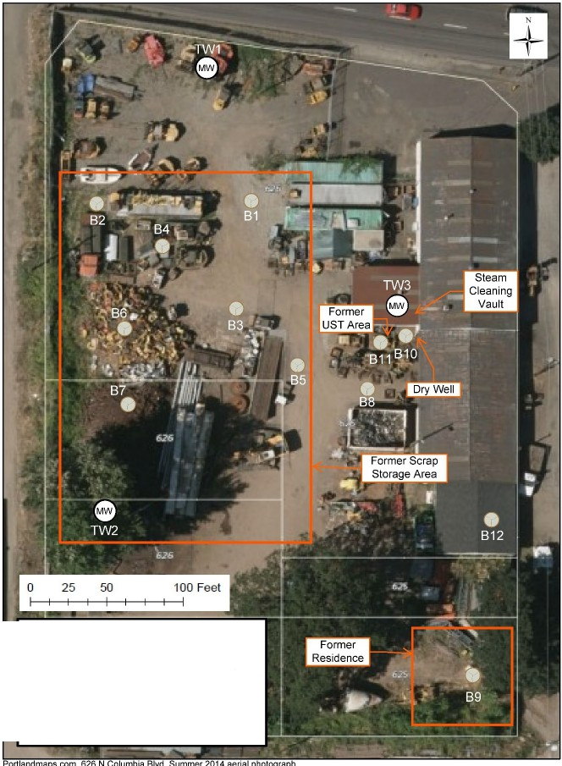

Legend
Temporary Groundwater

