State of Oregon
Department of Environmental Quality Memorandum
________________________________________________________________________

Date: December 14, 2017

To: DEQ Northwest Cleanup Section file

Through: Daniel Hafley, Lead Worker, NWR Cleanup Section
Paul Seidel, Acting Manager, NWR Cleanup Section

From: Kenneth Thiessen, Hydrogeologist, NWR Cleanup Section

Subject: Potential for Site-Related EDB Contamination
Townsend Farms
ECSI # 4230

Introduction
This memo presents DEQ’s analysis of ethylene dibromide (EDB) contamination in groundwater that has been detected in the Fairview, Oregon area, including in City of Fairview water supply wells. One potential source of contamination is releases from the Townsend Farms property (“Site”) located in north Fairview and north of NE Sandy Blvd. Townsend Farms has worked in the past with DEQ’s Voluntary Cleanup Program to request no further action determinations for parcels in the Townsend Business Park, and will be doing so in the future for other business park parcels. An ongoing concern to DEQ has been the potential for contaminant releases at or associated with the Site to have caused or contributed to EDB contamination in area wells.
DEQ has looked at multiple lines of evidence to understand the origin, occurrence, transport and effects of EDB in groundwater in the vicinity of production wells at Townsend Farms and the City of Fairview municipal water supply production wells. The results of our analysis are presented below.

EDB detections in regional groundwater
During a meeting with DEQ staff and Site representative Mike Townsend on October 17, 2017, Mr. Townsend advised that cane fruit (berry) production was a regional industry and that this industry commonly used brominated fumigants as a soil treatment measure. Because of this, Mr. Townsend contends that EDB in groundwater is likely a regional problem.
To evaluate this contention, DEQ reviewed many groundwater data sets for water supply and monitoring wells in the region of Townsend Farms, from public and private sources. In summary, DEQ found EDB detections in area groundwater to be limited to Townsend private supply wells #2 (currently not in use) and #3 (in use), and Fairview municipal production wells #5, #6 (and possibly #9). DEQ did not find evidence of a widespread EDB problem in groundwater in East Multnomah County.

Information on the detection (or lack thereof) of EDB in area wells is summarized below.

Regional well data evaluated by DEQ

Well ownership/Database EDB detected? Data source
Fairview, City of (#5, #6, (#9?)) Yes Oregon Health Authority
Townsend Farms (#3 (EP-A)) Yes Oregon Health Authority
Troutdale, City of (#2,#3, #4, #5, #6, #7, #8) No Oregon Health Authority
Wood Village, City of (#1, #2, #3, #4) No Oregon Health Authority
Rockwood PUD (EP-A, B, C) No Oregon Health Authority
West Interlachen Coop No Oregon Health Authority
Interlachen PUD (#1, #2, #3, #4) No Oregon Health Authority
Boeing (420 data sets, many wells) No Landau Associates
PWB (21 production wells) No Oregon Health Authority
PWB monitoring well PMX 196 (3 nested) No Portland Water Bureau
PWB monitoring well #5 (2 nested, North of) No Portland Water Bureau Townsend Business Park)
PWB monitoring well #4 (3 nested) No Portland Water Bureau
(NW corner of Townsend Business Park)

Gresham, City of EDB not tested Oregon Health Authority
Wood Village Mobile Home park EDB not tested Oregon Health Authority
______________________________________________________________________________

From the data above, it appears that if EDB were used regionally as an agricultural pesticide, it did not adversely affect groundwater resources on a regional level. EDB was introduced in the US as a fumigant. In standard practice, it was applied as a gas to raised soil beds for pest control purposes. In application, farmers typically placed tarps or plastic film on treated fields to trap the gas, which helped it work better and eliminated exposure to workers or those living nearby. Under this type of use, it is unlikely that impacts to local groundwater would occur. A leak from a container of EDB pesticide onto the ground would be a more likely source of EDB contamination to groundwater. A few additional notes:

- The specific gravity of EDB is 2.16 (more than twice as dense as water), it is highly water-soluble, and it has limited affinity (adsorptive capacity) to soil particles and carbon in soil. These factors encourage the vertical migration of contamination from soil to groundwater, and within groundwater, when released in liquid (NAPL) form. r

- Documents prepared by Evren NW and Rapid Soil Solutions for Townsend Farms and the Townsend Business Park have concluded that the groundwater flow direction in unconfined and confined potable aquifers in the vicinity of Townsend Farms is from south to north. DEQ disagrees with these findings, which appear to result from pre-groundwater withdrawal flow assumptions or a misunderstanding of aquifer dynamics. While the “natural” groundwater flow direction is expected to be northerly, DEQ finds that during high-volume groundwater withdrawals in East Multnomah County, groundwater is replenished by the Columbia River resulting in a north-to-south groundwater flow pattern.

In aggregate, City of Fairview production wells are capable of withdrawing over 1.5 million gallons of water per day. Fairview and several other high-capacity pumping centers overwhelm older, gravity-based flow models and hydraulic head assumptions as were used by Evren NW and Rapid Soil Solutions documents.

- Townsend production well #3 is constructed with well perforations from 205 to 245 feet below ground surface (bgs), and has a continuous gravel pack from 155 to 260 feet bgs. The total depth of the well is 260 feet bgs. All Townsend and Fairview EDB-containing wells are screened in the Sand and Gravel Aquifer (SGA) (sensu GSI). As constructed, Townsend well #3 may provide a conduit for the vertical migration of EDB from the Troutdale Sandstone Aquifer (TSA) downward to the deeper SGA aquifer via the long gravel pack surrounding the well. This gravel pack appears to fully penetrate/breach the hydrogeological unit known as Confining Unit (CU2) CU 2 is an important regional confining unit which, in general, provides hydraulic isolation between the TSA and underlying SGA. Given the large quantities of water produced by the Townsend #3 well (100,000 to 300,000 gallons per day) and what appears to be cross-screening of the confining unit. Contaminant release in the vicinity of the well might allow migration to the deeper (SGA) aquifer.

- EDB source likelihood based on well concentration trends. Townsend #3, Fairview #6 and Fairview #5 show a higher-to-lower trend in EDB concentrations, which suggests that Fairview #3 is closest to the EDB source. These three wells are approximately 1200 feet from each other along a NE-to-SW trending line.

- Pesticide mixing building. Former DEQ project manager Bob Williams indicated via telephone in December 2017 that he made field and photo observations of a pesticide storage and mixing shed near the Townsend #2 and #3 wellheads. This needs to be investigated further to understand if it the local source of EDB contamination in Townsend/Fairview groundwater.

- The persistent pond at the NE corner if the Townsend Business Park appears to be an expression of the shallow water table (not a confined aquifer) and may be a factor in the transmission of pesticides to deeper groundwater. This pond may need to be further investigated if no other pesticide source is found.

- Fairview wells #5 and #6 are in close hydraulic communication within the SGA aquifer despite the 1200 foot distance between the wells. Figure 3 (below) illustrates the nearly coincident response in hydraulic head at Fairview #6 in response to rapid drawdown pumping in Fairview #5. This illustrates the high permeability of the SGA aquifer and the vulnerability to rapid transmission of contaminants.

Townsend #3 is 1300 feet from Fairview #6 and would be expected to exhibit a similar response to rapid drawdown pumping in Fairview #6.

- 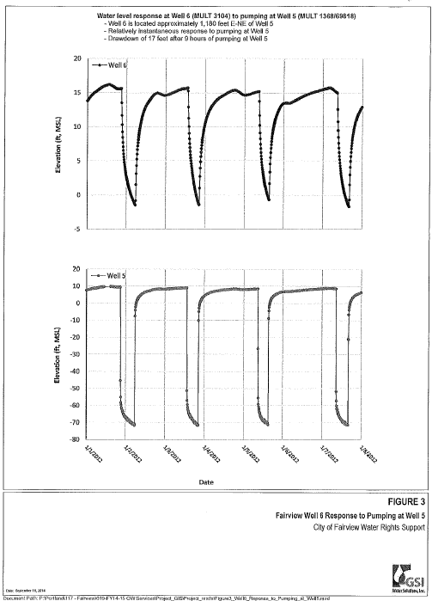

Based on information presented in this memo, and supporting material reviewed by DEQ, Townsend Farms activities is a probable source of contamination detected within Site wells, and in nearby City of Fairview wells. Additional investigation is necessary.

