TABLES

Well Name | Remedy Zone | PMX No. | Aquifer | Installed/ Completed Date | Decommission Date | Well Included in 2018 EMC  Well Network  (Yes/No)
A-1d (Supply Well) | Zone B | -- | TSA | 03/16/1976 | 08/01/2000 | No
A-2d (Supply Well) | Zone B | -- | TSA | 08/26/1964 | 07/01/1988 | No
A-3 (Supply Well) | Zone B | -- | TSA | 03/12/1957 | 06/01/1989 | No
A-4 (Supply Well) | Zone B | -- | TSA | 10/11/1961 | 06/29/2004 | No
A-5d (Supply Well) | Zone B | 555 | TSA | 01/25/1971 | -- | No
A-6 (Supply Well) | Zone B | -- | TSA | 06/01/1989 | 07/15/2004 | No
A-7 (Supply Well) | Zone B | -- | TSA | 05/14/1986 | 03/01/1990 | No
BOP-13(dg) | Zone C | -- | TSA | 1/4/1987 | -- | Yes
BOP-13(ds) | Zone C | 465 | TSA | 10/26/1993 | -- | Yes
BOP-14d | Zone C | -- | TSA Cong | 12/08/1986 | 03/12/1990 | No
BOP-14s | Zone C | -- | TSA SS | 02/12/1987 | 03/12/1990 | No
BOP-20(dg) | Zone B | 515 | TSA | 3/11/1989 | -- | Yes
BOP-20(ds) | Zone B | 516 | TSA | 16-Mar-89 | -- | Yes
BOP-21(dg) | Zone B | -- | TSA | 06-Mar-89 | 06/2000 | No
BOP-21(ds) | Zone B | 519 | TSA | 12-Mar-89 | -- | Yes
BOP-22(dg) | Zone B | -- | TSA | 05-Mar-89 | 10/21/2016 | No
BOP-22(ds) | Zone B | -- | TSA | 13-Mar-89 | 01/05/2009 | No
BOP-22R(ds) | Zone B | -- | TSA | 14-Oct-08 | 11/17/2019 | Yes
BOP-23(dg) | Zone C | 522 | TSA | 02-Feb-90 | -- | Yes
BOP-23(ds) | Zone C | -- | TSA | 10-Mar-10 | 03/10/2010 | No
BOP-31(dg) | Zone C | 528 | TSA | 16-Jan-91 | -- | Yes
BOP-31(ds) | Zone C | 526 | TSA | 09-Jan-91 | -- | Yes
BOP-41(dg) | Zone B | 542 | TSA | 04-Feb-92 | 11/01/2015 | No
BOP-41(ds) | Zone B | 543 | TSA | 27-Jan-92 | 11/01/2015 | No
BOP-42(dg) | Zone B | 544 | TSA | 05-Feb-92 | -- | Yes
BOP-42(ds) | Zone B | 545 | TSA | 07-Feb-93 | -- | Yes
BOP-43(dg) | Zone A | 546 | TSA | 17-Apr-92 | 09/06/2012 | No
BOP-43(ds) | Zone A | 547 | TSA | 22-Apr-92 | 09/05/2012 | No
BOP-44(dg) | Zone A | 592 | TSA | 01-Aug-07 | pending | Yes
BOP-44(ds) | Zone A | 591 | TSA | 01-Aug-07 | pending | Yes
BOP-44(usg) | Zone A | -- | SGA | 01-Aug-07 | pending | Yes
BOP-60(dg) | Zone B | 455 | TSA | 18-Apr-94 | -- | Yes
BOP-60(ds) | Zone B | -- | TSA | 09-May-94 | 03/30/2010 | No
BOP-60R(ds) | Zone B | -- | TSA | 03-Mar-10 | 11/17/2019 | Yes
BOP-61(dg) | Zone B | 457 | TSA | 24-Jun-94 | -- | Yes
BOP-61(ds) | Zone B | 456 | TSA | 31-May-94 | -- | Yes
BOP-62(ds) | Zone B | 458 | TSA | 15-Mar-94 | -- | Yes
BOP-63(ds) | Zone B | -- | TSA | 13-Jul-94 | 06/2000 | No
BOP-64(ds) | Zone B | -- | TSA | 03/22/1994 | 06/2000 | No
BOP-65(ds) | Zone B | 461 | TSA | 07/05/1994 | -- | Yes
BOP-66(ds) | Zone B | 462 | TSA | 05/17/1994 | -- | Yes
BOP-67(ds) | Zone B | -- | TSA | 02/02/1995 | 06/2000 | No
BOP-68(usg) | -- | -- | SGA | 05/08/1995 | 09/06/2012 | No
BOP-69(usg) | -- | -- | CU2/SGA | 07/01/1997 | 05/24/2012 | No
BOP-70(ds-215) | Zone A | -- | TSA | 03/29/2007 | 10/30/2018 | No
BOP-70(ds-245) | Zone A | -- | TSA | 03/29/2007 | 10/30/2018 | No
BOP-70(ds-275) | Zone A | -- | TSA | 03/29/2007 | 10/30/2018 | No
BOP-71(ds) | Zone A | -- | TSA | 03/01/2007 | pending | No
C-3/PW7 | -- | 136 | SGA | 11/24/1981 | PW | No
Cascade Industrial Well  (Supply Well) | Zone C | -- | TSA | 10/26/1964 | 01/01/1991 | No
D-15(dg) | Zone A | 590 | TSA | 02/04/1993 | 03/01/2010 | No
D-15(ds) | Zone A | 589 | TSA | 02/09/1993 | 03/01/2010 | No
D-16(dg) | Zone A | 594 | TSA | 08/10/1993 | 10/02/2018 | No

Well Name | Remedy Zone | PMX No. | Aquifer | Installed/ Completed Date | Decommission Date | Well Included in 2018 EMC  Well Network  (Yes/No)
D-16(ds) | Zone A | 593 | TSA | 09/02/1993 | 10/01/2018 | No
D-17(dg) | Zone C | 467 | TSA | 11/17/1993 | -- | Yes
D-17(ds) | Zone C | 466 | TSA | 11/12/1993 | -- | Yes
D-18(dg) | Zone A | -- | TSA | 04/13/1995 | 03/02/2010 | No
D-18(ds) | Zone A | -- | TSA SS | 04/19/1995 | 10/10/2018 | No
DEQ-1(dg) | Zone C | 902 | TSA | 10/25/1990 | 07/11/2019 | Yes
DEQ-1(ds) | Zone C | 901 | TSA | 09/17/1990 | 03/02/2010 | No
DEQ-3(d) | -- | 905 | SGA | 10/25/1990 | 10/18/2006 | No
DEQ-3(i) | Zone A | 904 | TSA | 10/31/1990 | 10/18/2006 | No
DEQ-3(s) | Zone A | -- | TSA | 09/06/1990 | 05/1998 | No
DEQ-3(usg) | -- | -- | SGA | 11/27/1996 | 10/18/2006 | No
DEQ-4(d) | -- | 907 | SGA | 09/24/1990 | 08/03/1999 | No
DEQ-4(s) | Zone A | 906 | TSA | 09/14/1990 | 08/03/1999 | No
DEQ-5(dg) | Zone B | 910 | TSA | 03/16/1993 | 07/10/2019 | Yes
DEQ-5(ds) | Zone B | 909 | TSA | 03/29/1993 | 07/10/2019 | Yes
EMC-1(dg) | Zone A | 912 | TSA | 02/12/1993 | 03/15/2000 | No
EMC-1(ds) | Zone A | 911 | TSA | 02/24/1993 | 03/15/2000 | No
EMC-2(dg) | Zone A | 914 | TSA | 05/28/1993 | pending | Yes
EMC-2(ds) | Zone A | 913 | TSA | 06/03/1993 | 03/02/2010 | No
EMC-2(usg) | -- | -- | SGA | 09/11/1997 | 04/27/2017 | No
EW-1 | Zone C | -- | TSA | 12/07/1996 | -- | Yes
EW-10 [PMX-189] | Zone A | 189 | TSA | 08/25/1950 | 05/2005 | No
EW-11 | Zone C/D | -- | TSA | 01/23/1998 | -- | Yes
EW-12 | Zone C | -- | TSA | 06/26/1997 | -- | Yes
EW-13 | Zone B | -- | TSA | 11/25/1997 | -- | Yes
EW-14 | Zone C | -- | TSA | 11/13/1997 | -- | Yes
EW-15 | Zone D | -- | TSA | 07/16/1998 | -- | Yes
EW-16 | Zone D | -- | TSA Cong & CU2 | 10/21/1997 | -- | Yes
EW-17 | Zone A | -- | TSA | 02/11/1998 | 10/23/2008 | No
EW-18 | Zone C/D | -- | TSA | 05/08/1998 | 11/20/2015 | No
EW-19 | Zone A | -- | TSA | 11/24/1997 | 10/23/2008 | No
EW-2 | Zone C | -- | TSA | 09/23/1996 | -- | Yes
EW-20(usg) | -- | -- | CU2 Equiv & Upper | 05/27/1998 | 10/18/2006 | No
EW-21 [PMX-417] | Zone D | 417 | TSA | 02/02/1983 | PW | No
EW-22 | Zone B | -- | TSA | 06/12/2003 | 03/26/2010 | No
EW-23 | Zone B/C | -- | Lower TSA | 01/23/2007 | -- | Yes
EW-3 | Zone B | -- | TSA | 10/28/1996 | -- | Yes
EW-6 | Zone A | -- | TSA | 05/12/1997 | 10/18/2006 | No
EW-7 | Zone A | -- | TSA | 05/07/1997 | 10/23/2008 | No
EW-8 | Zone C | -- | TSA | 06/10/1997 | -- | Yes
EW-9 | Zone A | -- | TSA | 05/20/1997 | 10/23/2008 | No
MW-10(dg) | Zone C | 816 | TSA | 05/14/1990 | pending | Yes
MW-10(ds) | Zone C | 821 | TSA | 12/26/1990 | -- | Yes
MW-14(dg) | Zone C | 825 | TSA | 12/14/1990 | 03/2007 | No
MW-14(ds) | Zone C | 826 | TSA | 12/11/1990 | 03/2007 | No
MW-14(usg) | -- | -- | SGA | 10/27/1995 | 03/13/2007 | No
MW-14R(dg) | Zone C | -- | TSA | 02/06/2007 | 03/01/2010 | No
MW-14R(ds) | Zone C | -- | TSA | 02/07/2007 | -- | Yes
MW-16(dg) [EW-4] | Zone D | 831 | TSA | 06/02/1992 | 11/12/2015 | No
MW-17(ds) | Zone C | 833 | TSA | 05/06/1992 | -- | Yes
MW-18(ds) | Zone C | 834 | TSA | 06/19/1992 | -- | Yes
MW-19(ds) | Zone C | 835 | TSA | 06/08/1992 | -- | Yes
MW-2 | Zone C | 802 | TSA SS & Cong | 09/11/1988 | 12/11/2000 | No
MW-20(dg) | Zone C | 851 | TSA | 01/19/1993 | 03/02/2010 | No

Well Name | Remedy Zone | PMX No. | Aquifer | Installed/ Completed Date | Decommission Date | Well Included in 2018 EMC  Well Network  (Yes/No)
MW-20(ds) | Zone C | 850 | TSA | 01/22/1993 | -- | Yes
MW-22(dg) | Zone C | 855 | TSA | 05/10/1993 | -- | Yes
MW-22(ds) | Zone C | 854 | TSA | 05/14/1993 | 03/01/2010 | No
MW-23(ds) | Zone C | 836 | TSA | 06/26/1992 | 03/13/2007 | No
MW-24(dg) [EW-5] | Zone C | 847 | TSA | 10/07/1992 | -- | Yes
MW-25(dg) | Zone C | 848 | TSA | 09/24/1992 | -- | Yes
MW-26(dg) | Zone D | -- | TSA | 03/04/1994 | -- | Yes
MW-26(ds) | Zone D | 837 | TSA | 03/07/1994 | 11/22/2005 | No
MW-29(dg) | Zone D | 866 | TSA | 03/22/1995 | 03/15/2000 | No
MW-29(ds) | Zone D | 865 | TSA | 03/01/1995 | 03/01/2010 | No
MW-3 | Zone C | 803 | TSA SS & Cong | 10/06/1988 | pending | Yes
MW-36(dg) | Zone A/C | -- | TSA | 11/08/1996 | -- | Yes
MW-37(usg) | -- | -- | SGA | 12/13/1996 | 03/2007 | No
MW-38(usg) | -- | -- | SGA | 09/30/1997 | 03/13/2007 | No
MW-41(ds) | Zone A | -- | TSA | 08/28/1998 | 03/02/2010 | No
MW-8(dg) | Zone C | 811 | TSA | 04/02/1990 | pending | Yes
PMX128 | Zone A | 128 | TSA | 09/10/1980 | 09/02/1987 | No
PMX-133 | -- | 133 | BLA | NA | PW | No
PMX-135 | -- | 135 | SGA | 08/01/1981 | 06/27/1990 | No
PMX138 | Zone A | 138 | TSA | 01/01/1976 | PW | No
PMX-140 | -- | 140 | SGA | 07/22/1977 | 12/2000 | No
PMX-141 | Zone A | 141 | TSA | 08/29/1977 | PW | No
PMX-147 | -- | 147 | BLA | 10/11/1982 | PW | No
PMX-165 [E. Interlachen] | Zone A | 165 | TSA | 08/01/1981 | PW | No
PMX-166 [W. Interlachen] | -- | 166 | SGA | 07/27/1967 | PW | No
PMX-167 [W. Interlachen] | Zone A | 167 | TSA | 08/01/1981 | PW | Yes
PMX168 | -- | 168 | TSA | NA | 05/06/1992 | No
PMX-170 | -- | 170 | BLA | 10/07/1982 | PW | No
PMX-174 [E. Interlachen] | -- | 174 | SGA | 10/17/1967 | PW | No
PMX175 | -- | 175 | TSA | NA | PW | No
PMX176 | -- | 176 | SGA | 05/30/1956 | PW | No
PMX-192 [Pelfrey] | -- | 192 | SGA | 12/12/1959 | PW | No
PMX-194 [Schmidt] | -- | 194 | SGA | 05/14/1962 | 06/01/1998 | No
PMX-195 [Handy] | -- | 195 | SGA | 12/01/1968 | 07/1998 | No
PMX-196 [Andrews] | Zone A | 196 | TSA | 06/25/1982 | PW | No
PMX-198 [Udd] | Zone A | 198 | TSA | 03/19/1964 | PW | No
PMX-202 [Rolling Hills] | -- | 202 | SGA | 09/27/1971 | PW | No
PMX-207 [Shepard] | -- | 207 | SGA | 10/01/1951 | 10/10/1996 | No
PMX-208(dg) [Sandy Mobile] | Zone C | 208 | TSA | 07/09/1965 | PW | No
PMX-208R [Sandy Mobile] | -- | 208R | SGA | 07/30/1999 | PW | No
PMX-225 [Cherry Blossom] | -- | 225 | SGA | 08/30/1967 | 05/29/1997 | No
PMX-227 [Rockwood] | -- | 227 | SGA | 12/17/1980 | 01/01/2005 | No
PMX235 | -- | 235 | SGA | NA | PW | No
PMX239 | -- | 239 | SGA | 01/01/1976 | PW | No
PMX-345 [Edwards] | Zone A | 345 | TSA Cong | 12/15/1976 | PW | No
PMX-409 [Sandy Mobile] | -- | 409 | SGA | NA | 07/31/1997 | No
PMX-410R [Terrand] | -- | 410R | SGA | 06/16/1997 | PW | No
PMX-419 [Big Eddy] | Zone A | 419 | TSA | NA | PW | No
PMX-434 [Schmautz] | Zone A | 434 | TSA | 03/23/1977 | PW | No
PMX60 | -- | 60 | SGA | 09/02/1987 | PW | No
PMX66 | -- | 66 | SGA | NA | PW | No
PMX72 | -- | 72 | TSA | NA | PW | No
PMX78 | -- | 78 | SGA | NA | PW | No
PMX8 | -- | 8 | SGA | NA | PW | No

Well Name | Remedy Zone | PMX No. | Aquifer | Installed/ Completed Date | Decommission Date | Well Included in 2018 EMC  Well Network  (Yes/No)
PW-11 | -- | 12 | SGA | NA | 09/02/1987 | No
PW-12 | -- | 150 | BLA | 10/26/1982 | PW | No
PW-13 | -- | 162 | BLA | 09/13/1983 | PW | No
PW-14 | -- | 132 | SGA | 06/13/1983 | PW | No
PW-17 | -- | 148 | BLA | 11/18/1983 | PW | No
PW-18 | -- | 155 | BLA | 10/31/1983 | PW | No
PW-19 | -- | 158 | BLA | 05/09/1984 | PW | No
PW-4 | -- | 122 | SGA | 07/15/1980 | PW | No
PW-8 | -- | 142 | SGA | 09/28/1981 | PW | No
PW-9 | -- | 126 | SGA | 03/22/1982 | PW | No
PWB-1(lts) | Zone A | 392 | TSA | 08/08/1992 | PW | Yes
PWB-1(usg) | -- | 393 | SGA | 08/07/1992 | PW | No
PWB-1(uts) | Zone A | 391 | TSA | 08/09/1992 | PW | Yes
PWB-2(lts) | Zone A | -- | TSA | 09/21/1994 | PW | Yes
PWB-2(usg) | -- | -- | SGA | 09/30/1994 | PW | No
PWB-4(d) | -- | -- | SGA | 05/30/1997 | PW | No
PWB-4(i) | -- | -- | TSA | 06/16/1997 | PW | No
PWB-4(s) | Zone A | -- | TSA | 06/06/1997 | PW | No
RPW-1(dg) | Zone A | 859 | TSA | 08/18/1993 | 09/14/2010 | No
RPW-1(ds) | -- | 858 | TSA | 08/08/1993 | 07/01/2018 | No
RPW-2 | Zone A | 860 | TSA | 04/04/1994 | 10/23/2008 | No
TW-14 | -- | 131 | SGA | 01/18/1978 | PW | No
TW-19 | -- | 157 | BLA | 04/29/1983 | PW | No
VMW-A | Zone C | -- | TSA | 11/21/2016 | -- | Yes
VMW-B | Zone C | -- | TSA | 11/23/2016 | -- | Yes
VMW-C | Zone C | -- | TSA | 11/30/2016 | -- | Yes
VMW-D | Zone C | -- | TSA | 12/05/2016 | -- | Yes
VMW-E | Zone C | -- | TSA | 02/23/2019 | -- | Yes
VMW-F | Zone C | -- | TSA | 02/20/2019 | -- | Yes
VMW-G | Zone C | -- | TSA | 02/26/2019 | -- | Yes
VMW-H | Zone C | -- | TSA | 02/28/2019 | -- | Yes
VW-17d-75.0 | Zone C | -- | TSA SS | 03/08/2012 | 10/01/2018 | No
VW-17d-95.5 | Zone C | -- | TSA | 03/23/2012 | -- | Yes

Notes:
‐‐ Not applicable
NA = Data not available BLA = Blue Lake Aquifer CGL = conglomerate
CU 1 = Confining Unit 1
CU 2 = Confining Unit 2
PMX = Portland Monitoring Reference identification system developed by the East County Site project.
PW = Well owned by either private property owner and used as a domestic well or a well utilized by Portland Water Bureau (PWB) as part of the Columbia South Shore Wellfield.
SGA = Sand and Gravel Aquifer SS = Sandstone
TSA = Troutdale Sandstone Aquifer

Table 2
Remedy Well Network Criteria East Multnomah County TSA Remedy
This table summarizes TSA remedy criteria for extraction well pilot shutdown, well and system decommissioning, monitoring well network modifications, and changes in sampling frequency. These criteria were presented in Section 5 of the eighth TSA annual performance report¹ and are summarized below for ongoing reference.
1. PILOT SHUTDOWN CRITERIA
The following criteria are for TSA extraction well(s) currently in pilot shutdown mode:
- If TCE concentrations in these pilot shutdown wells increase to levels equal to or above the MCL for two consecutive quarters, extraction at individual wells shall resume.
- If TCE remains below the MCL cleanup level for 2 years, DEQ will evaluate potential decommissioning of these wells.
2. MONITORING WELL NETWORK MODIFICATION
Wells may be removed from the monitoring program if a well meets one or more of the following criteria:
- TCE concentrations have been consistently below detection limits for 2 or more years.
- The well is located outside the limits of the plume and is no longer needed to monitor hydraulic plume control or restoration progress.
- The location of a well duplicates another well better suited to evaluate hydraulic control and restoration progress.
3. SAMPLING FREQUENCY MODIFICATIONS
The following criteria serve to standardize current and future monitoring adjustments as restoration progresses over the coming years: Criteria for Increasing Sampling Frequency:
- The sampling frequency will be increased at a well if TCE concentrations increase to detected levels for two consecutive sampling events where they have been below detection limits for 2 or more years.
- The sampling frequency will be increased at a well if TCE concentrations increase above the MCL for two consecutive sampling events where they have been below the MCL for 2 or more years.
Criteria for Reducing Sampling Frequency:
- If TCE has been consistently below detection limits for the prior 2 years, the sampling frequency may be reduced.
- If TCE has been stable to declining for the prior 2 years, the sampling frequency may be reduced.
4. CRITERIA FOR WELL DECOMMISSIONINGS
Extraction and monitoring well decommissionings will be proposed to DEQ if the following criteria are met:
- Extraction well decommissioning may be proposed to DEQ if TCE concentrations remain consistently below the MCL in that well for 2 years following pilot shutdown; two consecutive TCE detections at or above the MCL may prompt resumed operation.
- Monitoring well decommissioning will be proposed to DEQ if TCE concentrations remain below the MCL for 2 consecutive years.
1Landau Associates, Prowell Environmental, Pegasus Geoscience, 2006. Troutdale Sandstone Aquifer Remedial Action Annual Performance Evaluation, 04/01/05 through 03/31/06. 30 June 2006.

T2_TSA 2018 Tbl 2-1_Remedy_Well_Network_Criteria.xlsx Page 1 of 1

FIGURES

PMX-122

PMX-126 PMX-125
" 15

7 #14

COLUMBIA RIVER

#14

  - 19

    - 13

- 12

- 18

BLUE LAKE

#8

FAIRVIEW LAKE

Remedy Zone A

¨¦§84

Remedy Zone B
Remedy Zone C

Remedy Zone D
Pky

¨¦§84

!H
G:\Projects\025\116\619\622\F01SiteMap.mxd 1/13/2020
!
!H H

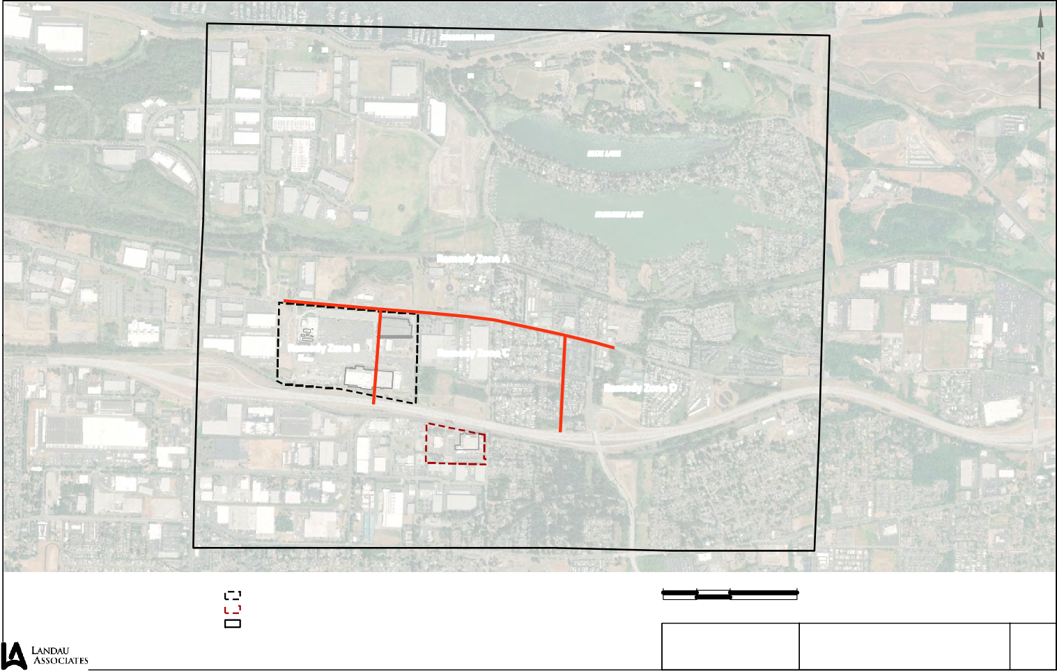
Legend
  - PWB BLA Production Well
# PWB SGA Production Well
" PWB TSA Production Well
!H Gresham/Rockwood Municipal Well

Boeing Portland Property Cascade Corporation Property Original EMC Site Study Area

0 1,200 2,400

Scale in Feet
Data Source: Esri World Imagery.

East Multnomah Site Gresham, Oregon

Note
1. Black and white reproduction of this color original may reduce its effectiveness and lead to incorrect interpretation.

Figure
Site Map 1

COLUMBIA RIVER

BLUE LAKE

FAIRVIEW LAKE

¨¦§84
Pky
¨¦§84

Legend
G:\Projects\025\116\619\622\F02PropertyMap.mxd 1/13/2020
Boeing Portland Property

Commercial

Generalized Zoning Classifications
Multi Family

Parks and Open Spaces

0 1,200 2,400

Note
1. Black and white reproduction of this color original may reduce its effectiveness and

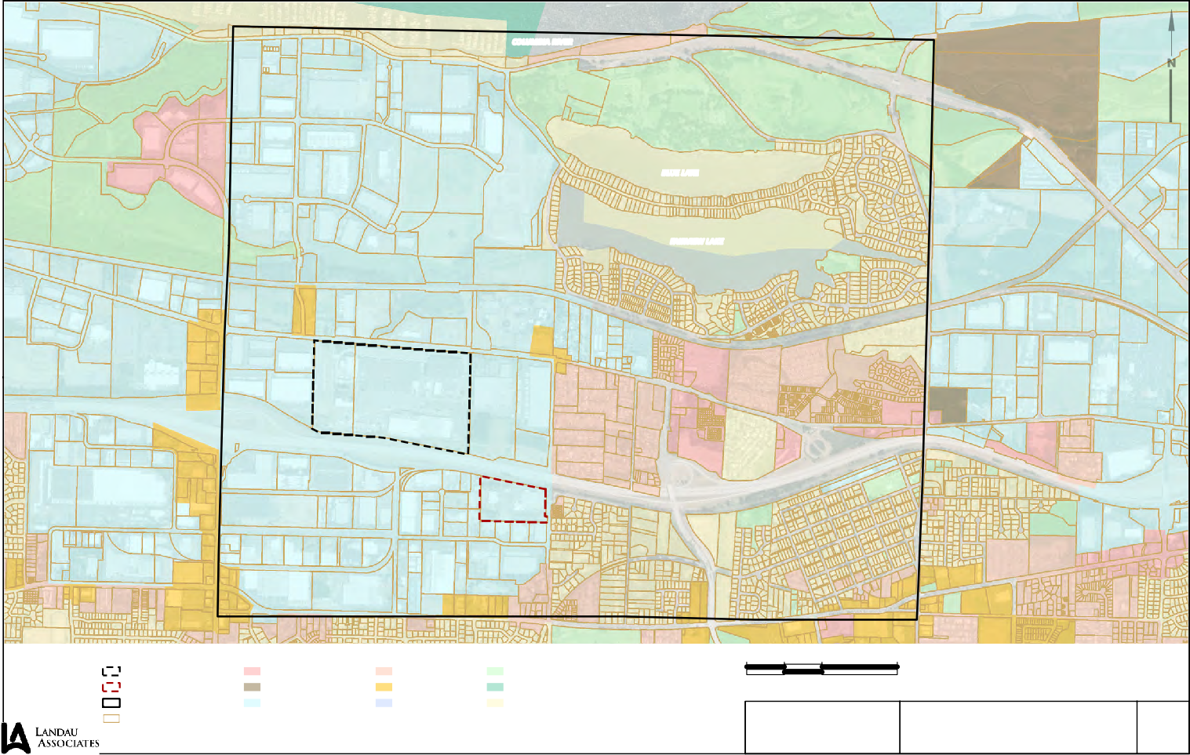
Cascade Corporation Property Original EMC Site Study Area Taxlots
Future Urban Development Industrial
Mixed Use Residential Public Facilities
Rural
Single Family
Scale in Feet
Data Sources: Oregon Metro RLIS; Esri World Imagery.

East Multnomah Site Gresham, Oregon
lead to incorrect interpretation.

Figure

Property Zoning Map 2

COLUMBIA RIVER

# D-15(ds)
# PMX-168

")Ò PMX-138.18

")Ò PMX-141

# D-16(ds)

#EMC-1(ds)
#RPW-1(ds)

# PMX-167

BLUE LAKE

#D-18(ds)

PWB-1(uts) #

FAIRVIEW LAKE

" A-7(i)

BOP-70(ds) # # BOP-71(ds)
BOP-22(ds) #

BOP-43(ds) # # BOP-21(ds)

BOP-44(ds)#
# EW-9

BOP-20(ds)

Remedy Zone A
North Groundwater Treatment System (Decommissioned 2008) # DEQ-3(s)

# EMC-2(ds)

#MW-41(ds)

PWB-4(s) #

#
BOP-22R(ds)
BOP-67(ds) #
# " A-5(d)
East Groundwater

A-3(s) "
A-6(ia) "
EW-22 # A-4(i)

Remedy Zone B
BOP-60R(ds)
# BOP-23(ds)
# BOP-14(s)
Treatment System (Decommissioned 2005)

# EW-10 (PMX-189)

A-2(d) #

BOP-60(ds) #"# BOP-63(ds)

Remedy Zone C

EW-3 #
#BOP-61(ds)

West Groundwater
BOP-65(ds) # #
# BOP-31(ds)

Treatment System
BOP-41(ds)#
"
A-1(d)
#
BOP-62(ds)
BOP-66(ds)

MW-17(ds)

Remedy Zone D
#MW-29(ds)

¨¦§84
G:\Projects\025\116\619\622\F03TSAUpperWellLocations.mxd 1/13/2020
#BOP-64(ds)
BOP-42(ds) #
VMW-A
D-17(ds) #VMW-H#
VW-17d-95.5 VW-17d-75.0

BOP-13(ds) #
VMW-C
##### VMW-G

VMW-B VMW-D
#
### MW-18(ds)
VMW-F
#MW-26(ds)
¨¦§

MW-20(ds) #
# DEQ-5(ds)
MW-19(ds)#
MW-3 #
# VMW-E MW-10(ds)

DEQ-1(ds) #
# EW-21 (PMX-417) 84
EW-21 Groundwater Treatment System (Decommissioned 2007)

Legend
" Supply Wells
TSA Extraction Wells
# TSA Monitoring Wells

Aquifer Restoration Zones Treatment Systems
Original EMC Site Study Area

TSA TCE Plume 1998 TSA TCE Plume 2019
Unsaturated Areas

# #
T TCross Section Location

0 1,000 2,000

Scale in Feet ta Source: Esri World Imagery.
Da

Note
- Black and white reproduction of this color original may reduce its effectiveness and lead to incorrect interpretation.

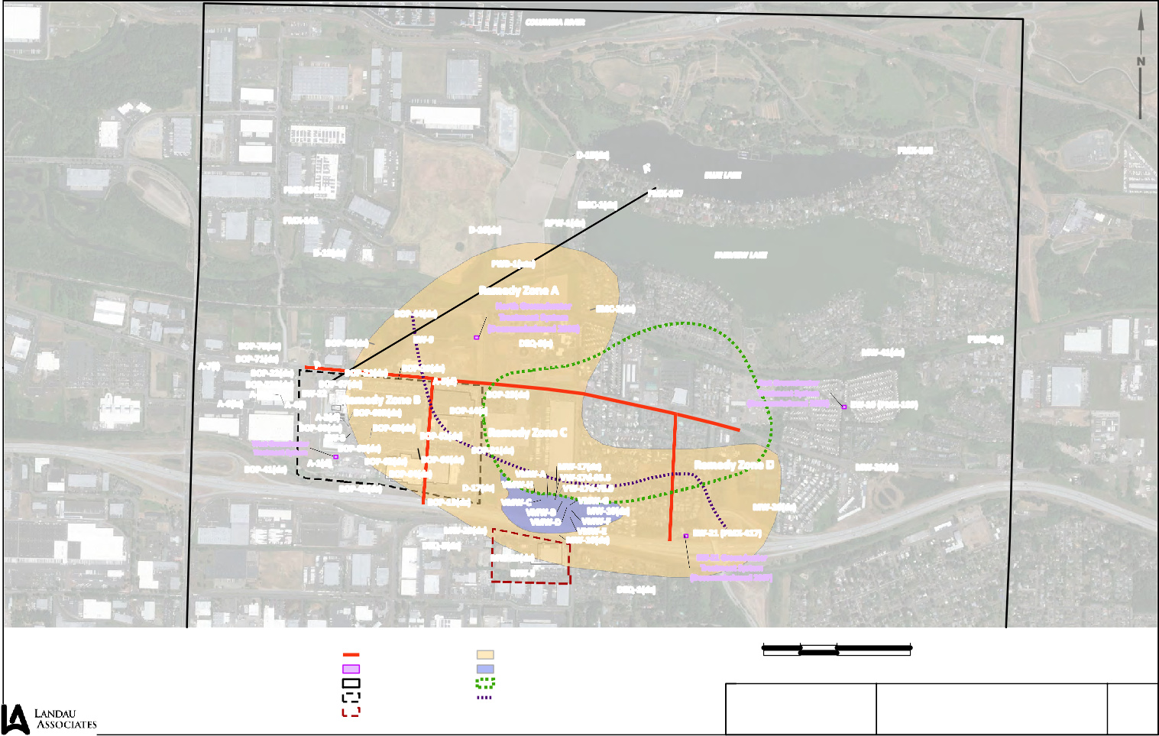

)Ò ! "
# TSA Monitoring Wells - Private
)Ò Upper/Lower TSA Monitoring Wells - Private
# Decommissioned Wells
Boeing Portland Property Cascade Corporation Property
Approximate Location of Truncation
East Multnomah Site Gresham, Oregon

Upper TSA Well Locations
Figure

3

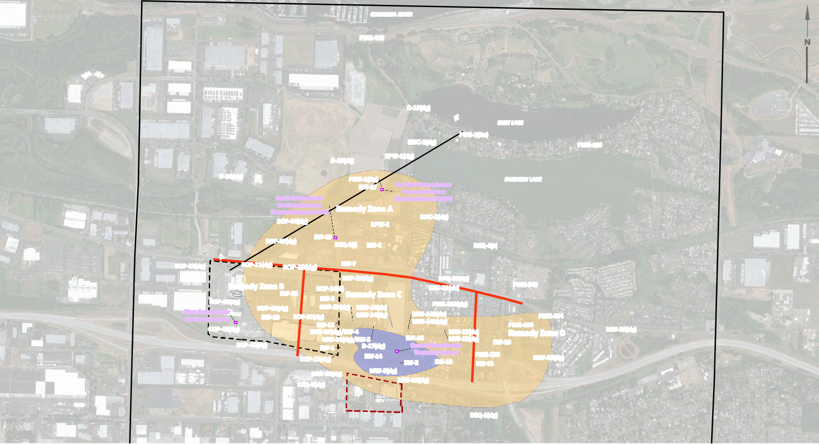

G:\Projects\025\116\619\622\F04TSALowerWellLocations.mxd 1/14/2020

COLUMBIA RIVER

# PMX-419

# D-15(dg)
BLUE LAKE
# PWB-2(Its)
# EMC-1(dg) # PMX-165
# D-16(dg) # RPW-1(dg)
# D-18(dg) PWB-1(Its) FAIRVIEW LAKE
EW-17 ## Far North Groundwater
Treatment System
North Groundwater (Decommissioned 2007)
Treatment System Remedy Zone A
(Decommissioned 2008) # EMC-2(dg)
BOP-44(dg) # #RPW-2
# BOP-43(dg) EW-19 # ##
DEQ-3(i) EW-6 # DEQ-4(s)

BOP-22(dg) # # BOP-21(dg) # BOP-20(dg) # EW-7
# BOP-23(dg) #MW-36(dg)
Remedy Zone B # BOP-14(d) # MW-23(ds) # PMX-345
EW-23# EW-8 # Remedy Zone C
BOP-60(dg) # # PMX-208(dg)
BOP-61(dg) # MW-25(dg) MW-14(ds)
West Groundwater
Treatment System EW-13 # BOP-31(dg) # # #MW-14(dg) MW-14R(ds) # PMX-434
# EW-12 ## # # # MW-14R(dg) # PMX-196 #
¦¨§ BOP-41(dg) MW-16(dg)/EW-4 # MW-22(ds) Remedy Zone D MW-29(dg)
84 # MW-24(dg)/EW-5 EW-18 MW-22(dg) #EW-16
BOP-42(dg) EW-1 # # D-17(dg) # Central Groundwater
# #EW-14 Treatment System # PMX-198 # MW-26(dg) BOP-13(dg) # EW-2 EW-15# # EW-11
MW-20(dg) # #MW-8(dg)
# #MW-10(dg) ¨¦§
DEQ-5(dg)
84

# DEQ-1(dg)

Legend # # 0 1,000 2,000 Note
T T 1. Black and white reproduction of this color
TSA Extraction Wells Aquifer Restoration Zones TSA TCE Plume 1998 Cross Section Location original may reduce its effectiveness and Scale in Feet lead to incorrect interpretation.
TSA Extraction Wells - Private Treatment Systems TSA TCE Plume 2019
# TSA Monitoring Wells Original EMC Site Study Area Data Source: Esri World Imagery.
# TSA Monitoring Wells - Private Boeing Portland Property  # Decommissioned Wells Cascade Corporation Property | East Multnomah Site Gresham, Oregon | Lower TSA Well Locations | Figure  4

PMX-135 X PMX-136
COLUMBIA RIVER

PMX-131X
X PMX-132

PW-19 ! TW-19

- PMX-133

  - PW-13

- PW-17

PW-11X

- PMX-147(a,b,c)
  - PW-18

- PW-12

  - PMX-170(a,b,c,d)

PMX-140 XX
PW-8

X PWB-2(usg)
X PMX-166
BLUE LAKE

XPMX-174

- PMX-175
X PMX-340

North Groundwater Treatment System (Decommissioned 2008)

BOP-44(usg)X
XBOP-68(usg)

XPWB-1(usg)

XEMC-2(usg)

EW-20XWXDEQ-3(usg)

XDEQ-4(d)
FAIRVIEW LAKE
XPMX-176

PWB-4(d) X

XBOP-69(usg)
XPMX-202

XMW-38(usg)
XPMX-192

¨¦§84

MW-14(usg) X
XPMX-409
XPMX-208
PMX-208R

XPMX-410(r)

XPMX-225

XPMX-194

XMW-37(usg) XPMX-195

¨¦§84

PMX-185 X

Legend
G:\Projects\025\116\619\622\F05SGAWellLocations.mxd 1/14/2020
  - Blue Lake Aquifer Wells
- SGA Extraction Wells

Treatment Systems
Original EMC Site Study Area

SGA Historical Plume (1997)
0 1,000 2,000

Scale in Feet
Note
  - Black and white reproduction of this color original may reduce its effectiveness and lead to incorrect interpretation.

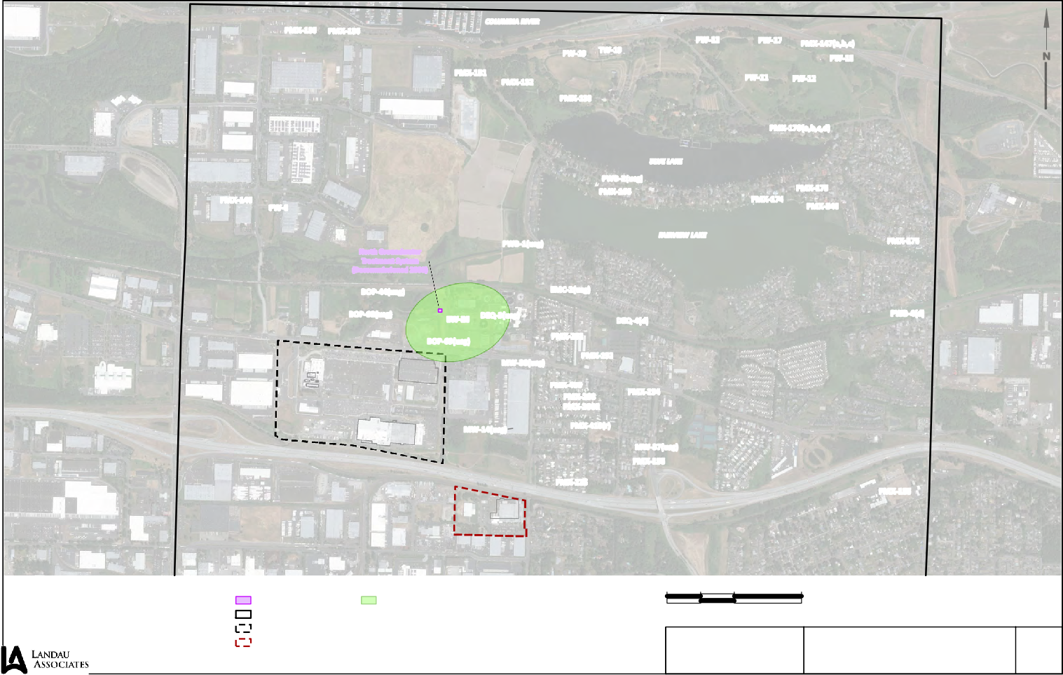
- SGA Monitoring Wells
X SGA Monitoring Wells - Private
WX Decommissioned Wells
Boeing Portland Property Cascade Corporation Property
Data Source: Esri World Imagery.

East Multnomah Site SGA and BLA Well Locations
Gresham, Oregon

Figure

5

TCE Concentration Notes
BOP-44(dg): TCE all ND at -RL ranging from 0.5 to 1.0 µg/L from 2006-2017

PWB-1(lts): TCE ranged from 1.1 to 1.8 µg/L between 2015 and 2018

Legend
A
Southwest

BOP-21(ds)
(Offset 12' NW)
100

Existing Surface Profile

BOP-44(usg)
(Offset 34' SE)

BOP-44(ds)
(Offset 10' NW)
BOP-44(dg)
(Offset 0')

PWB-1(usg)

PWB-1(uts)
(Offset 102' SE)

PWB-2(lts)
(Offset 7' NW)

PMX-167
(Offset 14' NW)
A'
Northeast

PWB-2(usg)
(Offset 14 SE)
100

BOP-21(ds)
Project Exploration Designation 50
(Offset 108' SE) 50

(Offset 12' W) Offset Distance in Feet and Direction
Soil Type Contact Well Screen Interval
0
Bottom of Exploration

TGA

SUD FP
PWB-1(lts)
(Offset 113' SE)

0

SUA SUB SUC SUD
FP: Flood Plain Deposits: Silty, sandy GRAVEL TGA: Troutdale Gravel: Sandy, silty GRAVEL
SU1: Siltstone Unit 1 consisting of four distinct low permeable layers (SUA, SUB/CU1, SUC, & SUD) with the second layer being a blueish/gray Clayey Siltstone

TSA (Upper): Upper portion of the Troutdale Sandstone Unit: Sandstone

TSA (Lower): Lower portion of the Troutdale Sandstone Unit: Conglomerate

SU2: Siltsone Unit 2
SGA: Sand and Gravel Aqufer

-50

-100
Elevation in ft (NAVD88)

?

-150 ?

TSA (upper)

TSA (lower)

SU2

PBW-1(uts)

PBW-1(lts)

PBW-1(usg)

PBW-2(lts)

-50
Elevation in ft (NAVD88)

-100

-150

Notes
Landau Associates | G:\Projects\025\116\619\622\F06CrossSection.dwg | 1/13/2020 2:46 PM
- Soil descriptions are generalized, based on interpretation of field and laboratory data. Stratigraphic contacts are interpolated between borings and based on topographic features; actual conditions may vary.

- See report text for descriptions of geologic units.

- For Cross Section location, see the Site and Exploration Plan, Figure _.

- Black and white reproduction of this color original may reduce its effectiveness and lead to incorrect interpretation.

-200

-250
?
SGA

1350 ft 1400 ft

Geologic Profile A-A'
Horizontal Scale in Feet: 1"=500' Vertical Scale in Feet: 1"=50'
0 500 1000

Scale in Feet

-200

-250

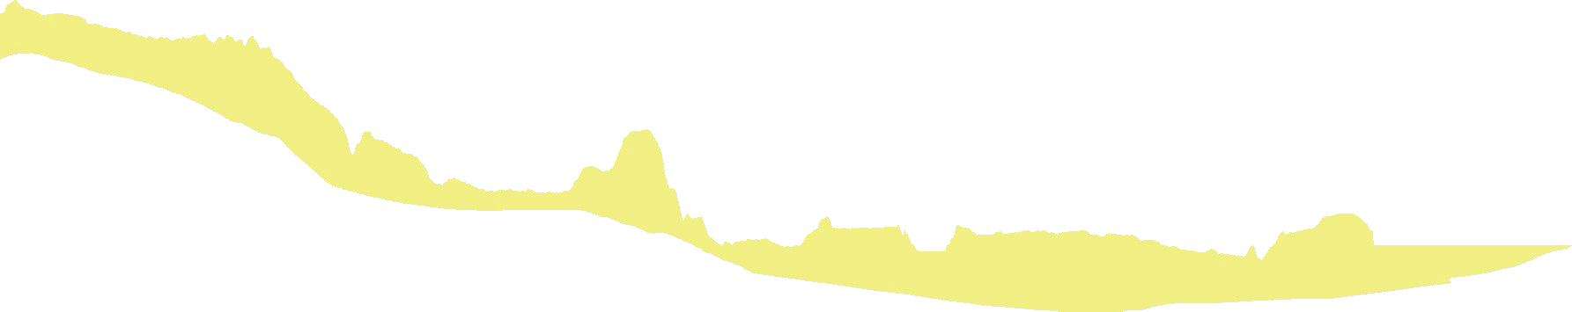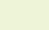Source: DOGAMI Lidar, 2014

East Multnomah Site Gresham, Oregon

Geologic Cross Section A-A'

Figure
6

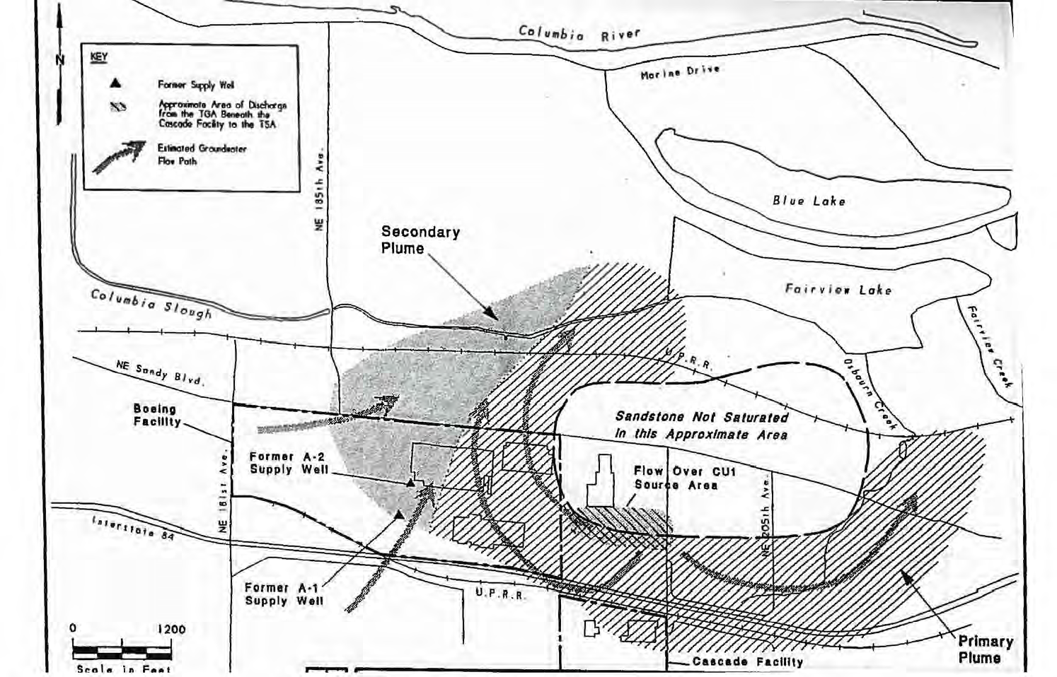
0 1,250 2,500

Scale in Feet
Data Source: Landau Associates, 1995.

East Multnomah Site Gresham, Oregon

Upper TSA Pre-Pumping Groundwater Flow Gradient

Figure

7

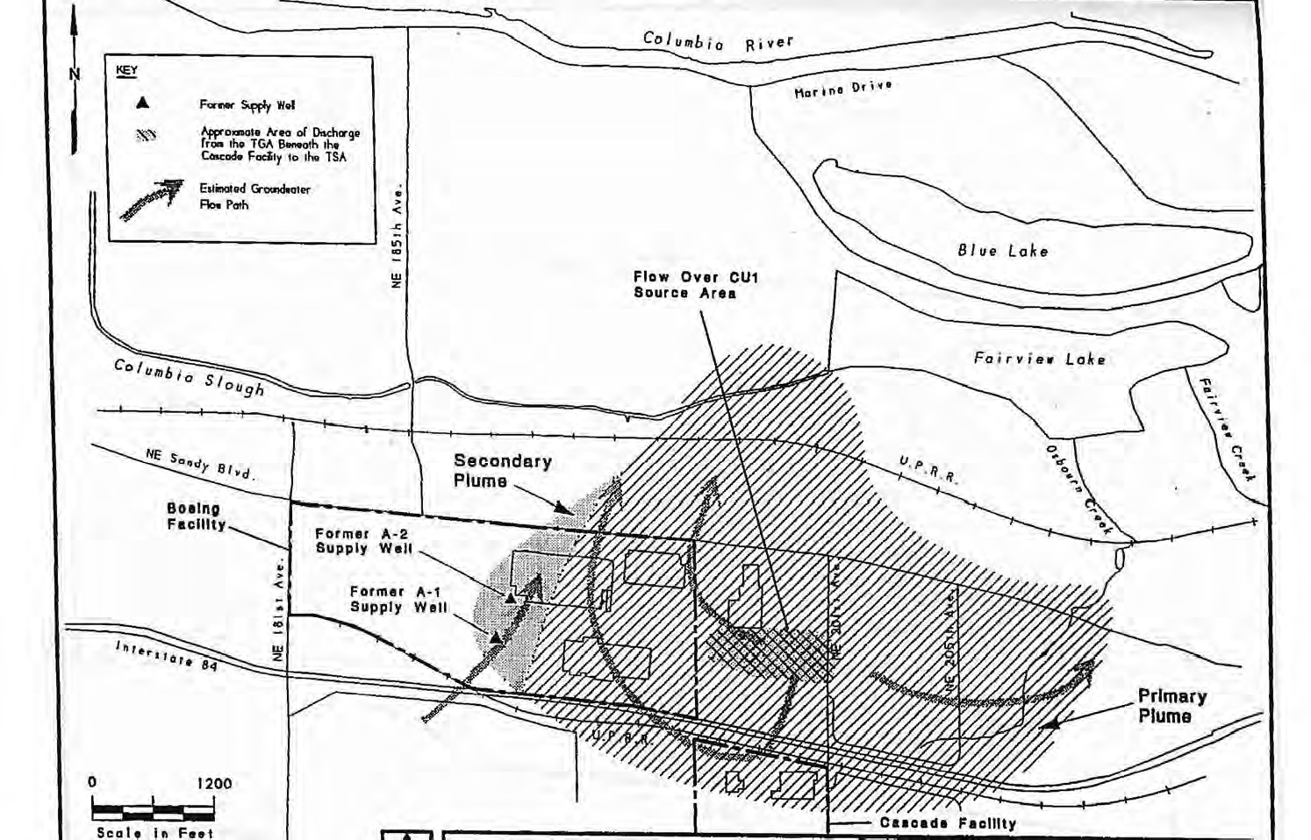
0 1,250 2,500

Scale in Feet
Data Source: Landau Associates, 1995.

East Multnomah Site Gresham, Oregon

Lower TSA Pre-Pumping Groundwater Flow Gradient

Figure

8

BOP-44ds* 9.80

BOP-22Rds 1.89
BOP-21ds 3.05

BOP-20ds 4.78

EW-3 0.91

BOP-65ds

BOP-61ds* 4.44

BOP-62ds 0.24
SantaBarbara-01\Data P:\GIS\PNG0564 - Cascade\Projects\2018\TSA 2018 Annual Report\Fig04-2a_Upper_TSA_Aquifer_GW_Elevations_2018-08.mxd (Author: SAntonelli) 20190425
5.21 BOP-66ds 7.40

BOP-31ds 9.84

BOP-42ds 8.94

BOP-13ds 9.10

CMW-20ds 15.14

CMW-17ds 21.68

18

CMW-18ds 6.17

CMW-19ds 16.15
CMW-10ds 14.35

600

300

0 600 Feet

Legend

Notes

Upper TSA Monitoring Well

Upper TSA Groundwater Elevation (ft. AMSL)

Inferred Upper TSA Groundwater Elevation (ft. AMSL)

Upper TSA Groundwater Elevation Depression (ft. AMSL)

Unsaturated Area Structure
Boeing Property Boundary

Cascade Corporation Property Boundary

CMW-3 17.55
Upper TSA Aquifer Groundwater Levels August 2018
East Multnomah County

Figure

9

BOP-65ds = Monitoring Well Location ID * - Groundwater elevation gauged in July 2018.

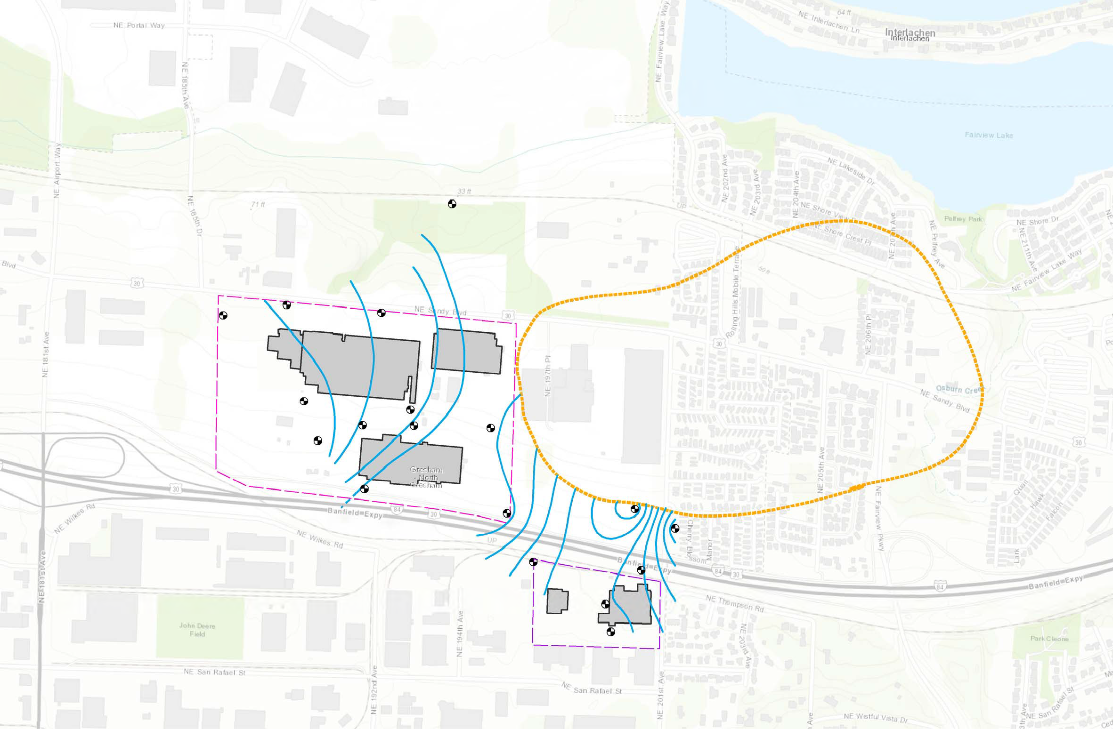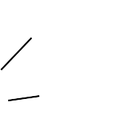5.21
= Groundwater Elevation (ft. AMSL)
PNG0564S
April 2019

D-16dg* 9.96

PWB-1lts* 11.63

BOP-44dg* 9.28
EMC-2dg* 8.12

BOP-20dg 4.74

BOP-23dg 6.82

CMW-36dg
11.23

BOP-60dg 2.85
SantaBarbara-01\Data P:\GIS\PNG0564 - Cascade\Projects\2018\TSA 2018 Annual Report\Fig04-2b_Lower_TSA_Aquifer_GW_Elevations_2018-08.mxd (Author: SAntonelli) 20190501

BOP-61dg 4.80

EW-13 8.46
-5 EW-23
-6.21

EW-8 10.18

BOP-31dg 9.44

EW-12 10.16
-5

CMW-25dg 11.47

D-17dg 10.22

CMW-24dg (EW-5) 13.56

CMW-14Rds 23.14

CMW-22dg 16.46

EW-16 18.36

Legend

Lower TSA Monitoring Well Extraction Well
Lower TSA Groundwater Elevation (ft. AMSL) Inferred Lower TSA Groundwater Elevation (ft. AMSL)
BOP-42dg
7.38
EW-1
-32.77

BOP-13dg 7.71
-10
-15
-20
-25

-20
-15

CMW-8dg 9.00
D-17ds
22.37

EW-14
-25.17

-25

EW-2
-29.30

CMW-10dg 9.70

EW-15+ 63.48

EW-11+ 59.55

CMW-26dg 14.57

600

300

0 600 Feet

Notes
Lower TSA Groundwater Elevation Depression (ft. AMSL) Structure
Boeing Property Boundary

Cascade Corporation Property Boundary

CMW-3 17.55

Lower TSA Aquifer Groundwater Levels August 2018
East Multnomah County

Figure

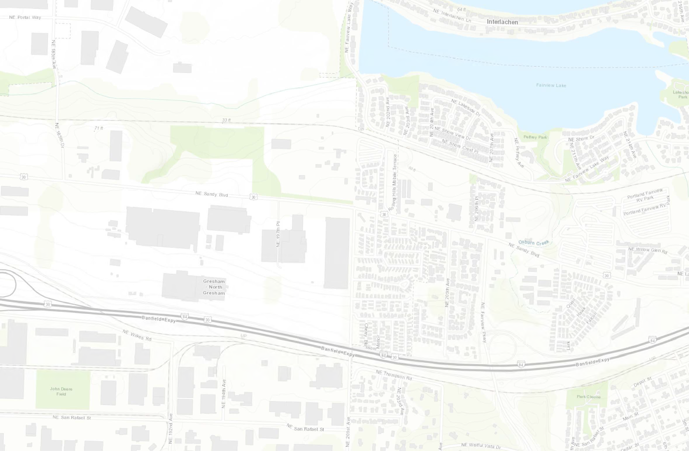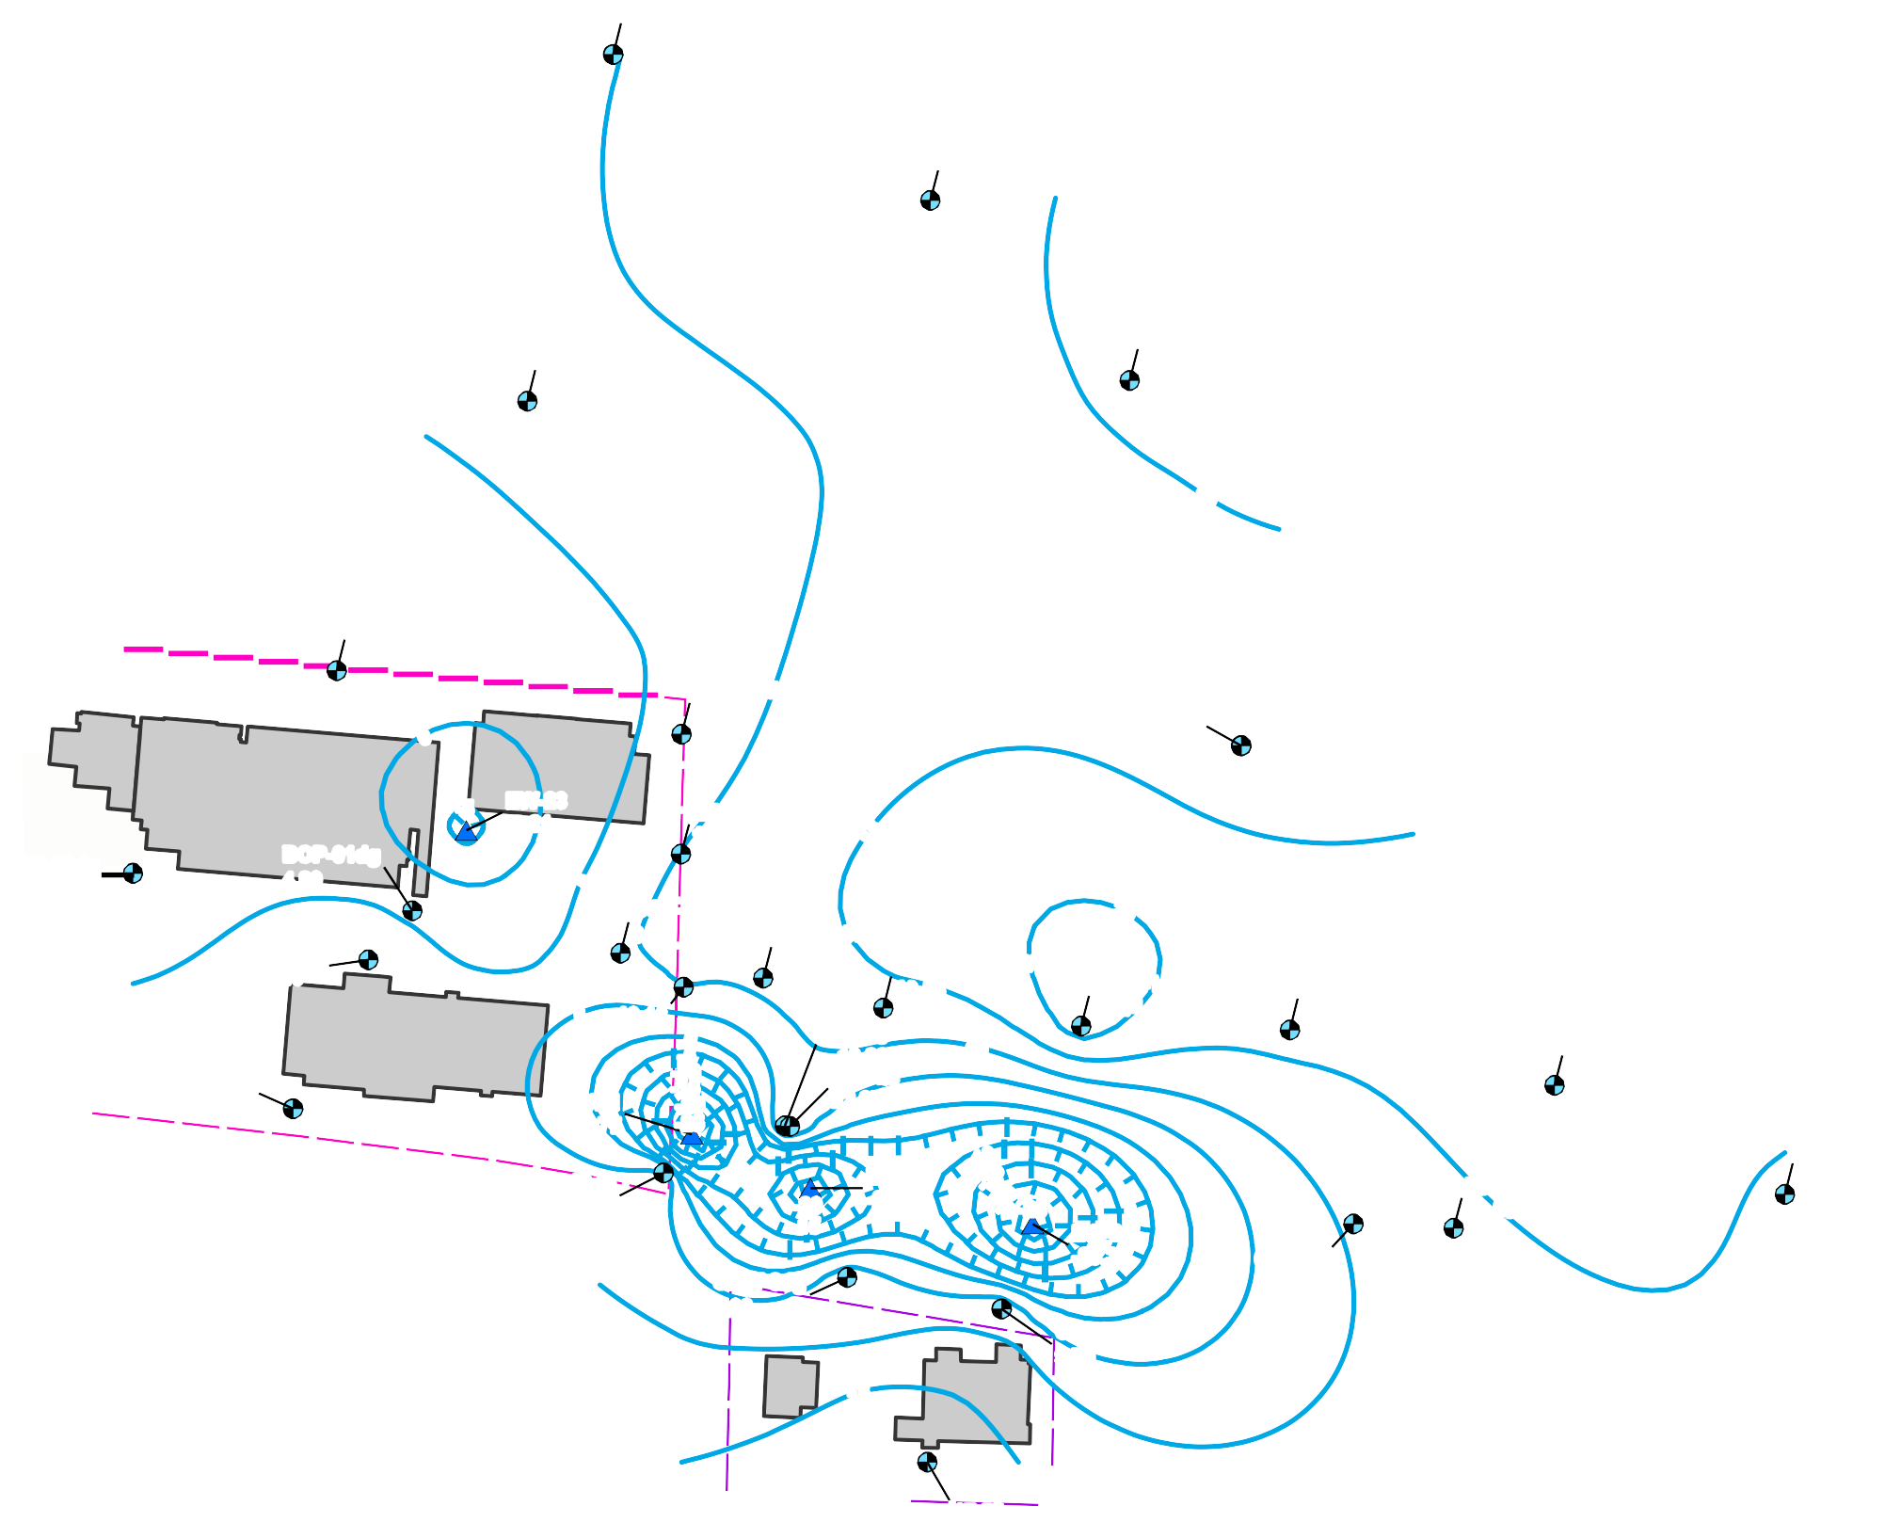BOP-31dg = Monitoring Well Location ID
9.44 = Groundwater Elevation (ft. AMSL)
* - Groundwater elevation gauged in July 2018.
+ - Groundwater elevation excluded from contouring.

PNG0564S

10
May 2019

APPENDIX A
Administrative Record Index

Appendix A Administrative Record Index
Emcon, 1997. Construction Report for Central Treatment System, Phase 1 TSA Remedial Action.
8.15.97.
Emcon and Landau Associates, 1995. Remedial Investigation and Feasibility Study, Troutdale Sandstone Aquifer, Part 1: Remedial Investigation (final report); Part 2: Endangerment Assessment. 6 October 1995.
Geosyntec, Landau, SSPA, 2019. Annual Performance Report 1 January 2018 – 31 December 2018; Five Year Remedy Performance Evaluation, East Multnomah County, Troutdale Sandstone Aquifer Remedy, ECSI 1479. 31 May 2019.
Landau Associates, 1995. Report, Phase III RCRA Facility Investigation, Boeing Portland, Gresham, Oregon. Prepared for the Boeing Company. July 31.
Landau Associates, 1999. Troutdale Sandstone Aquifer Remedial Action Annual Performance Evaluation for April 1, 1998 – March 31, 1999. 30 June 1999.
Landau Associates, 2015. Technical Memorandum: 2015 Monitoring and Contingency Plan for PWB Pumping Events. 21 July 2015.
Landau Associates, 2019. 2019 Draft Monitoring and Contingency Plan for PWB Pumping Events, East Multnomah County Troutdale Sandstone Aquifer Remedy, Gresham, Oregon, ECSI # 1479. 12 July 2019.
Landau Associates and Emcon, 1996. Troutdale Sandstone Aquifer Feasibility Study. 4 March 1996.
Landau Associates and Prowell Environmental, 1999. Institutional Controls Plan, Troutdale Sandstone Aquifer. 21 September 1999.
Landau Associates, Prowell Environmental, Pegasus Geoscience, 2006. Troutdale Sandstone Aquifer Remedial Action Annual Performance Evaluation, 04/01/05 through 03/31/06. 30 June 2006.
Oregon Department of Environmental Quality (DEQ), 1996. DEQ Remedial Action Record of Decision for the East Multnomah County Groundwater Contamination Site, Troutdale Sandstone Aquifer. Oregon Department of Environmental Quality, Waste Management & Cleanup Division. 31 December.
Oregon Department of Environmental Quality. 1997. DEQ Order on Consent No. WMCSR‐NWR‐ 96‐08 In the Matter of The Boeing Company and Cascade Corporation. Oregon Department of Environmental Quality. 14 February.
Oregon Department of Environmental Quality, 2005. Letter to J. Cushing, Cascade Corporation, Portland, OR re: East Multnomah County ‐ Troutdale Sandstone Aquifer Remedial Action, DEQ Order on Consent No. WMCSR‐NWR‐96‐08, Request for Authorization to Decommission

TSA East Treatment System. From B. Gilles, Oregon Department of Environmental Quality, Portland, OR. March 22.
Oregon Department of Environmental Quality 2005. Record of Decision Remedial Action Approach for Columbia Slough Sediment. Oregon Department of Environmental Quality, Environmental Cleanup Program.
Oregon Department of Environmental Quality, 2006. Email to S. Prowell, Prowell Environmental;
C. Kimmel, Landau Associates; K. Chaput, The Boeing Company; J. Cushing, Cascade Corporation. Re: Pilot Shutdown for EW‐7, EW‐9, EW‐19, and EW‐20. June 5.
Oregon Department of Environmental Quality, 2015. Order on Consent, DEQ No. WMCSR‐NWR‐ 96‐09, Certification of Completion. 21 January 2015.
Oregon Department of Environmental Quality, 2018a. Email from K. Thiessen RE: EMC TSA Remedy: Annual Performance Report 2017 [Partial approval of 2017 Annual Report]; 2 August 2018.
Oregon Department of Environmental Quality, 2018b. Email from K. Thiessen RE: Meeting with PWB today [DEQ support for NFA Closure for Zone A and SGA]. October 11.
S.S. Papadopulos & Associates, Inc. (SSPA), 1996a. Additional Remedial Options/or the TSA. Memorandum prepared for the Oregon Department of Environmental Quality. S.S. Papadopulos & Associates, Inc. 12 June 1996.
S.S. Papadopulos & Associates, Inc., 1996b. TCE Contamination in the TSA‐Areal Extent and Mass. Memorandum prepared for B. Gilles, Oregon Department of Environmental Quality 18 July 1996.
Swanson, R.D., McFarland, W.D., Gonthier, J.B., and Wilkinson, J.M., 1993, A description of hydrogeologic units in the Portland basin, Oregon and Washington; U.S. Geological Survey Water Resources Investigations Report 90‐4196, 64 p.

APPENDIX B
EMC TSA Remedy Timeline

Action | Date
Corrective Measures Element
Entered into Order on Consent with DEQ for TSA Removal Action to control northerly plume migration (DEQ No. ECSR-NWR-93-07) | 1993
Installed RPW-1 and RPW-2 and began extracting RPW-2 and treating effluent | 1994
Completed TSA RI/FS
Entered into Addendum to Order on Consent to complete TSA RI/FS | 1994
Entered into Second Addendum to Order on Consent for NPDES discharge permit | 1996
Performed and completed TSA RI/FS, including well installations, aquifer testing, model construction, evaluations, design planning, and reporting | 1994 - 1996
DEQ issued TSA Remedy Record of Decision | 1996
Enter into Order on Consent with DEQ for design and implementation of remedial measures (DEQ No. WMCSR-NWR-96-08) | 1997
Implemented TSA Remedy
Installed SGA monitoring wells to characterize water quality; decommissioned selected private SGA wells for migration pathway protection; provided replacement water supply to residences | 1996-1997
Performed phased remedy implementation including: construction of monitoring and extraction wells (EW- 1, EW-2, EW-3), convert monitoring wells MW-16 and MW-24 to extraction wells EW-4 and EW-5, install conveyance and treatment systems, and performance/protection evaluations | 1996-1998
Began phased startup of remedy extraction/treatment systems, installation of extraction wells EW-6, EW- 7, EW-8, EW-9, EW-10, EW-11, EW-12, EW-13, EW-14, EW-15, EW-16, EW-17, EW-18, EW-19, and EW-20 | 1996-1998
Entered into Order on Consent with DEQ for remedy implementation and effluent discharge | 1997

Action | Date
Began full scale remedy implementation of GWTS (West), Central, East, North, and Far North Systems | 1998
Began operating EW-21 Treatment System for TSA Sandstone plume capture near MW-26(ds) | 2000
Amended TSA RD/RA work plan and documented transfer of TSA remedy responsibilities from Boeing to Cascade | 2001
Began operating EW-22 for TSA Sandstone plume capture near BOP-22(ds) | 2003
Began operating EW-23 from Lower TSA | 2007
Began Remedy Modifications, Due to Restoration Progress
Decommission East Treatment System | 2005
Decommission Far North System | 2007
Decommission North Treatment System | 2008
Adopt diffusion bag samplers methods for groundwater sampling, pilot shutdown of EW-7, EW-9, EW-19, and EW-20; and installation of TSA Sandstone well EW-23 | 2006
Decommission BOP-22(ds) and install replacement well BOP-22R(ds), install BOP-70(ds) and BOP- 71(ds) | 2008-2009
Shutdown EW-22 | 2008
Pilot Shutdown EW-3 and EW-13 | 2009
Cessation of TSA treatment at Groundwater Treatment System (GWTS - West) | 2009
Install replacement well BOP-60R(ds) and decommission BOP-60(ds) | 2010
Decommission EW-22 | 2010
Cascade Corporation receives NFA for TGA | 2015
Begin SVE operation in TSA Mound Area | 2015

APPENDIX C
TCE profiles ‐ Select Zone A and SGA wells

1/14/20 P:\025\116\WIP\T\EQuIS\Exports\TSA\C-10 Zone A TCE Profiles.docx

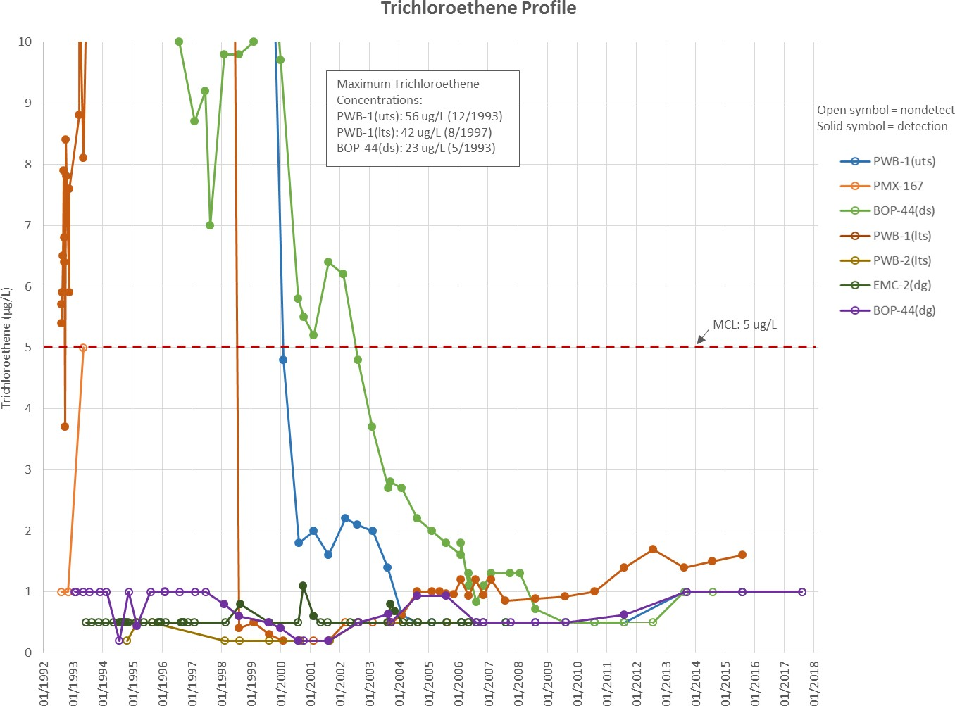

East Multnomah County

Zone A Select TSA Well- TCE Profiles
Figure
C-1

1/14/20 P:\025\116\WIP\T\EQuIS\Exports\TSA\C-11 TCE Profiles for SGA Wells.docx
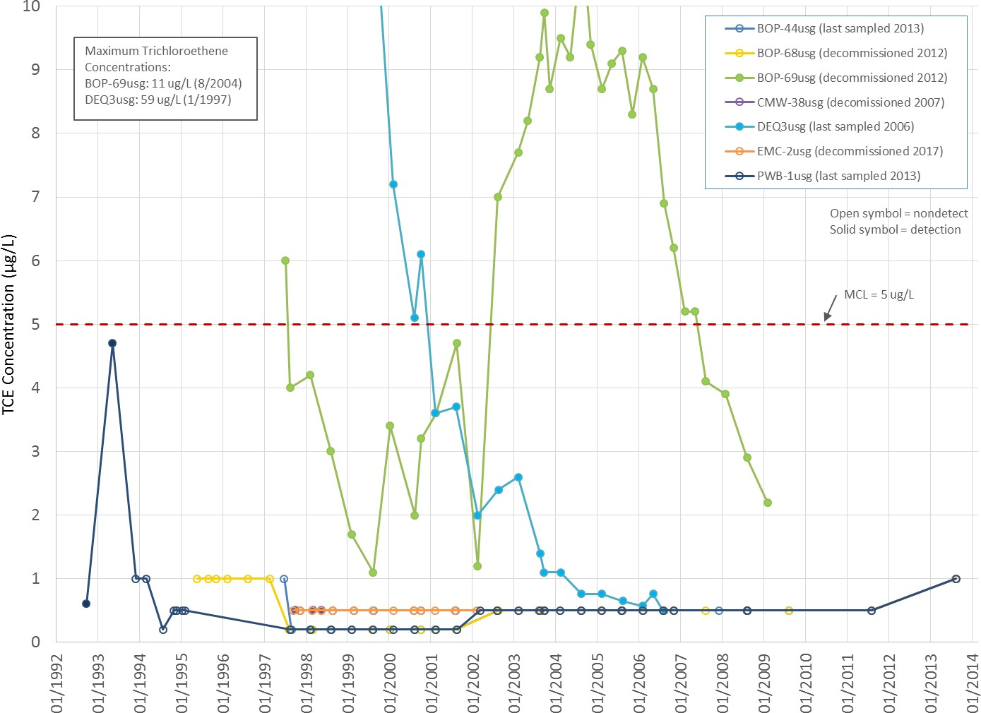

East Multnomah County

TCE Profiles for Select SGA Wells
Figure

C-2

