Cascade Corporation Remedy Progress Update December 2009

Fact Sheet

Small Headline
Welcome to the 1st Page of the Fact Sheet Template. This document contains sample text and graphics to give you an idea of what the first page of your new fact sheet can look like.

If you need help formatting text properly and inserting graphics please consult with your administrative and/or technical staff.

Creating a Fact Sheet from Scratch
If you are creating a fact sheet from scratch you can simply replace the sample text you are reading on this page with your own. Highlight and begin typing over the text. Your font style should automatically be applied to your new text.

Reformatting an old fact sheet
If you have a current fact sheet that you would like to convert into this template there are a few things to consider.

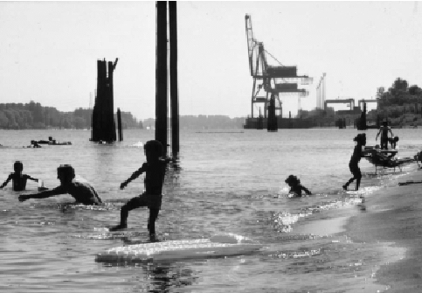

Caption. Your caption will go here to identify your photo

First try to determine how long your fact sheet will be in the new format. Next, if you are going to attempt to paste your text into this template, it is a good idea to save your old file as a “Text Only” document.

Why? When pasting text from one document to another MS Word will often import any existing formatting. Make life easy for yourself and remove the formatting so you have clean text ready to be molded by your template!

Creating a “Text Only” document
Print this page for reference. Open your existing fact sheet in Microsoft Word. Now select “File” then “Save As…” from the Standard Toolbar at the top of the screen.

A window pops up that asks you where you would like to save your document. Choose a location you can easily remember. Now look at the bottom of this new window.

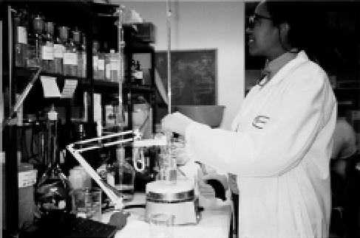

Caption. Tips for inserting pictures can be found in “fs4page2.doc”. Open this file and see!

Do you see the words “Save as type:” in the bottom left? In the long box just to the right of those words go ahead and left click with your mouse. A menu should drop down.

In that menu that drops down move your mouse pointer over “Text Only (*.txt)” and left click. Now hit the “Save” button in the top right and…Viola!

If you look in the top left you will notice that your document name has changed. Instead of “.doc” after the name it now has “.txt”. But you aren’t finished yet.

Close this document. Seriously, close it and now go up to “File” and when the file menu drops down look for your document name at the bottom. Highlight and left click to reopen your new Text Only file. Now your ready to select text and paste into your new template.

Saving your file from the template
Remember the “Save as…” feature in the file menu? When you first open this template it is a good idea to go to “Save as…” and change the name from “FSTemplate.doc” to a name you like and will recognize. In other words, create a new document to work with or you will forever alter your copy of the fact sheet template and will be forced to download it all over again.

For more information please contact:
Bill Knight, Public Affairs (503) 229-6840

Pre-Formatted Page 2
All your succeeding pages can resemble this one. The DEQ Logo only needs to be on the first page. However you must preserve the right hand white space.

Please put the following paragraph at the end of your document:

Alternative Formats
Alternative formats of this document can be made available. Contact DEQ Public Affairs for more information (503) 229-5696.

