Oregon
John A. Kitzhaber, MD, Governor
Department of Environmental Quality
Northwest Region Portland Office
2020 SW 4th Avenue, Suite 400
Portland, OR 97201-4987
(503) 229-5263
FAX (503) 229-6945
TTY (503) 229-5471
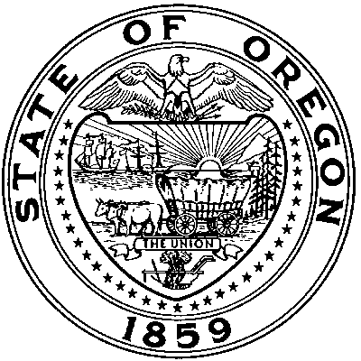

August 1, 2014

John Cushing
Cascade Corporation
P. O. Box 20187
Portland OR 97294-0187

RE: Project Completion Report
Cascade Corporation
ECSI #635

Dear Mr. Cushing:

The Department of Environmental Quality (DEQ) has reviewed the July 22, 2014 Geosyntec Project Completion Report for the Cascade Troutdale Gravel Aquifer remedy. The report is approved by DEQ. A public comment period on the proposed site closure begins August 1, 2014 and will run through September 2, 2014. Next steps for project closure include DEQs response to any comments we receive and finalizing and recording the Easement and Equitable Servitudes document. Once these steps are complete the Certification of Completion will follow.

DEQ appreciates your efforts over the years to bring the project to closure. If you have any questions, please contact me at (503) 229-6802 or by email at williams.robert.k@deq.state.or.us.

Sincerely,

Robert Williams
Project Manager

cc: Cindy Bartlett, Geosyntec
Charlie Andrews, Papadopulos & Associates

