EPA’s National Air Toxics Assessment

Fact Sheet

Oregon results

Air toxics are pollutants known or suspected to cause cancer or other serious health effects including birth defects, organ damage and respiratory irritation. Young children, older adults and people with asthma, lung or heart disease may be more sensitive to the effects of air toxics.

What is the 2005 National Air Toxics Assessment?

The National Air Toxics Assessment is an EPA computer modeling study that estimates concentrations of air toxics and potential health effects. Also called NATA, this study helps states identify problem pollutants and where they come from. Individual states submit emissions information for EPA to use in the model. The emissions used in the current assessment are from 2005 emission inventory which is the most complete and up-to-date available.

The assessment examines air toxics from many sources including:
- Businesses and industries
- Cars and trucks
- Residential activities (wood burning, painting, lawn mowing, etc.)
- Natural sources
- Pollutants persisting in the air from previous years

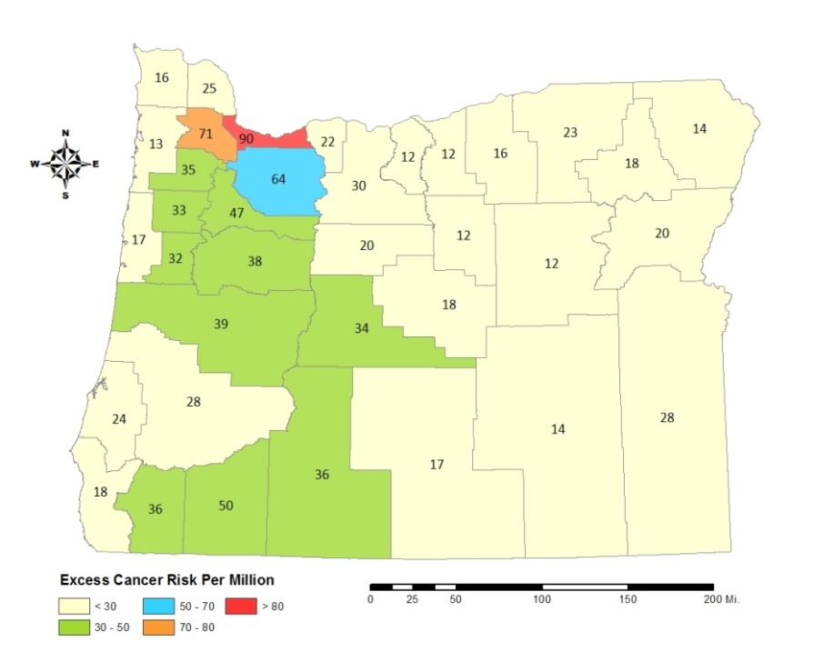
NATA helps DEQ prioritize pollution reduction strategies that will protect public health and the environment.

The current assessment is based on emissions data from 2005. EPA’s previous assessments were based on data from 1996, 1999 and 2002. To improve estimates, EPA made several changes to NATA. This makes it difficult to compare the current assessment to previous ones, or to make state-to-state comparisons.

Oregon results
Because there are no federal standards for individual air toxics, DEQ established health-based benchmarks for a wide range of air toxics in Oregon. NATA estimates that there are 17 air toxics above health-based benchmarks in Oregon. In Multnomah County there are 15 air toxics above benchmarks.
Estimated cancer risk from air toxics by county. The highest estimated risk is in the Portland area because it has the most people and businesses in the state.
According to NATA the pollutants with the most potential to cause serious health effects include:
- Acetaldehyde
- Formaldehyde
- Carbon tetrachloride
- Diesel particulate
- Benzene
- Polycyclic aromatic hydrocarbons (tar-like by-products from auto exhaust and other sources)

NATA also indicates that Oregon has reduced air toxics. DEQ attributes this improvement to several long-standing programs that have improved Oregon’s air quality over the past three decades including:
- Vehicle inspection programs in the Portland and Rogue Valley areas
- Regulating emissions from industry and small businesses
- Assistance to small businesses to reduce the use of toxic chemicals
- Year-round air pollution advisories
- Assistance with diesel engine retrofits and replacement
- Anti-idling initiatives for heavy duty diesel and passenger cars and trucks
- Stricter wood stove requirements and change-out program

These programs have reduced levels of smog, fine particles as well as air toxics.
What is DEQ doing to reduce air toxics?
DEQ is currently working with the Portland Air Toxics Solutions Advisory Committee to collaboratively develop a community plan to further reduce the air toxics causing the most health risk in the Portland area. Similar efforts are planned for other parts of the state.

For more information please contact:
Gregg Lande, 503-229-6411 or lande.gregg@deq.state.or.us.

Alternative formats
Alternative formats of this document can be made available. Call 503-229-5696.

