May 2, 2023 sent via email

Deborah Taege
The Boeing Company
EHS Remediation
Bldg. 10-20, MC 9U4-26
800 N 6th Street
Renton, WA 98055-1409

PWB Comments:
With respect to the 2022 Annual Progress Report for the Troutdale Gravel Aquifer Boeing Portland Facility ECSI #13 dated March 21, 2023, PWB has reviewed the recommendations in consultation with our technical advisers at GSI and offers the following:

PWB generally considers the recommendations reasonable with respect to well decommissioning in the central portion of the site and the reduction in monitoring to an annual basis. PWB does not concur with the recommendation to eliminate groundwater elevation monitoring altogether at the Upper TSA monitoring wells, however, which remains a requirement of the TGA Consent Order. (We’ll also note here that the closure of the TSA remedy should not result in changes to the requirements for the TGA remedy.) The TSA measurements are important to evaluating whether there is potential for downward movement of VOCs from the TGA to the TSA, and the data do indicate this potential exists. TSA observations therefore remain necessary to provide evidence against whether VOCs are escaping the TGA. This mechanism is even more important to maintain as the extraction wells are decommissioned in future years.

PWB would be amenable to a more narrowly targeted elevation data collection scheme that would reduce the overall monitoring burden but maintain sufficient data resolution to evaluate the TGA-TSA potential pathway. At minimum this should include the wells underlying areas of TGA contamination that have historically exhibited a downward vertical gradient.

Please feel free to call me with questions.

Sincerely,
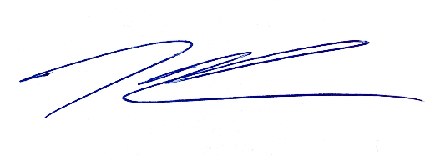
Kenneth Thiessen, RG, CEG
Northwest Region Cleanup Section
(503) 887-7636

cc: Erin Waibel, PE, Landau Associates
Evelyn Ives, PE, Landau Associates
Clint Jacob, PE, Landau Associates
Dan Hafley, RG, DEQ Northwest Region

ECSI #13

