January 24, 2022 sent via email

Deborah Taege, Remediation Program Manager
The Boeing Company
Bldg. 10-20, MC 9U4-26
800 N 6th Street
Renton, WA 98055-1409

RE: Technical Memorandum. 1, 4-Dioxane Reconnaissance-Level Investigation, Boeing Portland, Troutdale Gravel Aquifer. Gresham, Oregon. ECSI #13

Dear Ms. Taege,

Thank you for your 1,4-Dioxane Reconnaissance-Level Investigation, Technical Memorandum for the Troutdale Gravel Aquifer at the Portland Boeing facility, dated November 3, 2021. The Oregon Department of Environmental Quality (DEQ) approves this document with its addition of three additional groundwater sampling events for BOP-73(i) and BOP-82(i) as proposed.

The two wells proposed for additional sampling are about 250 feet apart. The former TCE source area near BOP-73(i), has received eight bioremediation injections to enhance reductive dechlorination. Are the effects of this bioremediation expected to be present at BOP-82(i)? Are wells BOP-73(i) and BOP-82(i) screened at approximately the same elevation and stratigraphic interval?

The DEQ Risk-Based Concentration used for screening of the 1, 4-dioxane detections for this Boeing work is the Urban Tap Water Ingestion and Inhalation RBC of 2.0 µg/L, as approved in the project workplan. The DEQ RBC used for screening of the 1, 4-dioxane detections for the East Multnomah County groundwater project is the Residential Tap Water Ingestion and Inhalation RBC of 0.46 µg/L. I do not recall why the different screening values were used on these two projects. For the Boeing project 1, 4-dioxane results, the reported sample quantitation limit is less than the 0.46 µg/L RBC, which allows DEQ to compare the results of both projects at the most conservative screening level.

Please provide DEQ with a 2022 groundwater sampling schedule when available.

If you have any questions, please contact me.

Sincerely,
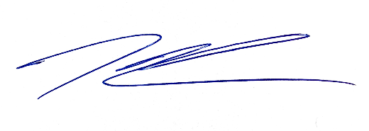
Kenneth Thiessen, CEG
Northwest Region Cleanup Section

cc: Evelyn Ives, PE, Landau Associates, Inc.
Jesikah Cavanaugh, EIT, Landau Associates, Inc.
Dan Hafley, RG, DEQ NWR
ECSI #13

