March 16, 2021

Deborah Taege, Remediation Program Manager 
The Boeing Company
Bldg. 10-20, MC 9U4-26
800 N 6th Street
Renton, WA 98055-1409

RE: Request for Reconnaissance-level groundwater sampling for 1, 4-Dioxane at Boeing Portland facility. ECSI #13

Dear Ms. Taege,

Thank you for our recent conversation on the sampling of 1,4-Dioxane in groundwater at the Boeing of Portland facility. As we discussed, the Oregon Department of Environmental Quality (DEQ) in interested in understanding if this chemical, a solvent stabilizer known to be present in both 1,1,1-TCA and TCE formulations, is present in groundwater at the site. Please provide DEQ with a brief workplan describing the choice of wells to be sampled as well as groundwater sampling and analytical methods. From our meeting, please plan to sample an upgradient well, relative to the known VOC-contaminated wells slated for sampling, to represent a background condition. 1,4-Dioxane is a regulated chemical with a risk-based cleanup standard in the State of Oregon. Our expectation is that a subset of groundwater monitoring wells with historical TCE impacts will be included in the investigation effort, including both the TGA and TSA aquifers.

We will complete expedited review of the workplan to facilitate completion of sampling as soon as is possible. Following sampling and receipt of lab reports, DEQ requests a brief letter report summarizing sampling activities and analytical results. After review of the results, a determination will be made as to whether any additional sampling is necessary.

If you have any questions, please contact me.

Sincerely,
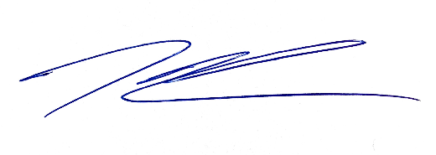
Kenneth Thiessen, CEG
Northwest Region Cleanup Section

cc: Evelyn Ives, Landau Associates
Dan Hafley, DEQ NWR
ECSI #13

