Q1: What is the speed at the East driveway of the Tack property at the top of the hill?
From: Leonard Rydell, 8/3/2017

A: Site specific speed study data does not exist at the driveway in question, therefore we don’t know what the operating speed is at the point of the east driveway of the Tack property. Absent this data, the street light data is selected for use as best data available.

Since the driveway is uphill of the street light, northbound traffic potentially operates at slower speeds as they climb the grade. The opposite is true for southbound vehicles.

AASHTO offers guidance for reducing the stopping time required on uphill grades such as this for sight distance. They don’t provide specific reduction values for the 10% grade in question, however extrapolation/judgement may be applied to reasonably reduce the stopping sight distance to at least 90% of level terrain (AASHTO 2011 Green Book, Table 9-4)

Q2: What impact will the flashing 25mph sign have on the 85% speeds?
From: Leonard Rydell, 8/3/2017

A: These devices were included in the project resulting from responses received in their favor at both open houses. Residents felt they offer an incremental improvement over existing conditions. A quantitative analysis to assess their effectiveness at reducing speeds remains outstanding.

Q3: … not understanding the engineering reasons that my design did not meet standards, so I would appreciate it if you would provide your calculations clearly documenting the problems for my review…
From: Leonard Rydell, 8/1/2017

A: The sight distance required for the Tack driveway is approximated using AASHTO’s ‘departure sight triangles’ (image shown below).

AASHTO’s 2011 Green Book, Page 9-31 indicates the height of eye and height of object be evaluated at the same height of 3.5 feet for departure sight triangles.

AASHTO’s 2011 Green Book, Table 9-6 indicates the length of sight triangle leg – Case B1 Left turn from minor road, or distance ‘b’ on the image below, as 280 feet. As noted in the response to Q1 above, this value was reduced to account for grade to approximately 250 feet (roughly 90% of 280 feet).

AASHTO’s 2011 Green Book, Page 9-36 indicates the vertex (decision point) for the sight triangle leg – Case B1 Left turn from minor road, or distance ‘a’ on the image below, be 14.5’ from the edge of the major-road travel way. The distance may be reduced to 6.5’ if the driver is allowed creep towards the travel lane for improved sight distance.

A revised departure sight distance exhibit is attached illustrating a Case B1 turning maneuver, with a=6.5 feet, b=250 feet, and both height of eye/object=3.5 feet (see 20170804-EXH-Driveway-Sight.pdf). This exhibit shows that the existing condition for the driveway in question has sight distance obstructions with the existing grade. Extending the existing grade of Villa Road to the south past the southern oak tree to facilitate a pavement overlay will exacerbate this condition.
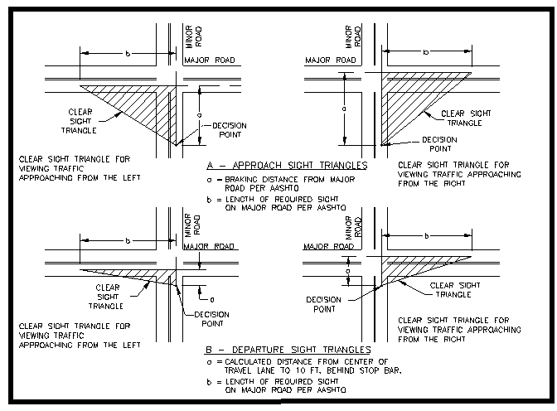

Q4: … Can you share with me why these standards were used?
From: Robert Soppe, 8/2/2017

A: The first sentence of the City’s Public Works Design and Construction Standards for Intersection Sight Distance under Section 5.23 states: “It is the policy of the City to have the applicant’s Project Engineer evaluate safe intersection sight distance using the principles and methods recommended by the current edition of AASHTO.”

Q5: From where is the 249’ distance derived? What speed (and other factors) were used to calculate this?
From: Robert Soppe, 8/1/2017

A: See response to Q3 above.

Q6: Why was the 2.0’ object height used? From my understanding, this would be covered as an Intersection Sight Distance issue, which appears to be calculated with a 3.5’ height.
From: Robert Soppe, 8/1/2017

A: See response to Q3 above.

Q7: Could you ask Kaaren respond to this question? It is my understanding from Kaaren that the excavation North of the Trestle is due to one driveway on the East Side of the road. That standard requires a 235 foot sight distance. However, in a similar situation of the South side of the Trestle at Orchard it does not appear that the design meets the same standard.
From: Leonard Rydell, 8/4/2017

A: See response to Q3 above regarding the 235 foot sight distance statement. A departure sight distance exhibit is attached illustrating a Case B1 turning maneuver, with a=29 feet, b=250 feet, and both height of eye/object=3.5 feet (see 20170804-EXH-Orchard-Driv-Sight.pdf). This exhibit shows that the proposed condition sight distance is an incremental improvement upon the existing condition for the driveway in question. Both conditions have sight distance obstructions. The finished grade may be revised prior to construction to eliminate the 6-inch sight obstruction caused by the roadway pavement elevations at the City Engineer’s direction.

Q8: I believe that I also asked you to verify that the sight distance for 32 MPH is also met from Orchard Drive. I think that Orchard Drive serves 12 tax lots.
From: Leonard Rydell, 8/4/2017

A: See response to Q7 above. That exhibit shows an obstructed sight distance at a 25 mph design speed. Increasing the analysis speed to 32 mph will exacerbate this condition.

Q9: I also asked whether or not the stop signs at Crestview and Villa Road which meter traffic, were considered in the traffic studies.
From: Leonard Rydell, 8/4/2017

A: The Martell developer’s traffic studies conducted rely upon speed data and traffic counts collected during field reconnaissance. The sample location for field data would reflect the effects of traffic devices proportionally to their proximity to the device.

Q10: I also asked whether or not the completion of the Northern ByPass was also considered in the traffic studies.
From: Leonard Rydell, 8/4/2017

A: The City’s Transportation System Plan identifies City-wide capital improvements anticipated to address anticipated traffic volumes through the year 2035. These traffic volumes account for the impacts generated by the ByPass project. These same traffic volumes were references against the Martell developer’s traffic studies to concur with their findings warranting a left-turn at Park Lane.

