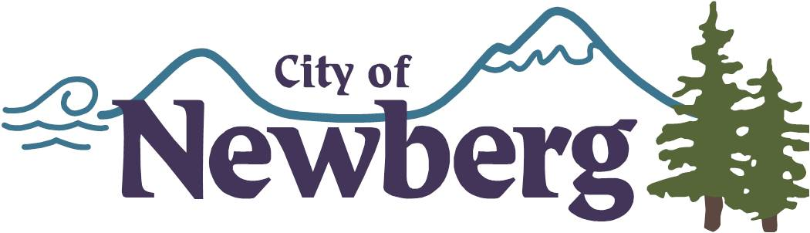 | memorandum  ENGINEERING SERVICES DEPARTMENT

TO: Kaaren Hofmann, City Engineer
FROM: Jason Wuertz
C: Jay Harris, Public Works Director, Jacque Betz, City Manager
SUBJECT: Basement Flood Repair Work (Insurance Claim)
DATE: 12/12/14

Attached is a check request for Water Bear, for the repair work done as part of the basement flooding issue. The amount invoiced for has been reviewed by our legal department and is consistent with the insurance claim value. A check from insurance has already been received by the City.

Please let me or know if you have any questions.

Thank You,

Jason
from the desk of…
Jason Wuertz

City of Newberg
P.O. Box 970
Newberg, OR 97132

