DEQ comments on MFA’s Site Assessment Report
Forest Creek Dump Site
Dated March 19, 2025
Sent Via Email to MFA 6/13/25

DEQ Comments summarized by Don Hanson, Project Manager
6/13/25

- Section 2.1. Regarding the 8 inch casing, was OHA notified, or Water Resources Department (WRD)?
- Section 2.3, 2nd paragraph. Delete first sentence. Replace with “On July 25, 2019 a General Judgment by Josephine County placed the property and all contents…..”
- Section 2.3, last sentence page 3. Add to the last sentence “…attended the Site walk, but only one submitted a bid. This resulted in significant delays as DEQ re-evaluated the scope of work and re-bid the project.”
- Section 2.3, first two paragraphs. Suggest that these two paragraphs can be deleted.
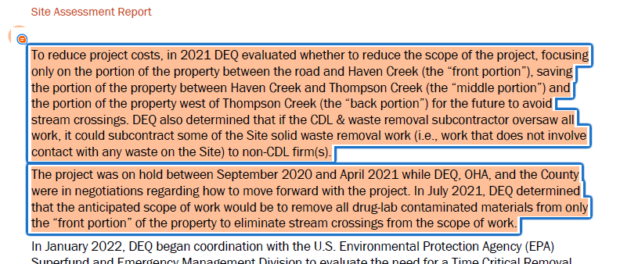

- Section 2.3, page 4, continued. In the paragraph below, suggest changing the language to something like: “requested an assessment of soil conditions at the site to evaluate potential risks to human health and the environment.”
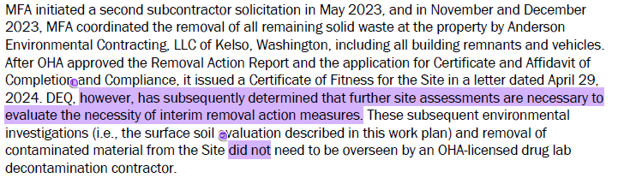
- Section 3.2. Land Use. In the 2nd paragraph, please just stick with the current zoning and the anticipated possible future uses, and remove the second sentence starting with “The County…”
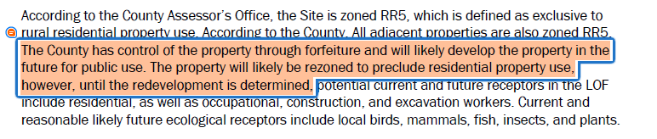
- Section 3.4, Surface Water. 2nd paragraph. Please indicate whether the water rights are up or down stream from the site. Also, what do the water rights allow as far as uses of the water? Irrigation, drinking, etc.?
- Section 4.2 Assessment Activities. Do we know why PCBs were not included in this assessment? Are PCBs suspected of being a COPC at this site?
- Section 4.4 Ecological Scoping. Sentence 3: Recommend changing the term “Ecologically important species” to “Threatened and endangered species” if that is the intent of the sentence.
- Values for “Diesel-range TPH” and “Motor oil-range TPH” should be combined and analyzed against Diesel RBCs if these were obtained using method TPH-Dx (no lab reports in the version I edited). Making this alteration will lead to some samples exceeding RBCs where they previously did not.
- Section 4.2.1. Suggest referring to the “back” portion of the site as “western” instead. And also maybe include this area was on DU-4.
- Section 6.1, Sources. Please include that for some chemicals (metals and dioxins), sources of contamination can also include background levels of metals (from regional geology) and dioxins (wildfires, and other natural events).
- Section 6.2 Exposure Pathways and Receptors: no ecological receptors named in the CSM. These should be included in the CSM (or should be a separate HH and Eco CSM).
- Section 6.2 Exposure Pathways and Receptors, add : “trespassers” to the list of potential human health receptors in the following sentence: “Therefore, potential human health receptors present at the Site include residents, occupational workers, construction workers, and excavation workers.”
- In the table showing exposure pathways for the site, add ecological receptors for surface water. Also add plants and invertebrates for soil and fish and aquatic invertebrates for surface water in addition to the birds and mammals named for ecological soil.
- Section 6.2. Regarding the second sentence, the site is not currently undergoing redevelopment, so remove that statement.
- In Table 5-1, when DEQ does not have human health RBCs, we rely on EPA RSLs to screen for risk. We noticed many screening levels were listed as “NV”, but there may actually be screening values to evaluate risk.
- Section 6.3.1.6. Typo. T&E, not T&S
- Section 7, first sentence. You mention the SA included an ecological scoping. Add that it also included human health risk screening.
- Section 7, page 21. Where it says no impacts to the ecological study area and surrounding areas were observed, please provide a few examples of what you would consider impacts. Also include that there were no “obvious” impacts observed.

