State of Oregon

Department of Environmental Quality Memorandum

**Date: October 12, 2020**

**To: Jim Orr**

**Project Manager, NWR Cleanup Program**

**From: Henning Larsen, R.G.**

**Senior Hydrogeologist**

**Subject: Zenith Energy – Proposed Storm Water Infiltration System**

5501 NW Front Avenue, Portland, Oregon 97201

I reviewed the September 10, 2020 *Groundwater Protection Report – Zenith Port Terminal Renewable Fuel Project* prepared by Apex on behalf Zenith Energy Holdings LLC.

**Background**

Zenith Energy has proposed constructing infiltration basins and an infiltration swale on the southeastern portion of their facility to dispose of industrial storm water runoff generated on the 33 acre property. This is an acceptable practice provided it does not adversely impact groundwater quality or its highest beneficial use.

DEQ requested Zenith evaluate the potential for the infiltration system to adversely impact groundwater quality based on the following information:

* Constructed in 1947, facility has operated as a petroleum refinery and bulk storage facility;
* The basins will be receiving industrial storm water from the tank farm area;
* Historical petroleum releases at the facility have impacted groundwater;
* The site is 600 ft away from the Willamette River and groundwater discharges within the boundaries of the Portland Harbor Superfund site.

In an August 17, 2020 e-mail to Apex Consulting, DEQ identified state regulations that apply to infiltration systems with respect to protecting groundwater quality. The email also provided the objectives and recommended content for a report addressing the Agency’s concerns.

**Apex Groundwater Protection Report**

In September 2020, Apex submitted a report on behalf of Zenith Energy to address DEQ concerns. Consistent with DEQ direction, the objectives of the report can be summarized:

*1)* *Evaluate the potential for storm water infiltration to pollute groundwater or impair its beneficial uses.* (Groundwater Protection Rules – OAR 340-40).

Information in the Apex report supporting the first objective is presented below:

Influent Storm Water Quality

PAHs -Trace levels of PAHs were detected in storm water samples collected during two sampling events in 2019 including benz(a)pyrene which was measured at levels approximately equivalent to its MCL of 0.002 ug/L. Recent data reflecting upgrades to the storm water management system indicate the storm water quality currently meets MCLs and other relevant screening values for PAHs.

Total Petroleum Hydrocarbons – Data on this parameter was limited to “oil and grease” analyses and there were no detections at a MRL of 4.76 mg/L. Although there is no MCL, the MRL is substantially higher than DEQ human health RBCs for corresponding petroleum hydrocarbon ranges.

Other Regulated Contaminants -Trace levels of total cyanide (6 ppb) and dissolved lead (1.3 ppb) were detected in 2019 storm water samples, well below their respective MCL and action level. These contaminants were not detected in the 2020 sampling.

Separation Distance between the Bottom of the Basin and the Water Table

Contaminant attenuation improves with increasing vertical separation between the point of infiltration and underlying groundwater. Groundwater elevation measurements from onsite wells indicate the minimum separation between the bottom of the proposed basin and groundwater was 6.8 ft and averaged 9.3 ft.

Historical Use of Proposed Infiltration Area

In the 1940s the area proposed for infiltration was used for shipyard worker housing which was later razed. Since then it’s been used occasionally for equipment storage. There is no history of petroleum storage, use or releases in this area of the facility.

Onsite Soil and Groundwater Data

Figure 2 and Figure 5 of the report indicate known historical releases are approximately 1,000 -1,500 ft cross-gradient from the proposed infiltration area and nearest detections of petroleum contamination in groundwater are greater than 600 ft cross-upgradient to the infiltration area.

No soil data has been collected within the footprint of the proposed infiltration facility although a pair of groundwater monitoring wells, U-North and U-South are located along the presumed downgradient boundary of the infiltration area. With the exception anthracene at 0.05 ug/L, metals, TPH (with MRLs at or below RBCs), VOCs and SVOCs were not detected during a July 2020 sampling.

And,

2) *Evaluate the potential for storm water infiltration to exacerbate groundwater contamination on adjacent and hydraulically downgradient properties.*

Information supporting the second objective included:

**Direction and Magnitude of the Shallow Groundwater Gradient and Identification of Nearby ECSI Sites**

Monitoring data indicates groundwater flows to the north-northeast under current conditions.

Based on Figure 6 and a north-northeastern flow direction, the Great Western Chemical (LUST # 26-89-0173,) Tube Forgings/Front LP (ECSI # 1239) and Hampton Lumber (ECSI #5761) sites are presumed to be hydraulically downgradient from proposed infiltration area. No significant plumes of groundwater contamination have been identified on these sites.

Another cleanup site, Kittridge Distribution, is located immediately east and cross-gradient of the infiltration areas. It is sufficiently close to the infiltration area that the gradient and flow direction of groundwater on the Kittridge site could be affected. However, previous investigations concluded no significant groundwater contamination is present on the Kittridge site and DEQ issued an NFA in 2007.

Primary Apex Finding

“

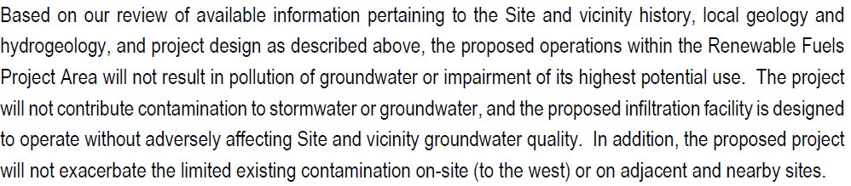”

My Conclusions

* Based on the September 10, 2020 report and additional ECSI site information, I concur with Apex that the proposed infiltration of storm water at the Zenith Energy facility is unlikely to impact groundwater quality and therefore is an acceptable method of storm water management. If new information becomes available or future hazardous substance releases occur, this conclusion will need to be revisited.

Recommendations

* Continue to monitor storm water quality on a routine basis.
* Establish limits for TPH in storm water discharged to the basins that are protective of groundwater. Note: The City of Portland’s 100 ppm sanitary sewer limit discussed in the report is not applicable to this discharge.
* Require notification if their free-product releases to the infiltration basins that exceed spill notification requirements.
* Provide a copy of this memo to Zenith Energy and the City of Portland BES.