State of Oregon

Department of Environmental Quality Memorandum

**To:** **Jim Orr, Project Manager, NWR**

**From: Jennifer Peterson, Toxicologist, NWR**

**DRAFT 2/17/2025**

**Subject: Gerber Legendary Blades (GLB), Ecological Risk Assessment**

**Site Description:** The Gerber Legendary Blades (GLB) site is in Tigard, Oregon at 14200 SW 72nd Ave, Portland, Oregon. It is zoned as heavy industrial with a building (77,882 sq feet) containing a warehouse and office used in the manufacturing of knives and other tools. Vapor degreaser and plating area present in the western portion of the GLB building.

The total lot size is 5-acres, which contains a paved parking lot, operational buildings, and landscaping. The property is bordered to the south by Ball Creek and to the east by an unnamed creek. Carter Creek an associated wetlands east of I-5 becomes Ball Creek as it discharges to the west to Fanno Creek. At some point, Ball Creek’s path to the south-west located to the south of the GLB property was re-routed to the north of its original location to immediately adjacent to the GLB property. After entering a culvert at the south-west part of the property, the creek is piped underground (96” pipe) until just south-west of the intersection of SW Bonita Rd and SW 72nd Avenue (Tigard Maps, **Figure 2**). The historic creek bed with hydric soils is shown in **Figure 1** and runs under the adjacent commercial property to the south, which currently houses Portland Community College Central Distribution Services, PARR Windows, Take Care Move Assistance, and Thermal Supply. One monitoring well (MW-18) generally falls within the buried hydric soils from the original creek bed after exiting from under this building. The piped section of Ball Creek then discharges aboveground at Bonita and 72nd as a natural creek with adjacent wetlands, and subsequently to Fanno Creek.

**Figure 1: GLB Site (yellow circle) with Adjacent Oregon Wetland Inventory Hydric Soils, Statewide Streams, and Wetland Delineation**

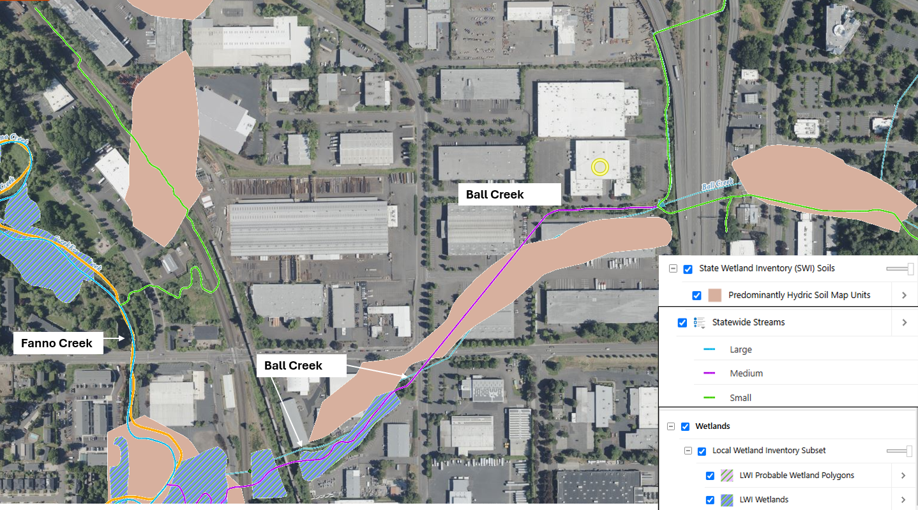

**Figure 2: Stormwater System for Ball Creek off GLB from Tigard Maps**

**Habitat:**

* Aquatic Habitat – Stream and Wetlands (**Figures 2 and 3**):
  + Ball Creek is a medium sized perennial stream flow coming from drainage from Carter Creek on the east side of I-5. This portion of Ball Creek is delineated as seasonal nontidal wetlands by the National Wetland’s Inventory (NWI).
  + Wetlands are delineated as a part of Tigard’s Local Wetland Inventory (LWI) and the NWI are present in Ball Creek southwest of the intersection of SW Bonita Rd and SW 72nd Avenue.
  + Ball Creek discharges to Fanno Creek, which is a large statewide stream with adjacent wetlands also delineated by the City of Tigard and the NWI. Fanno creek is listed as essential salmonid habitat (fish spawning areas) that are designated as essential for salmonid species to thrive. Fanno Creek is also listed for the Western Pond Turtle as a sensitive species.

**Figure 3: GLB Surrounding Wetlands and Hydrology, Essential Salmonid Habitat**

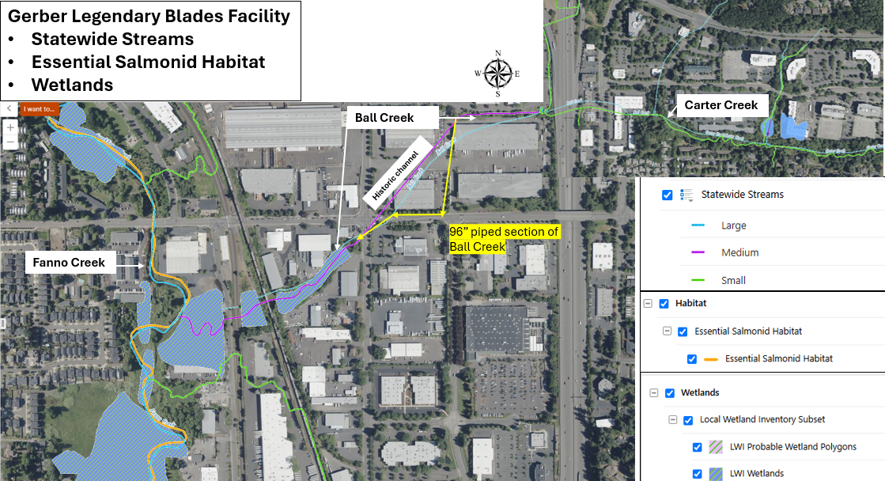

* Riparian Habitat: The section of Ball Creek to the south of GLB is delineated by the City of Tigard as Goal 5 safe harbor riparian corridor habitat which defines a setback distance to protect fish bearing streams (OAR 660-23-0030) (**Figure 4**).

**Figure 4: Tigard Environmental Regulation for Sensitive Lands**

**Contaminants of Interest:** The primary contaminants evaluated are HVOCs or chlorinated solvents including PCE, TCE and their degradation productions cis-1,2-dichloroethene, trans-1,2-dichloroethene, and vinyl chloride as characterized outlined in GLB’s Dec. 18th, 2013, Strategy Recommendation. If other data area available for screening, this memo should be updated.

Other COIs that are described as present or suspected to be present include:

* Hexavalent chrome (Chromium VI) from chromic acid (oxidizing agent) used in the plating process. There are no hexavalent chromium data presented in the strategy report.
* Chloroform: This COI is mentioned in the report as present in vapor samples, but there are no chloroform data present in the strategy report.
* Per-and poly-Fluoroalkyl substances (PFAS): PFAS are commonly used as a suppressant for harmful fumes emitted during hexavalent chromium plating. It is highly likely that due to the history of chromium plating at the site, PFAS may be present at significant concentrations.

**Complete Pathways:**

* Aquatic Life (Porewater, Surface Water, Sediment): Groundwater and potential stormwater discharge to the sediments and surface water of Ball Creek south of the GLB facility. Water piped from Ball Creek adjacent to GLB may potentially impact Ball and Fanno Creeks and associated wetlands to the southwest. Characterization data in Ball Creek are not presented in the strategy report, but upland groundwater data are available to evaluate this pathway.
* Wildlife (Surface Water): Wildlife exposure to surface water of Ball Creek through direct ingestion. Characterization data in Ball Creek are not presented in the strategy report, but upland groundwater data are available to evaluate this pathway.
* Wildlife (Soils and sediments): Wildlife exposure to sediments of Ball Creek and riparian soils through incidental ingestion and feeding. Soil data are not presented in the strategy report. This could represent a data gap.

**Screening:** Water concentrations measured in groundwater in monitoring wells and grab samples borings were compared to DEQ’s Table 2, *Risk Based Concentrations for Water* in *Conducting Ecological Risk Assessments*, Oregon DEQ, 2020. **Tables 1 and 2** lists the RBCs (aquatic and wildlife water) used in this evaluation. **Figure 5** shows the upland groundwater locations used in the screening.

**Table 1: Oregon DEQ Aquatic Risk Based Concentrations (ug/L) (ODEQ, 2020, Table 2)**

|  |  |  |  |  |
| --- | --- | --- | --- | --- |
| **Chemical Name** | **CASRN** | **units** | **RBC Chronic** | **RBC Acute** |
| 1,1-DICHLOROETHENE (1,1-DICHLOROETHYLENE) | 75-35-4 | ug/L | 130 | 1,200 |
| 1,2-TRANS-DICHLOROETHYLENE | 156-60-5 | ug/L | 560 | 10,000 |
| CHLOROETHENE (VINYL CHLORIDE) | 75-01-4 | ug/L | 930 | 8,400 |
| 1,2-CIS-DICHLOROETHYENE | 156-59-2 | ug/L | 620 | 5,500 |
| 1,1,2,2-TETRACHLOROETHYLENE (PCE) | 127-18-4 | ug/L | 53 | 430 |
| 1,1,2-TRICHLOROETHYLENE (TCE) | 79-01-6 | ug/L | 220 | 2,000 |

**Table 2: Oregon DEQ Wildlife Drinking Water Risk Based Concentrations (ug/L) (ODEQ, 2020, Table 1b)**

|  |  |  |  |  |  |
| --- | --- | --- | --- | --- | --- |
| **ODEQ Table 1b. Risk Based Concentrations for Wildlife Ingestion of Surface Watera** | | | | | |
| **Surface Water (ug/L)** | | | | | |
| **Analyte Name** | **Analyte Code** | **Birds** | | **Mammals** | |
| **T&E** | **Non-T&E** | **T&E** | **Non-T&E** |
| **Volatile Organic compound** |  |  |  |  |  |
| Acetone | 67-64-1 | 830,000 | 8,300,000 | 44,000 | 220,000 |
| Benzene | 71-43-2 |  |  | 110,000 | 1,100,000 |
| Butanone[2-] | 78-93-3 |  |  | 7,900,000 | 20,000,000 |
| Chlorobenzene | 108-90-7 |  |  | 260,000 | 2,600,000 |
| Chloroform | 67-66-3 |  |  | 67,000 | 180,000 |
| Dichlorobenzene[1,4-] | 106-46-7 |  |  | 11,000 | 44,000 |
| Dichloroethane[1,1-] | 75-34-3 |  |  | 1,700,000 | 17,000,000 |
| Dichloroethane[1,2-] | 107-06-2 | 19,000 | 37,000 | 220,000 | 2,200,000 |
| Dichloroethene[1,1-] | 75-35-4 |  |  | 130,000 | 1,300,000 |
| Dichloroethene[cis/trans-1,2-] | 540-59-0 |  |  | 200,000 | 2,000,000 |
| Methylene Chloride | 75-09-2 |  |  | 26,000 | 220,000 |
| Tetrachloroethene | 127-18-4 |  |  | 8,900 | 44,000 |
| Toluene | 108-88-3 |  |  | 110,000 | 1,100,000 |
| Trichlorobenzene[1,2,4-] | 120-82-1 |  |  | 6,600 | 66,000 |
| Trichloroethane[1,1,1-] | 71-55-6 |  |  | 4,400,000 | 44,000,000 |
| Trichloroethene | 79-01-6 |  |  | 440,000 | 4,400,000 |
| Xylene (Total) | 1330-20-7 | 440,000 | 4,400,000 | 9,400 | 1,100,000 |
| a These are direct water ingestion RBCs, no bioaccumulation, no food exposure. | | | | | |
| Reference: LANL (Los Alamos National Laboratory), September 2022. "ECORISK Database (Release 4.3)", LA-UR-17-26376, Los Alamos National Laboratory, Los Alamos, New Mexico. (LANL 2017, 602538). Lowest of avian and mammalian water ingestion for water only exposure (No food) | | | | | |
|  |
|  |
|  |
|  |

**Figure 5: Monitoring Well and Grab Groundwater Locations used in Screening ERA**

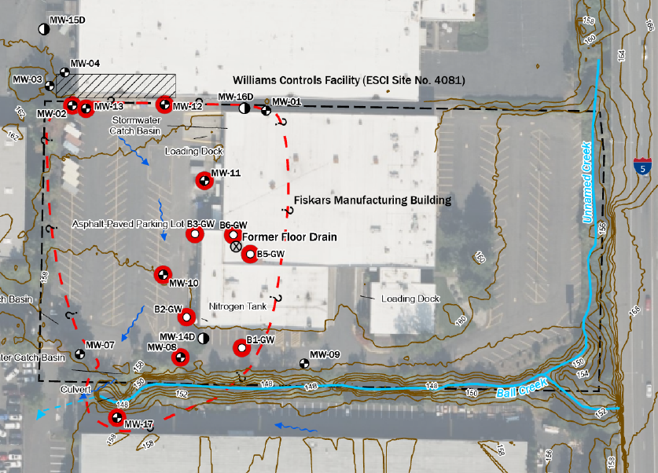

**Screening Results:**

To identify individual COPCs in a given exposure medium, the exposure point concentration (EPC) of each COI is compared to the relevant risk-based concentration (RBC). In this case, the EPC is the water concentration (ug/L) for each upland well or boring that has the potential to discharge to Ball Creek, and the RBC is the aquatic life RBCs from Table 2 of ODEQ’s *Conducting Ecological Risk Assessments*. The results are presented in **Table 3** and **Figures 4 and 5**.

Individual Risk Screening:

$$Hazard quotient \left(HQ\right)= \frac{EPC}{RBC}$$

Where:

Hazard quotient (HQ) = the ratio of the EPC to the RBC for each hazardous substance and pathway.

EPC = Exposure point concentration of a given COI in soil, sediment or water

RBC = Risk-based concentration for the COI, receptor class, and media

Chemicals for which the HQ is greater than or equal to 1.0 for a receptor class and pathway are individual COPCs.

Cumulative Risk Screening: To address cumulative risk, a hazard index (HI) is calculated by “totaling” the hazard quotients (HQs) for each receptor and media associated with each complete pathway. In this case, the media is upland groundwater concentrations.

Aquatic, Water:

* Hazard quotients and cumulative hazard indices are presented in **Table 3**. Samples exceeding chronic RBCs are highlighted in light orange, and those exceeding acute RBCs are highlighted in dark orange. Wells with chemical concentrations exceeding hot spot concentrations (10x RBC) are shown in red. Blue highlighted cells indicate exceedances of human health RBCs evaluated in the strategy recommendation.
* Wells with individual chemical hot spot concentrations include:
  + PCE in MW-13, B3-GW, and B6-GW
  + TCE in MW-13
  + cis-1,2-DCE in MW-8, MW-11, MW-13, and MW-17
* Individual COIs found at concentrations greater than chronic water RBCs include:
  + PCE: MW-11, MW-13, B1-GW, B2-GW, B3-GW, B5-GW, B6-GW
  + TCE: MW-2, MW-8, MW-10, MW-11, MW-12, MW-13
  + cis-1,2-DCE: MW-8, MW-11, MW-12, MW-13, MW-17, B6-GW
  + Vinyl Chloride: MW-11
* There were no individual water RBC exceedances for 1,1-DCE and trans-1,2-DCE, but in some wells these breakdown products contribute significantly to the cumulative risk (e.g., MW-8, MW-11, MW-12 for trans-1,2-DCE and MW-13 for 1,1-DCE).
* Wells with water concentrations exceeding chronic cumulative risk levels (HI > 1.0) include MW-1, MW-2, **MW-8**, MW-10, **MW-11**, MW-12, **MW-13**, **MW-17**, B1-GW, B2-GW, **B3-GW**, B5-GW, and **B6-GW**. Some include hot spot concentrations (in bold).
* Wells with water concentrations exceeding acute cumulative risk levels (acute HI >1) include MW-8, MW-11, MW-12, MW-13, B3-GW, and B6-GW.
* No groundwater concentrations exceeded wildlife drinking water RBCs
* Sediment: Not available?

Riparian / Terrestrial:

* There are no soil or sediment characterization data (?) to evaluate terrestrial exposure to the riparian area. If these data become available, the soil RBCs are (lowest listed below):
  + 1,1-Dichloroethene: Mammals 60 mg/kg
  + Tetrachloroethene: Mammals 0.94 mg/kg
  + Trichloroethene: Mammals 420 mg/kg
  + Vinyl Chloride: Mammals 1.2 mg/kg

**Uncertainty:**

* Source Area Well MW-13: The monitoring well concentrations in MW-13 are highly variable in magnitude. Sampling events from 2004 to 2006 have significant detections. After a gap in monitoring well characterization from 2006 to 2022, concentrations significantly decreased. It is unclear if this was due to a change in sampling methodology, or if there was a real drastic reduction in water concentrations (due to treatment?).
* Hydric Wetland Soil Pathway: Recommend characterization of the hydric soils represented by historic Ball Creek. These could transport contamination and vapor under the building to the south and result in human health risk, but it may also be a transport pathway to aquatic habitat to the south-west.
* Contaminants of Interest (COIs): Strongly recommend screening of the full COI list and PFAS sampling. Based on the large amount of chrome plating that occurred at the facility, this could be a large source of PFAS to the environment.

**Recommendations** Based on the screening results, there is a potential for water from upland groundwater sources to reach Ball Creek exceeding chronic and acute RBCs for protection of aquatic life (e.g., amphibians, reptiles, invertebrates plants, fish). Hot spot concentrations are present.

1. Conduct source control based on upland groundwater screening to eliminate discharge to Ball Creek above aquatic RBCs. Upland groundwater concentrations represent those that may be found in Ball Creek or where preferential discharge areas may be present. Additional nature and extent sampling is recommended in Ball Creek to determine the extent of chronic and acute exceedances.
2. Water discharge to the culvert at the SW portion of the property may result in the transport of contamination to downstream Ball Creek wetlands and Fanno Creek. Recommend water sampling in the creek to determine the nature and extent of contamination.
3. It is unclear soil characterization has been completed for the riparian corridor soils, surface water or sediments data of Ball Creek. Recommend soil characterization and comparison to wildlife soil RBCs presented above.

**Table 3: Screening for Groundwater Concentrations for Chlorinated VOCs. Chronic and Acute RBCs are screened individually (HQ) and cumulatively (total hazard index) at each well or boring location.**





**Figure 4: Map of GLB Cumulative Risk (Hazard Index) Exceedances**

**Figure 5: Figure Illustrating Distribution of Individual and Cumulative Exceedances by Monitoring Well / Boring and Sample Date**

