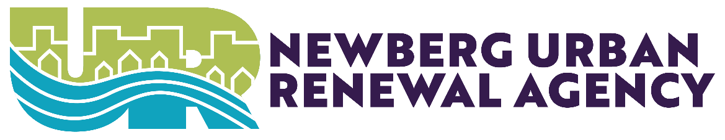
Newberg Urban Renewal Agency
August 19, 2024
Newberg Public Safety Building 401 E. Third Street
Denise Bacon Community Room
Hybrid Meeting
Hybrid: https://us06web.zoom.us/j/89536547180
Public Comment Registration: https://bit.ly/nbgcomment

- CALL TO ORDER
Meeting was called to order at 8:08PM
- ROLL CALL

COMMITTEE BUSINESS
3.1. RBA: Changes to the NURA Citizen Advisory Commission Bylaws
a Exhibit A: Approved NURA CAC Bylaws
Will Worthey gave a quick presentation on the small changes to the Newberg Urban Renewal Agency Citizens Advisory Committee Bylaws.
Council moved to approve the NURA CAC by laws.
1st: Mayor Rosacker
2nd: Councilor Wheatley
Motion was approved unanimously
3.2. RBA: NURA Citizen Advisory Committee Recommendations
a Atachment 1: Letter to NURA August 2024
Council accepted the letter from the NURA-CAC.

ADJOURNMENT
Meeting was adjourned at 8:12PM

_______________________________________ _____________________
City Recorder Rachel Thomas Date

_______________________________________ _____________________
NURA Chair Date

ADA STATEMENT
Contact the City Recorder’s Office for physical or language accommodations at least 2 business days before the meeting. Call (503) 537-1283 or email cityrecorder@newbergoregon.gov. For TTY services please dial 711.

