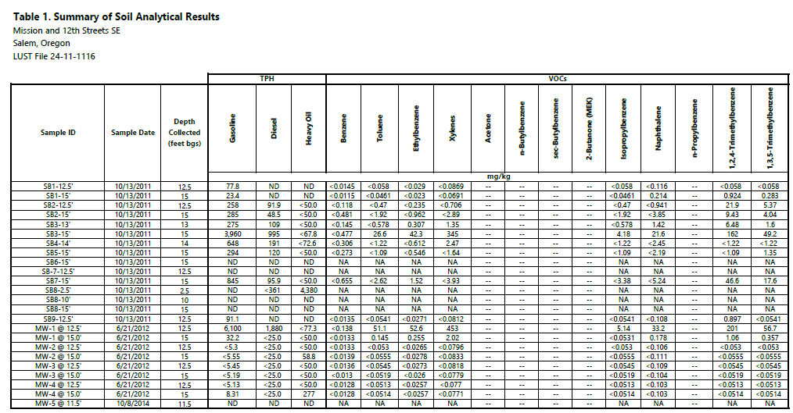

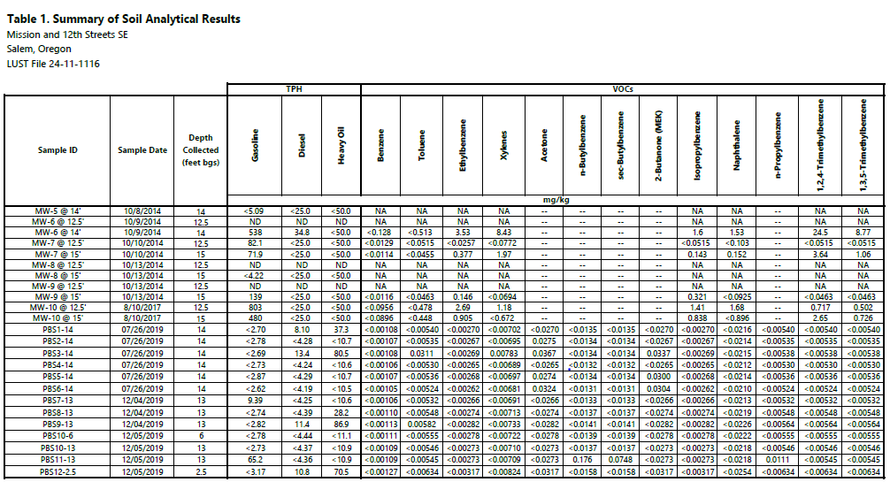
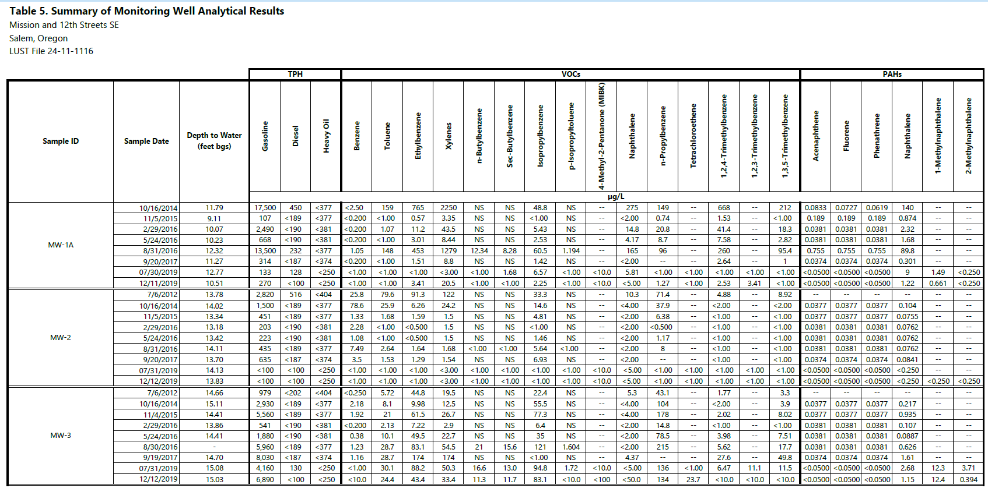
Table 2. Summary of Monitoring Well Analytical Results

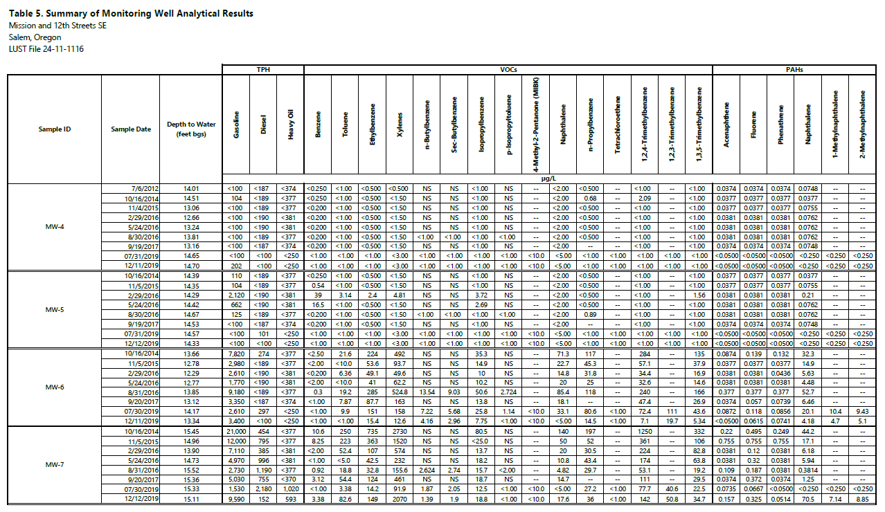
Table 2. Summary of Monitoring Well Analytical Results

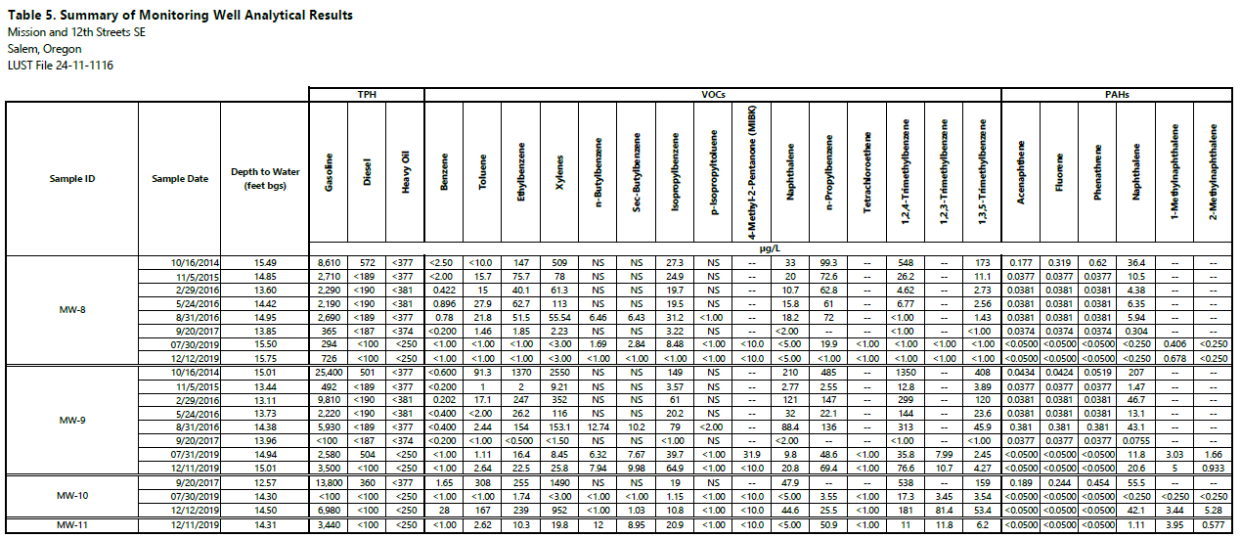
Table 2. Summary of Monitoring Well Analytical Results

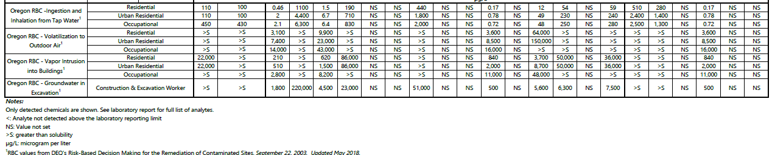
Table 3. Summary of Soil Gas Analytical Results
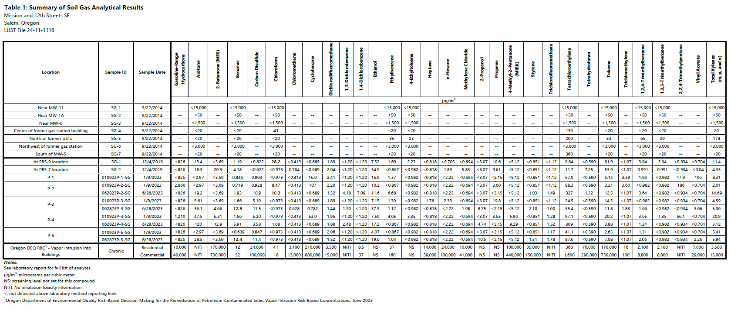
Table 3. Soil Gas Analytical Results

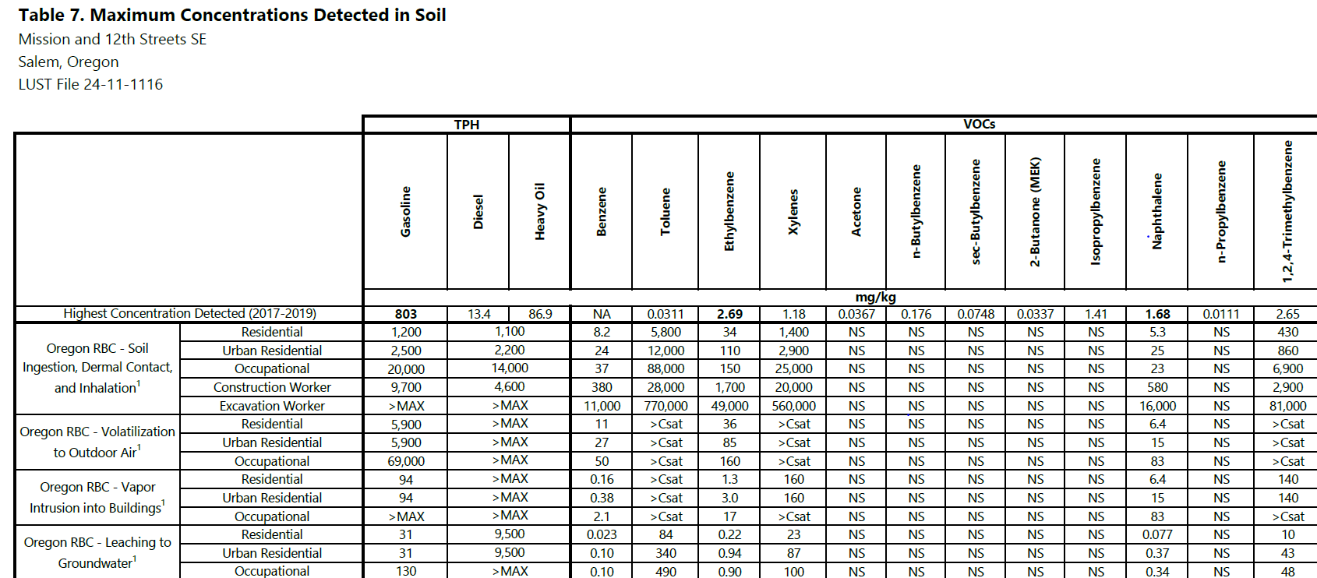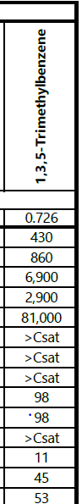
Table 4. Maximum Concentrations in Soil
Note: Note that since June 2023 and development of new vapor intrusions RBCs, soil is no longer used to evaluate for potential vapor intrusion and there are no longer RBCs for vapor intrusion into buildings from soil. Vapor intrusion is now evaluated through groundwater, soil gas and indoor air data.
