**Operation Welcome Home**

**LIBRARY JUNE 2020**

**Situation**:

On March 16, 2020 the NPL closed access to the building due to health concerns involving staff and patrons related to the COVID-19 pandemic. The outside drops were locked and patrons were asked not to return items to the Library until further notice. Both expired holds and holds requested by patrons were frozen by CCRLS.

This plan matches the specifications for Libraries issued by the Oregon Health Authority in mid May 2020, and the Newberg re-opening protocols produced in the same time frame.

**Mission**:

The mission will be to gather all returning items in a safe and fine free manner, and allow self-service checkout initially. If bins are brought by courier they will be checked in.

**Execution**:

The NPL will reopen in phases starting on June 2nd. This is the result of the Oregon reopening declaration level 1 announcement.

This plan is deliberately modular allowing (for example) for a roll back from phase [C] to phase [A] if the medical situation deteriorates again.

Phases overview:

|  |  |  |  |  |  |
| --- | --- | --- | --- | --- | --- |
| Situation | Austin Room | Holds | Staff checkout | Hours | Notes |
| Week 0  **June 2nd** | Library is closed | Library is closed | No library is closed. | None | Curb side drop off for materials.  Outside drop open.  Daily Annex storage, shifting materials to Austin room each night. |
| [A]  Partial opening:  Week 1  Oregon phase 1  **June 8th** | Used for sorting and quarantine (3 day) the mass influx of materials.  No in person programming. | No holds are pulled. | NO. Self-check only with rover assistance.  Kids desk is not staffed. | 12 noon to 6pm Tuesday to Saturday. | Outside drop open.  Daily Annex storage, shifting materials to Austin room each night. |
| [B]  Week 2  🡪  Oregon phase 1 – 2  **June 15th** | Used for sorting and quarantine (3 day) materials.  No in person programming. | Yes holds are pulled. | NO. Self-check only with rover assistance.  Kids desk is not staffed. | 12 noon to 6pm Tuesday to Saturday. | Outside drop open.  Daily Annex storage, shifting materials to Austin room each night. |
| [C]  Guidance changes for the better.  Oregon phase 3 | Returns to normal but no in person programming occurs. | Yes holds are pulled. | YES. Staff return to check out duty but barriers remain in place.  Kids desk is not staffed. | Hours return to normal. | For example level 3 re-opening declaration. Materials quarantine ends. |
| [D]  All restrictions are lifted | In person programming normalizes. | Yes holds are pulled. | YES. Barriers come down / PPE is removed.  Kids desk returns to normal. | Normal hours. | All clear is issued. |

Details on week 0

(1) When we are about to open curb side materials drop off will be allowed from 12 noon until 6pm.

(2) The materials will be stored in the Annex and brought over each night after 6pm to the Austin room.

(3) Materials sit dated for three days in the Austin room, so they can be checked-in in during phase [A].

(3) Staff will remain socially distanced and only a handful will come back to work, see when to work.

(4) Shared food preparation equipment will only be used when wiped first with sterilizing wipes (for example microwave ovens).

(5) The break room will NOT be used.

(6) In person staffing will be at about 30%.

(7) Staff will wear masks at all times.

Details on phase [A] partial re-opening:

(1) The outdoor drop boxes will remain open but with temporary item

storage each day in the Annex. Materials come to the Austin room at

night.

(2) No holds will be pulled for the first week.

(3) The Library will be open from 12 noon until 6pm Tuesday through Saturday.

(4) For the first week the Austin Room will be utilized to separate items in to four streams:

* Media.
* Adult materials (to include teen materials).
* Kids materials.
* Items that are obviously broken.

(5) The donation bin will be closed and donations will not be accepted.

(6) The front desk return bin will be closed so as to ensure that all materials flow to the Austin room first.

(7) For the first week the front desk station 1 & 2 will be staffed to deal

with patron issues.  
(8) For the first week back room stations 3 & 4 will be used to check in

materials and bins delivered.

(9) A staff member will serve as a rover in the lobby to direct the public into the Austin room and help individuals struggling with self-check.

(10) The rover will remind patrons of the rules to access the library at this time (use hand sanitizer, self-check only, stay six feet apart from other patrons not in your party, and please only send one family member to conduct library business).

(11) Shared food preparation equipment will only be used when wiped first with sterilizing wipes (for example microwave ovens).

(12) Staff social distancing will be strictly enforced.

(13) The break room will NOT be used.

(14) Staff with unavoidable childcare needs and formally identified underlying medical conditions will continue to telework.

(15) In person staffing will be at about 65%.

(16) Until the Government and Health authorities declare that more restrictions are lifted* only self-check will be allowed to limit staff / patron contacts.

(17) Overdue fines will automatically be waived during this period to minimize cash and card handling.

(18) Staff with underlying health conditions will continue to telework.

(19) Furloughed shelving staff will return to duty.

(20) To increase social distancing the kids desk is not staffed at this time, and children’s division staff will serve as rovers.

(21) Curb side drop off does not occur this week.

(22) Materials sit dated for three days in the Austin room, so they can be checked-in in during phase [A].

(23) Staff will wear masks at all times.

(24) In phase [A] custodian services will begin again at the library. The Library Director with the support of PW will review the safety standards with the assigned custodians including social distancing and the need for masks at all times.

(25) The public are encouraged constantly to wear masks and use hand sanitizer.

(26) Enhanced cleaning begins. The staff decontaminate between each task or PC use and never less than once per hour.

(27) The restrooms will be closed to the public.

* Described as phase three in the April 20 state publication ***Reopening Oregon: A Public Health Framework for Restarting Public Life and Business***.

Details on phase [B] – partial opening week two until guidance changes.

(1) Hold pulling will begin in week 2.

(2) The circulation staff roster will normalize (typically two on duty at a time).

(3) Only self-check will be used, no staff checkout.

(4) The donation bin will remain closed and donations will not be accepted.

(5) The outside book drop is still open.

(6) The front desk returns will start up again via a buggy placed in front of the circ desk.

(7) All materials will be taken to the Austin room to sit dated for three days prior to check in.

(8) Austin room sorting into four streams will continue. Two staff will work on this from 12 noon to 6pm daily.

(9) A rover will continue to help patrons with self-check, and reinforce the partial opening rules.

(10) Overdue fines will automatically be waived during this period to minimize cash and card handling.

(11) Staff with underlying health conditions will continue to telework from

home.

(12) For social distancing reasons the kid’s desk is not staffed at this time.

(13) Shared food preparation equipment will only be used when wiped first with sterilizing wipes (for example microwave ovens).

(14) Staff social distancing will be strictly enforced.

(15) The break room will NOT be used.

(16) Staff with unavoidable childcare needs and formally identified underlying medical conditions will continue to telework.

(17) In person staffing will continue to be at about 65%.

(18) Staff will wear masks at all times.

(19) The public are encouraged constantly to wear masks and use hand sanitizer.

(20) Enhanced cleaning continues.

(21) The bathrooms will continue to be closed.

Details on phase [C] – most restrictions are lifted.

(1) Staff checkout resumes.

(2) Donations resume.

(3) All staff return to work with PPE and barriers are still in place.

(4) The rover position is discontinued.

(5) Overdue fines return to normal.

(6) The volunteer schedule is normalized.

(7) The kid’s desk is now staffed with distance separation.

(8) Quarantine of materials and the Austin room sortation is ended.

(9) The break room can be used again.

(10) In person staffing normalizes.

(11) Staff still wear masks.

(12) Enhanced cleaning continues.

Phase [D] – all clear.

(1) All restrictions and barriers are lifted.

(2) In person programming resumes.

**Administration and Logistics**

To safely implement the process described above the following modifications to our regular operations and equipment will occur for the relevant phases:

Before phase [A], each desk will be outfitted with a Plexiglas shield at the points of service to ensure separation between patrons and staff.

Tables and carts in the Austin Room will form a linear desk pattern to create a barrier for phase [A to B].

Most of the public furniture will be stored to enforce social distancing phase [A to B].

The use of entrance and egress lines, and social distancing markers and barriers will be used to limit building occupancy phase [A to B].

The Rovers, E newsletter, paper newsletter, city web site and social media will be used to limit building occupancy. Patrons will be asked to send only one person to the library at a time from their social “bubble” unless they are single parents with no other options [A to B].

Appropriate social distancing marker tape will be applied to the floor in front of the desks, phase [A] to [C].

Signage at each desk will state “form line” for each of the service lines.

Masks and sanitizer will be worn/used by all staff in the building phase [A] to [C].

During phase [A] to [C] warning signs will be posted around the library stating “Stay six feet away from other patrons”, and “Please use hand sanitizer frequently”. Rovers will encourage these safe practices.

Equipment needs include the following:  
Physical signage and tape will highlight the Austin Room as the item return site for phase [A].

Signs to create the four streams in the Austin room will be created, for example “Kids Materials” for phase [A].

Dozens of open carts will be staged in the Austin room to shuttle materials to the work room during phase [A].

Bins will be staged in the Austin Room for returns and visibly damaged items for phase [A] and [B].

Our regular check in stations will run with Workflows in fine free mode during phase [A] and [B] (Blue Cloud does not have the option to check in fine free).

10 boxes of gloves size M & 5 boxes of gloves size L will be obtained for staff use.

Staff and some volunteers will be scheduled to assist during open hours for phase [A] to [C]. The volunteers will be used early in the day before the staff enter the building, in other words de-conflicted by time.

For phase [A] to [C] there will be Plexiglas, guide tape for social distancing, and barriers that will control the movement of patrons in and out of the building and allow for line formation at the correct places. See appendix A Physical Controls.

**Command and control**:  
The Library Director or Assistant Library Director will be on site at all times to guide the process and reassure the publ

In phase [A] Circulation staff check in materials and bins at stations 3 & 4.

In phase [A to B] two staff will separate items in the Austin Room.

Circulation staff at the Front Desk remind patrons “items on account may linger” and assist patrons. Select Volunteers will shelve items once they are checked in. The volunteer force will grow as we move through the phases.

No later than 1 week before implementing the plan we will notify the public via phone message, Facebook, city website, CCRLS website, e-newsletter  
that the NPL will be open for returning items inside the library only for the first week. This communication will also list the current restrictions in force.

As restrictions continue to lift phase [B] to [D] all channels will be used to message the new situation.

**Appendix A – physical controls**

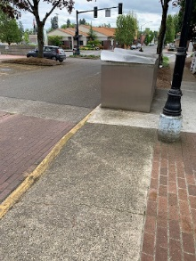For Week 0 only a canopy will be erected next to the drop boxes. Curb side staff will be stationed here and will bring returns to the Austin room. They will be dated but not sorted for three days.

This will help with social distancing and avoid cart congestion on the front ramp.

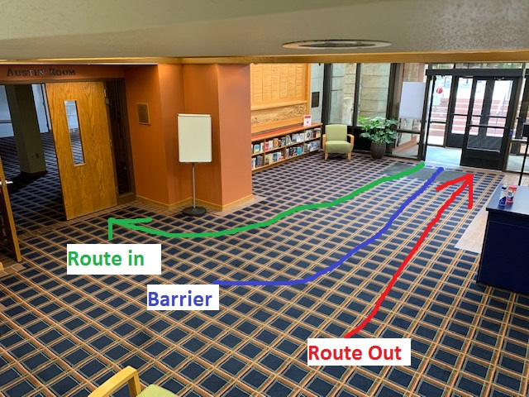A barrier will guide patrons during Phase [A] in to the Austin room, and out the building to provide at least some social distance. Six foot increments will be marked on these routes (Green and Red).

In phase [B] the green line will change to become the line for this self-check & the barrier will be removed.

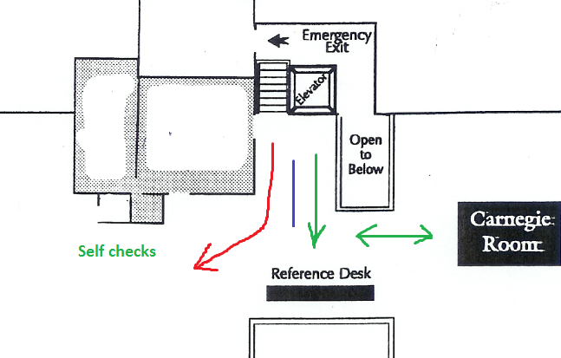Phases [A] to [C] As patrons arrive on the upper landing they will be directed by a barrier to one of two routes:

Reference / fiction (green) or non-fiction / self-check (red) the line up to reference will have social distancing 6 feet markers.

A sign will notify patrons that the new book section has been moved to near the puzzles to avoid congestion in front of the reference desk.

**Appendix A – physical controls**

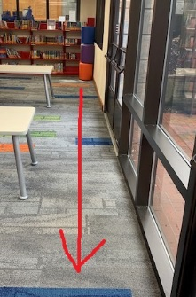

A line will be marked with social distanced markers along the floor at the back of the kids room. It will guide patrons towards the self-check machine.

A sign near this self-check will remind patrons to use the line and keep their distance.

This line will exist during phases [A] to [C].

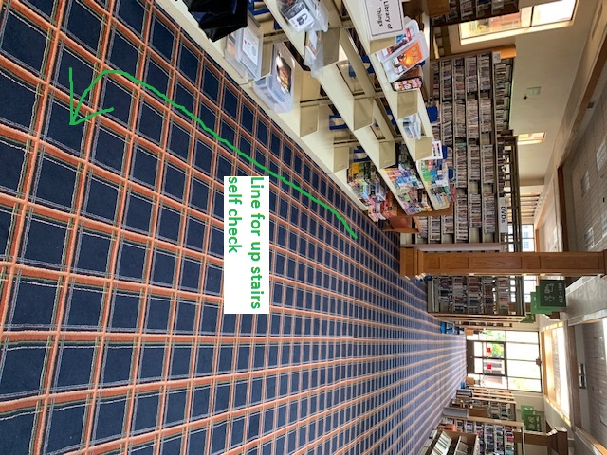

Another line will be marked out for the upstairs self-check machines to attempt social distancing there it will run along the puzzle zone towards the machine.

It is not possible to put this line in front of the reference desk with the other control line in place, insufficient width exists.

New books will be moved to this area to avoid congestion near the reference desk.

This line will exist during phases [A] to [C].

Lastly each shelving area will have floor arrows that direct patrons in one way traffic to increase social distancing. They look like this:

