On March 18, 2020, the United States Congress passed emergency legislation which grants emergency family leave and emergency paid sick to qualifying employees.

The following are interpretations of the Families First Coronavirus Response Act (the Act). The City of Newberg will rely on the text of the Act if there are any discrepancies in the information provided.

Emergency Paid Sick Leave (EPSL) is available only to employees who are not able to work, either in the office or remotely. 80 hours of paid sick leave in addition to leave accrued through employment, to be used first. This is available to everyone to use immediately – regardless of how long you have worked for the City. Part-time = # hours worked over a normal two-week period.

You need to document the reason you are not working and record that on timesheets. The City of Newberg will not require medical certification at this time. Please provide an email to your supervisor, copied to Alison Seiler in HR (alison.seiler@newbergoregon.gov) with the reason for your use of sick leave. Emails should not contain detailed personal health information or be copied to people who don’t need to know. Use the codes below!

Sample Email

Dear (Insert name of Supervisor), I will be working from home on the following projects:….
I anticipate that this will take 6 hours per day, when I will be available through City email and have forwarded my office phone to my home. I will not be able to work for 2 hours - Reason a.

What time off reasons are eligible for emergency paid sick leave?

- The employee is subject to a quarantine or isolation order for COVID-19 (by federal, state or local authority).
- The employee has been advised by a healthcare provider to self-quarantine due to concerns related to COVID-19
- The employee is experiencing symptoms of COVID-19 and is seeking medical diagnosis.
********
- The employee is caring for an individual subject to a) or b)
- The employee is caring for a son or daughter if the school or place of care has been closed or if the childcare provider is unavailable due to COVID-19 precautions.
- The employee experiences a substantially similar condition as specified by the secretary of health and human services.

Reasons a,b or c are paid at regular rate of pay with caps for highly paid employees.
Reasons d, e or f are paid at 2/3 rate of pay with caps for anyone who earns more than $37.50/hr.

Timesheet: Please note the total row of the timesheet will not calculate. It is more important that the City accurately track the type of leave. Dawn has kindly offered to make manual calculations.

Here are some possible scenarios. The maximum EPSL is 80 hours for full-time regular staff.

Scenario 1 [This will be the majority of you I hope]

You are not sick. You are working from home but not able to work a full-day. You worked 6 hours and did not work 2 hours. The City has asked you not to come to your regular worksite.
On the timesheet you put the number of hours you worked under regular hours and in sick leave you put the number of hours you did not work with the appropriate letter so: 6 Regular, Sick 2a
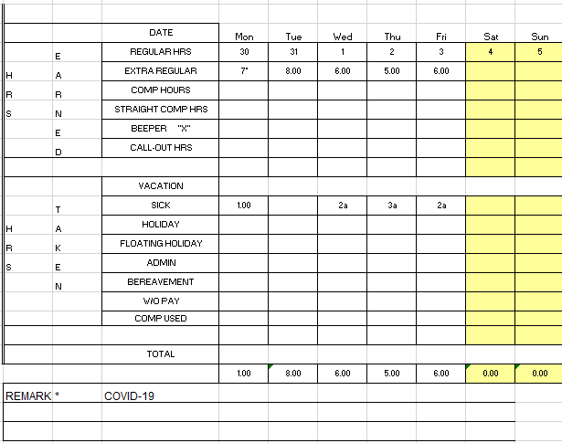
Scenario 2

You have been asked by a healthcare provider to self-quarantine because you had contact with someone who may have the virus or who was showing symptoms. You cannot work at all. Timesheet Sick 8b
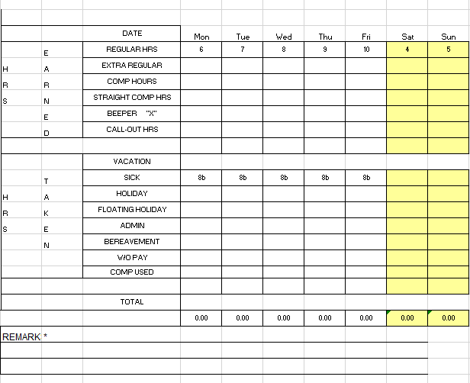

Scenario 3

You are experiencing symptoms of the virus and cannot work. Please do not work! Timesheet Sick 8c.
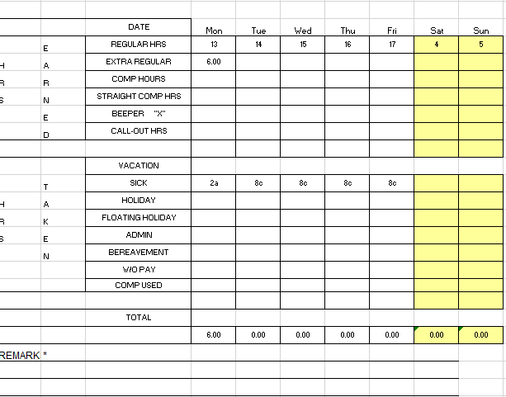

Scenario 4 [This scenario works for d,e,f where you are only paid 2/3 time.

You have children home from school or are without daycare for a child. The City is now open again for business. You work from home 4 hours but cannot work the remaining 4 hours. Timesheet 4 Regular, Sick 4e. In this scenario the City will allow you to use personally accrued sick leave, comp time or vacation to make up the balance of full-pay. Mark with an x the type of leave you want to use to make up your pay. Do not put a number!! You will also be eligible for EFMLA if you have worked for the City for more than 30 days.
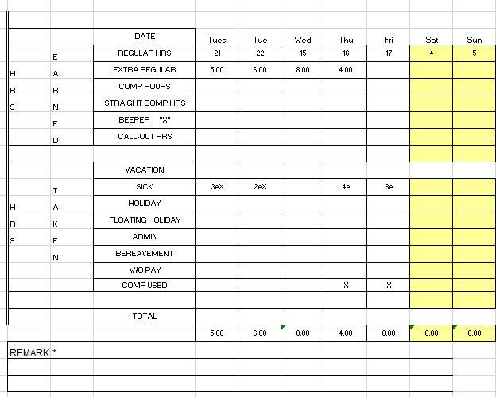

Scenario 5

The City closure has been extended and you have used all available EPSL. You do not have a child affected by a school closure. You have also exhausted most of the work you can do from home. In this scenario you may charge your accrued leave banks in the order of sick leave, comp time and vacation for hours not worked.

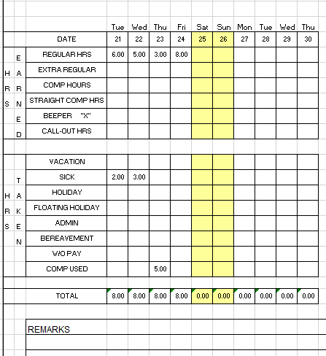

Emergency Family and Medical Leave (EFMLA)

Available to employees who have been working for the City of Newberg for at least 30 calendar days and who have a child under the age of 18, are entitled to 12 weeks of leave to care for their child if the child’s school or care provider is shut down or unavailable due to COVID-19. Please contact Alison for the appropriate FMLA form to complete.

The first 10 business days of leave taken for this qualifying purpose will not be paid. During the initial 10 days, employees can elect to use any accrued but unused paid time off or paid sick time, including the new emergency paid sick leave.

After the first 10 business days, employees will be paid at two-thirds of their regular rate of pay. Pay for qualifying leave is capped at $200.00 per day and $10,000 total.

