

**I HAVE COME TO VISIT!**

Customer or vendor enters without a mask, face shield or facial covering

Politely draw the customer’s attention to the public health requirement

**Best Practice:** Keep a supply of inexpensive disposable face coverings to offer customers who forgot or don’t have one.

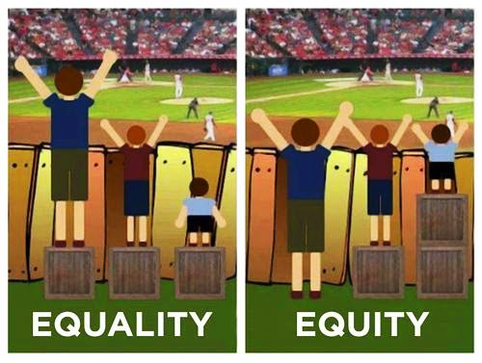**I CAN’T!**

If a customer or vendor declines to wear a mask, face shield or face covering

**ASK** politely if they have a medical issue/ disability that prevents them from using a mask.

***Remember: DO not attempt to validate the types of physical, mental health or ADA issues a customer claims. Do what you can to protect their privacy and dignity.***

**Best practice:** **Offer an alternative method of service that would still protect others**

**\*Phone/video appointment *Curbside pickup *Email /regular mail**

**\*Move to less crowded area/conference room**

HEARING ISSUES: OSHA states its acceptable to distance to +6 foot and then remove your mask to allow a person can hear you better or see your mouth.

**I SHAN’T - I WON’T! ITS AGAINST MY POLITICAL, PERSONAL OR MORAL BELIEFS/OPINIONS**

If the individual indicates no medical condition or disability/refuses to answer and wont comply

**Best practice: OFFER the same accommodations to serve them listed above for medical/ADA**

IF they won’t accept one of these options politely inform them that you cannot assist them without a face covering.

Avoid debating - It’s unnecessary to providing services and won’t help calm the situation.

If the individual refuses to accept accommodations offered AND refuses to leave, follow whatever procedures would normally be used when a person refuses to leave. (including contacting local law enforcement to indicate that the individual is trespassing).

***Remember: Under no circumstances should anyone attempt to physically block an individual from entering or physically remove them from the premises. Consult with your supervisor and local law enforcement.***

**Management:**

* Discuss in advance with your staff the procedure for a difficult encounter.
* Make sure accommodations and extra supplies are prearranged and ready.
* Have a plan for staff to be able to call in a second or higher authority to help defuse a situation.
* Have the discussion with CM, LEGAL and Local Law Enforcement now.
* Review with staff which services you provide that are mandated. Be sure your staff knows which services your organization must provide and how it will be accomplished.