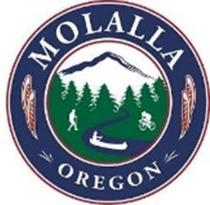
CITY OF MOLALLA
117 N. Molalla Avenue
PO Box 248
Molalla, OR 97038
Staff Report
Agenda Category: General Discussion

Agenda Date: January 11, 2023 From: Adam Shultz, PW’s Maintenance Manager
Approved by: Dan Huff, City Manager

SUBJECT: Project 22-22, On-Call Paving Services

FISCAL IMPACT: $250,000.00

RECOMMENDATION/RECOMMEND MOTION: Is to approve the Contract for an On-Call Paving Contractor as the responsible responsive bidder.

BACKGROUND: The City of Molalla requires asphalt pavement (AC) restoration services. The City is seeking a qualified Contractor to provide such services on a long‐term, as‐needed basis for the repair of AC pavement on City streets and other paved areas. The City expects to award a one‐year Contract with the option to extend the Contract for up to four (4) additional one‐year terms. If the option to extend the Contract is exercised by the City, the unit costs will / may be escalated based on the ENR Construction Cost Index (Seattle). The Contractor is expected to provide all materials and services that will fulfill or exceed the requirements and conditions set forth.
The successful bidder shall provide pavement repair services on an as‐needed basis as assigned by authorized City of Molalla Personnel. The locations that will be assigned for repair services consist of local, collector and arterial roadways and other paved areas. The City will provide the Contractor with a list of pavement restoration areas by the end of each month, and the Contractor will have until the end of the following month to complete the work. All work must be approved by the City of Molalla Public Works Department prior to acceptance for ownership and operation. Once repair services have been accepted (for ownership and operation) a two-year warranty for craftsmanship and materials will begin prior to acceptance for maintenance by the City.
The following bids were received: See attached document for the cost break down.

Successful Bidder – Roy Houck Construction
Eagle-Elsner Inc.
North Santiam Paving
S-2 Contractors Inc.
Brix Paving Northwest Inc.

