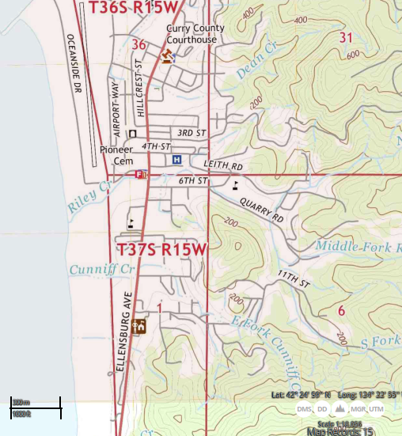
  USGS 7.5 Gold Beach, Oregon Quadrangle  Created: 2020 | KEY:  Site Location

