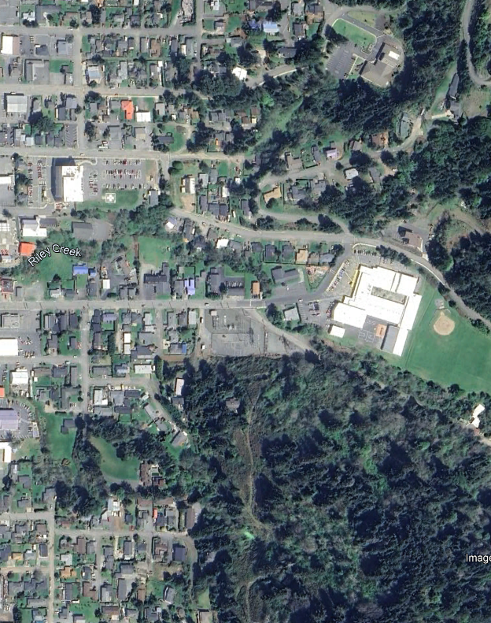
Coos-Curry
Electric Coop
Residential
Undeveloped Woodland
See Figure 2
Quarry Road
6th Street
  Drawing Not To Scale | KEY:  Subject Property

