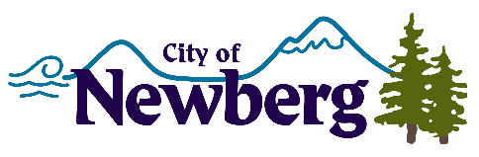
PROCLAMATION

A PROCLAMATION DECLARING November 25, 2023 AS SMALL BUSINESS SATURDAY

WHEREAS, the government of Newberg, Oregon, celebrates our local small businesses and the contributions they make to our local economy and community; and
WHEREAS, according to the U.S. Small Business Administration, there are 33.2 million small businesses in the United States: small businesses represent 99.7% of firms with paid employees, small businesses are responsible for 62.7% of net new jobs created since 1995, and small businesses employ 46.4% of the employees in the private sector in the United States; and
WHEREAS, 68 cents of every dollar spent at a small business in the United States stays in the local community and every dollar spent at small businesses creates an additional 48 cents in local business activity as a result of employees and local businesses purchasing local goods and services; and
WHEREAS, 72% of consumers reported that Small Business Saturday 2022 made them want to shop and dine at small, independently-owned retailers and restaurants all year long; and
WHEREAS, Newberg, Oregon, supports our local businesses that create jobs, boost our local economy, and preserve our communities; and
WHEREAS, advocacy groups, as well as public and private organizations, across the country have endorsed the Saturday after Thanksgiving as Small Business Saturday.

NOW, THEREFORE, be it resolved that the Mayor and City Council of Newberg, Oregon do hereby proclaim November 25, 2023, as
SMALL BUSINESS SATURDAY
And urge the residents of our community, and communities across the country, to support small businesses and merchants on Small Business Saturday and to Shop Small throughout the year.
IN WITNESS WHEREOF, I have hereunto set my hand and cause the Seal of the City of Newberg to be affixed on this 20th day of November 2023.

________________________________
Bill Rosacker, Mayor

