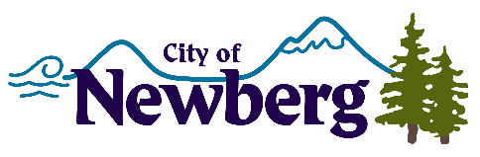
PROCLAMATION

A PROCLAMATION DECLARING APRIL 2023 AS CHILD ABUSE PREVENTION MONTH IN THE CITY OF NEWBERG

WHEREAS, child abuse is one of our nation’s most serious public health problems; and
WHEREAS, it is estimated that 1 in 4 children will suffer significant abuse before the age of 18 and in FFY 2021 over 160,000 contacts were made to the Oregon Child Abuse Hotline; and
WHEREAS, the physical, emotional, mental, and fiscal impact of abuse falls on children of all ages, abilities and backgrounds; and
WHEREAS, each of us has a role to play in stopping the problem of child abuse as part of the solution – by learning how to prevent, recognize, and report child abuse and supporting prevention, education and empowerment programs for children and youth;
NOW, THEREFORE, the Mayor and City Council of the City of Newberg, Oregon, do hereby proclaim April 2023 as

CHILD ABUSE PREVENTION MONTH

in the City of Newberg and encourage all residents to wear blue in support each Friday during the month of April. To learn more about how you can help, visit Juliette’s House, a community resource, by visiting www.julietteshouse.org.
IN WITNESS WHEREOF, I have hereunto set my hand and cause the Seal of the City of Newberg to be affixed on this 3rd day of April, 2023.

________________________________
Bill Rosacker, Mayor

