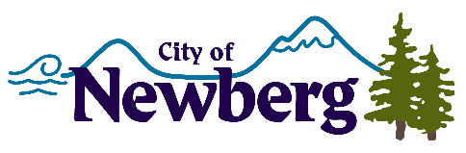
PROCLAMATION

A PROCLAMATION DECLARING APRIL 2023 AS CHILD ABUSE PREVENTION MONTH IN THE CITY OF NEWBERG
WHEREAS, child abuse is one of our nation’s most serious public health problems with scientific studies documenting the link between the abuse of children and a wide range of medical, emotional, psychological, and behavioral disorders; and
WHEREAS, it is estimated that 1 in 4 children will suffer significant abuse before the age of 18 and in FFY 2021 over 160,000 contacts were made to the Oregon Child Abuse Hotline – a total of 42,876 received reports were assigned for CPS assessment, of all completed CPS assessments, 7,352 were founded for abuse and involved 10,766 victims; and
WHEREAS, the physical, emotional, mental, and fiscal impact of abuse falls on children of all ages and abilities, who come from all economic, racial, and social backgrounds; and these crimes affect many more family members, friends, neighbors, and community; and
WHEREAS, effective child abuse prevention efforts succeed because of partnerships created among state and local government agencies, schools, faith communities, civic and community organizations, law enforcement agencies, and the business community while recognizing that feeling connected to community can be a protective factor against child abuse; and
WHEREAS, the City of Newberg is dedicated to stopping child abuse and supporting survivors and their non-offending families while working to prevent it;
WHEREAS, each of us has a role to play in stopping the problem of child abuse as part of the solution – by learning how to prevent, recognize, and report child abuse and supporting prevention, education and empowerment programs for children and youth;
NOW, THEREFORE, the Mayor and City Council of the City of Newberg, Oregon, do hereby proclaim April 2023 as
CHILD ABUSE PREVENTION MONTH
We reaffirm Newberg, Oregon’s commitment to creating a safer, healthier, more thriving community for our children and taking steps to help prevent child abuse through awareness efforts, prevention promotion, and training on responding responsibly. We encourage all citizens to Wear Blue each Friday in April – as a public statement in Newberg in support of child abuse prevention! We encourage community members to join in awareness rallies on April 22nd throughout Yamhill County. Further we call upon all citizens to invest in the lives of children by learning what they can do to help stop child abuse through Juliette’s House, a community resource, by visiting www.julietteshouse.org.
IN WITNESS WHEREOF, I have hereunto set my hand and cause the Seal of the City of Newberg to be affixed on this 3rd day of April, 2023.

________________________________
Bill Rosacker, Mayor

