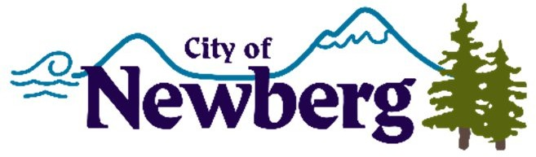
PROCLAMATION

A PROCLAMATION DECLARING OCTOBER 2022 AS BREAST CANCER AWARENESS MONTH IN THE CITY OF NEWBERG

WHEREAS, October is National Breast Cancer Awareness Month; and
WHEREAS, breast cancer is experienced by both men and women. According to the World Health Organization, breast cancer became the most common cancer globally as of 2021; and
WHEREAS, about 1 in 8 U.S. women and 1 in 833 U.S. men will develop invasive breast cancer over the course of their lives; and
WHEREAS, Breast Cancer Awareness Month is an opportunity to unite the community and spread the important message of early detection, screening and prevention to women and men in order to prevent additional diagnoses, or even breast cancer deaths;
NOW, THEREFORE, I, Rick Rogers, Mayor of the City of Newberg, Oregon, do hereby proclaim October 2022 as

BREAST CANCER AWARENESS MONTH

IN WITNESS WHEREOF, I have hereunto set my hand and cause the Seal of the City of Newberg to be affixed on this 3rd day of October 2022.

Rick Rogers, Mayor

