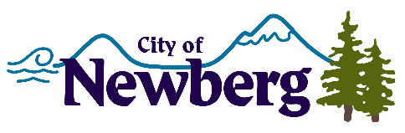
PROCLAMATION

A PROCLAMATION DECLARING AUGUST 24, 2022 AS SOLIDARITY WITH UKRAINE DAY IN THE CITY OF NEWBERG

WHEREAS, Ukraine proclaimed independence from the Union of Soviet Socialist Republics on August 24, 1991, adopted its constitution in 1996, and has been a fully independent country and home to 44 million citizens led by a president elected by overwhelming popular vote; and
WHEREAS, on February 24, 2022, Russian military forces conducted an unprovoked invasion of Ukraine, resulting in the destruction of cities and towns and thousands of civilian casualties; and
WHEREAS, the people of Ukraine have been caught in the middle of this invasion, creating millions of external refugees; and
WHEREAS, the invasion of Ukraine and attacks against its people have been broadly condemned by the United Nations, the United States government, and the leadership of the European Union; and
WHEREAS, the City of Newberg condemns the unprovoked invasion of Ukraine and urges the United States government and our allies to use every diplomatic tool to bring an end to the conflict; and
NOW, THEREFORE, BE IT RESOLVED I, Rick Rogers, Mayor, do hereby ask the residents of Newberg, Oregon, to join us in expressing support for the people of Ukraine; and
NOW, THEREFORE, BE IT RUTHER RESOLVED I, Rick Rogers, Mayor, do hereby ask the residents of Newberg, Oregon, to join us in expressing support and for those in our community with Ukrainian roots, who are especially concerned for the well-being of their loved ones; and
NOW, THEREFORE, BE IT FINALLY RESOLVED I, Rick Rogers, Mayor, do hereby proclaim August 24, 2022 as

SOLIDARITY WITH UKRAINE DAY

IN WITNESS WHEREOF, I have hereunto set my hand and cause the Seal of the City of Newberg to be affixed on this 15th day of August 2022.

________________________________
Rick Rogers, Mayor

