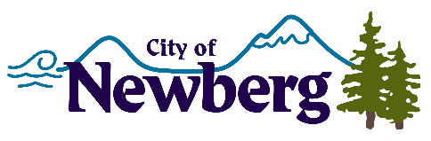
PROCLAMATION

A PROCLAMATION DECLARING NOVEMBER 26, 2022 AS SMALL BUSINESS SATURDAY IN THE CITY OF NEWBERG

WHEREAS, the government of Newberg, Oregon, celebrates our local small businesses and the contributions they make to our local economy and community; and
WHEREAS, according to the United States Small Business Administration, there are 32.5 million small businesses in the United States, small businesses represent 99.7% of firms with paid employees, small businesses are responsible for 62% of net new jobs created since 1995, and small businesses employ 46.8% of the employees in the private sector in the United States, and
WHEREAS, 79% of consumers understand the importance of supporting the small businesses in their community on Small Business Saturday®, 70% report the day makes them want to encourage others to Shop Small®, independently-owned retailers, and 66% report that the day makes them want to Shop Small all year long; and
WHEREAS, 58% of shoppers reported they shopped online with a small business and 54% reported they dined or ordered takeout from a small restaurant, bar, or café on Small Business Saturday in 2021; and
WHEREAS, Newberg, Oregon supports our local businesses that create jobs, boost our local economy, and preserve our communities; and
WHEREAS, advocacy groups, as well as public and private organizations, across the country have endorsed the Saturday after Thanksgiving as Small Business Saturday;
NOW, THEREFORE, I, Rick Rogers, Mayor of the City of Newberg, Oregon, do hereby proclaim November 26, 2022, as
SMALL BUSINESS SATURDAY
And urge the residents of our community, and communities across the country, to support small businesses and merchants on Small Business Saturday and throughout the year.
IN WITNESS WHEREOF, I have hereunto set my hand and cause the Seal of the City of Newberg to be affixed on this 21st day of November 2022.

________________________________
Rick Rogers, Mayor

