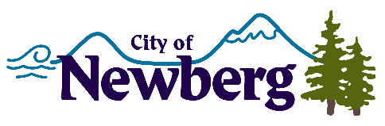
PROCLAMATION

A PROCLAMATION DECLARING JULY 28-31, 2022 AS NEWBERG OLD FASHIONED FESTIVAL WEEK IN THE CITY OF NEWBERG

WHEREAS, the City of Newberg is a family friendly and inclusive community that hosts many gatherings, numerous celebrations, and a variety of entertainment venues where old friends and new ones can get together; and
WHEREAS, each year the City of Newberg and many members of the community participate by celebrating community spirit, during the last full weekend in July; and
WHEREAS, the City of Newberg welcomes the community and visitors each year to join them in the Newberg Old Fashioned Festival activities, and enjoy the camaraderie and sense of community build by the festival of this extent; and
WHEREAS, the many Newberg Old Fashioned Festival events that take place during the week bring the community together for fun and entertainment. The theme for this year is, “Portrait of Our Community.”
NOW, THEREFORE, I, Rick Rogers, Mayor of the City of Newberg, Oregon, do hereby proclaim July 28-31, 2022 as

NEWBERG OLD FASHIONED FESTIVAL WEEK

IN WITNESS WHEREOF, I have hereunto set my hand and cause the Seal of the City of Newberg to be affixed on this 5th day of July 2022.

________________________________
Rick Rogers, Mayor

