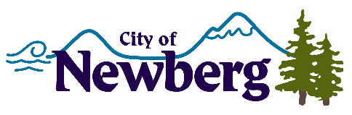
PROCLAMATION

A PROCLAMATION DECLARING NOVEMBER 2022 AS NATIVE AMERICAN HERIGATE MONTH IN THE CITY OF NEWBERG

WHEREAS, in 1990 President George Bush designated the month of November as National American Indian Heritage Month, however recognition dates back to as early as 1916; and
WHEREAS, it is a time to celebrate and honor the history, rich traditions, and achievements of indigenous peoples; and
WHEREAS, despite the injustices that Native Americans have endured for centuries, they have persevered through remarkable strength and resilience; and
WHEREAS, the city of Newberg rests on land that was first inhabited by the Tualatin Kalapuyas (Atfalati), who flourished here for thousands of years and today are represented by the Confederated Tribes of the Grand Ronde,
NOW, THEREFORE, I, Rick Rogers, Mayor of the City of Newberg, Oregon, do hereby proclaim November 2022, as,
NATIVE AMERICAN HERITAGE MONTH
and invite all residents to visit the Newberg Library to check out their Native American Heritage Month book displays.
IN WITNESS WHEREOF, I have hereunto set my hand and cause the Seal of the City of Newberg to be affixed on this 7th day of November 2022.

________________________________
Rick Rogers, Mayor

