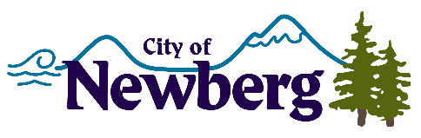
PROCLAMATION

A PROCLAMATION DECLARING APRIL 22, 2022, AS EARTH DAY IN THE CITY OF NEWBERG

WHEREAS, Earth Day is recognized on April 22nd. It is an annual event celebrated nationwide to demonstrate support for environmental protection; and
WHEREAS, the theme of Earth Day 2022 is “Invest In Our Planet”; and
WHEREAS, the idea behind the theme is to encourage governments, corporations, and residents to take concrete steps towards following more sustainable practices; and
WHEREAS, investing in our planet is vital to enhance environmental awareness. Creating and implementing effective plans will help minimize the environmental impact and protect the planet for generations to come; and
NOW, THEREFORE, I, Rick Rogers, Mayor of the City of Newberg, Oregon, do hereby proclaim April 22, 2022 as

EARTH DAY

in the City of Newberg and encourage all residents, businesses, and institutions to use Earth Day to celebrate the Earth and promote the Earth’s wellbeing.
IN WITNESS WHEREOF, I have hereunto set my hand and cause the Seal of the City of Newberg to be affixed on this 18 day of April, 2022.

________________________________
Rick Rogers, Mayor

