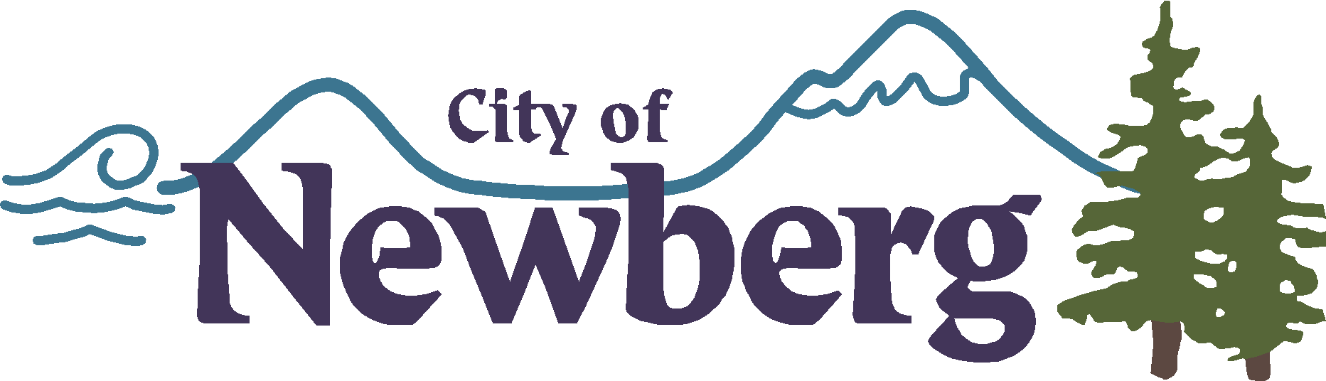

PROCLAMATION
2021 Dave Adrian Appreciation Day

WHEREAS, Dave Adrian is set to retire from 41 years of service to George Fox University in Newberg, Oregon; and

WHEREAS, Mr. Adrian's commitment to his profession, life calling, and the community around him serve as an exemplary model for generations to come. Over the four decades he served at George Fox University he displayed unwavering support for the university and the education it provides; and

WHEREAS, Mr. Adrian’s fundraising efforts and philanthropic spirit have provided endless support for student scholarships, capital projects, and many other university programs and has inspired a culture of philanthropy and giving; and

WHEREAS, in celebration of his legacy, it is fitting that we honor this exemplary role model and express our deepest gratitude for his service to George Fox University and the surrounding community, for his commitment to his profession, and the vocational calling on his life. We believe the dedication of Mr. Adrian should be recognized and commended;

NOW, THEREFORE, IT IS PROCLAIMED, by the Mayor and on behalf of the people of the City of Newberg, Oregon, that we express our warmest appreciation and gratitude to Dave Adrian and proclaim December 15, 2021 as Dave Adrian Appreciation Day.

IN WITNESS WHEREOF, I have hereunto set my hand and cause the Seal of the City of Newberg to be affixed on this 15th of December, 2021.

________________________________
Rick Rogers, Mayor

