July 9, 2021 *sent via email*

Deborah Taege, Remediation Program Manager 

The Boeing Company

Bldg. 10-20, MC 9U4-26

800 N 6th Street

Renton, WA 98055-1409

**RE: Technical Memorandum. 1, 4-Dioxane Reconnaissance-Level Investigation Work Plan, Boeing Portland Troutdale Gravel Aquifer. Gresham, Oregon. ECSI #13**

Dear Ms. Taege,

Thank you for your *1,4-Dioxane Reconnaissance-Level Investigation Work Plan*, Troutdale Gravel Aquifer at the Portland Boeing facility. Oregon Department of Environmental Quality (DEQ) approves this document with the comment include below to be addressed in the summary technical memorandum. The *Work Plan*, received on June 28, 2021, was prepared on your behalf by Landau Associates, Inc.

Sampling and Analytical Procedures, page 3.  Text at the bottom of the page indicates a minimum 3 week equilibration time for DMPDB deployment, but equilibration times for monitored VOCs and 1,4-dioxane are not discussed.  Please identify equilibration time for 1,4-dioxane if known.

Following groundwater sampling, verification and validation of lab data, please prepare a technical memorandum summarizing sampling activities and analytical results. After review of the results, a determination will be made as to whether additional sampling or other steps are necessary.

If you have any questions, please contact me.

Sincerely,

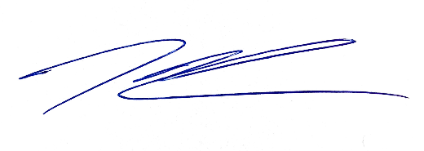

Kenneth Thiessen, CEG

Northwest Region Cleanup Section

cc: Evelyn Ives, PE, Landau Associates, Inc.

Christine Kimmel, LHG, Landau Associates, Inc.

Dan Hafley, RG, DEQ NWR

ECSI #13