State of Oregon
Department of Environmental Quality Memorandum
To: | ECSI File #1311 Johnson Lake |  | Date: 7/27/2020
From: | Franziska Landes, Project Manager and Data Analyst
Subject: | ODOT Culvert Repairs (07/21/2020) near site

On 7/21/2020 ODOT conducted repairs to the Myer’s Container (ECSI #2062) side of a culvert that passes under I-205 to Johnson Lake (ECSI #1311). The repair fixed a union between the ODOT culvert and the capped end piece installed when the water scrubber was installed. Water level was below the pipe inlet, so there was no water/sediment released into Johnson Lake.
ODOT points of contact are Charles Schwarz (Charles.SCHWARZ@odot.state.or.us and 503-880-9074) and for CMS: Daniel Scarpine (Aquarius Environmental, contact: daniels@aquariusenv.com and 503.317.5114).
Work included:
- Removing blackberries to expose the pipe joint closest to the inlet.
- Removing the joint and repairing the union between the culvert and end cap.
  - ODOT opened the hugger band, put in foam backer, caulk sealed, and new gasket, hugger band

Photos of the repair and site location are included on the next pages. Emails and additional photos can be found on the V drive at: \\deqnwr1\vcsshare\Franziska Landes Project Files\2086 Johnson Lake\15 Operations & Maintenance\2020 ODOT Pipe Repair - Myers side of culvert\Photos

Photos of repair (from Daniel Scarpine, Aquarius Environmental, on behalf of CMS).
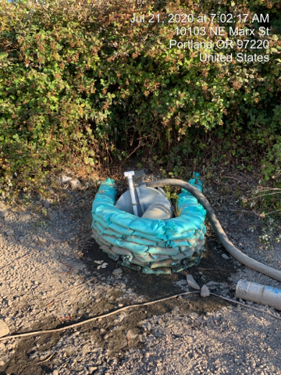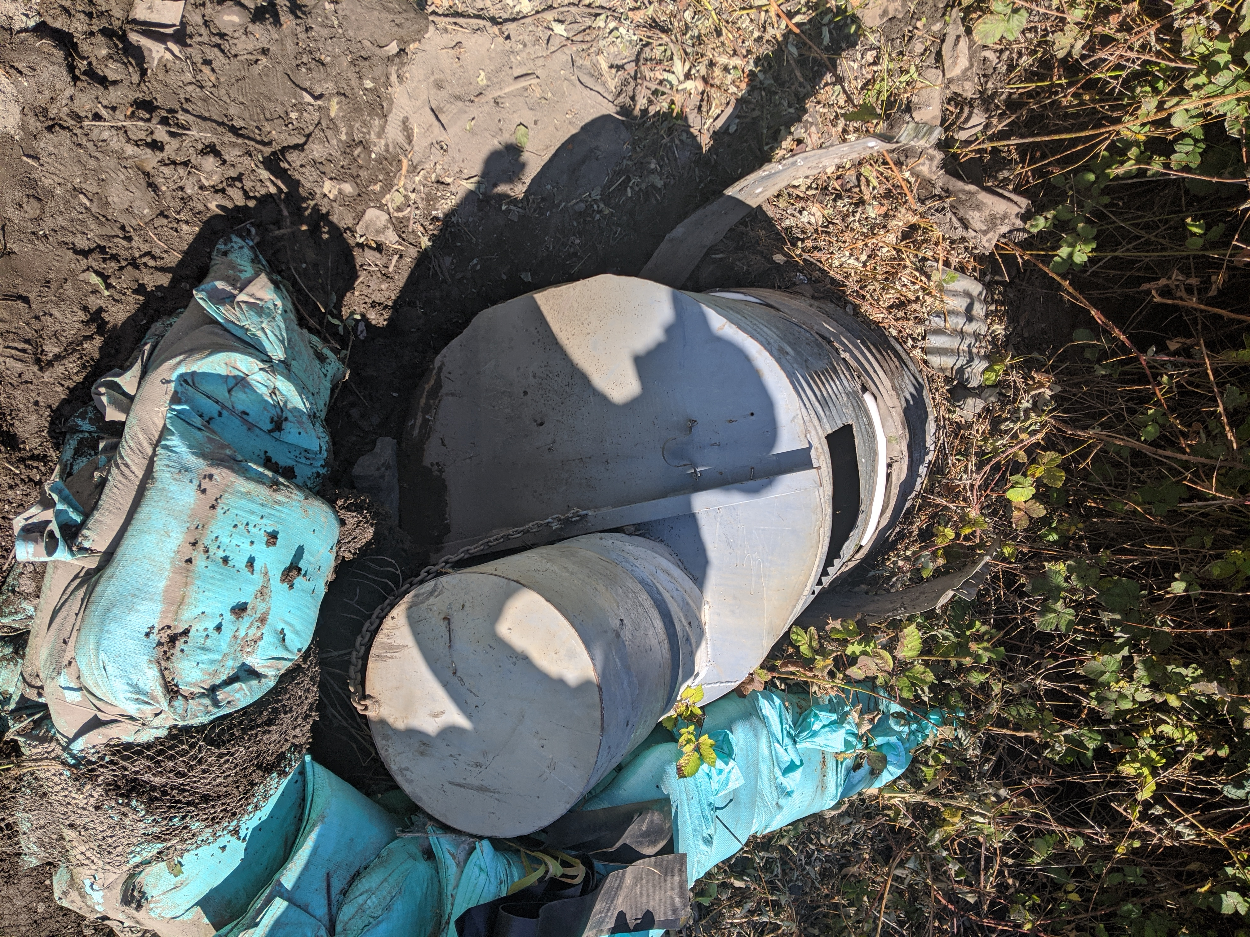
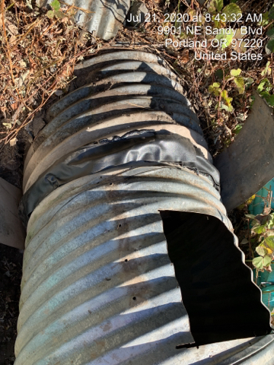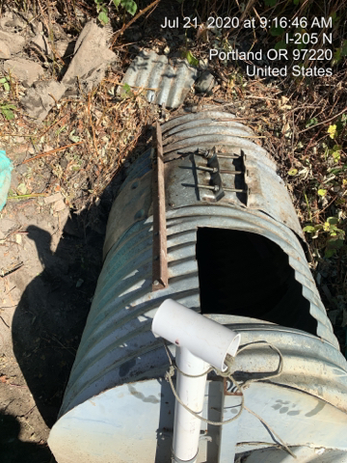

Location maps
Zoomed in view of culvert repair location. Culvert repair occurred on 7/21/2020 on the Myer’s Container (ECSI #2062) side. Culvert passes under I-205 to Johnson Lake (ECSI #1311).
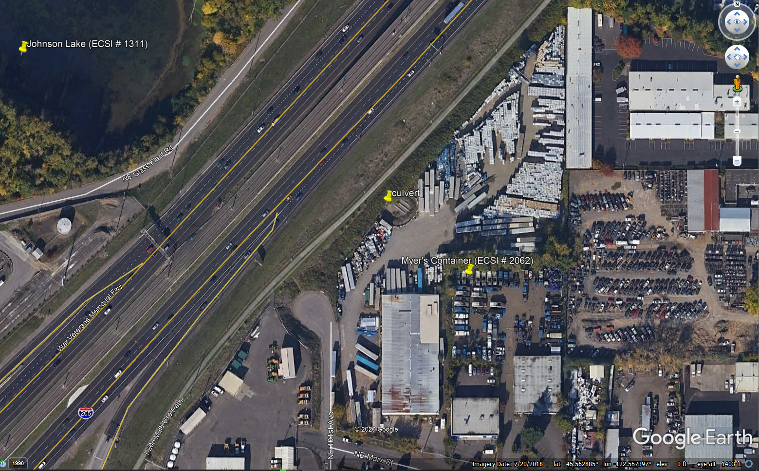

Zoomed in view – Johnson Lake and Myer’s Container, and location of culvert: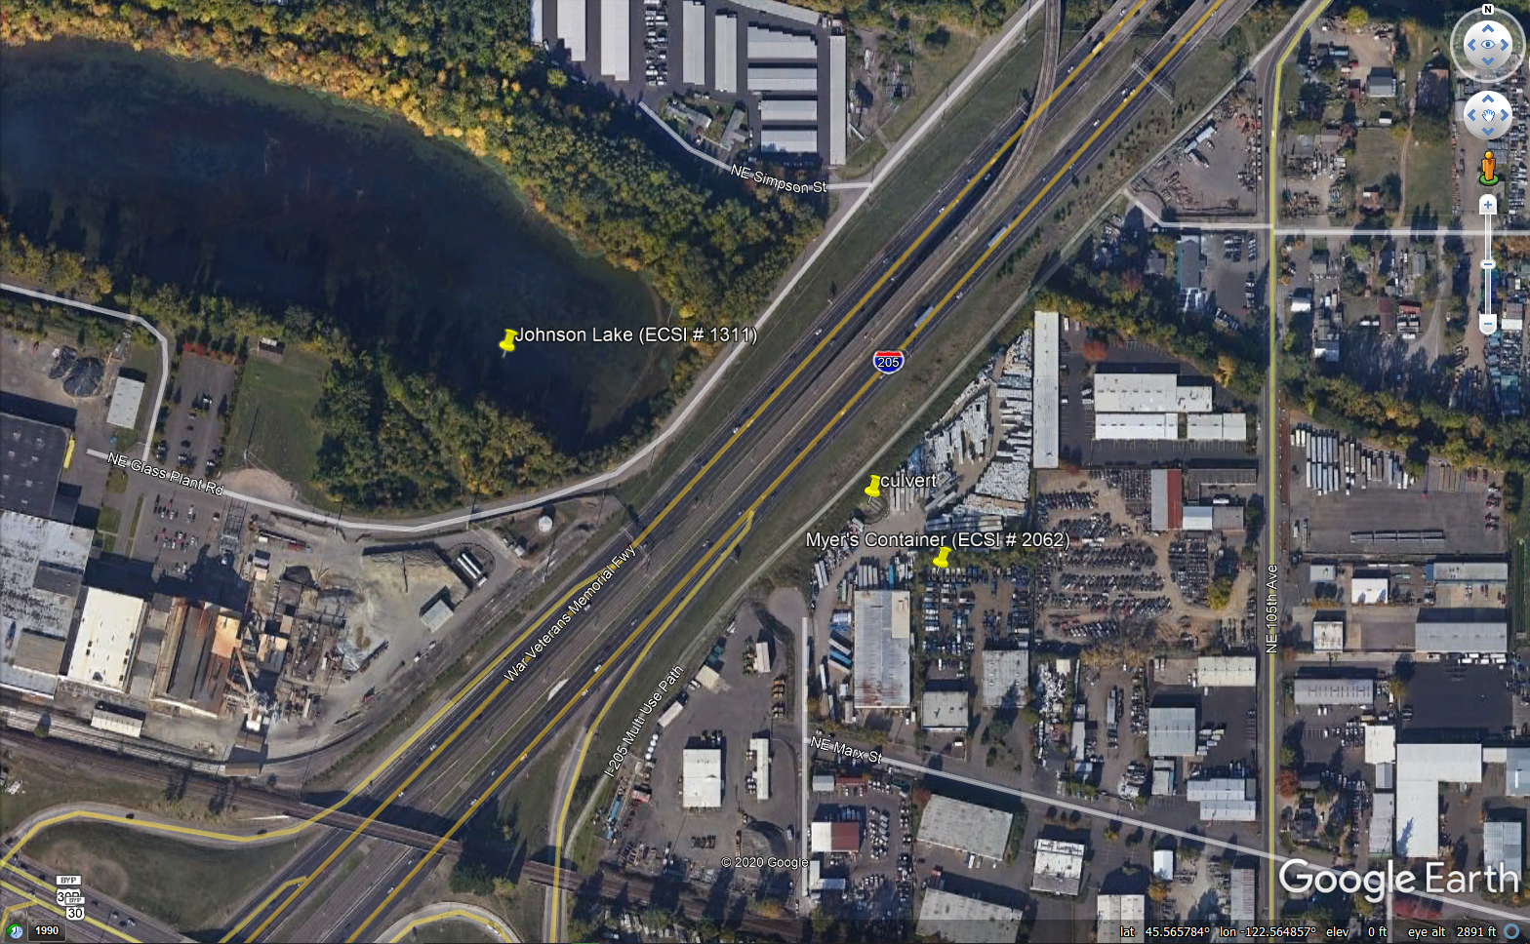

Zoomed out view – Johnson Lake and Myers container: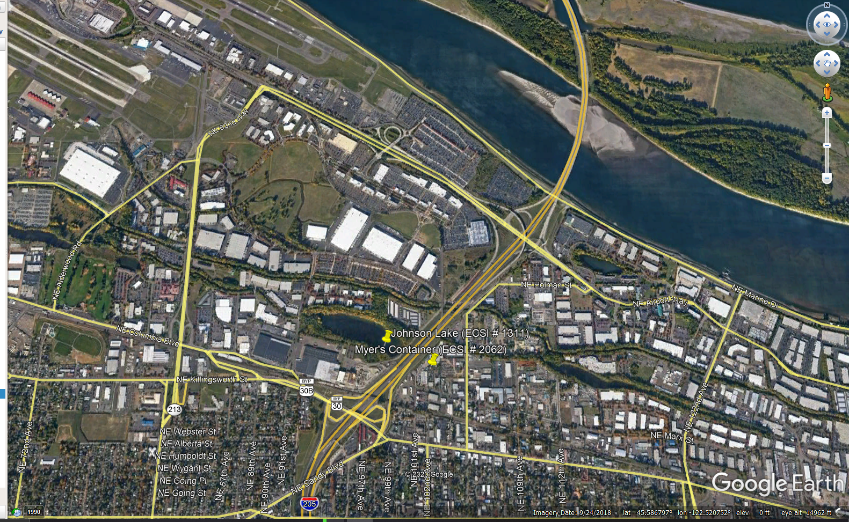
Zoomed out view – City of Portland level: