September 21, 2016
Jesus and Laura Arellano
110 Ridings Avenue
Molalla, OR 97038

RE: Molalla Municipal Code (MMC) 8.08.150 – Prohibited dump site at 633 Metzler Avenue, 13.08.330 Unauthorized connections and disturbances.

Dear Mr. & Mrs. Arellano,
You are receiving this letter because we received a complaint that you and/or persons working for you have used the property at 633 Metzler Avenue as an illegal dump site for construction debris and waste. On August 31, 2016, City staff performed a site visit and confirmed that materials had been dumped on the site, a large debris pile was placed in front of a stop sign at Meztler Avenue and 7th Street, and that unpermitted construction and installation of a drainage pipe and access were completed in public right of way along the north side of 7th Street. See images below.
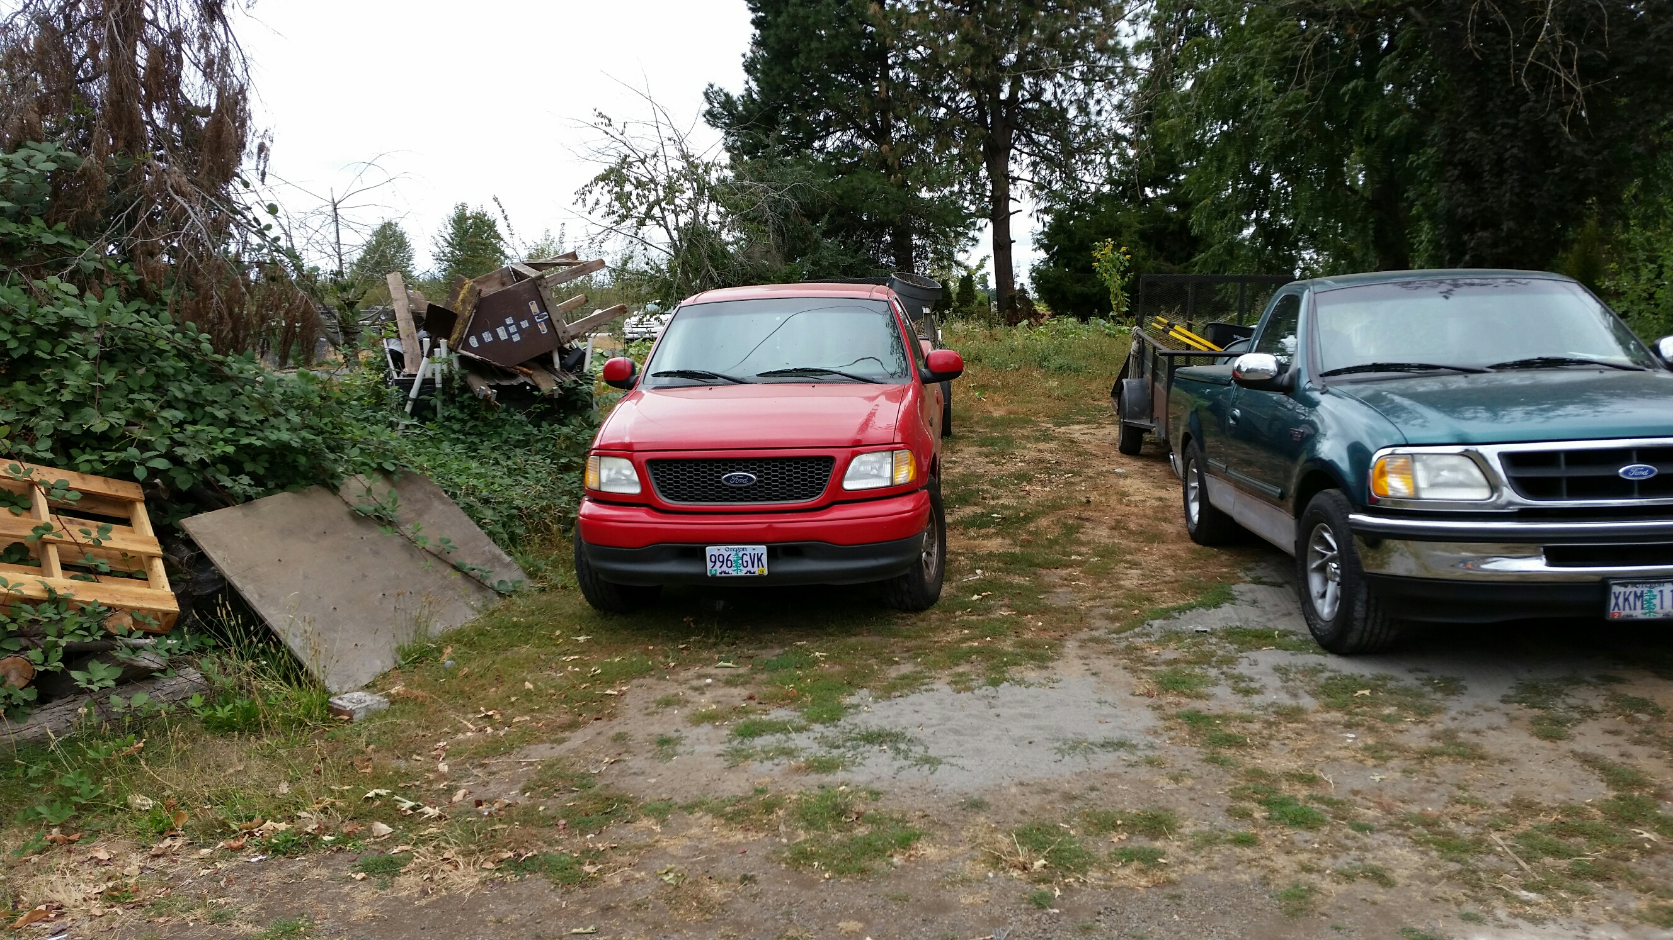

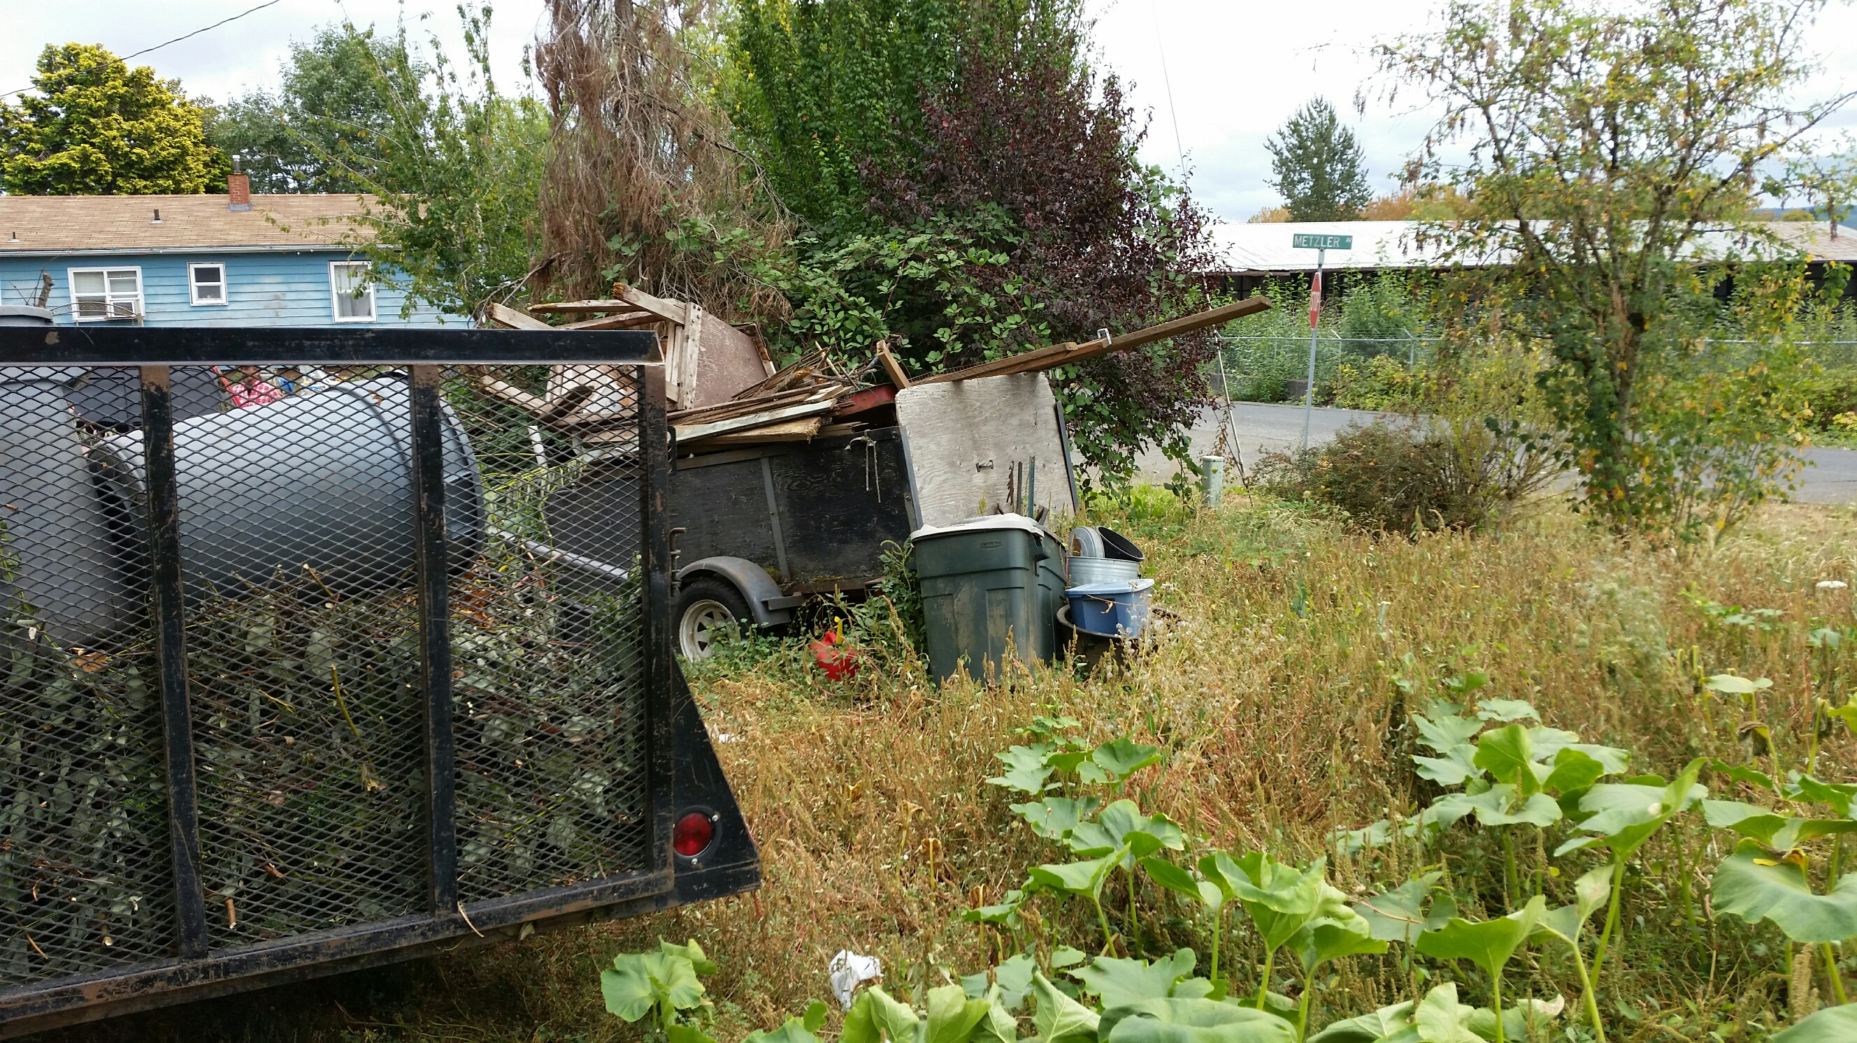

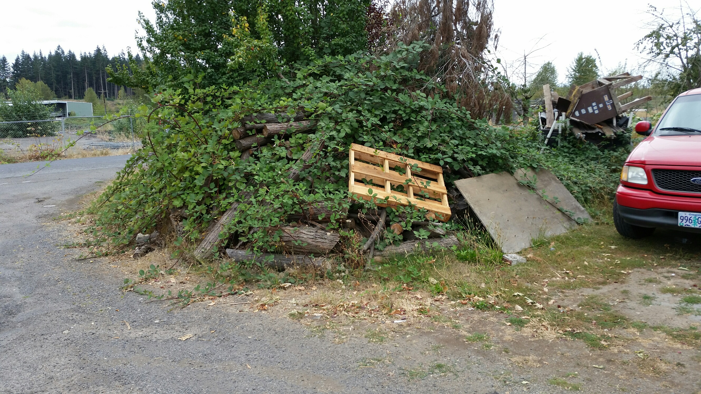

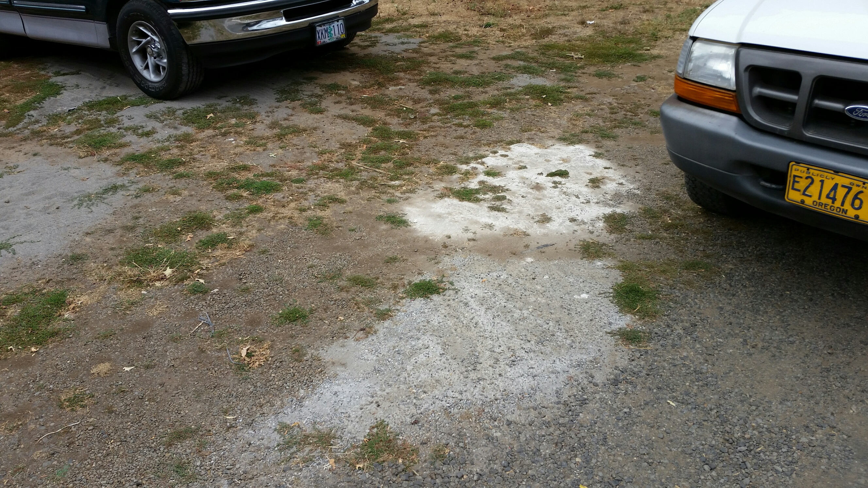

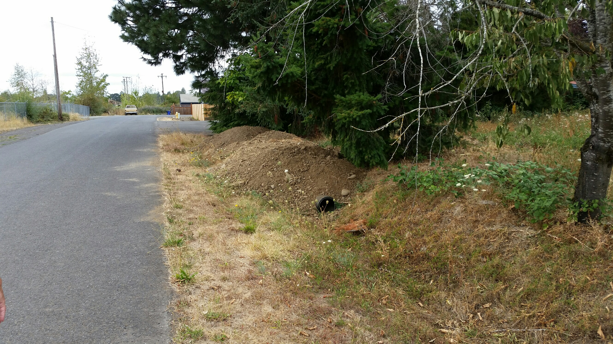
This letter serves as your official notice from Public Works that all debris piles are to be removed from the site and construction within the ditch along the north side of 7th Street shall be immediately removed and returned to its original condition. You have 15 days from the date of this letter (deadline October 6, 2106) to complete this work and contact my office at 503.759.0218 or gfisher@cityofmolalla.com for an inspection of the cleanup of the site. If I do not hear from you by the October 6th deadline then this matter will be turned over to Code Enforcement. Thank you for your immediate attention to this matter.

Sincerely,

Gerald Fisher, Public Works Director

Cc: Dan Huff, City Manager
Rod Lucich, Chief of Police
Dan Zinder, Code Enforcement

