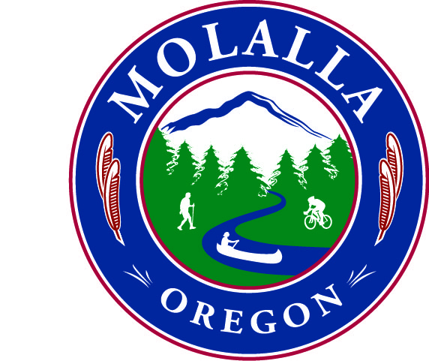
Molalla Parks & Recreation Board

Regular Meeting Minutes

January 15, 2014 – Regular Meeting
Present: Scott Clarke, Amy Cain, Julie Harris, City of Molalla Liaison Melissa Georgesen

Absent: Shane Potter, Betty Martin, Alice Flintjer, Dennis Wise

Guest(s): City Manager, Dan Huff

Call to order: 7:12pm @ Molalla City Hall

Next meeting: January 15, 2014 7:00pm Molalla City Hall

Next event: None Scheduled

I. Approval of Minutes
November minutes were approved; motion made by Harris, second by Cain. All in favor.

II. Public Comments
None.

III. Continuing Business
  - Parks Master Plan Revisions have been completed and the final version will be emailed to members as soon as Georgesen receives it. The plan will be presented to council on Wednesday, January 22, 2014.

IV. New Business
  - Capital Improvement Plan
  - Clarke: would like five to ten acres of park space, looking for property in Big Meadow.
  - Huff: Remember that parks can be built outside of the UGB.
  - Clarke: The existing park- June Burghart- is it possible to expand? Thinking that the property owner will ask $50,000 for 6,500 square feet.
  - Huff: Cite specific opportunities in the parks plan. Believes everyone would agree that the northwest portion needs something. Estacada has some items in their CIP I would not recommend including, such as picnic tables, treated lumber and steel. Two things that I have heard people say we need: 1) a park in Big Meadow 2) a trail on the old rail line.
  - Clarke: Hoping to get a strip of property along the backside of Big Meadow.
  - Huff: If the UGB was expanded, a property owner may donate land for parks. We have some things to accomplish on the city’s end of things, but it isn’t impossible. Neighborhood park in the northwest quadrant and affix a dollar amount to it. This can be changed in the event that someone donates land or money. We can do some of it tonight, or come back with it. Email Georgesen and she will create a list to begin working with.
  - Clarke: Big Meadow Park & trail system on the old rail line.
  - Huff: Perhaps phase the trail- Phase 1, Hwy 211 to Toliver Rd., etc.
  - Clarke: Someone was looking to add a trail?
  - Huff: Trail is Industrial to Toliver, on the backside of Fountain Valley Dental.
  - General discussion regarding the Sally Fox Trust. It was determined that the trust was costing the City more to maintain it than the City was receiving out of it. We asked the court to release the balance, $96,000, that we previously could not access, and they have granted its release. The only stipulations are that it must be used in Fox Park only; and it has to be spent by June 30, 2014. Looking at updating the splash pad; new playground equipment or restoring the restrooms. Staff will acquire prices for all options.
  - Huff: Make sure you go back to the plan and see what is recommended in there. If each of you comes up with five projects, what can be done in a fiscal year? There is grant money out there, but that could slow down the process. The money follows later, which means items can be stretched out over several years.
  - Cain: What about the possibility of a dog park?
  - Huff: The city has some extra land that is not being used much. Open space that is unimproved is typically ideal for such a park. What really helps is a local group raising awareness for a dog park to get us there.

V. Board Comments

Huff: The SDC fund for parks balance = $521,770.76.

VI. Adjournment
- Meeting was adjourned at 8:10pm. Motion made by Harris, second by Cain; all in favor.
- The next meeting is scheduled for February 19, 2014 at 7:00pm.

