City Of Molalla
City Council Meeting
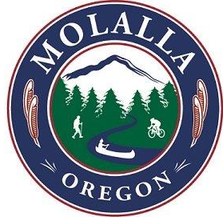
Agenda Category: New Business
Subject: Local Truck Route Approval Procedure

Recommendation: No Action Required.

Date of Meeting to be Presented: May 09, 2018
Fiscal Impact: None

Background:
Included for discussion is a copy of the 2007 Local Truck Route Approval Procedure from ODOT. Staff will be providing a breakdown of the process at the City Council meeting. Staff has also requested a scope of work and fee from the City’s on-call transportation engineering firm DKS Associates. Due to current work load, the scope and fee may not be available until the May 23, 2018 meeting. The focus of this New Business item will be do discuss the process for receiving ODOT approvals for a local truck route. Staff intends to cover the costs to perform this work at the May 23, 2018 meeting.

SUBMITTED BY: Gerald Fisher, Public Works Director
APPROVED BY: Dan Huff, City Manager

