February 24, 2018
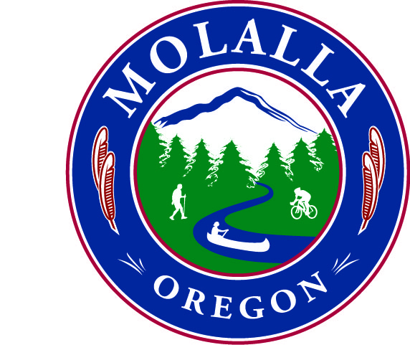
  - civic engagement award

Of

appriciation

We the molalla city council would like to thank you for all that you have done for the city in 2017.
Erin Devlin |  | Mayor Thompson
In Recognition Of |  | Issued By

