March 2, 2023

Charlotte A Wiley Trustee
Marble Concepts & Designs LLC et al.
680 S Front St
Central Point, OR 97502-2724

RE: Opportunity to Comment
Proposed Conditional No Further Action Determination
Rogue Primary School, ECSI #6520
COMMENTS DUE: April 6, 2023

Dear Property Owner:

The Oregon Department of Environmental Quality (DEQ) is providing oversight for the investigation and cleanup of petroleum contamination at the above referenced site. Based on our review of site information, we have determined that site meets the cleanup standards in Oregon Environmental Cleanup Law, ORS 465.200 et seq. This determination is summarized in our Staff Memorandum in support of a Conditional No Further Action determination dated February 15, 2023. DEQ issues a Conditional No Further Action (CNFA) determination when a cleanup has met regulatory standards under Oregon’s Cleanup law, but some ongoing requirements or restrictions apply.

DEQ is notifying you of its proposal to issue a CNFA determination because the of residual contamination from the school property that extends into the South 1st Street right-of-way. It is possible that low levels of contamination may also extend beneath the northern/eastern part of your property (see included figures).

Diesel is the main contaminant of concern. Residual diesel contamination remains in soil beneath the school entrance at depths of 3.5 feet and greater and extends to the west, including underneath the South 1st Street right-of-way. The highest concentration of diesel detected in soils adjacent to your property was observed at 6 feet below ground surface at 732 milligrams per kilogram. The highest concentration of diesel detected in groundwater adjacent to your property was 52.7 micrograms per liter. Both of these concentrations of diesel are well below DEQ’s risk screening levels for direct contact with soil and for tap water consumption of groundwater.

You are not liable for the contamination from the school that may have migrated beneath your property. Also, even though DEQ is not requiring any further action by the school district now, they remain responsible for the contamination from their property.

We will consider any comments that you may have before finalizing the decision. Directions on how to comment on DEQ’s proposal and where to find additional information are provided below.

How to Comment
Send comments by 5 p.m. on April 6, 2023, to DEQ Project Manager Ellen Woods by phone 541-606-0490, email ellen.woods@deq.oregon.gov, fax 541-686-7551 or mail 165 E. 7th Ave., Suite 100, Eugene, OR 97401.

Where to Find Additional Information
Detailed information supporting DEQ’s proposed conditional no further action determination is contained in a DEQ Staff Memo dated February 15, 2023. This document and other site documents may be viewed on DEQ’s website at: https://www.deq.state.or.us/lq/ECSI/ecsiquery.asp. Enter ECSI #6520 in the Site ID box and click “Submit” at the bottom of the page. Next, click the link labeled ECSI 6520 in the Site ID/Info column. A link to the Staff Memo is available toward the bottom of the web page.

The complete project file is available for review by appointment. Information about requesting a review of DEQ project files is at: http://www.oregon.gov/deq/about-us/Pages/Request-Public-Record.aspx. To schedule a file review, please submit an online Records Request Form at https://oregondeq.govqa.us/WEBAPP/_rs/(S(iffvqh03uzsb2nchjrpiwsgm))/supporthome.aspx

You may contact me at 541-606-0490 or email at ellen.woods@deq.oregon.gov if you have questions about the project or how to comment.

Sincerely,
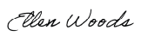
Ellen Woods, Project Manager
Western Region Cleanup Program

Alternate Formats
DEQ can provide documents in an alternate format or in a language other than English upon request. Call DEQ at 800-452-4011 or email deqinfo@deq.oregon.gov.

Attachments: Estimated plume of residual diesel contamination in soil
Estimated plume of residual diesel contamination in groundwater

cc: File, ECSI #6520 (w/ attachments)

Figure 1. Estimated plume of residual diesel contamination in soil
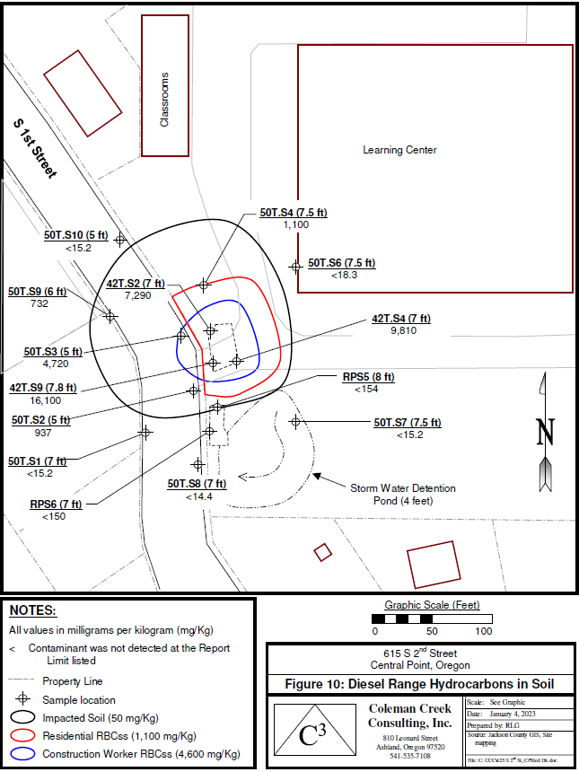
Figure 5
From Cleanup and Risk-Based Assessment of Rogue Primary School, Coleman Creek Consulting (2023)

Figure 2. Estimated plume of residual diesel contamination in groundwater
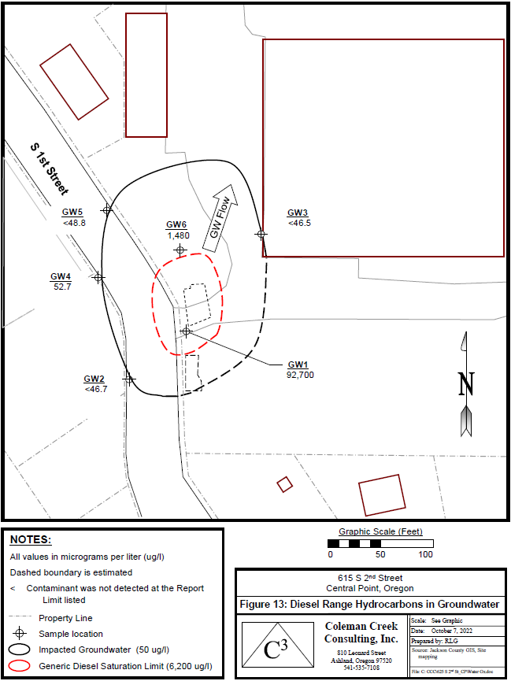
Figure 6
From Cleanup and Risk-Based Assessment of Rogue Primary School, Coleman Creek Consulting (2023)

