
INSPECTOR’S DAILY REPORT

City of Molalla • Public Works Department
117 N. Molalla Ave. • Molalla, OR 97038
(503) 829-6855 Phone • (503) 829-3676 Fax

Date: 06/05/2020 | Project Name: 302 N Cole Ave
Weather/Temp: ±65° | Permit No.: PW38-2020
Type of Inspection: Water Tap | Engineering File: 302 N Cole Home Cons.

Contractors, Personnel, & Equipment (if needed)

Gen. Contractor: Spanfellner Construction | Superintendent: Cody
Sub-Contractor: Columbia Excavating | Foreman: Chas
Personnel: Foreman (1), Operators (1), Laborers (2)
Equipment: Track Hoe & Dump Truck

COMMENTS

Arrived on site at 8:30 am. to inspect Water Tap

Double A Tapping Services conducting service line tap to the main water line for 302 N Cole Ave. Water Tap involved a street cut on west side of Cole Ave. Columbia Excavating exposed the water main line by removing approx. 5 yards of fill to open a 3’ wide by 4’ deep trench. line tap was core drilled though a double bale saddle clamp with corporation stop. Columbia Excavating installed a 1’ service line from saddle clamp to meter box location behind the ROW.

Columbia Excavating completed 4” sewer line from the street into the property with clean out behind the ROW. Green tracer wire was placed over pipe with one foot a ¾-0 gravel and green reflective tape. ¾-0 gravel was placed in the trench and compacted in 3’ increments. Cold patch to be placed over the trenches at the end of the Day

Left the site at 9:30 am

See Images Below.

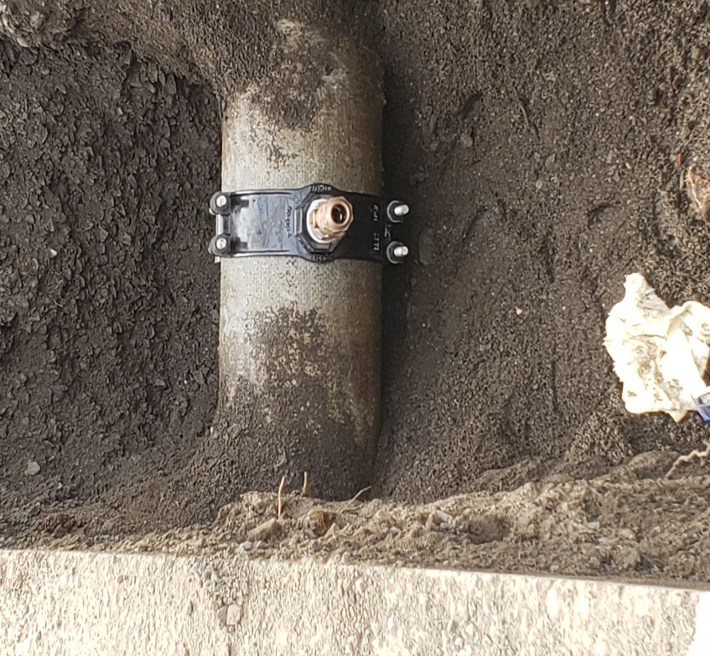

View to the East, Tap connection to the main water line

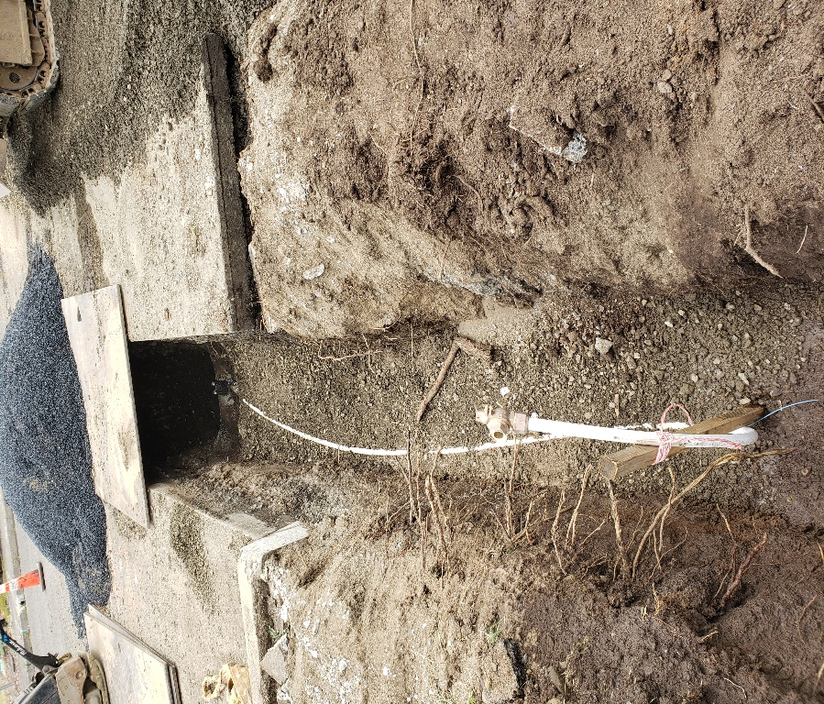

View to the East, 1” service line into the property

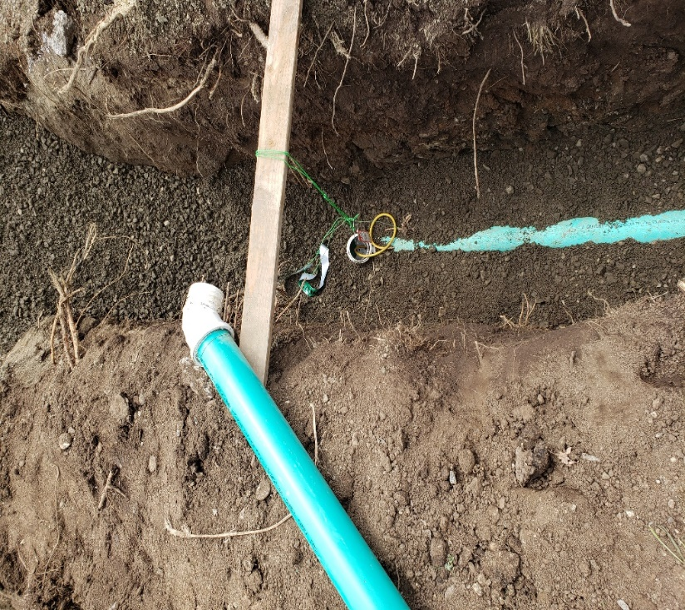

View to the East, Public clean out

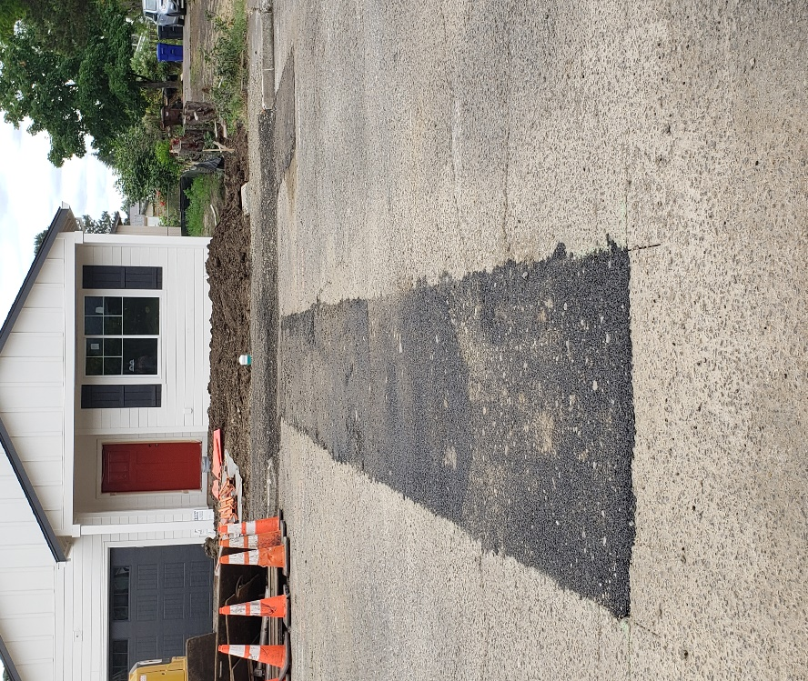

View to the West, Cold Patch

Approx. 3’ wide x 8’ long and 4” deep AC and Approx. 5 yards of fill was removed. One double bale saddle clamp with corporation stop.14’ of 4” PVC pipe installed. Approx. 16 yards of ¾-0 gravel of back fill placed in trench and Approx. 8 yards of AC Cold Patch.

______________________

Sam Miller
Sr. Engineer Tech.

