**EQC HW Fees Presentation Script**

**Slide 1**

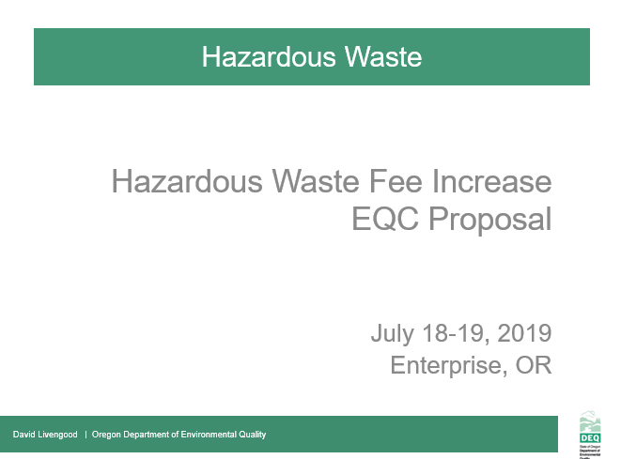

* Good morning Chair George and commissioners, my name is David Livengood. I manage DEQ’s Hazardous Waste and Tanks program from headquarters in Portland.
* Today, I am joined by my colleague, Jeannette Acomb, whom you met in January when she presented background on the Hazardous Waste Program’s structure and budget outlook in preparation for today’s rulemaking presentation.
* Jeannette and I are here to present proposed rules to increase hazardous waste generator and Treatment, Storage and Disposal fees in Oregon for the first time in a generation. Throughout the process of developing this proposed rule, we have been aware of the potential impact on our stakeholder community. In fact, we asked for feedback and received ideas from a number of stakeholders.
* Today’s proposed rule changes represent in-depth staff analyses, as well as Advisory Committee input. I’m looking forward to sharing with you details about our proposed changes and implementation timeline.
* I welcome your questions and thoughts as we move through the presentation. **[CLICK]**

**Slide 2**

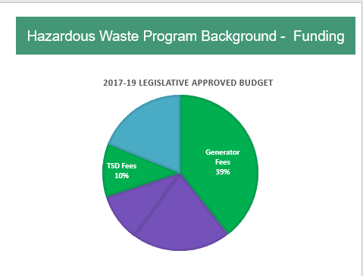

* As we presented during our January EQC pre-inform presentation, like other programs at DEQ, our Hazardous Waste Program is largely supported by fees.
* Annually, DEQ receives approximately $3.5 million from multiple sources. Of that total, approximately 80% are in fees -- and 20% in federal grant dollars.

**(CLICK)**

* Today, we are proposing to only increase the Generator and TSD Fees, highlighted in green.
* For many years, we have run a lean program by seeking efficiencies and cost-saving measures, including: Shifting more to electronic reporting and invoicing, delaying hiring, eliminating positions, and reducing overhead expenses.
* Now, we are operating at a deficit and eroding our ending fund balance. Without additional revenue, the program will continue to experience an annual deficit and will need to consider further reductions by December 2019.
* Several factors contributed to this deficit:
  + **First**, most of our program fees have remained unchanged for over a decade without adjustment for inflation or increased program costs, which include, salaries, benefits and information technology updates. The proposed Generator and TSD Fees have remained unchanged since the late 1990’s.
  + **Second,** the program has experienced decreases in funding. For example, since 2004, the Hazardous Waste Program tipping fee has decreased by approximately 60%. And, since 2008, DEQ’s EPA grant has decreased by 7%.
  + **And third**, we have experienced a significant change in state revenue. The program received $1.2 million in state General Funds in 1999. Since then, the amount of General Fund allocation steadily declined until its elimination in 2015. **[CLICK]**

**--------------------------**

**Potential Questions:**

* **Is Land Quality interested in receiving general funds again?** *Ans: It is an agency allocation decision for those state funds received. In the past, other programs in air and water have had higher priority funding needs.*
* **Is this an urgent concern, why were we not made aware of the issue earlier? Are we being asked to rubber stamp a fee increase?** *Ans:* *Trend towards fee-based programs. Many entities pay fees associated with several DEQ programs (e.g. land, air , water) and DEQ had to make tough decisions about which fee increases to prioritize to not overburden the regulated community. Now, due to program need, it’s Hazardous Waste Program’s time to request fee increases*.  *No, we are not asking for a rubber stamp, but your help in address this issue.*
* **What is the relationship between hazardous waste work/fees and GHG goals for waste reduction?** *Direct to Director Whitman.*

**--------------------------**

**Potential Questions:**

* **Is Land Quality interested in receiving general funds again?** *Ans: it is an agency allocation decision for those state funds received, in the past other programs such as air and water had high priority funding needs.*
* **Is this an urgent concern, why were we not made aware of the issue earlier? Are we being asked to rubber stamp a fee increase?** *Ans:* *Trend towards fee-based programs. Many entities pay fees associated with several DEQ programs (e.g., land, air, water) and DEQ had to make policy decisions about which fee increases to prioritize in order to not overburden the regulated community. Now is the hazardous waste program time to request fee increases*.  *No, we are not asking for a rubber stamp, but your help in address this issue.*

**What is the relationship between hazardous waste work/fees and GHG goals for waste reduction?** *Direct to Director Whitman.*

**Slide 3**

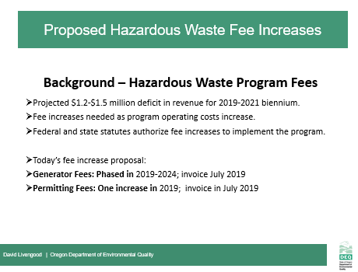

* Today, we face a projected $1.2 to $1.5 million deficit in Hazardous Waste Program revenue for the 2019-2021 biennium.
* This shortfall threatens DEQ’s ability to ensure safe management and disposal of hazardous waste and greatly reduces compliance assistance to small businesses. Also, the deficit potentially impacts Oregon’s ability to maintain the state’s status as a federally-authorized hazardous waste program.
* DEQ last increased the Hazardous Waste fee cap and per metric ton fees in 2007. *[Both 2007 fees increased 18%: Cap from $27,500 to current $32,500 & Metric ton from $110 to current $130 per metric ton]*  However, the fees rules we are proposing have not increased since 1998.
* The two types of fee increases that we are proposing today will help support our current staffing level and meet our core commitments to Oregon and to EPA:
* First, we are proposing increases to two existing hazardous waste generator fees:
  + Annual hazardous waste generators activity verification fees, and
  + Annual hazardous waste generators management method fee factors

[PAUSE]

* + If implemented, these proposed fee increases will impact approximately 500 businesses and organizations in Oregon that currently pay hazardous waste fees. For us to minimize impact on our fee-paying generators, we are proposing to phase in these fee increases over several years.
* Second, we are proposing to change the permitted fees for Treatment Storage and Disposal (TSD) fee structure, including:
  + An increase in annual compliance determination fees (TSD annual base fee for treatment, storage and disposal activities)
  + An increase to Permit Modification fees, and
  + An addition of an operating permitted disposal administrative fee (for permitted facilities disposing solid and hazardous wastes in Oregon, either by land unit such as in a permitted SW or HW landfillor surface impoundment such as apermitted surface lagoon.

[PAUSE]

* + These TSD fees will apply to two operating treatment, storage and disposal facilities in Oregon, and we are proposing one fee increase in 2019. **[CLICK]**

**Slide 4**

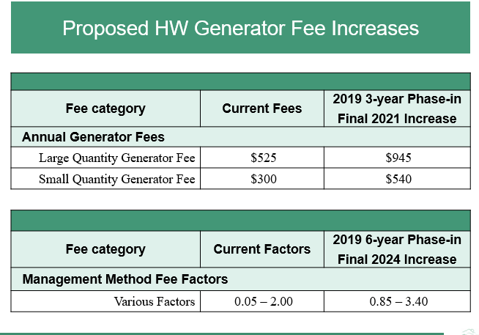

* This table illustrates our hazardous waste annual generator fee and management method fee factors.
* DEQ is proposing to increase the annual base fee that all hazardous waste generators pay over three years – from the current fee of $300 per year for small quantity generators (also known as SQGs) and $525 per year for large quantity generators (also known as LQGs) to $540 for SQGs and $945 for LQGs by 2021.
  + This phased-in fee increase will impact less than 500 small and large quantity generators in Oregon.

**[PAUSE]**

* Next, DEQ is proposing to increase the management method fee factors that we apply to fee calculations for small and large quantity generators depending on which method they use to dispose of their hazardous waste. The management method factors reflect Oregon’s environmental hierarchy of preferred management methods, ranging from a preference for recovery of valuable materials like metals and solvents to less environmentally-preferable options such as land disposal.
* You can find a full description of the management method factors and their impact on our hazardous waste generator fee structure on **pages 13 and 16,** respectively, of our of our Hazardous Waste Fees 2019 Staff Report.
* For the purpose of this presentation, we wanted to highlight our current management method factors range from .50 to 2.00 and, with the adoption of the proposed hazardous waste fee increase, we will phase in multiple increases to these fee factors over six years to reduce impact to generators.
* By 2024, our management method fee factors will range from .85 to 3.40 for the various management methods outline in your Staff Report.
* **[PAUSE]**
* Together, fee increases will bridge our projected deficit and support safe management and disposal of wastes in Oregon by keeping our staffing at current levels. **[CLICK]**

**Slide 5**

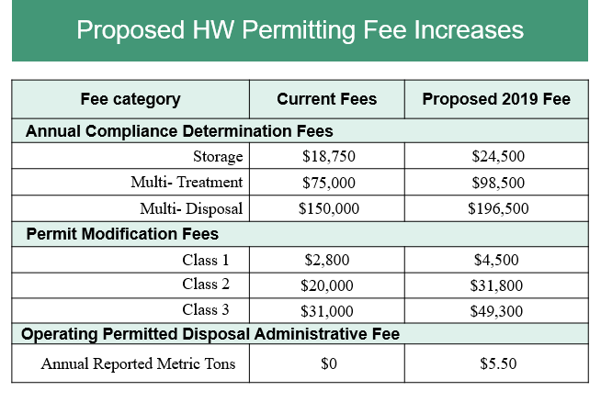

* You can find a full description of the proposed permitting fee increase and their impact on our hazardous waste generator fee structure on **pages 14 and 16,** respectively, of our Hazardous Waste Fees 2019 Staff Report. **MOVED, work?**
* This table shows various Treatment, Storage and Disposal (or, TSD) fee categories – from Annual Compliance Determination, to Permit Modification Fees, as well as a new proposed category of Operating Permitted Disposal Administrative Fee. We propose to implement all of the fee increases in 2019.
* All permitted hazardous waste TSD facilities with operating hazardous waste units are subject to Annual Compliance Determination fees. We propose increasing the annual compliance determination base fees for storage, treatment and disposal. We list here just three of the proposed annual compliance determination fee increases DEQ currently charges annually. Where more than one hazardous waste management activity occurs at a single facility, DEQ charges a fee for each activity as reflected here in the chart.
* **[PAUSE]**
* Also, we propose to increase the Permit Modification fees for Classes 1, 2 and 3 modifications. This proposal streamlines the current multiple permit modification classifications to just one fee per class. The range is Class 1 as the simplest permit modification to class 3 as the most complex requiring significant review. These fees are an inconsistent source of revenue since we only assesses fees when permittees request a modification.
* **[PAUSE]**
* Finally, we propose to add a new Operating Permitted Disposal Administrative fee of $5.50 per metric ton for waste TSDs dispose in solid waste and hazardous permitted land units in Oregon. **Note: New admin fee affects only one operating permitted disposal facility in Oregon.**
* Together, these proposed fee increases will help align our hazardous waste permit fees with the Consumer Price Index and our needs to administer the program. **[CLICK]**

**Slide 6**

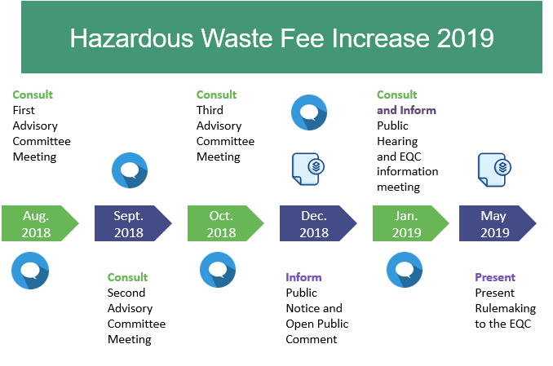

* This calendar reflects ourwork-to-date for this rulemaking. The blue circles represent our public engagement process, and the blue paper stacks represent documents we developed in support of this rulemaking.
* As mentioned earlier, from the beginning, we were aware of many of the potential impacts this rulemaking would potentially have on businesses producing hazardous waste, as well as the permitted facilities in Oregon that treat, store and dispose hazardous waste.
* During the past year, we have sought stakeholder input to help us better understand impacts.
* In fall 2018, we received input on the rulemaking from a nine-member advisory committee comprised of statewide stakeholders, including representatives of small and large businesses, business advocates, education, and environmental interests.
  + The advisory committee met three times (in Aug, Sept, and Oct) to discuss the pros and cons associated with the proposed rules, as well as the anticipated fiscal impacts on Oregon’s businesses.
  + While there will be impacts, the Committee did not identify significant adverse impacts on Oregon small businesses as a result of our proposed fee increase. The committee expressed support for the proposed fees increase to maintain DEQ Hazardous Waste Program’s current servicelevel. The Committee also supported the concept of phasing-in fee increases for those affected hazardous waste generators.
* We published public notice for the proposed rulemaking on December 14, 2018.
* On January 17, 2019, we held a public hearing in Portland *(6-8pm)*. The public comment period ended at 4pm on January 22, 2019, and we received no comments.
* *Because we did not receive comments during the public comment period, we did not make changes to the proposed rules.*
* In addition to the elements to this rulemaking timeline **[point to/glance at screen],** we would also like to note that today’s proposed rulemaking is the first phase of an anticipated multi-phase effort to fully address our funding deficit. The phases will help fund the program to at least 2026.
* To secure long-term, stable funding, including the fees increases proposed in this rulemaking package, we must seek legislative changes -- ideally during 2023 legislative session. This would help build the next piece of our funding bridge, allowing us to continue the current level of service covering our hazardous waste generators and permitted businesses in Oregon.

------------------------------------------------------------------------------------------------------------------------------

**Notes:**

We notified 23,744 interested people by GovDelivery bulletins, emails and US mail about the advisory committee meetings, public comment period and public hearing. Our distribution list for this information

Includes notification of 1,014 hazardous waste generators who reported to DEQ within the last three years

DEQ held a public hearing on Jan 17, 2018. 2 interested people attended the public hearing in person and an unknown number by phone.

* Potential Question: Be prepared to answer what we may propose to change via statute:
  + hazardous waste generator fee cap **$32,500**: Est 1992

1997 Cap $15,000 to $22,500

2003 Cap $22,500 to $27,500

2007 Cap $27,500 to $32,500

* + per metric ton fee **$130** : Est 1992

1997 $60 to $90

2003 $90 to $110

2007 $110 to $130

**Slide 7**

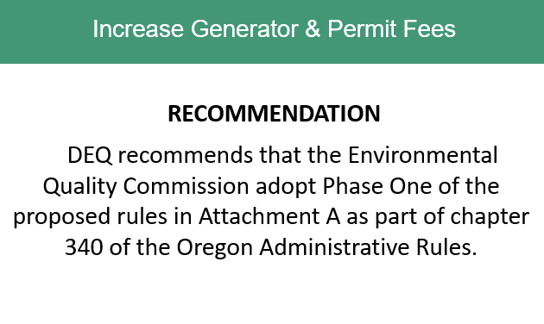

* In conclusion, DEQ recommends the Environmental Quality Commission adopt the proposed rules in Attachment A as part of chapter 340 of the Oregon Administrative Rules.
* Chair George and Commissioners, thank you for your consideration of the information we presented today, and for addressing the Hazardous Waste Program’s funding needs.
* We welcome any additional questions you may have about the program, rulemaking background, and our plans moving forward. (PAUSE)

(Wait for EQC actions)

**Thank you, Commissioners.**

**Slide 8**

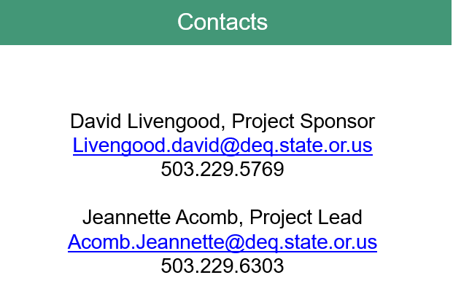

No script