**May EQC HW Fees Presentation Script**

**Slide 1**

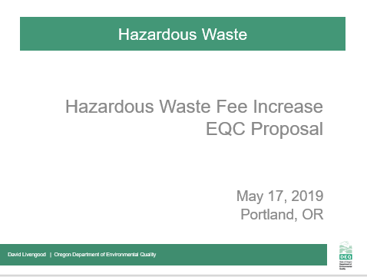

* Good morning Chair George and commissioners, my name is David Livengood– I manage DEQ’s Hazardous Waste and Tanks program out of DEQ’s headquarters office in Portland, OR.
* Today, I am joined by my colleague, Jeannette Acomb, whom you met in January when she presented background on the Hazardous Waste Program’s program structure and budgetary outlook in preparation for today’s rulemaking presentation to the EQC.
* Jeannette and I are here today to present a proposed rule to increase hazardous waste generator and Treatment, Storage and Disposal fees in Oregon for the first time in a generation. Throughout the process of developing this proposed rule, we have been aware of the potential impact on our stakeholder community and we have sought input on potential impacts from a variety of stakeholders.
* Today’s proposal represents both staff analysis as well as Advisory Committee input. I’m looking forward to sharing the details of our proposal and implementation timeline with you.
* I welcome your questions and thoughts as we move through the presentation.

**Slide 2**

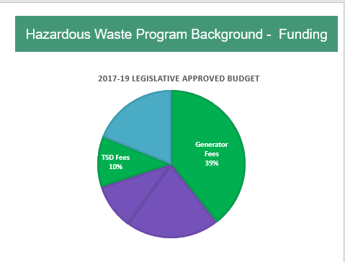

* Like other programs at DEQ, our Hazardous Waste Program is largely supported by fees.
* Annually, DEQ receives approximately $3.5 million from multiple sources. Of that total, approximately 80% are in fees, and 20% in federal grant.
  + (CLICK) For our purposes today, we are especially interested in increasing the Generator and TSD Fees, now highlighted in green. Increases to both these fees is included in this rulemaking proposal.
* For many years, we have run a lean program by seeking efficiencies and cost-saving measures including: delaying hiring, eliminating positions, and reducing overhead expenses.
* Now, in spite of these efforts, we are operating at a deficit and eroding our ending fund balance. Without additional revenue, the program will continue to experience an annual deficit and will need to consider further cost reductions by December 2019.
* Several factors contributed to this deficit:
  + **First**, most of our program fees have remained unchanged for over a decade without adjustment for inflation or increased program costs which include, salaries, benefits and information technology updates. The proposed Generator and TSD Fees have remained unchanged since the late 1990s.
  + **Second,** the program has experienced decreases in funding. For example, since 2004, the Hazardous Waste Program tipping fee has decreased by approximately 60 percent. And, since 2008, DEQ’s EPA grant has decreased by 7%.
  + **And third**, we have experienced a significant change in state revenue. The program received $1.2 million in state General Funds in 1999. Since then, the amount of General Fund allocation steadily declined until its elimination from hazardous waste funding in 2015.

**--------------------------**

**Potential Questions:**

* **Is Land Quality interested in receiving general funds again?** *Ans: it is an agency allocation decision for those state funds received, in the past other programs such as air and water had high priority funding needs.*
* **Is this an urgent concern, why were we not made aware of the issue earlier? Are we being asked to rubber stamp a fee increase?** *Ans:* *Trend towards fee-based programs. Many entities pay fees associated with several DEQ programs (e.g., land, air, water) and DEQ had to make policy decisions about which fee increases to prioritize in order to not overburden the regulated community. Now is the hazardous waste program time to request fee increases*.  *No, we are not asking for a rubber stamp, but your help in address this issue.*

**What is the relationship between hazardous waste work/fees and GHG goals for waste reduction?** *Direct to Director Whitman.*

**Slide 3**

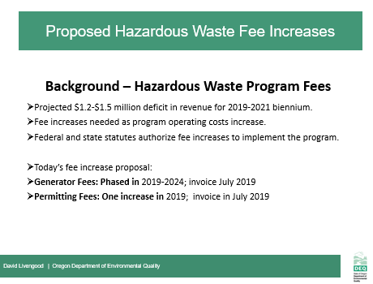

* First, we are proposing increases to two existing hazardous waste generator fees:
  + Annual hazardous waste generators activity verification fees, and
  + Annual hazardous waste generators management method fee factors

[PAUSE]

* + If implemented, these proposed fee increases will impact approximately 500 businesses and organizations in Oregon that currently pay hazardous waste fees. In order to minimize impact on our fee-paying generators, we are proposing to phrase-in these fee increases over several years’ time.
* Second, we are proposing to change the permitted fees for Treatment Storage and Disposal (TSD) fee structure, including:
  + An increase in annual compliance determination fees (TSD annual base fee for treatment, storage and disposal activities)
  + An increase to Permitting modification fees, and
  + An addition of an operating permitted disposal administrative fee (for facilities disposing wastes in Oregon, either by land unit or surface impoundment)

[PAUSE]

* + These TSD fees will apply to two operating treatment, storage and disposal facilities in Oregon, and we are proposing one fee increase in 2019.

**Slide 4**

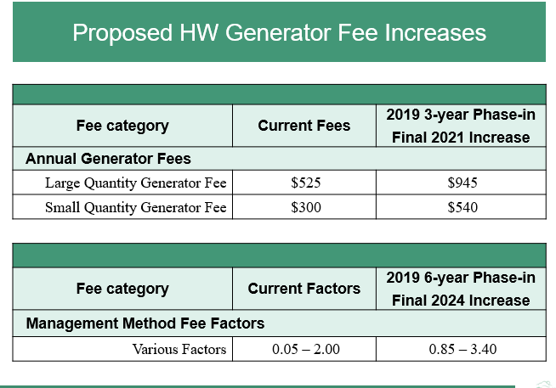

* This table illustrates our hazardous waste annual generator fee and management method fee factors.
* DEQ is proposing to increase the annual base fee that all hazardous waste generators pay over a period of three years– from the current fee of $300 per year for small quantity generators (also known as SQGs) and $525 per year for large quantity generators (also known as LQGs) to $540 for SQGs and $945 for LQGs by 2021.
  + This phased-in fee increase will impact less than 500 small and large quantity generators in Oregon.
* Next, DEQ is proposing to increase the management method fee factors that we apply to fee calculations for small and large quantity generators depending on which method they use to dispose of their hazardous waste. The management method factors reflect Oregon’s environmental hierarchy of preferred management methods, ranging from a preference for recovery of valuable materials like metals and solvents to less environmentally preferable options such as land disposal.
* You can find a full description of the management method factors and their impact on our hazardous waste generator fee structure on **pages 13 and 16,** respectively, of our of our Hazardous Waste Fees 2019 Staff Report.
* For the purpose of this presentation, we wanted to highlight that our current management method factors range from .50 to 2.00 and, if the proposed hazardous waste fee increase is finalized, we will phase in multiple increases to these fee factors over a period of six years.
* By 2024, our management method fee factors will range from .85 to 3.40 for the various management methods outline in your Staff Report.
* Together, fee increases will bridge our projected deficit and support safe management and disposal of wastes in Oregon by keeping our staffing at current levels.

**Slide 5**

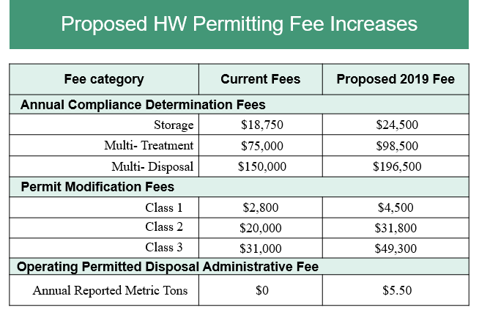

* This table shows various Treatment, Storage and Disposal (or, TSD) fee categories – from Annual Compliance Determination, to Permit Modification Fees, as well as a new proposed category of Operating Permitted Disposal Administrative Fee. We propose to implement all of the fee increases in 2019.
* All permitted hazardous waste TSD facilities with operating hazardous waste units are subject to annual compliance determination fees. We propose increasing the annual compliance determination base fees for storage, treatment and disposal. We list here just three of the proposed annual compliance determination fee increases which DEQ currently charges annually. Where more than one hazardous waste management activity occurs at a single facility, DEQ charges a fee for each activity as reflected here in the chart.

You can find a full description of the proposed permitting fee increase and their impact on our hazardous waste generator fee structure on **pages 14 and 16,** respectively, of our Hazardous Waste Fees 2019 Staff Report.

* We also propose to increase the permit modification fees for Classes 1, 2 and 3 modifications. This proposal streamlines the current multiple permit modification classifications to just one fee per class. Class 1 is designated as the simplest permit modification, and class 3 as the most complex modification requiring significant review. These fees are not a consistent source of revenue because DEQ only assesses fees when permittees request a modification.
* Finally, we propose to add a new operating permitted disposal administrative fee of $5.50 per metric ton for waste TSDs dispose in solid waste and hazardous permitted land units in Oregon.
* Together, these proposed fee increases will help align our hazardous waste permit fees with the Consumer Price Index and our cost in administering the program.

**Notes**

**New admin fee affects only one operating permitted disposal facility in Oregon.**

**Slide 6**

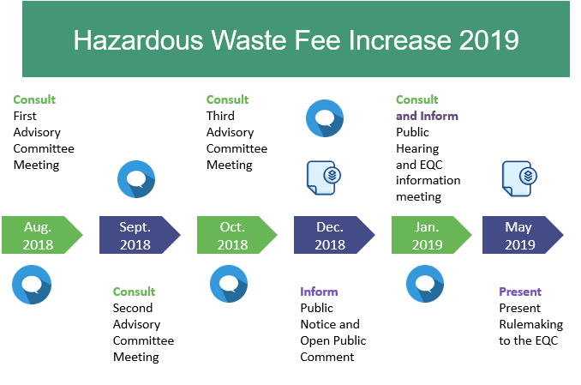

* The calendar before you reflects ourwork-to-date on this rulemaking. The blue circles represent our public engagement process, and the blue paper stacks represent the documents that we developed in support of this rulemaking.
* As I mentioned earlier in the presentation, from the begin of this process, we were aware of the potential impact this rulemaking would have on businesses that generate hazardous waste, as well as those permitted facilities that Treat, Store and Dispose of hazardous waste in Oregon.
* During the past year, we have sought stakeholder input to help us understand that impact.
* This past fall, we sought input on the rulemaking from a nine-member advisory committee comprised of statewide stakeholders including representatives of small and large businesses, business advocates, education and environmental interests.
  + The advisory committee met three times (in Aug, Sept, and Oct) to discuss pros and cons associated with the proposed rules, as well as the anticipated fiscal impact on Oregon’s businesses.
  + While there will be impacts, the Committee did not identify significant adverse impacts on small businesses in Oregon as a result of our proposed fee increase. The committee was supportive of the proposed fee increase to maintain DEQ Hazardous Waste Program’s current servicelevel. The Committee also supported the concept of phasing-in fee increases for generators.
* We published the public notice for the proposed rulemaking on December 14, 2018 and on January 17, 2019 we held a public hearing in Portland *(6-8pm)*. The public comment period ended 4pm Jan 22, 2019 and we received no comments.
* *Because we did not receive comments during the public comment period, we did not make changes to the proposed rules.*
* In addition to the elements of the rulemaking timeline that you see represented here, we would also like to note that today’s proposed rulemaking is the first phase of an anticipated multi-phase effort to fully address our funding deficit by 2026.
* To secure long-term, stable funding, in addition to increasing fees by rulemaking, we must also seek additional changes under statutory authority within the next several years in order to completely bridge our projected deficit and allow us to continue the current level of service to our hazardous waste generator and TSD community in Oregon.

------------------------------------------------------------------------------------------------------------------------------

**Notes:**

We notified 23,744 interested people by GovDelivery bulletins, emails and US mail about the advisory committee meetings, public comment period and public hearing. Our distribution list for this information

Includes notification of 1,014 hazardous waste generators who reported to DEQ within the last three years

DEQ held a public hearing on Jan 17, 2018. 2 interested people attended the public hearing in person and an unknown number by phone.

* Potential Question: Be prepared to answer what we may propose to change via statute:
  + hazardous waste generator fee cap **$32,500**: Est 1992 1997 Cap $15,000 to $22,500

2003 Cap $22,500 to $27,500

2007 Cap $27,500 to $32,500

* + per metric ton fee **$130** : Est 1992

1997 $60 to $90

2003 $90 to $110

2007 $110 to $130

**Slide 7**

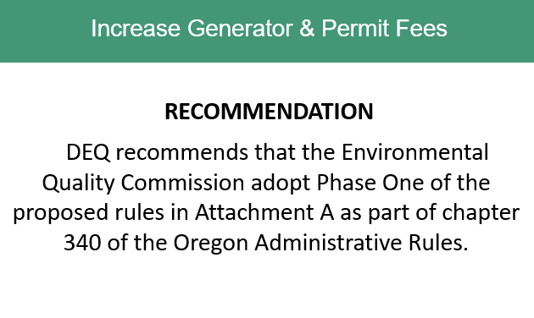

* In conclusion, DEQ recommends the Environmental Quality Commission adopt the proposed rules in Attachment A as part of chapter 340 of the Oregon Administrative Rules.
* Chair George and Commissioners, thank you for your consideration of the information we presented today, and for addressing the Hazardous Waste Program’s funding needs.
* We welcome any additional questions you might have about the program, rulemaking background and our plans moving forward. (PAUSE)

(Wait for EQC actions)

**Thank you, Commissioners.**

**Slide 8**

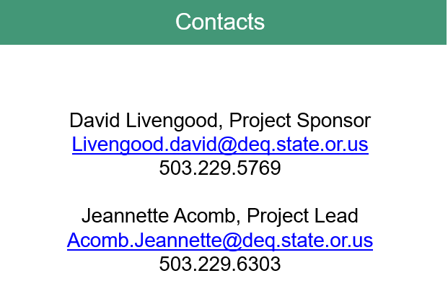

No script