**EQC HW Fees Presentation Script**

**Slide 1**

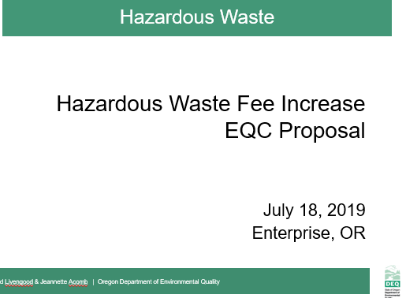

* **David Livengood**
* Good morning Chair George and commissioners, my name is David Livengood. I manage DEQ’s Hazardous Waste and Tanks program from headquarters in Portland.
* Today, I am joined by my colleague, Jeannette Acomb, whom you met in January when she presented background on the Hazardous Waste Program’s structure and budget outlook in preparation for today’s rulemaking presentation.
* Jeannette and I are here to present proposed rules to increase these hazardous waste generator and Treatment, Storage and Disposal fees in Oregon for the first time in approximately 20 years. Throughout the process of developing the proposed rules before you today, we have been aware of the potential impact on our regulated stakeholder community. In fact, we asked for feedback and received ideas from some of those stakeholders.
* **[CLICK]**

**Slide 2**

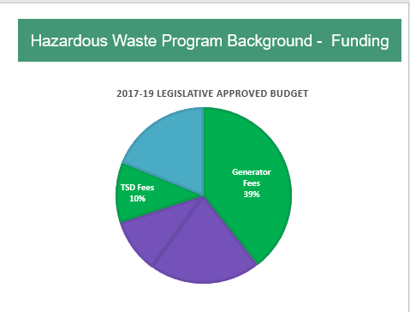

**David Livengood**

* As we presented during our January EQC pre-inform presentation, like other programs at DEQ, our Hazardous Waste Program is largely supported by fees.
* Annually, DEQ Hazardous Waste Program receives approximately $3.5 million from multiple sources. Of that total, approximately 80% are in fees -- and 20% in federal grant dollars.
* Today’s proposed rule changes represent in-depth staff analyses, as well as Advisory Committee input.
* **For the purpose of this rulemaking, we used these figures. (CLICK)**
* Today, we are proposing to only increase the Generator and TSD Fees, highlighted in green.
* For many years, we have run a lean program by seeking efficiencies and cost-saving measures, including: Shifting more to electronic reporting and invoicing, delaying hiring, eliminating positions, and reducing overhead expenses.
* Now, our expenses are overrunning our revenue, thus eroding our ending fund balance. Without additional revenue, our program will continue to dwindle the ending fund balance. We estimate by December of this year, and we will need to consider further reductions, which will adversely impact our current services.
* Several factors contributed to this deficit:
  + **First**, most of our program fees have remained unchanged for over a decade -- without adjusting for inflation or increased program costs. These costs include salaries and benefits – by far our largest expenses -- and information technology updates. The proposed Generator and TSD fee increases we are proposing have remained unchanged since the late 1990’s.
  + **Second,** the program has had revenue decreases. For example, since 2004, the Hazardous Waste Program tipping fee has decreased by approximately 60%. And, since 2008, our portion of an EPA grant decreased 7%.
  + **And third**, we have experienced a significant change in state revenue. The program received $1.2 million in state General Funds in 1999. Since then, our General Fund allocation steadily declined until its’ elimination in 2015. **[CLICK]**

**--------------------------**

**Potential Questions:**

* **Is Land Quality interested in receiving general funds again?** *Ans: It is an agency allocation decision for those state funds received. In the past, other programs in air and water have had higher priority funding needs.*
* **Is this an urgent concern, why were we not made aware of the issue earlier? Are we being asked to rubber stamp a fee increase?** *Ans:* *Trend towards fee-based programs. Many entities pay fees associated with several DEQ programs (e.g. land, air , water) and DEQ had to make tough decisions about which fee increases to prioritize to not overburden the regulated community. Now, due to program need, it’s Hazardous Waste Program’s time to request fee increases*.  *No, we are not asking for a rubber stamp, but your help in address this issue.*
* **What is the relationship between hazardous waste work/fees and GHG goals for waste reduction?** *Direct to Director Whitman.*

**Slide 3**

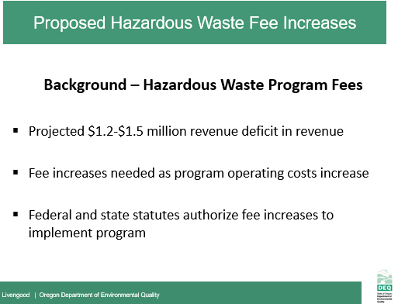

**David Livengood**

* + Today, we face a projected $1.2 to $1.5 million revenue deficit in the 2019 - 2021 biennium.
  + This shortfall threatens DEQ’s ability to ensure safe management and disposal of hazardous waste via inspections and complaint responses, and greatly reduces compliance assistance to small businesses.
  + The deficit potentially impacts Oregon’s ability to maintain the state’s status as a federally-authorized program.
  + **We are looking to regain our legislatively-approved budget service level of staff – and not add staff through this rulemaking.**
  + **[CLICK]**

~~~~~~

Notes

* + DEQ last increased the Hazardous Waste fee cap and per metric ton fees in 2007 through by way of statutory changes. However, the fees we are proposing have not increased since 1998

**Slide 4**

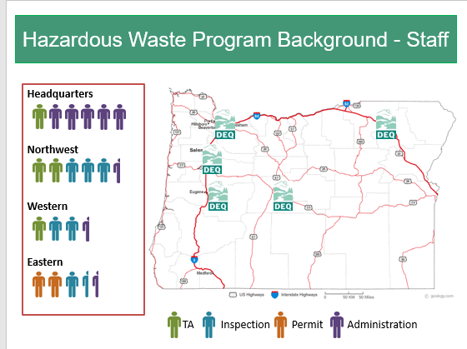

**David Livengood**

* We have 19 regional and headquarters staff working with approximately 500 generators (aka businesses producing hazardous waste) throughout the state.
* On the map we have highlighted our hazardous waste staff offices, and by color, identified the different types of work. Our program has four areas.
  + In Blue we have **6.5** Compliance and Enforcement staff who inspect each of Oregon’s generators every three years.
  + In Green we have **4** technical assistance staff whowork with businesses of all sizes throughout the state to implement regulatory requirements and reduce wastes and toxic chemicals.
  + In Orange we have **2** permitting and Corrective Action staff who are responsible for permitting, corrective action, and compliance activities in Oregon.
  + And in Purple we have **6.5** Administrationstaff who coordinate the program, perform mandatory tracking and reporting of data to EPA, invoicing, policy analysis and implementing state rules such as the federal rule adoptions and the recent delisting.
* Our program is legislatively approved for 25 staff. However, due to current funding levels, the program has 3 vacancies. These vacancies include 2 field inspectors, and 1 permit writer *(LAB 2019-2021 25.44)*

---------------------------------------------------------------------------------------------------

**Potential Questions & Notes:**

* **What would happen if we chose to inspect every 5 years (EPA requirement), instead of every 3 years (DEQ standard)?**
* You have more program administration staff than other types of core staff. Is it possible to put more FTE towards technical assistance and inspection work and less staff towards program administration?
* 7 permitted sites – Baron Blakeslee *(Portland)*, Evanite Fiber Corp *(Corvallis)*, Lockheed (*The Dalles)*, Permapost Products Co (*Hillsboro)*, Tektronix Inc *(Beaverton)*
* 2 Operating TSDs – Chemical Waste of Northwest, Safety-Kleen, Inc
* corrective actions sites - Boeing of Portland, Cascade Wood Products, Columbia Helicopters, Evraz Oregon Steel, JH Baxter & Co. – Eugene, Marion County Road Dept., Mew Data Arms (MDA), NW Industries Pacific Fabricators, Potter Manufacturing, Roseburg Forest Products – Dillard, Safety-Kleen – Springfield, Taylor Lumber & Treating Inc., Teledyne Wah Chang Albany, Univar, Velco, Inc. (Former)

(*It is worth noting that while we only have two operating permitted TSDs, DEQ’s data shows sometimes it can cost up to $140,000 in staff hours per complex permit modification.)*

**Slide 5**

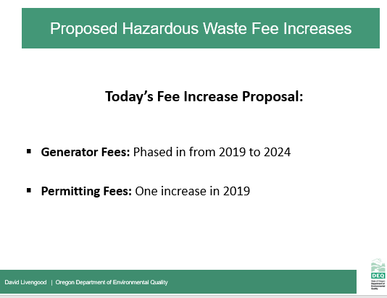

**David Livengood**

* The two types of fee increases that we are proposing today will help support and meet our core commitments to Oregon and EPA:
* First, we are proposing increases to two existing hazardous waste generator fees:
  + Annual hazardous waste generators activity verification fees, and
  + Annual hazardous waste generators management method fee factors

[PAUSE]

* + If implemented, these proposed fee increases will impact the approximately 500 businesses and organizations in Oregon currently paying hazardous waste fees. As a way to moderate the impact to our fee-paying generators, we are proposing to phase in these fee increases over several years.
* Second, we are proposing to change the permitted fees for Treatment Storage and Disposal (TSD) fee structure.

And now, I will hand off to Jeannette, who will give a breakdown and explanation of each proposal.

~~~~~~~~~~

Notes

*Both 2007 fees increased 18%: Cap from $27,500 to current $32,500 & Metric ton from $110 to current $130 per metric ton*

**Slide 6**

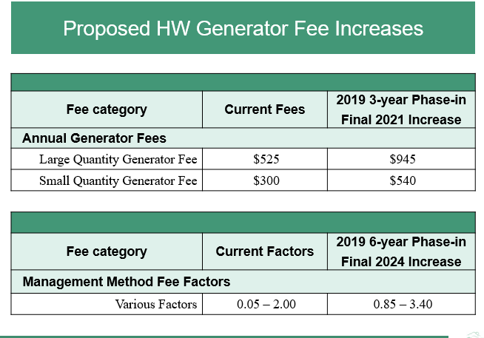

**Jeannette Acomb**

Thank you, David.

* This table illustrates our Hazardous Waste Annual Generator Fee and Management Method Fee Factors. In our Staff Report on page 13, you can see a full breakdown of these fees and their impact to generators.
* We are proposing to increase the Annual Base Fees all hazardous waste generators pay. These fees will incrementally increase over three years - changing the current fee for Large Quantity Generators from $525 to $945, and for small quantity generators from $300 to $540 by 2021.
  + This phased-in fee increase will impact less than 500 small and large quantity generators in Oregon. As of Oct 2018. we had 197 large and 272 small quantity generators

**[PAUSE]**

* Next, DEQ proposes to increase the Management Method Fee Factors, which are part of the Base Annual Fees.
* The Management Method Factors reflect Oregon’s environmental hierarchy of preferred management methods, ranging from a low factor giving preference to recovery of valuable materials, like metals and solvents -- to a high factor for less environmentally-preferable options, such as land disposal.
* As you can see, the current factors range from .5 to 2. By 2024, the factors will range from .85 to 3.4.
* We will phase in the factor fee increases as six annual increases to mitigate the overall impact to generators giving ample time to budget for the incremental increases. The Advisory Committee favored this approach.

**[PAUSE]**

* Together, fee increases will bridge our projected deficit and support safe management and disposal of wastes in Oregon, allowing us to hire and begin to bring our staffing up to legislatively-approved levels.

**[CLICK]**

**Slide 7**

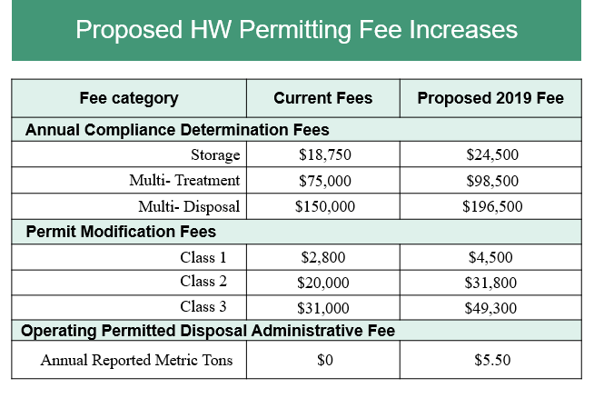

**Jeannette Acomb**

* We now shift to our proposed permitting fee increases and a new fee.
* On page 14 of our Staff Report, there is a full description of these proposed fees and the potential fiscal impacts.
* In this table, we show the Hazardous Waste Permitted Treatment, Storage and Disposal (or, TSD) fee categories **(PAUSE)** –--- from the top Annual Compliance Determination, to Permit Modification Fees, and to our new, proposed category called Operating Permitted Disposal Administrative Fee.
* In Oregon, all operating permitted hazardous waste TSD’s are subject to our Annual Compliance Determination Fees.
* We propose increasing the Annual Compliance Determination Fees for treatment, storage and disposal. We show the three current Annual Compliance Determination Fees DEQ charges annually. DEQ charges a fee for each activity, as reflected in the chart. **Of our two operating, permitted TSD facilities in Oregon: one facility stores hazardous waste only and the other treats, stores and disposes of hazardous wastes and the applicable fees apply.**
* **[PAUSE]**
* Next, we propose to increase the Permit Modification Fees. These fees are broken down into three classes currently based on DEQ work level is to modify the permit. Class 1 modifications are the simplest and class 3 as the most complex requiring significant review. Our proposal also streamlines to just one fee per class. These fees are an inconsistent source of revenue since the fees are only assessed when permittees request a modification.
* **[PAUSE]**
* Finally, we propose a new Operating Permitted Disposal Administrative fee of $5.50 per metric ton. DEQ will assess fees for waste disposed into a permitted Subtitle C land disposal unit.
* At $5.50 per ton this fee could potentially bring in $400, 000 annually in additional revenue. *(90,000 tons)*
* Together, these proposed fee increases will help align our hazardous waste permit fees with the Consumer Price Index and help us meet our program administration costs.
* We propose implementing all of these permitting fee increases in 2019.
* **Now, I will return the presentation back to David. [CLICK]**

~~~~~~~~~~~~~~~~~~~

* Fee increases including:
  + An increase in annual compliance determination fees (TSD annual base fee for treatment, storage and disposal activities)
  + An increase to Permit Modification fees, and
  + An addition of an operating permitted disposal administrative fee for permitted facilities disposing solid and hazardous wastes in Oregon Detail , either by land unit such as in a permitted SW or HW landfillor surface impoundment such as apermitted surface lagoon.
  + These TSD fees will apply to two operating treatment, storage and disposal facilities in Oregon, and we are proposing one fee increase in 2019. **[CLICK]**

**Slide 8**

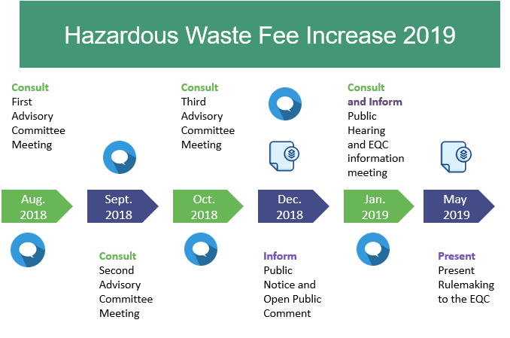

**David Livengood**

* This calendar reflects ourwork-to-date for this rulemaking. The blue circles represent our public engagement process, and the blue paper stacks represent documents we developed in support of this rulemaking.
* As mentioned earlier, from the beginning, we were aware of many of the potential impacts this rulemaking would have on businesses producing hazardous waste, as well as the permitted facilities in Oregon that treat, store and dispose hazardous waste.
* During the past year, we sought stakeholder input, primarily from a 9-member advisory committee. The nine-member advisory committee was comprised of statewide stakeholders, including representatives of small and large businesses, business advocates, education, and environmental interests meet three times (in Aug, Sept, and Oct).
* Topics covered ranged from type of fee increases, amount of fees, and the current service needed to help us better understand impacts. Stakeholder supported and agreed to our current service level, and on which fees to change and how to change them to mitigate impacts.
* During the meetings, the committee discussed impacts on Oregon’s hazardous waste management and the anticipated fiscal impacts on Oregon’s. While there will be impacts, the Committee did not identify significant adverse impacts on Oregon small businesses as a result of our proposed fee increases. The committee expressed support for the proposed fees increase to maintain DEQ Hazardous Waste Program’s current servicelevel. The Committee also supported the concept of phasing-in fee increases for affected hazardous waste generators.
* Next on the chart, we published public notice for the proposed rulemaking on December 14, 2018.
* And on January 17, 2019, we held a public hearing in Portland. The public comment period ended January 22, 2019, and we received no comments.
* Today, we are seeking your approval for phase 1 of our fee increase rulemaking effort.
* Phase 2 involves statutory changes followed by additional rulemaking with a goal to secure program funding through 2026.
* If you approve Phase 1 today, we will send out invoices to our regulated businesses and organizations within the next 30 days. We have been keeping them informed of our fee increase activities as a courtesy.

--------------------------------------------------------------------------------------------------------------------------------------------------

**Notes: (6-8 pm Hearing)**

We notified 23,744 interested people by GovDelivery bulletins, emails and US mail about the advisory committee meetings, public comment period and public hearing. Our distribution list for this information

Includes notification of 1,014 hazardous waste generators who reported to DEQ within the last three years

DEQ held a public hearing on Jan 17, 2018. 2 interested people attended the public hearing in person and an unknown number by phone.

* Potential Question: Be prepared to answer what we may propose to change via statute:
  + hazardous waste generator fee cap **$32,500**: Est 1992 1997 Cap $15,000 to $22,500

2003 Cap $22,500 to $27,500

2007 Cap $27,500 to $32,500

* + per metric ton fee **$130** : Est 1992 1997 $60 to $90

2003 $90 to $110

2007 $110 to $130

* In addition to the elements to this rulemaking timeline **[point to/glance at screen],** we would also like to note that today’s proposed rulemaking is the first phase of an anticipated multi-phase effort to fully address our funding deficit. The phases will help fund the program to at least 2026.
* To secure long-term, stable funding, including the fees increases proposed in this rulemaking package, we must seek legislative changes -- ideally during 2021 legislative session. This would help build the next phase of our funding bridge, allowing us to continue the current level of service covering our hazardous waste generators and permitted businesses in Oregon.

**Slide 9**

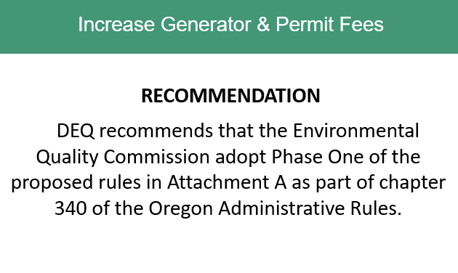

**David Livengood**

* In conclusion, DEQ recommends the Environmental Quality Commission adopt the proposed rules in Attachment A as part of chapter 340 of the Oregon Administrative Rules.
* Chair George and Commissioners, thank you for your consideration of the information we presented today, and for addressing the Hazardous Waste Program’s funding needs.
* We welcome any additional questions you may have about the program, rulemaking background, and our plans moving forward. (PAUSE)

(Wait for EQC actions)

**Thank you, Commissioners.**

**Slide 10**

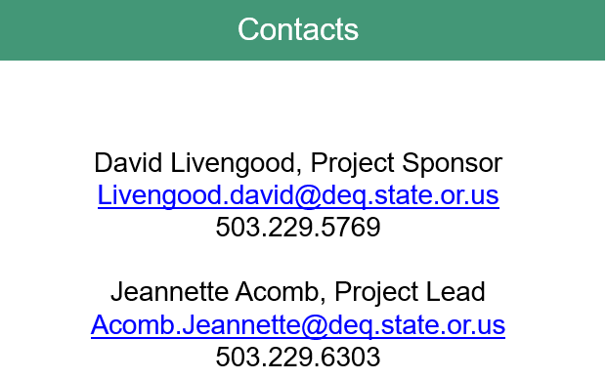

**David Livengood**