|  |  |
| --- | --- |
| LogoColorRegular.jpg | State of Oregon Department of Environmental Quality |
| Recommended Procedures for Pollution Prevention |
| Contact: Kevin Masterson  475 NE Bellevue, Suite 110  Bend, OR 97701 |

Pollution prevention seeks to reduce the quantity or toxicity of toxic pollutants at the source before they are released to the outdoor air, indoor air, water or land. These measures can include changes in material inputs, product designs or formulations, industrial processes, or production equipment. Two important tools used to reduce toxic air pollutants include pollution prevention opportunity assessments and chemicals alternatives assessment.

Pollution prevention opportunity assessments involve a detailed review of facility and process level data related to the toxic chemicals of concern. Chemical alternatives assessment is more specifically focused on identifying chemical or non-chemical replacements for a chemical of concern, which is one approach for reducing toxic pollution at the source. This overview provides a high level summary of the fundamental considerations and components of toxics pollution prevention and chemical alternatives assessments. The details of either assessment are dependent on the nature of each facility’s chemical use profile and industrial processes. The resources listed below can provide additional help.

# Toxics Pollution Prevention Assessment Considerations

The basic steps in conducting a pollution prevention assessment entail a detailed review of facility and process level data, the identification of pollution prevention options based on the data reviews, and the technical and economic feasibility analysis of those options.

Process level assessments involve characterizing individual facility processes to understand the flow of materials. A process flow diagram is a visual representation of the movement of the toxic chemical(s) through the processes within a facility. Process flow diagrams show the steps through which material inputs pass to form a product and the point at which toxics enter the system and leave the production unit, with identification of the inputs and outputs relevant to generation of pollutants.

https://docs.google.com/drawings/d/saZFNso6lqBsK69yUg0r64w/image?w=359&h=43&rev=1&ac=1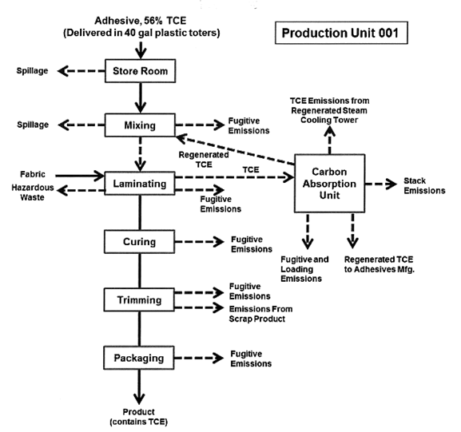

The next step would be an accounting of the toxic chemical inputs and outputs for each of the production processes that have been mapped. Materials accounting quantifies the total inputs and outputs of a particular toxic chemical in a process, and ultimately, facility-wide usage. Tracking the amount and location of material entering or leaving a product process - and the facility as a whole - helps determine where and how substances are used, where opportunities exist for reductions in use and how to quantify the costs of using toxic chemicals.

**Facility-Level Materials Accounting Summary**

|  |  |
| --- | --- |
| **Toxic Chemical Inputs (pounds)** | **Outputs (pounds)** |
| * Starting inventory | * Consumed onsite |
| * Produced on site | * Shipped off site as/in product |
| * Brought on site | * Ending inventory |
| * Recycled out-of-process and reused onsite | * Recycled out-of-process and reused on site |
|  | * Destroyed through on site treatment |
|  | * Destroyed through on site energy recovery |
|  | * Stack air emissions |
|  | * Fugitive air emissions |
|  | * Discharged to sewer or storm drain |
|  | * Land disposal on site |
|  | * Transferred off site |

Identifying toxics pollution prevention options starts with brainstorming an extensive list of ideas focused on the chemicals, by-products (outputs not in products) and processes that have been mapped and quantified. This exercise often involves a broad range of facility employees and starts without any evaluation of feasibility, to encourage creativity. Once a list of options is created, the team can evaluate each for potential to reduce pollutants of concern, feasibility of implementation and the business case, and then prioritize the optimal solutions. The categories of toxics pollution prevention options include the following:

* Chemical input substitution (e.g., use water-based cleaners instead of solvents) ***[See Chemical Alternatives Assessment Considerations below for more information]***
* Product reformulation (e.g., switch to high solids paint formulation to reduce solvent needed in paint)
* Production process redesign or modification (e.g.,  replace solvent-based strippers with mechanical processes)
* Production process modernization (e.g., install high efficiency nozzles and applicators to conserve coatings)
* Improved operations and maintenance (e.g., install lids on process tanks to reduce evaporation)
* In-process recycling (e.g., capture and recycle clean-up solvents)
* Inventory management controls (e.g., optimal order quantities to ensure use before expiration)

The technical screening and feasibility evaluation of toxics pollution prevention options involves first examining basic factors such as availability of equipment, worker skills and the impact on product quality. A more in-depth technical feasibility analysis can focus on these questions:

* What are the performance needs for the application, process or product that contains the toxic chemical for which the pollution prevention option is being sought?
* Has the option already been identified as favorable with respect to performance (i.e., by other industries)?
* Is the option available as “off-the-shelf” technology with demonstrated successful use?
* Is the option compatible with existing process technology?
* Will product quality be affected? If so, how and will it comply with customer specifications?
* Will this option be viable for a sufficiently long term?

The economic feasibility evaluation of toxics pollution prevention options is intended to determine all of the costs and savings associated with implementing the option. The questions and issues to address during an economic feasibility evaluation include:

* What are the direct costs or savings of this option? (e.g., capital investment, operations and maintenance, annual chemical costs vs. per unit cost)
* What are the hidden costs or savings with this option? (e.g., reduced worker health and safety costs, compliance cost reductions, and lower waste and by-product management costs)
* Will the option affect future liability? (e.g., liability insurance premium reductions)
* Are there non-monetized costs or benefits? (e.g., improved company public image and community relations)
* Are there new revenue sources associated with this option (e.g., will there be new markets for modified products?)

# Chemical Alternatives Assessment Considerations

One common type of toxics pollution prevention option is to replace a toxic chemical of concern used in an industrial process by identifying viable alternatives. These alternatives could be chemical or non-chemical options. Methodologies for conducting chemical alternatives assessment have been developed recently (see resources below) to help businesses make informed substitutions of toxic chemicals.

The initial evaluation prior to conducting the chemical alternatives assessment centers on the question of why a chemical of concern was added to the product or process.  Was it intentionally or unintentionally added, or is the reason for its use unknown? The answers to these questions will determine whether investing the resources into an alternatives assessment is appropriate. For instance, a chemical could be unintentionally added to a product because it’s an impurity or byproduct of the manufacturing process (e.g., caustic soda produced in a mercury cell could contain traces of the metal). If so, a different source of the same chemical may be available without doing an assessment on alternatives. If the chemical is intentionally used in an industrial process, the answer to why it’s used will determine whether an alternatives assessment should be conducted. For instance, if there is a regulatory requirement to use the chemical in a manufacturing process, no alternatives can be considered. If not, an assessment of alternatives could be pursued.

A chemical alternatives assessment would consider the following attributes of alternatives:

* Hazard
* Technical performance
* Cost and availability
* Exposure

Other assessment elements can be added to conduct a more comprehensive comparative evaluation of alternatives. Those additional elements are: materials management, social impact and life cycle assessments. These additional steps in the process can help businesses differentiate alternatives that are closely ranked after the completion of the four main elements. Information on how to evaluate these elements can be found in the *Interstate Chemicals Clearinghouse Alternatives Assessment Guide* referenced below.

The alternatives assessment process can involve evaluating these elements sequentially or simultaneously. The sequential process is depicted below. Evaluating hazard characteristics is the first step in this process because the ultimate goal of the assessment is to replace chemicals of concern with inherently safer alternatives.

https://docs.google.com/drawings/d/s528gMQPxzK7Ujdz8Afb72g/image?w=288&h=45&rev=1&ac=1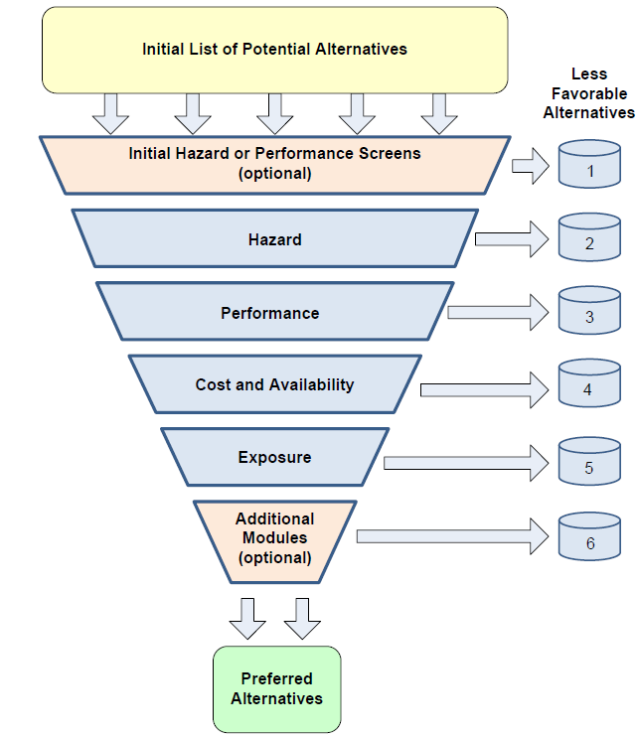

Below are brief summaries of the basic considerations associated with the four main elements of the assessment process:

Hazard

Hazard is the set of inherent properties of a substance, mixture of substances or processes that, under production, usage, or disposal, makes it capable of causing adverse effects to humans, animals, and the environment. Hazard can be measured for a number of human and environmental traits. Information on each trait may come either from experimental data or, lacking experimental data, from modeling results. Hazard traits included in the assessment include: *carcinogenicity, acute mammalian toxicity, mutagenicity and genotoxicity, reproductive toxicity, systemic toxicity and organ effects, developmental toxicity, neurotoxicity, endocrine activity, respiratory and skin sensitization, acute and chronic aquatic toxicity, persistence, bioaccumulation, reactivity and flammability*. There are data gaps in the health data for many of the chemicals used today. Confidence in the hazards posed by a chemical increases as the amount and quality of data increases. Tools and methodologies for comprehensive hazard assessments are available and referenced below.

Technical Performance

Without assurance that alternatives are technically favorable for the desired application and meet performance requirements, businesses are unlikely to adopt safer alternatives for their products or processes. Companies are encouraged to create performance-based specifications that allow for innovation using safer alternatives. The initial steps in a performance evaluation can focus on answering these questions:

* What are the performance needs for the application, process, or product that contains the chemical of concern (COC)? Why is the COC being used in this specific application? (e.g., would using a less toxic surfactant affect the surface tension of the chemical in a way that would impede performance?)
* Has the alternative(s) already been identified as a favorable alternative with respect to performance? (e.g., is the alternative being used in similar products found on the commercial market?)
* Has an authoritative body demonstrated that the alternative functions adequately for both the process and product? Are there reports from an authoritative body that evaluates the alternative(s) for use in the specific or similar applications?
* Is the proposed alternative(s) considered favorable but there are indications that it does not perform as well as the current chemical? For example, has the alternative been tested and found to fulfill the necessary function less satisfactorily? If yes, can the process or product be modified to accommodate the alternative and improve its performance?
* Has the proposed alternative(s) been identified by expert sources NOT a viable alternative based on performance? If yes, how do the performance results compare to the desired function in the specific product or process?

Cost and Availability

Many alternatives that appear feasible may either be cost prohibitive or not available in sufficient quantities to remain a favorable alternative. However, an analysis that considers all costs and savings fully may expand the number of viable alternatives. For instance, if an alternative costs three times as much per pound as the chemical of concern, but requires five times fewer pounds per production cycle (e.g., if the volatile organic content is much lower) there will be a short payback of the initial investment. Not only should the immediate cost of a chemical or material be considered but also the cost of chemicals in the final product. An example would be if the alternative allows for or results in a product redesign, which causes the cost to be comparable at the product level.  Also, costs over the product’s life cycle should be considered, including those externalities (e.g., health and environmental costs) that may become “internalized” through regulation. Economies of scale should be evaluated and used to determine whether or not a chemical that is not currently manufactured in sufficient amounts or is too costly to be favorable *could* be produced in sufficient amounts or at a lower cost if demand increased. An alternative should not be eliminated solely because it is currently unavailable at sufficient quantities or at too high of a cost when, if demand increased, it could be produced at both an amount and cost to compete with the chemical of concern.

Exposure

The exposure assessment is conducted after the hazard assessment in order to reduce risk. Exposure assessment can support selection of alternatives when the inherent hazards are equivalent, for example when the functional use of one alternative would result in increased risk due to the quality and quantity of the resulting exposure. Not all alternatives will result in the same exposure scenarios. Both near field (direct consumer) and far field (environmental) exposures are considered. The initial assessment would involve comparing the physiochemical properties and exposure pathways between the alternative and the chemical of concern. Physiochemical properties of interest include*: volatility/vapor pressure, molecular weight, molecular size, solvent properties (phase partitioning and solubility), boiling point, melting point, density/specific gravity, pH, corrosivity, and environmental partitioning.* The exposure pathways include ingestion, inhalation, and dermal contact. Differences in these properties and pathways could indicate whether the alternative is more or less favorable than the chemical of concern with regard to exposure. Further, an analysis of how the alternative is used in the production process is relevant. If use levels or use methods (e.g., blended or chemically attached to product?) are different between the two chemicals being compared, it could affect exposure levels. Finally, exposure through the entire life cycle (manufacturing, transportation, product use, end-of life) should be examined.

# Technical Assistance Resources, References and Tools

## Regional Technical Assistance and Applied Research Organizations

Pacific Northwest Pollution Prevention Resource Center

<http://pprc.org/>

Northwest Green Chemistry

<https://www.northwestgreenchemistry.org/>

## Toxics Pollution Prevention Resources

Pollution Prevention Info House (searchable on-line collection of pollution prevention publications and resources):

<http://infohouse.p2ric.org/>

EPA Pollution Prevention Clearinghouse:

<https://www.epa.gov/p2/forms/pollution-prevention-information-clearinghouse-contact-form#form>

Toxics Use Reduction to Achieve Enhanced Pollution Prevention Success, Massachusetts Toxics Reduction Institute

<https://www.epa.gov/p2/toxics-use-reduction-achieve-enhanced-pollution-prevention-success>

Process Mapping and Mass Balancing Seminar Notes, Washington Department of Ecology: <https://fortress.wa.gov/ecy/publications/publications/0004007.pdf>

TRI Pollution Prevention Search Tool (case studies of facility actions to reduce toxics) <https://www3.epa.gov/enviro/facts/tri/p2.html>

Oregon DEQ Toxics Use Reduction Clearinghouse (case studies of toxics reduction sorted by chemical or sector):

<http://www.deq.state.or.us/turreportsearch/>

## Chemical Alternatives Assessment Resources

Interstate Chemicals Clearinghouse Alternatives Assessment Guide

<http://theic2.org/alternatives_assessment_guide>

Washington State Alternatives Assessment Guide for Small and Medium Sized Businesses

<https://fortress.wa.gov/ecy/publications/documents/1504002.pdf>

National Academy of Sciences Alternatives Assessment Framework

<https://www.nap.edu/catalog/18872/a-framework-to-guide-selection-of-chemical-alternatives>

OECD (Organization for Economic Cooperation and Development) Substitution and Alternatives Assessment Toolbox <http://www.oecdsaatoolbox.org/>

Marketplace by Chemsec (helps businesses find safer alternatives)

<https://marketplace.chemsec.org/>

## Chemical Hazard Assessment Tools and Resources

Green Screen For Safer Chemicals from Clean Production Action

<https://www.greenscreenchemicals.org/>

Washington Quick Chemical Assessment Tool (QCAT)

<http://www.ecy.wa.gov/greenchemistry/QCAT.html>

Interstate Chemicals Clearinghouse Chemical Hazard assessment database:

<http://theic2.org/hazard-assessment>

ToxNot chemical hazard database

<https://toxnot.com>  (free CHA database)

Pharos project chemical hazard database:

<https://www.pharosproject.net>

ChemHat chemical and alternatives assessment tool:

<http://www.chemhat.org/en>

# Alternative formats

Documents can be provided upon request in an alternate format for individuals with disabilities or in a language other than English for people with limited English skills. To request a document in another format or language, call DEQ in Portland at 503-229-5696, or toll-free in Oregon at 1-800-452-4011, ext. 5696; or email [deqinfo@deq.state.or.us](mailto:deqinfo@deq.state.or.us).