DELETE THIS PAGE BEFORE PUBLISHING THESE RULES TO THE PUBLIC

If your rules include tables, please follow this example as a template of how to format your rules. If your rules do not have tables, you can ignore this example.

|  |  |  |  |
| --- | --- | --- | --- |
| **Table Title Additional Title Even More Info, Date** | | | |
| **Subheading 1** | | **Subheading 2** | |
| Data | Data | Data | Data |
| Data | Data | Data | Data |

**Rule Formatting Standards -OAR 166-500-0055**

1. Microsoft Word
2. Single spaced
3. Left justified
4. 12 point, Times New Roman font
5. One extra (blank) line (carriage return) between each rule segment
6. No auto numbering/auto numbering turned off
7. Tables formatted according to DEQ standard
8. If you are not familiar with creating or formatting tables, ask rules group lead or agency rules coordinator for help
9. Keep Track Changes function turned on
10. Only make edits on SharePoint version of rules

ONLY THE RULES GROUP LEADER OR AGENCY RULES COORDINATOR MAY ADD RULES TO THIS TEMPLATE

BEFORE EDITING THESE RULES, THE EDITOR SHOULD:  
-CHECK THE DOCUMENT OUT OF SHAREPOINT  
-CHECK TO MAKE SURE TRACK CHANGES IS TURNED ON  
-CHECK THE DOCUMENT BACK IN TO SHAREPOINT WHEN DONE

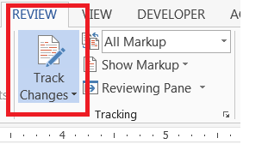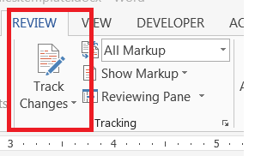TRACK CHANGES OFF TRACK CHANGES ON



**Key to Identifying Changed Text:**

**~~Deleted Text~~**  
New/inserted text  
~~Text deleted from one location~~ - and moved to another location

**DEPARTMENT OF ENVIRONMENTAL QUALITY**

XXX-XXX-XXXX