Oregon Regional Haze Plan

**5-Year Progress Report and Update**

**To Satisfy Sections 308 (g), (h), (i) of the Regional Haze Rule (40 CFR 51.308)**



Final Report

July 2017



**Air Quality Planning**

700 NE Multnomah Street

Portland, OR 97232

Phone: 503-229-6549

800-452-4011

Fax: 503-229-6762

Contact: Kevin Downing

*www.oregon.gov/DEQ*

***DEQ is a leader in restoring, maintaining and enhancing the quality of Oregon’s air, land and water.***

This report prepared by:

Oregon Department of Environmental Quality

700 NE Multnomah Street

Portland, OR 97232

1-800-452-4011

www.oregon.gov/deq

Contact:

Kevin Downing

503-229-6549

Documents can be provided upon request in an alternate format for individuals with disabilities or in a language other than English for people with limited English skills. To request a document in another format or language, call DEQ in Portland at 503-229-5696, or toll-free in Oregon at 1-800-452-4011, ext. 5696; or email [deqinfo@deq.state.or.us](mailto:deqinfo@deq.state.or.us).

**Acknowledgements**

Major assistance in preparing this report was provided by the Western Regional Air Partnership (WRAP), who provided Oregon with much of the data and technical support needed to meet the progress report requirements of Section 308(g), (h) and (i) of the Regional Haze Rule. Special thanks to the following staff:

• Tom Moore, Western Governors’ Association

• Cassie Archuleta, Air Resource Specialists, Inc

• Emily Vanden Hoek, Air Resource Specialists, Inc

• Bob Lebens, Western States Air Resources Council, WESTAR

Principal Author: Kevin Downing, Environmental Solutions Division, Air Planning

Brian Finneran, Environmental Solutions Division, Air Planning

DEQ Staff Contributors: Jeffrey Stocum, Environmental Solutions Division, Air Technical

Brandy Albertson, Environmental Solutions Division, Air Technical

Chris Swab, Environmental Solutions Division, Air Technical

Rachel Sakata, Environmental Solutions Division, Air Planning

Table of Contents

1. Introduction 1

1.1 Purpose of this Document 1

1.1.1 Oregon Class I Areas 1

1.1.2 Columbia River Gorge National Scenic Area 4

1.2 Requirements for Periodic Reports 5

1.3 Technical Information and Data Relied Upon 6

1.3.1 Oregon IMPROVE Monitoring Network 6

1.3.2 The WRAP Technical Support System 9

1.3.3 The WRAP Regional Haze Progress Report 9

1.4 Clean Air Act Requirements for Addressing Regional Haze 10

1.5 Summary of the 2010 Oregon Regional Haze Plan 11

1.5.1 2018 Reasonable Progress Goals for Oregon Class I areas. 12

2. Status of SIP Measures 13

2.1 Regional Haze SIP requirements 13

2.1.1 Best Available Retrofit Technology 13

2.1.2 Oregon Smoke Management Plan 15

2.2 Emission Reductions Achieved by SIP Measures 16

2.2.1 BART 16

2.2.2 Smoke Management Plan 19

2.3 Long Term Strategy Update 21

2.3.1 Non-BART Source Evaluation 21

2.3.2 Update on Columbia Gorge Visibility 21

2.3.3 Evaluate Contribution from General Outdoor Open Burning 24

2.3.4 Evaluate Contribution from Rangeland Burning 24

2.3.5 Efforts to Address Offshore Shipping 24

2.3.6 Update WRAP SO2 and NOx Emission Inventory for Point Sources 25

2.3.7 Update on Ammonia Emission Inventory and Possible Reductions 25

2.3.8 Update on 2010 Changes to Willamette Valley Field Burning 26

2.3.9 Updates to Long Term Strategy from Ongoing Air Pollution Programs - Interstate Transport, Ravi BART, Oregon Phase I Visibility Program, PSD/New Source Review, Mobile Sources, PM10 & PM2.5 NAAQS and Nonattainment Areas 26

2.3.10 Wildfire Emission Trends 27

2.3.11 Update to WRAP Regional Modeling 28

2.3.12 Other State Class I Areas Affected by Oregon Emissions 28

2.3.13 Reasonable Progress Demonstration Relative to Oregon Reasonable Progress Goals 28

3. Visibility Trends and Emissions Changes 29

3.1 Overview of Monitoring Data Analysis 30

3.1.1 Monitoring Data and the 20% Best and Worst Days 30

3.2 Results of Analysis of Monitoring Data and Visibility Trends 31

3.2.1 Summary 31

3.2.2 Conditions for the 2010-2014 Current Visibility Period 31

3.2.3 Differences Between Baseline and Current Period Visibility Conditions 33

3.2.4 Changes in Visibility Impairment for First Progress Period Compared to Baseline Conditions 34

3.2.5 Visibility through 2010 – 2014 Progress Period 39

3.3 Overview of Emission Inventory Analysis 41

3.3.1 Inventory Descriptions 41

3.4 Results of the Emission Inventory Analysis 48

3.4.1 Changes in Emissions 48

3.5 Assessment of Current Monitoring Strategy 59

3.6 Electrical Generating Unit Emission Summary 59

3.7 Oregon’s Impact on Nearby Class I Areas 60

3.8 Analysis of Impediments to Progress 61

4. Determination of Adequacy, Procedural Requirements and Conclusions 63

Figures

Figure 1: Columbia River Gorge Visibility Trend, CORI1 and COGO1 site ii

Figure 2 Oregon Class I Areas Map 1

Figure 3 Columbia River Gorge Scenic Area 5

Figure 4 Oregon IMPROVE Sites 8

Figure 5 Prescribed Burning Emissions Estimate PM 2.5 20

Figure 6 Visibility Trends - Columbia River Gorge - CORI1 & COGO1 23

Figure 7 North American ECA Projected PM Concentration Reductions 25

Figure 8 Oregon Wildfire Acres Burned - Historic and Trends 28

Figure 9 Average Extinction for Baseline and First Progress Period Extinction for Worst (Most Impaired) Days Measured at Oregon IMPROVE Sites 37

Figure 10: Difference Between Average Extinction for First Progress Period (2005-2009) and Baseline Period (2000-2004) for the Worst (Most Impaired) Days Measured at Oregon IMPROVE Sites 37

Figure 11 Average Extinction for Baseline and First Progress Period Extinction for Best (Least Impaired) Days Measured at Oregon IMPROVE Sites 37

Figure 12 Difference between Average Extinction for First Progress Period (2005-2009) and Baseline Period (2000-2004) for the Best (Least Impaired) Days Measured at Oregon Improve Sites 38

Figure 13 2002 and 2008 Emission and Difference Between Emission Inventory Totals, for Sulfur Dioxide by Source Category 51

2002 and 2008 Emission and Difference Between Emission Inventory Totals, for Oxides of Nitrogen by Source Category 52

Figure 14 2002 and 2008 Emission and Difference Between Emission Inventory Totals, for Ammonia by Source Category 53

Figure 15 2002 and 2008 Emission and Difference Between Emission Inventory Totals, for Volatile Organic Compounds by Source Category 54

2002 and 2008 Emission and Difference Between Emission Inventory Totals, for Primary Organic Aerosol by Source Category 55

Figure 16 2002 and 2008 Emission and Difference Between Emission Inventory Totals, for Elemental Carbon by Source Category 56

Figure 17 2002 and 2008 Emission and Difference Between Emission Inventory Totals, for Fine Soil by Source Category 57

Figure 18 2002 and 2008 Emission and Difference Between Emission Inventory Totals, for Coarse Mass by Source Category 58

Figure 19 Electrical Generating Unit Emissions of SOx and NOx, 1996 - 2014 60

Figure 20 Trend line for Worst 20% Visibility Days, THSI1 61

Figure 21 Recent Deciview and OM Extinction at THSI1 on Worst Days 62

Tables

Table 1: Comparison of current visibility data (2014) to reasonable progress goals (2018) ii

Table 2 Oregon Class I Areas 2

Table 3 Oregon IMPROVE Monitoring Network 7

Table 4 20% Best and Worst Days Baseline, Natural Conditions, Uniform Rate of Progress and Reasonable Progress Goal for Oregon Class I Areas 13

Table 5 PGE Boardman Emissions to date 16

Table 6 PGE Beaver Emissions with FEPL 17

Table 7 GP Wauna Emissions with FEPL 18

Table 8 International Paper Emissions with FEPL 19

Table 9 Amalgamated Sugar Emissions with FEPL 19

Table 10 Forest Land Acres Treated - 2015 20

Table 11 Prescribed Forestry Burns and Intrusions 2008 - 2015 21

Table 13 Open Burning Emissions in 2008 and 2011, tons per year 24

Table 14 Oregon Visibility Observed Relative to Reasonable Progress Goals Through 2014 29

Table 15: Oregon IMPROVE Monitoring Network 31

Table 16 Oregon IMPROVE Sites, Visibility Conditions 2010-2014 Current Period, 20% Most Impaired Days 32

Table 17 Oregon IMPROVE Sites, Visibility Conditions 2005-2009 Progress Period, 20% Least Impaired Days 33

Table 19 Oregon IMPROVE Sites - Difference in Aerosol Extinction by Species, 2000-2004 Baseline Period to 2005-2009 Progress Period, 20% Most Impaired Days 36

Table 20 Oregon IMPROVE Sites - Difference in Aerosol Extinction by Species, 2000-2004 Baseline Period to 2005-2009 Progress Period, 20% Least Impaired Days 36

Table 22 Emissions Inventory Descriptions 44

Table 23 Sulfur Dioxide Emissions by Category 51

Table 24 Oxides of Nitrogen Emissions by Category 52

Table 25 Ammonia Emissions by Category 53

Table 26 Volatile Organic Compound Emissions by Category 54

Table 27 Primary Organic Aerosol Emissions by Category 55

Table 28 Elemental Carbon Emissions by Category 56

Table 29 Fine Soil Emissions by Category 57

Table 30 Coarse Mass Emissions by Category 58

Appendices

Appendix A – Prescribed Burning Impact Analysis

Appendix B – NON-BART Source Evaluation

Appendix C – Background on Visibility and Regional Haze Program Elements

Appendix D – Consultation with Tribal Governments and Federal Land Managers

Appendix K – Oregon IMPROVE Monitoring Data Summary Tables and Charts

**Executive Summary**

Regional haze is air pollution that reduces visibility in scenic areas. The haze that affects visibility in Oregon comes from motor vehicles, power plants, industrial and manufacturing processes, forestry, agricultural (including dairies) and other open burning, as well as natural sources such as wildfire and windblown dust. The federal Clean Air Act contains requirements to protect and improve visibility in national parks and wilderness areas in the country. In 1977, Congress designated certain national parks and wilderness areas as "Class 1 areas," where visibility was identified as an important value deserving protection. Oregon has 12 Class 1 areas that include Crater Lake National Park and 11 wilderness areas.

To address the problem of regional haze, the Environmental Protection Agency (EPA) adopted the Regional Haze Rule in 1999. This rule requires states to adopt regional haze plans to incrementally improve visibility in all Class 1 areas over the next 60 years. The visibility improvement goal is to ensure that visibility on the worst days improves toward a natural conditions goal, and that visibility on the best days does not get worse.

This progress report evaluates progress towards the reasonable progress goals prescribed for the first ten year interval of Oregon’s regional haze state implementation plan. These progress reports are required to summarize recent changes in monitoring and emissions data, and evaluate the adequacy of the current State Implementation Plan to meet interim progress goals.

On Dec. 9, 2010, the Environmental Quality Commission adopted the first regional haze plan for Oregon. A plan was first adopted in 2009 but amended in 2010 based on a revision to the Best Available Retrofit Technology (BART) determination for the PGE Boardman coal-fired power plant. Since visibility impairing pollutants readily cross state lines, it is important to note that Washington State has developed a closure plan for an electrical generating facility in Centralia, Washington that would eliminate coal fired burning by 2025.

In the years since the regional haze plan was adopted, Oregon has taken several significant steps to reduce anthropogenic sources of visibility impairing pollutants. The BART analysis for the coal fired electrical generating facility at PGE Boardman has resulted in the installation of controls reducing NOx and SO2. Full implementation of BART will require the plant to permanently cease burning coal in the main boiler by December 31, 2020. Analyses for four other permitted facilities identified potential impacts to Class I areas. These sources have agreed to federally enforceable permit limits to reduce pollution causing visibility impacts to insignificant levels.

Modifications to the Oregon Smoke Management Plan governing forestry practices were incorporated into the State Implementation Plan after analysis identified impacts on Class I areas in southern Oregon from prescribed burning. Additionally the state has adopted statutory restrictions on grass field burning in the Willamette Valley that will reduce visibility impacts in the Cascades.

Strategies implemented at the federal level to reduce emissions from diesel and gasoline powered vehicles and equipment will also result in lower levels of visibility impairing pollutants like SO2 and NOx. The North American Emission Control Area, in place as a result of an international treaty, will similarly reduce emission of these pollutants from ocean going ships that travel coastwise to Oregon as well as upriver to inland ports.

Each strategy is in varying stages towards full implementation but improvements in visibility are already evident in the monitoring data.

Visibility impairment is measured by a network of monitors that capture pollution and calculate the light scatter effect of each pollutant such as carbon, sulfur and ammonia. The main metric describing visibility impairment is the deciview, analogous to decibel as a measurement of sound. In the case of deciview, a low deciview number means clearer visibility while a high deciview number reflects increased haziness.

To assess Oregon’s progress under the timeframe for the 5-year progress report, DEQ is analyzing the period between 2010-2014. This encompasses the 5-year timeframe since Oregon adopted the first Regional Haze Plan in 2009. The analysis will help Oregon assess its progress towards meeting the reasonable progress goals in 2018.

A review of 2014 data from monitors associated with most Oregon Class I areas shows improvements in visibility for both the worst and best days, exceeding reasonable progress goals set for 2018.

Table 1: Comparison of current visibility data (2014) to reasonable progress goals (2018)

|  |  |  |  |  |  |  |  |
| --- | --- | --- | --- | --- | --- | --- | --- |
| Actual Visibility Observed in 2014 Relative to 2018 Goals | | Mt. Hood Wilderness Area | Mt. Jefferson, Mt. Washington, Three Sisters Wilderness | Crater Lake NP, Diamond Peak, Mountain Lakes, Gearhart Mountain Wilderness | Kalmiopsis Wilderness | Strawberry Mountain, Eagle Cap Wilderness | Hells Canyon Wilderness |
| 20% Worst Days | 2018 Reasonable Progress Goal (dv) | 13.8 | 14.3 | 13.4 | 15.1 | 17.5 | 16.6 |
| 2014 Visibility (dv) | 12.4 | 14.0 | 12.9 | 13.4 | 13.4 | 15.3 |
| 20% Best Days | 2018 Reasonable Progress Goal (dv) | 2.0 | 2.9 | 1.5 | 6.1 | 4.1 | 4.7 |
| 2014 Visibility (dv) | 1.4 | 2.6 | 1.0 | **6.5** | 2.7 | 4.0 |

Periodically exceptions occur as in 2012 for the monitor located near the Three Sisters, Mt. Jefferson and Mt. Washington wilderness areas in central Oregon. This monitor showed impairments that are largely attributable to unplanned wildfires in 2011 and 2012 even as other haze impairing pollutants are declining. Unplanned wildfires are episodic and occur in varied geographies that are unpredictable but are nonetheless, over the past five years, increasing in frequency and the number of acres affected. This result at this particular monitor highlights in microcosm, both the advances made in reducing many human-caused sources of visibility impairing pollution and the challenges faced in improving visibility in the face of relatively uncontrollable events.

Figure 1: Columbia River Gorge Visibility Trend, CORI1 and COGO1[1] site

Although the Columbia River Gorge National Scenic Area is not a Class I area, visibility is a very important concern. The Scenic Area faces additional challenges because of the varied land uses within the scenic area itself as well as proximity to other sources of haze pollution. We expect that visibility impairment in the Gorge to be generally higher than in Class I wilderness areas. At the same time, efforts that focus on improving visibility in nearby Class I areas in both Washington state and Oregon have also resulted in improvements to visibility in the Gorge. The long term trend for the Columbia River Gorge Scenic Area, as seen below, also shows a positive improvement in visibility over time.

After review of current visibility data compared to the reasonable progress goals of the Oregon regional haze plan and the suitability of the current visibility monitoring strategy, the state of Oregon, after consultation with tribal governments and federal land managers, concludes that no substantive revision is needed at this time to meet established goals of the regional haze plan.

# 1. Introduction

## 1.1 Purpose of this Document

The report has been prepared to meet the requirements of the Federal Regional Haze Rule, Section 40 CFR, Part 51, Section 308(g) for submitting the 5-year progress report.

The original update cycle for Oregon was slated for 2013 based on the Departments’ expectation of completing the first haze plan in 2008. The Oregon Regional Haze Plan was not adopted until 2009, and then amended in 2010 because of a revision to the BART determination for the PGE Boardman coal-fired power plant. This submittal occurred in December 2010, and therefore Oregon’s first progress report is technically due by December 2015. Resource availability has delayed submission of the update to 2017.

### 1.1.1 Oregon Class I Areas

The Regional Haze Rule under 40 CFR 51.308 requires states to address visibility protection for regional haze in Class I Areas in each state. In Oregon there are 12 mandatory federal Class I areas, including Crater Lake National Park and 11 wilderness areas. These areas are shown in Figure 2 and listed in Table 2.

Figure 2 Oregon Class I Areas Map

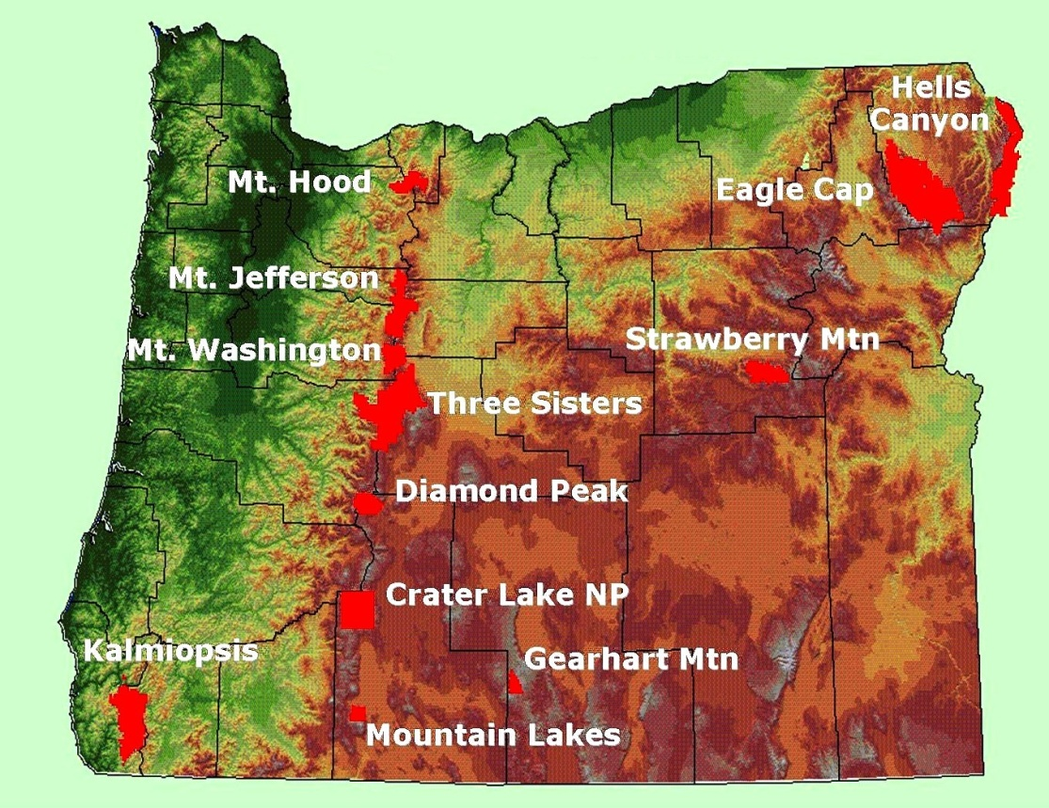

Table 2 Oregon Class I Areas

|  |  |
| --- | --- |
| **Class I Area** | **Acreage** |
| Mt. Hood Wilderness | 47,160 |
| Mt. Jefferson Wilderness | 107,008 |
| Mt. Washington Wilderness | 52,516 |
| Three Sisters Wilderness | 285,202 |
| Diamond Peak Wilderness | 52,337 |
| Crater Lake | 183,315 |
| Mountain Lakes Wilderness | 23,071 |
| Gearhart Mtn. Wilderness | 22,809 |
| Kalmiopsis Wilderness | 179,700 |
| Strawberry Mtn. Wilderness | 69,350 |
| Eagle Cap Wilderness | 360,275 |
| Hells Canyon Wilderness | 131,133* |

* Oregon portion only. Total acreage is 214,944

#### Mt. Hood Wilderness Area

The Mt Hood Wilderness Area is located on the slopes of Mt Hood in the northern Oregon Cascades. Wilderness elevations range from 3,426 m (11,237 ft) on the summit of Mt Hood down to almost 600 m (2,000 ft) at the western boundary. It is almost adjacent to the Portland Oregon metropolitan area; the westernmost boundary is about 20 km east of the Portland Oregon suburb of Sandy and 40 km from the heavily populated metropolitan center, elevation 100 m (300 ft). Visitation to the Mt. Hood Wilderness Area is approximately 50,000 visitors a year, primarily between May and October. Most visitors come from the Portland/Vancouver area that has a population of approximately 2 million.

#### Mt. Jefferson Wilderness Area

The Mt. Jefferson Wilderness Area is located on the crest of the Cascade Range in central Oregon. Its southern boundary is a few km north of the northern boundary of the Mt Washington Wilderness and it extends 40 to 50 km north along the Cascade crest. West of the crest, it consists primarily of the eastern side of the North Santiam River headwaters basin that connects to the Willamette Valley source region near Salem Oregon, 100 km (60 mi) to the west. East of the crest it occupies the western slopes of the Metolius River drainage that connects eastern slopes with Deschutes River in eastern Oregon. The highest Wilderness elevation is 3,200 m (10,497 ft) at the summit of Mt Jefferson in the northern part of the Wilderness. Lowest Wilderness elevations are near 1,000 m (3,000 ft) along the western boundary in the North Santiam headwaters basin and along the eastern boundary in the Metolius River basin.

#### Mt. Washington Wilderness Area

The Mt. Washington Wilderness Area is located on the crest of the Cascade Range in central Oregon. Like the Three Sisters Wilderness that it borders to the south, it includes headwaters tributaries of the McKenzie River that flow west into the Willamette Valley near Eugene and connect the Wilderness with that source region. On the east side eastern slopes of the Cascades descend to the Deschutes River near Bend. The highest Wilderness elevation is 2,376 m (7,794 ft) at the summit of Mt Washington. Lowest elevations are near 900 m (3,000 ft) in the upper headwaters basin of the McKenzie River.

#### Three Sisters Wilderness Area

The Three Sisters Wilderness Area is located abreast the crest of the Cascade Range in central Oregon. It includes headwaters tributaries of the McKenzie River that flow west into the Willamette Valley near Eugene and connect the Wilderness with that source region. On the east side streams flow east to the Deschutes River near Bend. The highest crest elevation is 3,158 m (10,358 ft) at the summit of the South Sister. Lowest elevations are near 600 m (2,000 ft) where the South Fork of the McKenzie River exits the Wilderness on the west boundary. This is about 500 m (1,600 ft) above the Willamette Valley at Eugene 70 km (40 mi) west.

#### Diamond Peak Wilderness Area

The Diamond Peak Wilderness Area straddles the Cascade Range 50 km (30 mi) north of Crater Lake National Park. The highest crest elevation in the Wilderness is 2,666 m (8,744 ft) at Diamond Peak, which is also the highest summit in this region of the Cascade Range. Lowest elevations are near 1,450 m (5,000 ft) where streams exit the Wilderness on the west side. On the east side the Wilderness is bordered by mountain lakes with elevations from 1,459 m to 1,693 m (4,786 to 5,553 ft). The area includes headwaters of the Middle Fork of the Willamette River that flows to the Willamette Valley near Eugene, elevation 100 m (300 ft) and 90 km (60 mi) distant. Wilderness elevations are thus some 1,400 m (4,600 ft) above the Willamette Valley floor. East of the Cascade crest, streams flow to the Deschutes River in eastern Oregon.

#### Crater Lake National Park

Crater Lake National Park is the only national park in Oregon. The park was established on May 22, 1902, and now consists of 183,315 acres. It is located in southwestern Oregon on the crest of the Cascade Mountain range, 100 miles east of the Pacific Ocean. Rim elevations range from about 900 to 1,873 ft above lake level. The highest park elevation is 8,929 ft at the peak of Mt. Scott, in the eastern Park area. The National Park includes headwaters of the Rogue River that flows southwest towards the Medford/Grants Pass area, and Sun Creek/Wood River that flows southeast to the Klamath Falls area.

#### Mountain Lakes Wilderness Area

The Mountain Lakes Wilderness Area is a relatively small Class 1 Area in southern Oregon of 23,071 acres, 50 km (30 mi) south of Crater Lake National Park. It consists of several peaks with a highest elevation of 2,502 m (8,208 ft) at the crest of Aspen Butte. Lowest elevations are near 1,500 m (5,000 ft). Primary drainages are Varney Creek and Moss Creek that flow into the Upper Klamath Lake, 3 km northeast of the Wilderness boundary.

#### Gearhart Mountain Wilderness Area

The Gearhart Mountain Wilderness Area is located on the flanks of Gearhart Mountain in south central Oregon, primarily the northern slope and eastern drainages of Gearhart Mountain, the dominant topographic feature. Elevations range from near 5,900 ft at the North Fork of the Sprague River in the northern Wilderness to 8,364 ft at the summit of Gearhart Mountain.

#### Kalmiopsis Wilderness Area

The Kalmiopsis Wilderness Area is managed by the U.S. Forest Service. The Kalmiopsis Wilderness is located in the Klamath Mountains of southwestern Oregon, part of the coastal temperate rainforest zone that lies between the Pacific Ocean and the east side of the coast ranges in northwestern U.S. and Canada. Its western boundary is 20 to 25 km (12 to 15 mi) from the coast. Its easternmost extent is about 40 km (25 mi) from the coast. Elevations range from about 300 m (900 ft) on the western boundary where the Chetco River exits the Wilderness towards the Pacific Ocean 25 to 30 miles further west, to 1,554 m (5,098 ft) on Pearsoll Peak on the eastern Wilderness boundary. Terrain is steep canyons and long broad ridges. The Wilderness is mostly west of the general crest of the coast range, thus exposed to precipitation caused by lifting of eastward moving maritime air, primarily during the winter. Precipitation ranges from 150 to 350 cm (60 to 140 in) annually, depending on elevation.

#### Strawberry Mountain Wilderness Area

The Strawberry Mountain Wilderness Area is located in eastern Oregon, just east of John Day. The Wilderness comprises most of the Strawberry Mountain Range. Terrain is rugged, with elevations ranging from 1,220 m (4,000 ft) to 2,755 m (9,038 ft) at the summit of Strawberry Mountain. It borders the upper John Day River valley to the north.

#### Eagle Cap Wilderness Area

The Eagle Cap Wilderness Area is located in northeastern Oregon. Terrain is characterized by bare peaks and ridges and U-shaped glaciated valleys. Elevations range from 5,000 ft in lower valleys to near 10,000 ft at the highest mountain summits. The Lostine and Minam Rivers flow north from the center of the Wilderness towards Pendleton and the Columbia, 130 km northwest.

#### Hells Canyon Wilderness Area

The Hells Canyon Wilderness Area is located on the Oregon-Idaho border. The Snake River divides the wilderness, with 131,133 acres in Oregon, and 83,811 acres are in Idaho. It is managed by the Bureau of Land Management and the Forest Service. The Snake River canyon is the deepest river gorge in North America. The higher terrain is located on the Oregon side. Popular Oregon-side viewpoints are McGraw, Hat Point, and Somers Point.

### 1.1.2 Columbia River Gorge National Scenic Area

The Columbia River Gorge National Scenic Area was designated a National Scenic Area by Congress in 1986 but it is not otherwise a Class I area. The National Scenic Area Act of 1986 requires the protection and enhancement of the scenic, natural, cultural, and recreational resources of the Gorge, while at the same time supporting the local economy. The Scenic Area consists of 292,500 acres, running from the mouth of the Sandy River to the mouth of the Deschutes and spanning southern Washington and northern Oregon.

The Columbia River Gorge Commission was authorized to administer the National Scenic Area Act. While the Gorge is not classified as a Class I area, the CRGC did recognize that air quality degradation can jeopardize those resources, and that in order to protect air quality in the Gorge, the CRGC would rely on state air quality agencies to develop an air quality strategy for the Scenic Area.

The dynamics of regional haze are similar for the Gorge to those impacting visibility in Class I areas. The Scenic Area faces additional challenges because it is a mixed use area, with qualities of both urbanized and rural areas. The Columbia River Gorge Scenic Area is situated between two Class I areas (Mt. Hood and Mt. Adams) and the Gorge will benefit from Oregon and Washington’s long term regional haze process. Although the Gorge is not a Class I area and will not be expected to be on the same reasonable progress glide path as the Class I areas, visibility in the Gorge can be measured against the nearby Class I areas. This comparison will allow DEQ to track the Gorge’s progress for continued visibility improvement.

Figure 3 Columbia River Gorge Scenic Area

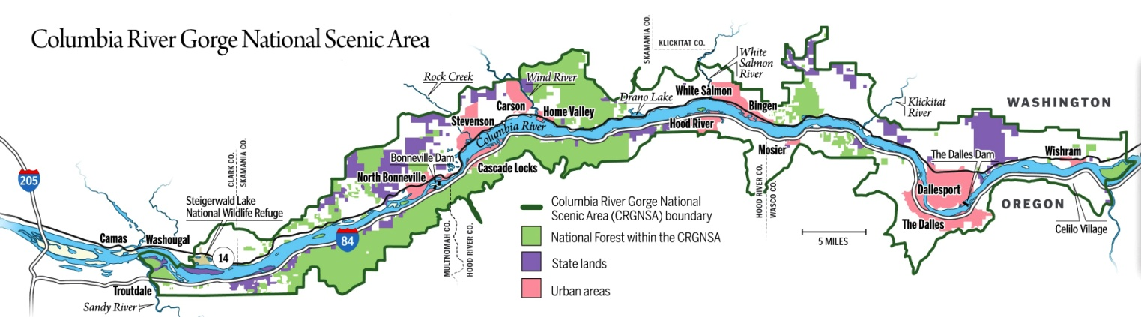

## 1.2 Requirements for Periodic Reports

40 CFR Section 51.308 (g) requires periodic reports every five years after the initial regional haze SIP has been submitted. Periodic reports must evaluate progress towards the reasonable progress goals for each Class I area located within the state, as well as those located outside the state which may be affected by emissions from within the state. This report satisfies the first 5-year progress report requirement. The minimum elements required in each periodic report are listed in 40 CFR 51.308(g)(1-7) and 308(h)(1-4). This report is organized according to those elements.

Five-year progress reports must include:

1. the status of implementation of control measures included in the original regional haze SIP (Section 2.1),
2. a summary of emission reductions achieved through the implementation of control measures (Section 2.2),
3. an assessment of visibility conditions (Section 3.2.2, Section 3.2.5),
4. an analysis of the changes in emissions of visibility-impairing pollutants (Section 3.2.3, Section 3.2.4, Section 3.4),
5. a review of the state’s visibility monitoring strategy (Section 3.5),
6. an assessment of significant changes in anthropogenic emissions that may have limited or impeded progress in improving visibility (Section 3.7),
7. an assessment of whether the current SIP elements and strategies are sufficient to meet reasonable progress goals (Section 4 )

At the same time the state submits its progress report, the state must also make a determination of the adequacy of the existing implementation plan. This 5-year review provides a progress report on the initial 2010 Regional Haze SIP. It addresses each required element based on data that was available as of March 1, 2014. The 2000 through 2004 baseline period planning inventory was developed by the WRAP to represent baseline conditions for comparison with future year projected emissions, as well as for gauging reasonable progress with respect to future year visibility. The baseline inventory, Plan02d, was used in the initial RH SIP and is used in this report, also, as the reference planning period. To assess progress, this report relies on emissions information from the 2008 National Emissions Inventory (NEI) as updated by the WRAP through its WestJump Air Quality Modeling Study (WestJump 2008), 2011 NEI data, and visibility data from the 5-year period from 2008 to 2012.

In discussing the status of control strategies, USEPA guidance suggests that “[t]he report should focus on a targeted evaluation of important control measures that achieve reductions in visibility impairing pollutant species.”

The 2010 RH SIP identifies the relative contribution of each visibility impairing pollutant from anthropogenic and natural emission sources. The data show sulfur dioxide (SO2) and nitrogen dioxide (NO2) emissions are predominately from anthropogenic sources, such as point, mobile and area sources. Oregon’s long-term strategy for the first planning period focused on these pollutants in part due to the important role of Best Available Retrofit Technology[2] for the first planning period, but also due to the controllable nature of these emissions. This report, therefore, focuses on the status of efforts to date to control SO2 and NO2 emissions. In addition, controlling SO2 and NO2 emissions has a co-benefit of reducing visibility impairment from these pollutants as well as reducing the adverse impact of SO2 and NO2 deposition on ecosystems.

Section 308 (i) prescribes requirements for State and federal land managers’ coordination, including the opportunity for FLMs to consult with the state on visibility impairment, reasonable progress goals and control strategies for Class I areas in the state. Evidence of compliance with these requirements will be included in Appendix D of this report. Subparagraph (4) requires a plan for continued consultation by the state with FLMs. In the 2010 RH SIP, Oregon committed to continuing consultation between the State and FLMs on the implementation of the visibility protection program, including development and review of implementation plan revisions and 5-year progress reports, and on the implementation of other programs having the potential to contribute to impairment of visibility in any mandatory federal Class I area within the state. Oregon will continue to participate in the WRAP, including coordination and consultation with nearby states, tribes, the U.S. Forest Service, the Bureau of Land Management, the U.S. Fish and Wildlife Service and the National Park Service.

## 1.3 Technical Information and Data Relied Upon

This section describes the information relied upon by the Department in developing this regional haze progress report. The first part of this chapter describes the IMPROVE monitoring data and network that is used throughout the country by states in measuring Class I area visibility. The second part describes the Western Air Regional Partnership (WRAP) work product provided to Oregon and other western states.

### 1.3.1 Oregon IMPROVE Monitoring Network

In the mid-1980’s, the Interagency Monitoring of PROtected Visual Environments program was established to measure visibility impairment in mandatory Class I Federal areas throughout the United States. The monitoring sites are operated and maintained through a formal cooperative relationship between the EPA, National Park Service, U.S. Fish and Wildlife Service, Bureau of Land Management, and U.S. Forest Service. In 1991, several additional organizations joined the effort: National Association of Clean Air Agencies, Western States Air Resources Council, Mid-Atlantic Regional Air Management Association, and Northeast States for Coordinated Air Use Management.

The objectives of the IMPROVE program include establishing the current visibility and aerosol conditions in mandatory Class I federal areas; identifying the chemical species and emission sources responsible for existing human-made visibility impairment; documenting long-term trends for assessing progress towards the national visibility goals; and support the requirements of the Regional Haze Rule by providing regional haze monitoring representing all visibility-protected federal Class I areas where practical.

In Oregon there are six IMPROVE monitors associated with Class I areas that are listed under the site name in Table 3. Three are located in the Oregon Cascades, two in Eastern Oregon, and one in the Coast Range. Since there are 12 Class I areas in Oregon, some monitors serve multiple Class I areas. While it is desirable to have one monitor per Class I area, in some cases one monitor can be “representative” of haze conditions in nearby Class I areas. shows the location of the IMPROVE monitors and the Class I areas covered by each monitor, as indicated by the yellow circles.

The Columbia River Gorge National Scenic Area, which is not a Class I area, also has had at times two IMPROVE monitors, also described in Table 3. The monitor at the western end of the Gorge was discontinued in 2011.

Table 3 Oregon IMPROVE Monitoring Network

|  |  |  |  |  |  |
| --- | --- | --- | --- | --- | --- |
| **Site Code** | **Class I Area** | **Location** | **Sponsor** | **Elevation MSL** | **Start Date** |
| MOHO1 | Mt. Hood Wilderness | inside | USFS | 1531 m (5022 ft) | 3/7/2000 |
| THSI1 | Mt. Jefferson Wilderness  Mt. Washington Wilderness  Three Sisters Wilderness | 10 mi  4 mi  10 mi | USFS | 885 m (2903 ft) | 7/24/1993 |
| CRLA1 | Crater Lake National Park;  Diamond Peak Wilderness  Mountain Lakes Wilderness  Gearhart Mountain Wilderness | inside  35 mi  37 mi  68 mi | NPS | 1996 m (6548 ft) | 3/2/1988 |
| KALM1 | Kalmiopsis Wilderness | 6 mi | USFS | 80 m (262 ft) | 3/7/2000 |
| STAR1 | Strawberry Mountain Wilderness  Eagle Cap Wilderness | 58 mi  39 mi | USFS | 1259 m (4130 ft) | 3/7/2000 |
| HECA1 | Hells Canyon Wilderness Area | 9 mi | USFS | 655 m (2148 ft) | 8/1/2000 |
| **Site Code** | **Scenic Area** | **Location** | **Sponsor** | **Elevation MSL** | **Start Date** |
| CORI1 | Columbia River Gorge National Scenic Area | inside | USFS | 178 m (584 ft) | 6/26/1993 |
| COGO1[3] | Columbia River Gorge National Scenic Area | inside | USFS | 230 m (755 ft) | 9/16/1996 |

Figure 4 Oregon IMPROVE Sites

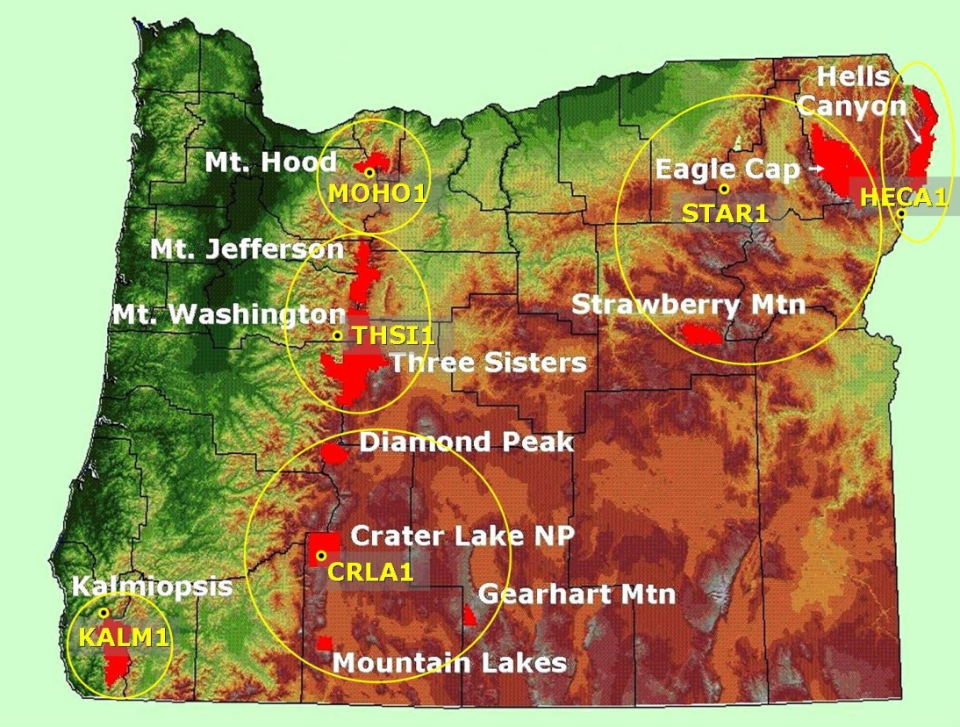

MOHO1

The MOHO1 IMPROVE site is the monitor for the Mt. Hood Wilderness Area. It is located just south of the wilderness boundary near Government Camp, at an elevation of 5,022 feet.

#### THSI1

The THSI1 IMPROVE site is the monitor for the Mt Washington, Three Sisters, and Mt Jefferson Wilderness Areas. It is located 5 miles to the west of Mt Washington, 12 miles southwest of Mt Jefferson, and 10 miles northwest of Three Sisters, at an elevation of 2,903 feet.

#### CRLA1

The CRLA1 IMPROVE site is the monitor for Crater Lake National Park, and is used as the representative site for Diamond Peak, Mountain Lakes, and Gearhart Mountain Wilderness Areas. It is located at the Park Headquarters in the park, to the south of the crater rim, at an elevation of 6,548 feet. The CRLA1 site is located 40 miles to the south of Diamond Peak, 35 miles to the north of Mountain Lakes, and 70 miles to the northeast of Gearhart Mountain.

#### KALM1

The KALM1 IMPROVE site is the monitor for the Kalmiopsis Wilderness Area. It is located 6 miles north of the wilderness boundary near where the Illinois River merges with the Rogue River, at an elevation of 262 feet.

#### STAR1

The STAR1 IMPROVE site is the representative monitoring site for the Strawberry Mountain and Eagle Cap Wilderness Areas. It is located 60 miles north of the Strawberry Mountain Wilderness, and 40 miles west of the Eagle Cap Wilderness, at an elevation of 4,130 feet.

HECA1

The HECA1 IMPROVE site is the monitor for the Hells Canyon Wilderness Area. It is located 10 miles south of the wilderness boundary, at an elevation of 2,148 feet.

CORI1

An additional IMPROVE site has been operating inside the Columbia River Gorge National Scenic Area (CORI1) by the U.S. Forest Service since 1993. This location is on the Washington side of the river about 10 miles upriver from The Dalles.

COGO1

The COGO1 IMPROVE site operated in the Columbia River Gorge Scenic Area between 1996 and 2011 by the U.S. Forest Service. The location was on the Washington side of the river about 8 miles east of Washougal, Washington.

### 1.3.2 The WRAP Technical Support System

The primary purpose of the TSS is to provide key summary analytical results and methods documentation for the required technical elements of the Regional Haze Rule, to support the preparation, completion, evaluation, and implementation of the regional haze implementation plans to improve visibility in Class I areas. The TSS provides technical results prepared using a regional approach, to include summaries and analysis of the comprehensive datasets used to identify the sources and regions contributing to regional haze in the Western Regional Air Partnership region.

The secondary purpose of the TSS is to be the one-stop-shop for access, visualization, analysis, and retrieval of the technical data and regional analytical results prepared by WRAP Forums and Workgroups in support of regional haze planning in the West. The TSS specifically summarizes results and consolidates information about air quality monitoring, meteorological and receptor modeling data analyses, emissions inventories and models, and gridded air quality/visibility regional modeling simulations. These copious and diverse data are integrated for application to air quality planning purposes by prioritizing and refining key information and results into explanatory tools.

Additional information on the TSS can be found here: <http://vista.cira.colostate.edu/tss/>.

### 1.3.3 The WRAP Regional Haze Progress Report

The Department has relied upon the WRAP Regional Haze Reasonable Progress Report completed on June 28, 2013.

This progress report support document was prepared for the 15 western state members in the WRAP region, to provide the technical basis for the first of their individual reasonable progress reports for the 116 Federal Class I areas located in the western states. Data are presented in this report on a regional, state, and Class I area specific basis that characterize the difference between 2000-2004 baseline conditions and current conditions, represented here by the most recent successive 5-year average, or the 2005-2009 period. Changes in visibility impairment are characterized using aerosol measurements from the IMPROVE network, and the differences between emissions inventory years representing both the baseline and current progress period.

Analysis and summaries provided in this report were developed cooperatively with representatives from each state in the WRAP region, and were designed to provide western states with the technical basis necessary to support their evaluation of the current or proposed elements and strategies as outlined in their initial RHR implementation plans. Summaries here are also supported by interactive tools available from the online WRAP Technical Support System.

## 1.4 Clean Air Act Requirements for Addressing Regional Haze

In 1977, Congress amended the CAA, establishing a national goal to protect visibility in Class I federal areas – national parks and wilderness areas greater than 6,000 or 5,000 acres, respectively. The amendments called for the “prevention of any future, and the remedying of any existing, impairment of visibility in mandatory class I Federal areas which impairment results from manmade air pollution.”

In 1979, the USEPA, in consultation with the Secretary of Interior, promulgated a list of 156 mandatory Class I Areas in which visibility was determined to be an important factor. In Oregon there are twelve Class I Areas.

On July 1, 1999, USEPA issued the Regional Haze Rule, thereby establishing a comprehensive visibility protection program for Class I federal areas. The rule is codified in 40 CFR 51.308. The intent of the RHR is to improve visibility over the long term in all 156 mandatory Class I areas across the country. It requires each affected state to develop and adopt an implementation plan that will improve the haziest days and protect the clearest days at each mandatory Class I area in the state, with a goal of returning to natural visibility conditions by the year 2064. Each plan must provide a comprehensive analysis of natural and man-made sources of haze in each mandatory Class I area in the state and contain strategies to control anthropogenic emissions that contribute to haze. The plan must also address the transport of haze across state boundaries.

The 2010 Regional Haze State Implementation Plan, prepared by the Oregon DEQ, was submitted to the USEPA in December 2010. The 2010 RH SIP addressed the initial planning period of the RHR, 2008-2018, and is considered the foundational plan for subsequent planning periods.

The USEPA designated five Regional Planning Organizations to assist with the technical support, coordination and cooperation needed to address the visibility issue for the first regional haze SIPs. The multistate RPOs were established to perform the technical regional analyses for these SIPs. The RPO supporting the western states’ regional haze effort is the Western Regional Air Partnership.

Most of the technical data included in this progress report is from the “Western Regional Air Partnership Regional Haze Rule Reasonable Progress Summary Report” developed by the WRAP (www.wrapair2.org) in June of 2013 and the WRAP Technical Support System (http://vista.cira.colostate.edu/tss/). The WRAP report was prepared to provide the technical basis for use by the western states to develop the first of their individual reasonable progress reports for the 116 federal Class I areas located in the western states. Data are presented in the WRAP report on a regional, state, and Class I area-specific basis that characterize the difference between 2000-2004 baseline conditions and current conditions, represented by the most recent successive 5-year average, that is, the 2005-2009 period. The WRAP report characterizes changes in visibility impairment using aerosol measurements from the Interagency Monitoring of Protected Visual Environments (IMPROVE) network, and it analyzes the differences between emissions inventory years represented by the baseline and current progress periods.

## 1.5 Summary of the 2010 Oregon Regional Haze Plan

On December 9, 2010, Oregon adopted the final elements of the first regional haze plan for implementing Section 308 of the Regional Haze Rule, as a revision to the State Implementation Plan (SIP). EPA took action for final approval of the Oregon haze plan in the federal register on July 5, 2011 (76 FR 38997) and August 8, 2012 (77 FR 50611).

The plan included:

* A comprehensive review and technical assessment of visibility conditions in each of Oregon’s 12 Class I areas, showing major pollutants and source categories in Oregon and other states causing haze, and a projection of visibility by a required “milestone” date of 2018.
* DEQ’s evaluation of ten “BART-eligible” sources, and proposal to require retrofit controls on the power plant, and reduce emissions at four other facilities to below the visibility impact level considered to be significant.
* “Reasonable Progress Goals” established by DEQ for Oregon’s 12 Class I area, which show improvements in visibility for the haziest or worst days (but less than the first uniform rate of progress (URP) milestone for 2018) and no visibility degradation for the clearest or best days.
* A “Long-Term Strategy” that describes what actions DEQ will take to address major sources of haze over the next 10 years, and commitments for future plan updates and revisions.
* Summary of the efforts by DEQ to consult and coordinate with other States, Tribes, and Federal Land Managers on the regional haze strategies contained in this plan.

DEQ’s analysis of emissions data, source apportionment, and modeling results strongly supported the finding that the contribution of natural sources, such as wildfire and windblown dust, is the primary reason for slow progress in achieving the milestones in Oregon’s Class I areas.

Similar to the contribution of natural sources, DEQ reported marine vessel emissions were also affecting progress in making visibility improvements. These emissions were estimated to be half of the statewide SO2 emissions and one-third the statewide NOx emissions. While modeling of marine emissions has not been conducted with regards to its exact impact on western Oregon Class I areas, the contribution of these emissions is significant in the state. Current DEQ authority to regulate offshore shipping emissions is limited.

DEQ’s analysis of projected visibility improvements from sulfate and nitrate impacts in Oregon Class I areas showed about a 20 percent reduction in these pollutants by the 2018 milestone. Given the strong association of these pollutant species to anthropogenic sources, DEQ believes this is a more realistic indicator of reasonable progress. If natural sources are excluded, this 20 percent reduction in sulfates and nitrates corresponds to the same percent reduction that is represented by the 2018 milestone.

Mobile sources (mostly cars and trucks) are the largest anthropogenic source of emissions in Oregon. By 2018 more than half of these emissions are projected to decrease due to numerous federal emission standards that are already “on the books”, as well as programs in Oregon that will reduce these emissions. DEQ believes this major reduction supports the demonstration that RPGs are reasonable based on the considerable progress being made reducing this large source of emissions.

DEQ conducted a “Four-Factor Analysis” as required under the Regional Haze rule to evaluate other large sources of emissions (non-BART sources) that could be reduced or controlled to improve visibility by 2018. Using this analysis DEQ did not find any controls that were reasonable to pursue at that time. However the BART controls for the PGE Boardman power plant will result in a 48% reduction in emissions prior to 2018, followed by the elimination of emissions from burning coal in the main boiler after 2020. Overall, this represents a total emission reduction of approximately 25,500 tons per year. Although not a direct result of the four-factor analysis, this does represent a “greater than BART” emission reduction that is significant, and will provide noticeable visibility improvements in 14 different Class I areas. Based on the preliminary information obtained from the four-factor analysis, DEQ has proposed in the Long-Term Strategy of the plan to further evaluate non-BART industrial sources for possible new controls in the next five years to make additional visibility improvements by 2018.

### 1.5.1 2018 Reasonable Progress Goals for Oregon Class I areas.

States and tribes are required to establish “reasonable progress goals”[4] for each Class I area to improve visibility on the 20% haziest days and to prevent visibility degradation on the 20% clearest days. States are to evaluate their contributions to visibility impairment at Class I areas both within and outside the State and to develop long-term control strategies to reduce emissions of air pollutants that impair visibility. The national goal is to return visibility to natural background levels by 2064. Using the period 2000 to 2004 as the baseline period, the Uniform Rate of Progress (URP) is a linear rate of progress or “glide path” towards natural conditions in 2064. States are to evaluate progress in improving visibility to the 2018 URP planning goal, and every 10 years thereafter.

Table 4 below is a summary of the goals for the 20% worst and best days for Oregon’s 12 Class I areas, comparing baseline monitored conditions (2000-04) to estimated natural conditions in 2064. (To see Oregon’s progress related to the goals, please see Table 14). For the 20% worst days, the 2018 URP Goal is indicated as is the Reasonable Progress Goal for both worst and best 20% visibility days. Class I areas are grouped by the IMPROVE monitoring site that represents each area.

Table 4 20% Best and Worst Days Baseline, Natural Conditions, Uniform Rate of Progress and Reasonable Progress Goal for Oregon Class I Areas

|  |  |  |  |  |  |  |  |
| --- | --- | --- | --- | --- | --- | --- | --- |
| **Region** | **Oregon**  **Class I Area** | **20% Worst Days** | | | | **20% Best Days** | |
| **2000-04 Baseline (dv)** | **2018**  **URP Goal (dv)** | **2018 Reasonable Progress Goal (dv)** | **2064 Natural Conditions (dv)** | **2000-04 Baseline (dv)** | **2018 Reasonable Progress Goal**  **(dv)** |
| **Northern Cascades** | **Mt. Hood Wilderness Area** | **14.9** | **13.4** | **13.8** | **8.4** | **2.2** | **2.0** |
| **Central Cascades** | **Mt. Jefferson, Mt. Washington,**  **and Three Sisters Wilderness Areas** | **15.3** | **13.8** | **14.3** | **8.8** | **3.0** | **2.9** |
| **Southern Cascades** | **Crater Lake**  **National Park;**  **Diamond Peak, Mountain Lakes, and Gearhart Mountain Wilderness Areas** | **13.7** | **12.3** | **13.4** | **7.6** | **1.7** | **1.5** |
| **Coast Range** | **Kalmiopsis Wilderness Area** | **15.5** | **14.1** | **15.1** | **9.4** | **6.3** | **6.1** |
| **Eastern Oregon** | **Strawberry Mountain and Eagle Cap Wilderness Areas** | **18.6** | **16.3** | **17.5** | **8.9** | **4.5** | **4.1** |
| **Eastern Oregon/ Western Idaho** | **Hells Canyon Wilderness Area** | **18.6** | **16.2** | **16.6** | **8.3** | **5.5** | **4.7** |

# 2. Status of SIP Measures

The 2010 Oregon Regional Haze Plan included a number of elements adopted as part of the State Implementation Plan. This section of the five year update provides information about the status of the implementation of these measures and emission reductions that have resulted. This addresses the requirements in 40 CFR 51.308 (g) (1) and (2). In addition, 2010 Plan identified work commitments associated with the five year progress report not otherwise identified in the federal regional haze rule. These commitments are identified and discussed below in Section 2.3 Long Term Strategy Update.

## 2.1 Regional Haze SIP requirements

#### 40 CFR 51.308 (g) (1)

### 2.1.1 Best Available Retrofit Technology

DEQ evaluated ten BART eligible sources and found that the Portland General Electric Boardman plant had, by far, the greatest visibility impact covering 14 Class I areas throughout the Pacific Northwest and the Columbia River Gorge National Scenic Area. The Title V permit for the facility was amended to include conditions requiring installation of BART controls and permanently cease burning coal in the main boiler by December 31, 2020. DEQ also determined that four other sources, PGE Beaver Power Plant, Georgia Pacific Wauna Mill, International Paper and the Amalgamated Sugar Plant were subject to BART. Each of these facilities opted for one or more federally enforceable permit limits to reduce visibility impacts to below 0.5 dv.

PGE Boardman

PGE Boardman is a coal fired steam electric generating unit near Boardman, Oregon. The plant, which began operation in 1980, operated with a Foster Wheeler dry bottom opposing wall fired design with first generation low NOx burners and overfire air with a Title V permit number 25-0016. The adopted BART requirements for the PGE Boardman plant that include a December 31, 2020 closure date for the plant. Prior to 2020, PGE Boardman installed low NOx burners with a modified over-fire air system in 2011 and is meeting BART NOx emission limitations. In early 2014 BART SO2 controls, consisting of a dry sorbent injection (DSI) system, were installed and is in compliance with the applicable BART SO2 emission limitation. A further reduced BART SO2 emission limit is required in 2018.

PGE Beaver

The PGE Beaver plant is an electrical power generation facility located in Clatskanie Oregon. This plant has a Title V Operating Permit No. 05-2520, which was modified on January 21, 2009 to incorporate the FEPL requirements.

The plant has six combined cycle turbines that are the BART-eligible emission units, which are listed below in Table 5. PGE requested daily fuel oil limits for these turbines based upon the daily quantity and the sulfur content of the fuel oil combusted, as well as a requirement that all future shipments of oil contain no more than 0.0015% sulfur (i.e. Ultra Low Sulfur Diesel). An equation was developed to determine a daily fuel oil quantity limit that is tied to the sulfur content of the fuel, so as not to exceed the visibility impact threshold level of 0.5 dv.

Georgia Pacific Wauna Mill

The Georgia-Pacific Wauna Mill is a large, integrated pulp and paper facility which produces wood pulp using the Kraft pulping process, located in Clatskanie Oregon. This plant has a Title V Operating Permit No. 04-0004, which was modified on June 18, 2009 to incorporate the FEPL requirements. This permit was revised on December 2, 2010 to reflect completion of the CNCG project (see description below) and elimination of a major BART-eligible emission unit.

Georgia-Pacific proposed a FEPL that provided for reduced emissions of visibility pollutants in two steps. The first step would be a FEPL prior to eliminating the Non-Condensible Gas (NCG) Incinerator (EU-23), while second step would be the FEPL after. As indicated below, the NCG Incinerator was the largest source of SO2 emissions at the mill. The project to eliminate this incinerator was called the CNCG Project, and would route the NCG gases to the Recovery Furnace and the Lime Kiln for destruction. Based on this, the FEPL for this source assumed the NCG Incinerator would be operated until the CNCG Project was completed. This is identified as FEPL1 below. FEPL2 is after the elimination of this emission unit. The major FEPL requirements were:

* The use of fuel oil in the Power Boiler was permanently discontinued.
* Use of fuel oil in the Lime Kiln was discontinued until completion of the CNCG Project, after which fuel oil could again be used; and
* The maximum pulp production rate was limited to 1,030 tons per day until completion of this project, after which the maximum pulp production limit would increase to 1,350 tons per day.

The CNCG Project was completed in April 2010, and the NCG Incinerator has been eliminated. The use of fuel oil in the Power Boiler has been permanently discontinued, and the other conditions above now apply.

International Paper

The International Paper Company, Springfield mill manufactures linerboard, primarily from wood chips and recycled old corrugated containers. The plant is located in Springfield, Oregon, and has a Title V Operating Permit No. 208850, issued by the Lane Regional Air Protection Agency, which was modified on April 7, 2009 to incorporate the FEPL requirements.

The plant has seven different BART-eligible emission units. The No.4 Recovery Furnace is the primary recovery furnace and the No. 3 Recovery Furnace is only operated when it is necessary to take No.4 Recovery Furnace down for maintenance or repair. Due to cracking in the No. 4 Recovery Furnace steam and mud drums, the facility was performing more frequent than normal shutdowns and inspections for safety purposes. It was decided to replace the steam and mud drums on No. 4 Recovery, and this would take up to two years, or by the end of 2010. Until that time, there was the potential that on days that the No. 3 Recovery Furnace was being operated, visibility impacts could equal or slightly exceed the 0.5 dv threshold. In order to minimize the likelihood if this occurring, conditions were added to the Scheduled Maintenance Plan that included a requirement the facility not burn No.6 Fuel Oil in the Power Boiler when the No.3 Recovery Furnace is operating. As an extra measure, emissions from the Package Boiler (EU-150A, a non-BART emission unit) would be included when demonstrating compliance with the visibility permit limit, until the project to replace the steam drum on No. 4 Recovery Furnace was completed. Compliance with the condition to limit visibility impacts is demonstrated through the use of a formula, emission factors and continuous emissions monitoring data.

Amalgamated Sugar

This Amalgamated Sugar plant is a sugar beet processing facility located in Nyssa, in eastern Oregon, near the Idaho border. This facility has a Title V Operating Permit No. 23-0002. The plant is currently shutdown, and has not identified a date to resume operations. DEQ’s BART rules in 340-223-0040(3) specify that this facility must either modify its permit by adopting an FEPL or be subject to BART, before resuming operation. At this time, this facility is still shutdown, and the permit has not been modified.

### 2.1.2 Oregon Smoke Management Plan

Prescribed burning on forest lands is the largest anthropogenic fire source in Oregon at an estimated 18,500 tons per year of PM10 in 2005. Under state statute, ORS 477.013, the State Forester and DEQ are required to protect air quality through a smoke management plan. The plan includes consideration of weather, fuels, burning techniques and considerations of impacts to population centers and Class I areas. The Oregon Department of Forestry, in consultation with DEQ, revised the Oregon Smoke Management Plan in November 2007, including new visibility protection measures. These measures have “visibility objectives” that include voluntary measures to minimize smoke impacts in Class I areas during the summer protection period and to use caution when burning upwind to avoid ground plume impacts outside of the summer protection period. The plan was incorporated into the State Implementation Plan in 2009.

In 2013 the Department completed an evaluation of the contribution of prescribed fire to Oregon Class I areas, showing impacts in at least two areas, the Kalmiopsis Wilderness and Crater Lake National Park. (See Appendix A). Recommended changes included:

1) During October and November, prescribed burns within 50 miles of either area would be evaluated for potential to impact visibility;

2) Assessing potential for a direct plume impact at ground level in Class I areas;

3) In the event of a likely impact, utilize additional emission reduction techniques, test fires, partial burns or postponement;

4) Consider use of rapid mop-up of residual smoke when necessary to prevent intrusion;

5) Post-burn reporting and evaluation of smoke intrusion.

The Oregon Department of Forestry subsequently modified the Smoke Management Plan to incorporate the recommended practices. These changes were submitted to EPA in June 2014 as a revision to the State Implementation Plan and are still under review for final approval.

## 2.2 Emission Reductions Achieved by SIP Measures

#### 40 CFR 51.308 (g) (2)

### 2.2.1 BART

PGE Boardman

Table 5 shows the emissions modeled for the BART-eligible emission unit, by pollutant, and the emissions reduction achieved to date by the BART controls, and corresponding change in visibility impact for the highest impacted Class I area (98th percentile, or 22nd highest day, per DEQ modeling protocol). Based on DEQ’s modeling results, the highest visibility impact in any Class I area under this action, at this time is 2.5 dv, but will drop to 1.0 dv when a more stringent BART SO2 emission limit is required starting July 1, 2018. The plant will cease coal burning operation after December 31, 2020.

Table 5 PGE Boardman Emissions to date

|  |  |  |  |  |  |  |  |  |  |
| --- | --- | --- | --- | --- | --- | --- | --- | --- | --- |
|  |  | **Emissions without BART4** | | | | **Emissions with BART (2014)[5]** | | | |
| **PGE Boardman** | Unit | Visibility | SO2 | NOx | PM10 | Visibility | SO2 | NOx | PM10 |
| BART Emission Units | ID | dv | tons/yr | tons/yr | tons/yr | dv | tons/yr | tons/yr | tons/yr |
| Main Boiler | MB.EU |  | **30449.1** | **17762.0** | **1015.0** |  | **3044.9** | **5836.1** | **304.5** |
| H22H  (2003-2005) = |  | **4.6** |  |  |  | **2.5** |  |  |  |

PGE Beaver

Table 6 shows the emissions modeled for each BART-eligible emission unit, by pollutant, and the emissions reduction achieved by the FEPL, and corresponding change in visibility impact for the highest impacted Class I area (98th percentile, or 22nd highest day, per DEQ modeling protocol). Based on DEQ’s modeling results, the highest visibility impact in any Class I area under this FEPL is 0.414 dv, well under the 0.5 dv threshold level.

Table 6 PGE Beaver Emissions with FEPL

|  |  |  |  |  |  |  |  |  |  |
| --- | --- | --- | --- | --- | --- | --- | --- | --- | --- |
|  |  | **Emissions without FEPL[6]** | | | | **Emissions with FEPL5** | | | |
| **PGE Beaver** | Unit | Visibility | SO2 | NOx | PM10 | Visibility | SO2 | NOx | PM10 |
| BART Emission Units | ID | dv | lbs/hr | lbs/hr | lbs/hr | dv | lbs/hr | lbs/hr | lbs/hr |
| Combustion Turbine | EU-1 |  | 12.3 | 129.6 | 17.6 |  | 0.8 | 126.6 | 2.0 |
| Combustion Turbine | EU-2 |  | 12.3 | 129.6 | 17.6 |  | 0.8 | 126.6 | 2.0 |
| Combustion Turbine | EU-3 |  | 12.3 | 129.6 | 17.6 |  | 0.8 | 126.6 | 2.0 |
| Combustion Turbine | EU-4 |  | 12.3 | 129.6 | 17.6 |  | 0.8 | 126.6 | 2.0 |
| Combustion Turbine | EU-5 |  | 12.3 | 129.6 | 17.6 |  | 0.8 | 126.6 | 2.0 |
| Combustion Turbine | EU-6 |  | 12.3 | 129.6 | 17.6 |  | 0.8 | 126.6 | 2.0 |
| Total Emissions = |  |  | **73.7** | **777.7** | **105.5** |  | **4.6** | **759.8** | **12.2** |
| H22H (2003-2005) = |  | **0.679** |  |  |  | **0.414** |  |  |  |

Georgia Pacific Wauna Mill

Table 7 shows the emissions modeled for each BART-eligible emission unit, by pollutant, and the emissions reduction achieved by the FEPL, and corresponding change in visibility impact for the highest impacted Class I area (98th percentile, or 22nd highest day, per DEQ modeling protocol). Based on DEQ’s modeling results, the highest visibility impact in any Class I area under FEPL1 is 0.483 dv, and FEPL 2 is 0.447 dv. The plant is now operating under FEPL2, which is well under the 0.5 dv threshold level.

Table 7 GP Wauna Emissions with FEPL

|  |  |  |  |  |  |  |  |  |  |  |  |  |  |  |
| --- | --- | --- | --- | --- | --- | --- | --- | --- | --- | --- | --- | --- | --- | --- |
|  |  | **Emissions without FEPL** | | | | | | | | | **Emissions with FEPL1** | | | |
| **G-P Wauna** | Unit | Visibility | SO2 | | | | NOx | | PM10 | | Visibility | SO2 | NOx | PM10 |
| BART Emission Units | ID | dv | lbs/hr | | | | lbs/hr | | lbs/hr | | dv | lbs/hr | lbs/hr | lbs/hr |
| Lime Kiln | EU-21 |  | 41.6 | | | | 23.9 | | 34.1 | |  | 8.6 | 42.9 | 31.3 |
| NCG Incinerator | EU-23 |  | 342.4 | | | | 1.3 | | 14.0 | |  | 357.6 | 10.7 | 0.5 |
| Chem Recovery Stack 1 | EU-24 |  | 0.0 | | | | 80.0 | | 50.6 | |  | 37.1 | 60.2 | 42.7 |
| Chem Recovery Stack 2 | EU-24 |  | 0.0 | | | | 0.0 | | 0.0 | |  | 37.1 | 60.2 | 42.7 |
| Smelt Dissolving Tank | EU-25 |  | 0.0 | | | | 5.7 | | 8.4 | |  | 8.6 | 7.0 | 21.5 |
| Power Boiler | EU-33 |  | 437.6 | | | | 128.1 | | 24.4 | |  | 1.4 | 252.8 | 1.3 |
| Paper Machine #1 | EU-39 |  | 0.1 | | | | 1.2 | | 10.3 | |  | 0.1 | 3.1 | 8.0 |
| Paper Machine #2 | EU-39 |  | 0.1 | | | | 2.8 | | 10.3 | |  | 0.1 | 3.1 | 8.0 |
| Chip silos | EU-51 |  | 0.0 | | | | 0.0 | | 11.9 | |  | 0.1 | 0.0 | 12.3 |
| Total Emissions = |  |  | | | **821.9** | | **243.0** | | **163.8** | |  | **450.6** | **439.9** | **168.3** |
| H22H (2003-2005) = |  | **0.568** | | |  | |  | |  | | **0.483** |  |  |  |
|  |  | **Emissions with FEPL2** | | | | | | | | |
| **G-P Wauna** | Unit | Visibility | | SO2 | | | | NOx | | PM10 |
| BART Emission Units | ID | dv | | lbs/hr | | | | lbs/hr | | lbs/hr |
| Lime Kiln | EU-21 |  | | 90.0 | | | | 56.3 | | 41.1 |
| NCG Incinerator | EU-23 |  | | 0.0 | | | | 0.0 | | 0.0 |
| Chem Recovery Stack 1 | EU-24 |  | | 72.1 | | | | 84.2 | | 55.2 |
| Chem Recovery Stack 2 | EU-24 |  | | 72.1 | | | | 84.2 | | 55.2 |
| Smelt Dissolving Tank | EU-25 |  | | 11.3 | | | | 9.2 | | 28.1 |
| Power Boiler | EU-33 |  | | 1.4 | | | | 252.8 | | 1.3 |
| Paper Machine #1 | EU-39 |  | | 0.1 | | | | 3.1 | | 8.0 |
| Paper Machine #2 | EU-39 |  | | 0.1 | | | | 3.1 | | 8.0 |
| Chip silos | EU-51 |  | | 0.0 | | | | 0.0 | | 12.3 |
| Total Emissions = |  |  | | | | **247.0** | | **492.9** | | **209.2** |
| H22H (2003-2005) = |  | **0.447** | | | |  | |  | |  |

International Paper

Table 8 shows the emissions modeled for each BART-eligible emission unit, by pollutant, and the emissions reduction achieved by the FEPL, and corresponding change in visibility impact for the highest impacted Class I area (98th percentile, or 22nd highest day, per DEQ modeling protocol). Based on DEQ’s modeling results, the highest visibility impact in any Class I area under this FEPL is 0.444 dv, well under the 0.5 dv threshold level.

The facility completed repairs of the No. 4 Recovery Furnace steam and mud drums on December 7, 2009. The FEPL continues to remain in the permit since the facility would continue to have the potential to emit above the levels that exceed the 0.5 dv threshold level, as noted under “Emissions without FEPL” below.

Table 8 International Paper Emissions with FEPL

|  |  |  |  |  |  |  |  |  |  |
| --- | --- | --- | --- | --- | --- | --- | --- | --- | --- |
|  |  | **Emissions without FEPL** | | | | **Emissions with FEPL** | | | |
| **International Paper** | Unit | Visibility | SO2 | NOx | PM10 | Visibility | SO2 | NOx | PM10 |
| BART Emission Units | ID | dv | lbs/hr | lbs/hr | lbs/hr | dv | lbs/hr | lbs/hr | lbs/hr |
|  |  |  |  |  |  |  |  |  |  |
| Power+Package Boilers | EU-150A |  | 561.7 | 191.7 | 36.9 |  | 210.65 | 99.1 | 39.23 |
| # 3 Recovery Furnace | EU-445A |  | 521.2 | 46.9 | 9.5 |  |  |  |  |
| # 3 Smelt Tank East | EU-445B |  | 1.4 | 1.3 | 6.7 |  |  |  |  |
| # 3 Smelt Tank West | EU-445B |  | 1.4 | 1.3 | 5.4 |  |  |  |  |
| # 4 Recovery Furnace | EU-445C |  | 41.9 | 78.7 | 21.1 |  |  |  | 10.69 |
| #4 Smelt Tank Vent | EU-445D |  | 2.9 | 3.4 | 8.3 |  |  |  | 6.9 |
| Lime Kilns | EU-455 |  | 59.6 | 15.7 | 3.2 |  |  |  | 1.23 |
| Total Emissions = |  |  | **1190.1** | **339.0** | **91.1** |  | **210.7** | **99.1** | **58.1** |
| H22H (2003-2005) = |  | **1.457** |  |  |  | **0.444** |  |  |  |

Amalgamated Sugar

Table 9 shows the emissions that were modeled for the one BART-eligible emission unit, by pollutant, and the emissions reduction achieved by the recommended FEPL, along with the corresponding change in visibility impact for the highest impacted Class I area (98th percentile, or 8th highest day, per DEQ modeling protocol). Based on DEQ’s modeling results, the highest visibility impact in any Class I area under the recommended FEPL would be 0.437 dv, well under the 0.5 dv threshold level.

Table 9 Amalgamated Sugar Emissions with FEPL

|  |  |  |  |  |  |  |  |  |  |  |  |
| --- | --- | --- | --- | --- | --- | --- | --- | --- | --- | --- | --- |
|  |  | **Emissions without FEPL** | | | | | **Emissions with FEPL** | | | | |
| **Amalgamated Sugar** | Unit | Visibility | | SO2 | NOx | PM10 | Visibility | SO2 | NOx | | PM10 |
| BART Emission Units | ID | dv | | lbs/hr | lbs/hr | lbs/hr | dv | lbs/hr | lbs/hr | | lbs/hr |
| Foster Wheeler Boiler | S-B3 |  | **205.0** | | **127.0** | **9.2** |  | **197.0** | **120.0** | **9.2** | |
| H8H (single year) = |  | **0.514** |  | |  |  | **0.437** |  |  |  | |

### 2.2.2 Smoke Management Plan

The Smoke Management Plan’s overall purpose is to keep smoke from forestland prescribed burning from being carried into Smoke Sensitive Receptor Areas, generally population centers, and to provide maximum opportunity for essential forestland burning while minimizing emissions. In 2014 the program began tracking acres of treated public and private forestland where alternatives to burning or emission reduction techniques were employed instead of using prescribed fire as shown in Table 10. Alternatives to burning include biomass removal, scattering material, chipping, crushing, firewood removal, non-treatment, other techniques to reduce fire hazard and/or creating planting spots. Emission reduction techniques include piling clean piles instead of broadcast or underburning, use of rapid ignition techniques, covering piles to keep dry, other techniques to reduce particulate and gaseous emissions. Of all the acres treated in 2015, 48 percent used prescribed burning and alternative methods were used on the remainder of acres treated. The program is not exclusively focused on prescribed burning but on the variety of treatment methods that that most effectively reduce fire hazard, maintains productive and resilient forests and keeps or improves air quality. Table 11 shows the number of acres burned over the past 8 years and the number of intrusions into one or more of the 37 listed communities defined by rule as a Smoke Sensitive Receptor Areas. The average number of intrusions per year remains low at 7 and continues to represent a very small percentage of overall prescribed burning activity. A smoke intrusion is defined as the verified entrance of smoke from prescribed burning into a Smoke Sensitive Receptor Area.

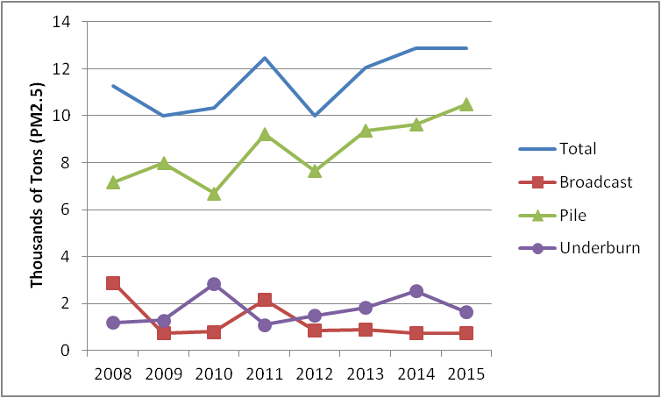An estimate of fine particulate matter emissions from prescribed burning from 2008 to 2015 is detailed in Figure 5. Avoided emissions from the techniques included as alternatives to burning is not ordinarily tracked but if the material were burned instead, it may have resulted in up to 13,500 tons of fine particulate emissions, which in 2015 would have exceeded emissions from prescribed burning.

Figure Prescribed Burning Emissions Estimate PM 2.5

The Smoke Management Plan was amended in 2014 to incorporate practices to minimize impacts to the Kalmiopsis Wilderness and Crater Lake National Park. While it is too early to assess the impact from these changes, it is clear that the management competence otherwise demonstrated in minimizing smoke intrusions into SSRAs (see Table 11) offers confidence the recommended changes can be effectively implemented.

The rules for Smoke Management Plan can be found here, <http://arcweb.sos.state.or.us/pages/rules/oars_600/oar_629/629_048.html>, and the implementing guidance document here, <http://www.oregon.gov/ODF/Documents/Fire/smd.pdf>.

Table 10 Forest Land Acres Treated - 2015

|  |  |
| --- | --- |
| from: *Oregon Smoke Management Annual Report 2015* | Total Statewide Acres |
| Prescribed Burning | 179,613 |
| Alternatives to Burning | 193,942 |
| Emission Reduction Techniques | 143,572 |

Table 11 Prescribed Forestry Burns and Intrusions 2008 - 2015

|  |  |  |  |  |  |
| --- | --- | --- | --- | --- | --- |
| Year | Total No. Units | No. Units Burned | Acres Burned | Number Intrusions | Percentage of Units with Intrusion |
| 2008 | 3,270 | 2,608 | 162,405 | 6 | 0.23% |
| 2009 | 3,222 | 2,492 | 139,000 | 5 | 0.20% |
| 2010 | 3,471 | 2,451 | 157,224 | 8 | 0.33% |
| 2011 | 3,544 | 2,880 | 162,154 | 6 | 0.21% |
| 2012 | 3,651 | 3,092 | 141,892 | 7 | 0.23% |
| 2013 | 3,890 | 3,104 | 182,189 | 3 | 0.10% |
| 2014 | 4,095 | 3,443 | 208,593 | 13 | 0.38% |
| 2015 | 3,601 | 3,076 | 179,613 | 9 | 0.29% |

## 2.3 Long Term Strategy Update

In the 2010 Regional Haze Plan Oregon DEQ identified several work commitments associated with the five-year progress report, not otherwise required in the federal regional haze rule (40 CFR 51.308 (g),(h) or (i)) for the purpose of achieving reasonable further progress. DEQ’s commitment was to evaluate the prescribed burning contribution to haze, described in Appendix A, and an evaluation of non-BART sources, described in Appendix B. Other work items are listed below with current updates and descriptions on evaluations completed to date as resources have allowed.

### 2.3.1 Non-BART Source Evaluation

The non-BART source evaluation was intended to identify facilities that may possibly contribute to impairment of visibility in Class I areas as a prelude to determine if additional controls are needed in the 10 year plan revision. A technical analysis protocol was developed for an initial screening evaluation relying on the four factors outlined in Section 308 of the Regional Haze Rule. Lacking specific guidance, DEQ relied on seven factors including size, location, distance to Class I area, quantity/distance calculation, visitation data, date of permit issuance and availability of modeling, to evaluate potential eligibility. This assessment is not a definitive impact analysis, but is meant simply to identify potential source candidates for further and more refined analysis in the next planning cycle. Thirty one sources were considered in the basic screening evaluation. Within that group, seven facilities were identified as potentially having an impact on one or more Class I areas in the state. No further action is required or needed at this time but these sources will be evaluated further during the next planning cycle.

Consideration of impact from non-BART sources is not required under the regional haze rule. DEQ undertook this evaluation as a commitment under the initial Regional Haze Plan. In undertaking any fuller analysis during the ten year plan update, which may include modeling, DEQ will consider any future guidance provided by EPA.

### 2.3.2 Update on Columbia Gorge Visibility

The Columbia River Gorge National Scenic Area was designated in 1986. While not a Class I area, air quality degradation, including visibility impairment, can lead to damaging the scenic, natural, cultural and recreational resources the designation was intended to protect. The Columbia River Gorge Commission and the U.S. Forest Service have the responsibility to administer the National Scenic Area Act and in its the Management Plan for the Columbia River Gorge National Scenic Area it requests state air quality agencies in Washington state and Oregon to develop and implement an air quality strategy for the Scenic Area.

Oregon DEQ and the Washington Southwest Clean Air Agency worked with the CRGC from 2001 to 2010 to study air quality and visibility in the Gorge, and the emission sources that contributed to haze in the Gorge. The study also included a projection of future visibility conditions in the Scenic Area. The study results identified that haze in the Gorge, attributed mostly to organic carbon, sulfates and nitrates, originated from many different sources. Improvements in visibility will necessarily result from the cumulative effect of numerous emission reduction activities.

Subsequently, the air agencies developed a strategy that is consistent with the National Scenic Area Act’s charge to “protect and enhance” the scenic, natural, cultural, and recreational resources of the Gorge. The goal for visibility in the Gorge is continued improvement using the same approach used in the Oregon’s regional haze plan. Because many of the same problems that affect haze in the Gorge are the same problems that affect haze across the western region, much of the visibility efforts under the regional haze program will benefit the Gorge, including for instance reductions in emission from the PGE Boardman facility. The Columbia River Gorge Scenic Area is situated between two Class I areas (Mt. Hood and Mt. Adams) and the Gorge will benefit from Oregon and Washington’s long term regional haze process.

The Gorge strategy also included commitments to review visibility trends in the Gorge as part of future regional haze plan updates. Therefore, as part of this federally mandated five-year regional haze plan update, DEQ is including a description of visibility conditions in the Gorge. DEQ can track Gorge visibility conditions to determine continued improvement, similar to but not on the same glide path as conditions in the Class I areas. If visibility in the Gorge is not improving or showing an increasing trend, then DEQ will reassess its Gorge strategy and potentially identify new strategies to ensure continued visibility improvement in the Gorge. Figure 6 shows visibility trends in the Gorge, from the baseline time period through the most recent available year. The COGO1 monitor (located in the western end of the Gorge) does not have data prior to 2002 and was discontinued in 2011 due to lack of funding. The CORI1 monitor (located in the eastern end of the Gorge) has two data gaps in 2002 and 2012 when data was not available.

Figure Visibility Trends - Columbia River Gorge - CORI1 & COGO1

Table 12 shows the changes in visibility affecting pollutants, light extinction and deciview for the Gorge for the most recent progress period as compared to the baseline period. Increases are seen in fine soil, coarse material and sea salt, primarily biogenic sources, highlighted in bold in the table below. The pollutants from anthropogenic sources show declines. Overall visibility has improved over this time period for both the best days and the worst days.  Data from the COGO1 site is not included because monitoring stopped in 2011 due to U.S. Forest Service funding cuts.

Table 12 Visibility Progress Summary for Columbia River Gorge National Scenic Area

|  |  |  |  |  |  |  |  |  |  |  |
| --- | --- | --- | --- | --- | --- | --- | --- | --- | --- | --- |
| **Site** | **Group** | **Change from 2000-04 to 2009-13 (Mm-1/year)** | | | | | | | | |
| **Sulfate** | **Nitrate** | **Organic Carbon** | **Elemental Carbon** | **Fine Soil** | **Coarse Material** | **Sea Salt** | **Total Light Extinction** | **Deciview** |
| CORI1 | 20% Best  20% Worst | -1.2  -1.1 | -0.1  -24 | -0.6  -6.6 | -0.4  -1.5 | **0.1**  **0.3** | -0.1  **1.5** | **0.1**  **0.1** | -2.1  -31.2 | -0.8  -2.8 |

The continuing operation of the CORI1 site has been at risk due to possible budget cuts but the U.S. Forest Service has announced that funding has been identified for the near term. DEQ does operate a nephelometer in The Dalles that can provide data on light scattering but does not provide a breakdown, or speciation, of individual pollutants contributing to the light scattering observed.

### 2.3.3 Evaluate Contribution from General Outdoor Open Burning

Industrial and commercial open burning is prohibited throughout the state except by permit. Residential open burning is restricted, if not prohibited in population centers of the state. Construction and demolition debris burning is prohibited in the Willamette Valley within 6 miles of cities over 45,000 in population and within 3 miles of remaining cities greater than 1,000 population. The net effect is to prohibit construction and demolition burning in population centers in the Willamette Valley. Emissions of nitrogen oxides declined in both types of open burning in contrast to an overall statewide increase as shown in Table 13. Sulfur dioxide emissions declined for residential open burning but increased for construction and demolition open burning. PM emissions increased for residential open burning but declined for construction and demolition burning. For both of these pollutants, the net change in emissions from open burning collectively represents a negligible contribution to the overall change in emissions from all sources statewide. The resulting emissions represent a negligible contribution to the overall inventory as shown by Table 13. Population centers that may be near Class I areas have controls in place. The remaining open burning that may otherwise occur nearer Class I areas is not likely to be a significant contributor to haze.

Table 13 Open Burning Emissions in 2008 and 2011, tons per year

|  |  |  |  |  |
| --- | --- | --- | --- | --- |
|  | | **Nitrogen Oxides** | **Sulfur Dioxide** | **PM2.5** |
| ResidentialOpen Burning | 2008 | 202.7 | 34.5 | 1,132.4 |
| 2011 | 144.6 | 24.1 | 4,505.7 |
| Construction & Demolition Open Burning | 2008 | 556.2 | 0.0 | 1,457.9 |
| 2011 | 301.9 | 7.9 | 620.3 |
| Statewide Inventory, Total | 2008 | 79,675.2 | 25,392.5 | 145,461.1 |
| 2011 | 173,522.4 | 30,284.7 | 182,517.2 |

### 2.3.4 Evaluate Contribution from Rangeland Burning

DEQ has been unable due to resource constraints to conduct a detailed analysis of the contribution to visibility impacts from rangeland burning. However, rangeland burning in southeastern Oregon is not likely to be a significant contributor to haze in Class I areas as the nearest sites, Strawberry Mountain and Eagle Cap Wilderness areas are located generally upwind of prevailing summertime wind flows. Further detailed analysis of the impacts of rangeland burning would require original investigative work as there are not established emission factors or data for this activity.

### 2.3.5 Efforts to Address Offshore Shipping

Ocean going vessels are sources of visibility impairing pollutants, PM, NOx and SOx. The Oregon coast extends approximately 363 miles from the mouth of the Columbia River in the north to the California state border in the south. Ship traffic operating coastwise offshore impacts continental locations because of prevailing westerly wind patterns year round. The Columbia River itself is a major freight corridor with ocean going vessels travelling 94 miles inland to the ports of Portland, Oregon and Vancouver, Washington with intermediate ports at Astoria, Oregon and Kalama and Longview, Washington.

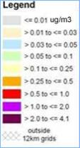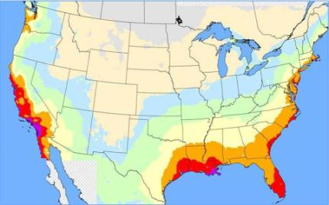The only state regulation controlling marine vessel emissions limits visible smoke in the Portland harbor area. Offshore emissions from ocean going vessels contribute as much as 85 percent of PM, NOx and SOx from all ocean going vessel emissions in the state. Until very recently those emission were uncontrolled. Under MARPOL Annex VI the United States and Canada obtained designation of an Emission Control Area for North America. This ECA will reduce emissions, primarily through fuel switching for existing vessels and exhaust controls for newer vessels. Overall NOx, PM and SOx emissions are expected to be reduced by 23 percent, 74 percent and 86 percent, respectively, below otherwise predicted levels in 2020 without the ECA. Figure 7 shows the extent of emission benefits that may occur inland with most Class I areas in Oregon experiencing a reduction in PM concentrations ranging between 0.03 ᶙg/m3 to 0.1 ᶙg/m3.

Figure North American ECA Projected PM Concentration Reductions

### 2.3.6 Update WRAP SO2 and NOx Emission Inventory for Point Sources

The WRAP update is not available at this time. See Section 3.4.1 for an analysis of changes in statewide emission inventories for point sources between 2002 and 2008.

### 2.3.7 Update on Ammonia Emission Inventory and Possible Reductions

To form ammonium sulfate and ammonium nitrate in the atmosphere, there must be readily available ammonia (NH3) in which to react. By far the most significant source of ammonia is the non-point source, agriculture livestock manure management, which includes the application of manure as fertilizer, followed by prescribed burning. Although total ammonia emissions statewide have increased to an estimated 71,695 tons per year in 2011 from 57,154 tons in 2002, the overall contribution of ammonia sulfates and nitrates to visibility impacts has not similarly increased. shows only the Crater Lake IMPROVE monitor site with a positive impairment to visibility associated with ammonium sulfate, measured as light extinction even as overall visibility has improved. Considering the major sources of ammonia in the state this incremental change may be more attributable to prescribed burning than agricultural practices. As noted in Section 2.2.2 and Appendix A recent changes to the Smoke Management Plan have been adopted specifically for the Crater Lake and Kalmiopsis Wilderness areas to address prescribed burning impacts. Since these controls have only recently been in place, it is too soon to evaluate effectiveness and consider whether additional controls are necessary. This can be an area for review for the 10 year update.

### 2.3.8 Update on 2010 Changes to Willamette Valley Field Burning

The 2009 Oregon Legislature adopted SB 528 that has resulted in a further reduction in agricultural field burning in the Willamette Valley. The burning of grass seed and cereal grain fields in the Willamette Valley is a summertime practice to dispose of leftover straw after harvest, improve yield and reduce herbicide and pesticide use. This practice produces smoke and fine particulate matter that can cause health problems and contribute to haze.

SB 528 eliminated regular field burning in the Willamette Valley, starting in 2010. Prior to that, up to 40,000 acres were allowed to be burned every year. The law also reduced burning of fields containing creeping red fescue, chewings fescue and highland bentgrass as well as fields on steep terrain from 25,000 to 15,000 acres per year. These fields are located almost entirely in Marion County. The law does allow up to 2,000 acres of “emergency burning” to address major disease outbreaks or insect infestations. There have been no applications for emergency burning to date. Acreage allowances for stack burning and propane flaming were reduced to 1,000 and 5,000 acres per year, respectively, but were eliminated after 2013. These changes were adopted by administrative rule as part of the State Implementation Plan by the Environmental Quality Commission in August 2010. These changes will provide minor visibility improvement during the summer months.

### 2.3.9 Updates to Long Term Strategy from Ongoing Air Pollution Programs - Interstate Transport, Ravi BART, Oregon Phase I Visibility Program, PSD/New Source Review, Mobile Sources, PM10 & PM2.5 NAAQS and Nonattainment Areas

The following summary describes updates to ongoing programs and regulations in Oregon that directly protect visibility, or can be expected to improve visibility in Oregon Class I areas, by reducing emissions in general. This summary does not attempt to estimate the actual improvements in visibility that will occur, as many of the benefits are secondary to the primary air pollution objective of these programs/rules, and consequently would extremely difficult to quantify, due to the technical complexity and limitations in current assessment techniques.

Interstate Transport

Section 12.3 of the 2010 Regional Haze Plan analyzes the impacts of haze pollutants transported from Oregon to Class I areas in adjoining states as well as the impact to Oregon’s Class I areas from haze pollutants transported into Oregon. As for impacts in out of state Class I areas, the BART controls for the PGE Boardman plant will make a significant difference as this facility was modeled to affect visibility in 14 Class I areas in Oregon, Washington, Idaho, Nevada and the Columbia Gorge National Scenic Area. The improvement in visibility in the Mt. Hood Wilderness, for instance will be 4.98 deciviews by 2020. Similarly the phase-out of the coal fired boilers at the TransAlta power plant in Centralia Washington will have visibility benefits in the 13 Class I areas modeled to be impacted by emissions. The phase-out occurs in two steps with one boiler ceasing operation by December 31, 2020 and the remaining coal boiler shut down in 2025. Ultimately the resulting improvement in visibility in the Mt. Hood Wilderness will be 3.47 deciviews.

Oregon Phase 1 Visibility Program

The Oregon Phase I Visibility Program remains in place since its adoption in Oregon in 1986. This program consists of short and long term strategies focused on nearby sources of visibility impairment in Class I areas. The program consists of RAVI BART, Prevention of Significant Deterioration New Source Review rules for industrial sources and seasonal protection during the summer months associated with prescribed forestry burning and agricultural field burning. The Phase I program also does not allow field burning on summer weekends upwind of Class I areas. Each of these programs remains in place and continue to function as designed.

RAVI BART

The Department includes Reasonably Attributable Visibility Impairment BART requirements as part of the Oregon Visibility Plan. RAVI BART is triggered by a certification from a federal land manager that visibility impairment exists in a federal Class I area. Since the adoption of RAVI BART, there has been no formal certification made in Oregon for reasonably attributable impairment.

PSD/New Source Review

The PSD/New Source Review rules protect visibility in Class I areas from new industrial sources and major changes to existing sources by requiring modeling to show no significant visibility impact defined as impairment above background more than 5%, expressed as visibility extinction. Over the past 5 years ten or more sources have undergone analysis of their potential impacts to visibility in Class I areas. Each of these reviews have resulted in determination of no significant impacts, i.e., below threshold levels, either through modification of the facility’s original operating plan, installation of controls or a decision to not build. The program remains in place and continues to protect visibility in the Class I areas.

Mobile Sources

Several mobile source regulations at the federal level are continuing and states like Oregon will see significant visibility benefits as a result. These programs include the movement to lower sulfur fuel concentrations in both diesel and gasoline, reduced PM and NOx emissions from heavy duty on-road vehicles and non-road equipment. Recent federal rules, such as the 2010 requirements that ultra low sulfur diesel fuel standard of 15 ppm sulfur be applied to all non-road diesel fuel. Locomotive and marine diesel fuel are required to meet the ULSD standard in 2012 resulting in further reductions of SO2, NOx and PM emissions.

Beginning with the 2009 model year, light and medium duty gasoline powered vehicles sold in Oregon must meet Low Emission Vehicle emission standards. Although the primary purpose is to reduce greenhouse gas emissions, these rules also lead to decreases in PM and NOx. The Department also operates vehicle inspection programs in both the Portland and Medford area ensuring that continued maintenance of emission control equipment on existing vehicles ensures the continued benefits of the federal and state programs requiring lower emitting newly manufactured vehicles.

PM10 & PM2.5 NAAQS and Nonattainment Areas

Oakridge and Klamath Falls are currently the only PM2.5 nonattainment areas in the state. Residential woodheating is the primary source of pollutants for each of these areas. The attainment plans include control strategies to reduce PM2.5 pollution, specifically through mandatory woodstove curtailment programs and enforcement which are effective in reducing pollution levels during the winter months, increased education and outreach to reduce smoke pollutant levels year-round, and woodstove changeouts. These controls will result in reductions of PM emissions in these communities and the surrounding area.

### 2.3.10 Wildfire Emission Trends

Oregon, like other western states, is subject to visibility impacts from wildfires. Trends in changing climate resulting in summers with lower precipitation and winters with reduced snow pack can otherwise exacerbate conditions that contribute to increases in the number of acres burned as shown in Figure 8 (from National Interagency Fire Center). Wildfires are occurring more frequently and burning increasing amounts of acreage as indicated in the trend line in the graph. Wildfires cause increases in a variety of visibility impairing pollutants that, depending upon location and wind direction, can have a material effect on Class I area visibility. The impacts are especially challenging because these are not directly controllable anthropogenic events. Wildfire smoke represents a challenge to achieving visibility improvement goals.

### 2.3.11 Update to WRAP Regional Modeling

Figure Oregon Wildfire Acres Burned - Historic and Trends

WRAP is not expected to update previous regional modeling work during the timeframe for this report.

### 2.3.12 Other State Class I Areas Affected by Oregon Emissions

In the 2010 Oregon Regional Haze Plan several Class I areas in adjoining states were identified as receiving impacts from emission sources in Oregon. These included Mt Rainier National Park and the Goat Rock Wilderness in Washington state, Sawtooth Wilderness in Idaho, Jarbridge Wilderness in Nevada, Lava Beds National Monument and Redwood National Park in California. In none of the examples was there a sizeable contribution from Oregon sources identified considering PSAT and WEP source apportionment information. Additional reductions will come when a more stringent BART SO2 emission limit is required starting July 1, 2018 at the PGE-Boardman coal-fired plant in NE Oregon, which was itself shown to impact 14 Class I areas in Oregon and Washington. Significant anthropogenic Oregon sources contributing to visibility degradation in adjoining states was identified in the first regional haze plan. With controls in place and underway, we expect these impacts to be lessened in the future.

### 2.3.13 Reasonable Progress Demonstration Relative to Oregon Reasonable Progress Goals

The 2010 Oregon Regional Haze Plan established reasonable progress goals to show achievements, or challenges, to achieving natural visibility conditions. Progress towards those goals at this intermediate interval is shown below but will be subject to a more thorough analysis in the 2018 report.

For both worst day and best day visibilities, the most recent data indicate progress in being made towards the overall regional haze goal but for worst day conditions in the Central Cascades, which includes the Mt. Jefferson, Mt. Washington and Three Sisters Wilderness areas. This adverse change in visibility is attributable to wildfire smoke as discussed in more detail in Section 3.8.

Table 14 Oregon Visibility Observed Relative to Reasonable Progress Goals Through 2014

|  |  |  |  |  |  |  |  |  |  |
| --- | --- | --- | --- | --- | --- | --- | --- | --- | --- |
| **Region** | **Oregon**  **Class I Area** | **20% Worst Days** | | | | **20% Best Days** | | | |
| **2000-04 Baseline (dv)** | **2005-09 First Progress Period**  **(dv)** | **2010-14 Current Period**  **(dv)** | **2018 Reasonable Progress Goal**  **(dv)** | **2000-04 Baseline (dv)** | **2005-09 First Progress Period**  **(dv)** | **2010-14 Current Period**  **(dv)** | **2018 Reasonable Progress Goal**  **(dv)** |
| **Northern Cascades** | **Mt. Hood Wilderness Area** | **14.9** | **13.7** | **13.2** | **13.8** | **2.2** | **1.7** | **1.3** | **2.0** |
| **Central Cascades** | **Mt. Jefferson, Mt. Washington,**  **and Three Sisters Wilderness Areas** | **15.3** | **16.2** | **14.9** | **14.3** | **3.0** | **3.0** | **2.5** | **2.9** |
| **Southern Cascades** | **Crater Lake**  **National Park;**  **Diamond Peak, Mountain Lakes, and Gearhart Mountain Wilderness Areas** | **13.7** | **13.8** | **11.7** | **13.4** | **1.7** | **1.6** | **1.2** | **1.5** |
| **Coast Range** | **Kalmiopsis Wilderness Area** | **15.5** | **16.4** | **14.6** | **15.1** | **6.3** | **6.4** | **6.1** | **6.1** |
| **Eastern Oregon** | **Strawberry Mountain and Eagle Cap Wilderness Areas** | **18.6** | **16.2** | **12.5** | **17.5** | **4.5** | **3.6** | **2.8** | **4.1** |
| **Eastern Oregon/ Western Idaho** | **Hells Canyon Wilderness Area** | **18.6** | **18.2** | **16.3** | **16.6** | **5.5** | **4.8** | **4.1** | **4.7** |

# 3. Visibility Trends and Emissions Changes

This section includes summaries of monitoring and emissions data for first 5-year regional haze progress report for Oregon. The monitoring data presented here are from the IMPROVE network, as described in Section 1.3.1. The emissions data was collected by the WRAP using inventories previously developed for the first regional haze plan, and emissions estimates more recently collected by the WRAP for this progress report.

## 3.1 Overview of Monitoring Data Analysis

The visibility improvement goal, as stated in the RHR, is to ensure that visibility on the worst days improves towards a natural conditions goal, and that visibility on the best days does not get worse. To measure progress towards natural conditions, the EPA provided the concept of a linear, or uniform, rate of reasonable progress between the 2000-2004 baseline period and a default natural conditions goal year of 2064. The RHR specifies that progress is determined for “current conditions” for the best and worst days.

In September 2003, EPA issued formal guidance for tracking progress under the RHR. In this guidance it specified that progress be tracked against the 2000-2004 baseline period using corresponding averages over successive 5-year periods (i.e. 2005-2009, 2010-2014, etc.). In April 2013, EPA issued general principles to assist States in preparing 5-year progress reports, where it specified that progress “should include the 5-year average that includes the most recent quality assured public data available at the time the state submits its 5-year progress report for public review”.

As noted in Section 1.3.2, the Department relied upon the WRAP Regional Haze Reasonable Progress Report completed in June 2013 for detailed information about visibility determinants. The Department also reviewed the 2010-2014 data in addition to the 2005-2009 averaging period, and has included these two five year periods in the evaluation of overall visibility trends, noting any data that indicates significant differences from the prior 5-year trend.

### 3.1.1 Monitoring Data and the 20% Best and Worst Days

Visibility impairment is the result of the cumulative effect of several different particle pollutant types. Many of these pollutants have individually consistent seasonal patterns. For example, ammonium nitrate is temperature sensitive, and formation often favored during colder winter months, while ammonium sulfate formation may be favored during warmer summer months. Other pollutants, such as particulate organic mass, may be impacted by large and variable episodic events such as unplanned fires, which generally occur during the summer.

To determine the 5-year average of the 20% best and worst days, the highest and lowest 20% of days for each complete year are first selected and averaged on an annual basis, with a 5-year average calculated from these annual averages. The timing for identification of the 20% best and worst days may be significantly influenced by large episodic events (e.g., unplanned fires) which may occur at different time during different years. As a result, the identification of more best or worst days during different seasons of different years may affect the averages for individual species in ways that are independent from actual increases or decreases of individual pollutants from one 5-year period to the next.

## 3.2 Results of Analysis of Monitoring Data and Visibility Trends

### 3.2.1 Summary

The following is a summary of current visibility conditions (2010-2014), the differences between the 2000-2004 baseline and current visibility conditions (2010-2014), and the differences between the 2000-2004 baseline and 2005-2009 period based on IMPROVE monitoring data, for the 20% best and worst days. Annual average trend for the 2000-2009, 10-year period are also presented here to support assessments of changes in each monitored species that contributes to visibility impairment. Some of the highlights regarding these comparisons are listed below, and more detailed state specific information is provided in monitoring and emissions sections that follow. Table 15 refers to the monitoring location sites.

Table 15: Oregon IMPROVE Monitoring Network

|  |  |
| --- | --- |
| **Site Code** | **Class I Area** |
| MOHO1 | Mt. Hood Wilderness |
| THSI1 | Mt. Jefferson Wilderness  Mt. Washington Wilderness  Three Sisters Wilderness |
| CRLA1 | Crater Lake National Park;  Diamond Peak Wilderness  Mountain Lakes Wilderness  Gearhart Mountain Wilderness |
| KALM1 | Kalmiopsis Wilderness |
| STAR1 | Strawberry Mountain Wilderness  Eagle Cap Wilderness |
| HECA1 | Hells Canyon Wilderness Area |
| **Site Code** | **Scenic Area** |
| CORI1 | Columbia River Gorge National Scenic Area |
| COGO1[7] | Columbia River Gorge National Scenic Area |

### 3.2.2 Conditions for the 2010-2014 Current Visibility Period

#### 40 CFR 51.308 (g) (3) (i)

This section addresses the required element describing conditions in the 2010-2014 current visibility period. and present the calculated deciview values for current conditions at each site, along with the percent contribution to extinction from each aerosol species for the 20% most impaired, or worst, and 20% least impaired, or best, days for each of the Federal Class I area IMPROVE monitors in Oregon. Note that the percentages in the tables consider only the aerosol species which contribute to extinction, while the charts also show Rayleigh, or scattering due to background gases in the atmosphere.

Specific observations for the visibility conditions in the current visibility period on the 20% most impaired days are as follows:

* The largest contributor to aerosol extinction at Oregon sites was organic carbon, ammonium nitrate and ammonium sulfate.
* For the 20% most impaired days, particulate organic matter was the highest pollutant contributor to visibility impairment at all Class 1 sites.
* The greatest increase in particulate organic matter was at the THS1 and CRLA1 monitoring sites.
* The highest aerosol extinction (16.3 dv) was measured at the HECA1 site, where organic carbon was the largest contributor to aerosol extinction, followed by ammonium nitrate. The lowest aerosol extinction (13.2 dv) was measured at the MOHO1 site.

Specific observations for the visibility conditions in this progress period on the 20% least impaired days are as follows:

* The aerosol contribution to total extinction on the best days was less than Rayleigh, or the background scattering that would occur in clear air. Average extinction (including Rayleigh) ranged from 1.2 dv (CRLA1) to 6.1 dv (KALM1).
* For all sites except KALM1, ammonium sulfate was the largest non-Rayleigh contributor to the aerosol species of extinction
* At the KALM1 site, organic carbon was the largest contributor to aerosol extinction, followed by ammonium sulfate.

Table 16 Oregon IMPROVE Sites, Visibility Conditions 2010-2014 Current Period, 20% Most Impaired Days

|  |  |  |  |  |  |  |  |  |
| --- | --- | --- | --- | --- | --- | --- | --- | --- |
| **Site** | **Deciviews (dv)** | **Percent Contribution to Aerosol Extinction by Species (Excludes Rayleigh) (% of Mm-1) and Rank* (20% most impaired) 2010-2014** | | | | | | |
| **Sulfate** | **Nitrate** | **Organic Carbon** | **Elemental Carbon** | **Fine Soil** | **Coarse Material** | **Sea Salt** |
| CRLA1 | 11.7 | 30% | 6% | **44%** | 9% | 3% | 7% | 1% |
| HECA1 | 16.3 | 12% | 36% | **39%** | 6% | 1% | 5% | 1% |
| KALM1 | 14.6 | 26% | 7% | **41%** | 7% | 1% | 6% | 12% |
| MOHO1 | 13.2 | 26% | 10% | **42%** | 6% | 3% | 12% | 2% |
| STAR1 | 14.5 | 19% | 20% | **43%** | 6% | 2% | 9% | 1% |
| THSI1 | 14.9 | 24% | 5% | **47%** | 7% | 3% | 14% | 1% |

*Highest aerosol species contribution per site is highlighted in bold

Table 17 Oregon IMPROVE Sites, Visibility Conditions 2005-2009 Progress Period, 20% Least Impaired Days

|  |  |  |  |  |  |  |  |  |
| --- | --- | --- | --- | --- | --- | --- | --- | --- |
| **Site** | **Deciviews (dv)** | **Percent Contribution to Aerosol Extinction by Species (Excludes Rayleigh) (% of Mm-1) and Rank (20% least impaired) 2010-2014** | | | | | | |
| **Sulfate** | **Nitrate** | **Organic Carbon** | **Elemental Carbon** | **Fine Soil** | **Coarse Material** | **Sea Salt** |
| CRLA1 | 1.2 | **43%** | 6% | 20% | 14% | 4% | 5% | 6% |
| HECA1 | 4.1 | **36%** | 11% | 27% | 6% | 4% | 12% | 3% |
| KALM1 | 6.1 | 25% | 5% | **42%** | 11% | 0% | 7% | 10% |
| MOHO1 | 1.3 | **46%** | 14% | 9% | 6% | 4% | 7% | 14% |
| STAR1 | 2.8 | **44%** | 13% | 19% | 4% | 2% | 10% | 8% |
| THSI1 | 2.5 | **49%** | 9% | 19% | 5% | 0% | 7% | 11% |

*Highest aerosol species contribution per site is highlighted in bold

### 3.2.3 Differences Between Baseline and Current Period Visibility Conditions

#### 40 CFR 51.308 (g) (3) (ii)

This section addresses the required element, what is the difference between visibility conditions for the most impaired and least impaired days from the baseline period to the current period. Table 18 displays changes in aerosol extinction and total light extinction for the Oregon based Class I IMPROVE monitors for the difference between the baseline period (2000-04) to the most recent 5 year progress period (2010-14). Changes in deciview are also calculated. Values indicating an increase from the earlier period are bolded.

Table 18 Changes in Visibility from Baseline to Most Recent Progress Period

|  |  |  |  |  |  |  |  |  |  |  |
| --- | --- | --- | --- | --- | --- | --- | --- | --- | --- | --- |
| **Site** | **Group** | **Change from 2000-04 (baseline) to 2010-14 (progress period) (Mm-1/year)** | | | | | | | | |
| **Sulfate** | **Nitrate** | **Organic Carbon** | **Elemental Carbon** | **Fine Soil** | **Coarse Material** | **Sea Salt** | **Total Light Extinction** | **Deciview** |
| CRLA1 | 20% Best | **0.1** | -0.2 | -0.1 | -0.4 | 0 | -0.1 | -0.1 | -0.6 | -0.5 |
| 20% Worst | **0.2** | -1.2 | -10.6 | -2.1 | 0 | -0.6 | **0.2** | -14.1 | -2.0 |
| HECA1 | 20% Best | -0.4 | -0.3 | -0.9 | -0.3 | -0.1 | -0.3 | 0 | -2.3 | -1.4 |
| 20% Worst | -2.6 | -11.4 | **3.1** | -0.2 | 0 | **0.7** | **0.2** | -10.1 | -2.3 |
| KALM1 | 20% Best | 0 | -0.1 | 0 | -0.1 | 0 | -0.1 | 0 | -0.3 | -0.2 |
| 20% Worst | -1.4 | -1.0 | -0.6 | -0.2 | -0.1 | 0 | **1.1** | -2.3 | 0 |
| MOHO1 | 20% Best | -0.6 | -0.2 | -0.1 | -0.1 | 0 | 0 | -0.1 | -1.1 | -0.9 |
| 20% Worst | -2.8 | -2.3 | -1.0 | -0.9 | **0.2** | **1.5** | **0.4** | -4.7 | -1.7 |
| STAR1 | 20% Best | -0.5 | -0.3 | -1.1 | -0.4 | 0 | -0.2 | **0.1** | -2.6 | -1.7 |
| 20% Worst | -0.5 | -8.1 | -7.8 | -1.9 | -0.4 | -1.5 | **0.1** | -20.1 | -4.1 |
| THSI1 | 20% Best | -0.2 | -0.1 | -0.2 | -0.1 | 0 | -0.1 | 0 | -0.7 | -0.5 |
| 20% Worst | -2.6 | -0.9 | **1.0** | -0.4 | **0.6** | **2.7** | **0.2** | **0.6** | -0.4 |

For the 20% best days, all areas show reductions, or at minimum, no to very little change in extinction over the time considered. Visibility as expressed in deciviews show improvement over this 14 year period.

For the 20% worst days, the change in extinction shows increases in several aerosols that are primarily biogenic in origin. At only the Three Sisters IMPROVE monitor does any of this change in resulting light extinction result in a worsening of visibility conditions. Section 3.8 provides a more detailed discussion of the situation evidenced at THSI1, which is attributed to the influence of wildfires. All other monitors show improvements in visibility over this longer term trend.

### 3.2.4 Changes in Visibility Impairment for First Progress Period Compared to Baseline Conditions

#### 40 CFR 51.308 (g) (3) (iii)

This section addresses the required element, what is the difference between visibility conditions for the most impaired and least impaired days from the baseline period to the first progress period. Included here are comparisons between the 5-year average baseline conditions (2000-2004) and first progress period extinction (2005-2009).

* For the best days, the 5-year average deciview metric decreased at all except the CORI1 and KALM1 sites. Note that the CORI1 site does not represent a Federal Class I area, but the state of Oregon tracks regional haze progress at this site.
  + Increases on best days at both sites were small (0.3 dv at CORI1 and 0.1 dv at KALM1). At the CORI1 site, higher deciview values were due to increases in ammonium nitrate, soil, coarse mass and sea salt. At the KALM1 site, the only aerosol species that increased on the best days was sea salt.
* For the worst days, the 5-year average deciview metric decreased at most sites, but increased at the CRLA1, KALM1 and THSI1 sites.

Notable differences for individual species averages were as follows:

* The largest increases in 5-year averages at the KALM1, HECA1, and CRLA1 sites were due to particulate organic mass and ammonium sulfate for the KALM1 and CRLA1 sites.
  + For particulate organic mass, several unplanned fire events during the summer months affected measurements at the sites for the current 5-year period. The largest events occurred at the KALM1 site in August 2008, the HECA1 site in July 2007, and at the CRLA1 site in July 2007.
  + For ammonium sulfate, increases in 5-year averages were consistent with slightly increasing ammonium sulfate trends for the southwest Oregon and nearby northeast California sites. Emissions inventories showed decreases in state-wide SO2 for all categories, but off-shore emissions that may affect these sites are not explicitly represented here.
* At the THSI1 site, coarse mass was the largest species contributor to increases in the 5-year average deciview metric. A slightly increasing annual average trend in coarse mass was also measured at the site, and emissions inventories showed increases in fugitive and road dust sources for coarse mass, partially offset by decreases in point and area sources.
* Ammonium nitrate decreased at all sites except KALM1, where the 5-year average remained the same. The largest decreases were measured at the CORI1 and HECA1 sites.
* At the CRLA1 and KALM1 sites, where the average deciview value increased, ammonium sulfate and particulate organic mass contributed to the largest increases in extinction.
* At the THSI1 site, coarse mass and soil were the largest aerosol species contributors to the increase in the deciview average at the site.

For the 20% least impaired days, the 5-year average deciview metric decreased at all sites except CORI1 and KALM1. Notable differences for individual species averages on the 20% least impaired days were as follows:

* The increase in 5-year average deciviews at the CORI1 site was due to increases in soil, coarse mass, sea salt and ammonium sulfate.
* The increase at the KALM1 site was due to increases in ammonium sulfate and sea salt.

Table 19 Oregon IMPROVE Sites - Difference in Aerosol Extinction by Species, 2000-2004 Baseline Period to 2005-2009 Progress Period, 20% Most Impaired Days



Table 20 Oregon IMPROVE Sites - Difference in Aerosol Extinction by Species, 2000-2004 Baseline Period to 2005-2009 Progress Period, 20% Least Impaired Days



Figure 9 Average Extinction for Baseline and First Progress Period Extinction for Worst (Most Impaired) Days Measured at Oregon IMPROVE Sites



Figure 10: Difference Between Average Extinction for First Progress Period (2005-2009) and Baseline Period (2000-2004) for the Worst (Most Impaired) Days Measured at Oregon IMPROVE Sites



Figure 11 Average Extinction for Baseline and First Progress Period Extinction for Best (Least Impaired) Days Measured at Oregon IMPROVE Sites



Figure 12 Difference between Average Extinction for First Progress Period (2005-2009) and Baseline Period (2000-2004) for the Best (Least Impaired) Days Measured at Oregon Improve Sites



### 3.2.5 Visibility through 2010 – 2014 Progress Period

This section addresses trends for the entire 10 year planning period. Trend statistics for the years 2000-2009 for each species at each site in Oregon are summarized in Table 21[8]. Only trends for aerosol species trends with p-value statistics less than 0.15 (85% confidence level) are presented in the table here, with increasing slopes in red and decreasing slopes in blue[9]. In some cases, trends may show decreasing tendencies while the difference between the 5-year averages do not (or vice versa). For instance, increases may be driven by uncharacteristically high average measurements that may not reflect overall downward trends. In these cases, the 5-year average for the best and worst days is the important metric for RHR regulatory purposes, but trend statistics may be of value to understand and address visibility impairment issues for planning purposes.

Table 21 Oregon IMPROVE Sites, Change in Aerosol Extinction by Species, 2000-2009 Annual Average Trends



For each site, a more comprehensive list of all trends for all species, including the associated p-values, is provided in Appendix K. Additionally, this appendix includes plots depicting 5-year, annual, monthly and daily average extinction for each site. These plots are intended to provide a fairly comprehensive compilation of reference information for individual states to investigate local and regional events and outliers that may have influenced changes in visibility impairment as tracked using the 5-year deciview metrics. Note that similar summary products are also available from the WRAP TSS website (http://vista.cira.colostate.edu/tss/). Some general observations regarding changes in visibility impairment at sites in Oregon are as follows:

* Ammonium nitrate showed decreasing annual average trends for the worst days at all Oregon sites, with the largest decreases measured at the HECA1, STAR1, CORI1, and COGO1 sites.
* Large particulate organic mass events occurred at all sites, generally between August and September. Monthly and daily charts in Appendix K indicate that the largest events occurred in August 2005 at KALM1, August and September 2006 at CRLA1, HECA1, MOHO1, and STAR1, July 2007 at HECA1 and July through September 2008 at CRLA1 and MOHO1.
* The increase in the deciview metric between the baseline period and the progress on the worst days at the THSI1 site was mostly due to coarse mass. Daily extinction plots in Appendix K indicate that this was due an anomalous increase in coarse mass measured between July and September of 2009 at the site.

## 3.3 Overview of Emission Inventory Analysis

To demonstrate RHR progress, states are required to report how total emissions in the state have changed over the initial reporting period, and to determine if there have been significant changes in emissions from the state or from other states affecting visibility at each Class I area. Comparisons between emissions inventories in this report use the inventories that represent both baseline and current conditions. Baseline emissions cited in the first regional haze plans used the 2002 inventory developed by the WRAP. Current emissions cited in this progress report were also developed by the WRAP, based on an updated and comprehensive inventory for the year 2008 that the WRAP used in modeling projects.

Emissions inventories in this report were complicated by the fact that a number of changes and enhancements have occurred between development of the baseline and current period inventories, such that many of the differences between inventories are more reflective of changes in inventory methodology, rather that changes in actual emissions. Differences in emissions are presented for all categories in this report, but summaries focus on aspects of source categories that have been more consistently inventoried over time, while noting any changes in methodologies that may affect differences in other categories. Detailed references regarding emissions inventories are presented in this section.

### 3.3.1 Inventory Descriptions

Emissions related to the different particle species that affect regional haze are varied and complex, including a number of both anthropogenic and natural source possibilities. Emissions estimates vary by source category according to the different characteristics and attributes of each category, and how the emissions are modeled. A number of anthropogenic, or man-made, sources such as motor vehicles and electric generating units (EGUs) are reported by states and may be subject to controls. Natural emissions, such as fires, biogenic emissions and some categories of dust can have large regional haze impacts, but are not subject to control strategies. Source categories for both anthropogenic and natural sources are listed and described briefly below.

* Point Sources: These are sources that are identified by point locations, typically because they are regulated and their locations are available in regulatory reports. In addition, elevated point sources will have their emissions allocated vertically through the model layers, as opposed to being emitted into only the first model layer. Point sources can be further subdivided into EGU sources and non-EGU sources, particularly in criteria inventories in which EGUs are a primary source of NOX and SO2. Examples of non-EGU point sources include chemical manufacturers and furniture refinishers.
* Area Sources: Sources that are treated as being spread over a spatial extent (usually a county or air district) and that are not movable (as compared to non-road mobile and on-road mobile sources). Because it is not possible to collect the emissions at each point of emission, they are estimated over larger regions. Examples of stationary area sources are residential heating and architectural coatings. Numerous sources, such as dry cleaning facilities, may be treated either as stationary area sources or as point sources.
* On-Road Mobile Sources: These include vehicular sources that travel on roadways. Emissions from these sources can be computed either as being spread over a spatial extent or as being assigned to a line location (called a link). Emissions are estimated as the product of emissions factors and activity data, such as vehicle miles traveled (VMT). Examples of on-road mobile sources include light-duty gasoline vehicles and heavy-duty diesel vehicles.
* Off-Road Mobile Sources: Off-road mobile sources are vehicles and engines that encompass a wide variety of equipment types that either move under their own power or are capable of being moved from site to site. Examples include agricultural equipment such as tractors or combines, aircraft, locomotives and oil field equipment such as mechanical drilling engines. Emissions from marine vessels are included here separately as offshore emissions.
* Off-shore: Commercial marine emissions comprise a wide variety of vessel types and uses. Emissions can be estimated for deep draft vessels within shore and near port using port call data, and offshore emissions generated from ship location data.
* Oil and Gas Sources: Oil and gas sources consist of a number of different types of activities from engine sources for drill rigs and compressor engines, to sources such as condensate tanks and fugitive gas emissions. The variety of emissions types for sources specific to oil and gas activity can, in some cases, overlap with mobile, area or point sources, but these can also be extracted and treated separately.
* Biogenic Emissions: Biogenic emissions are based on the activity fluxes modeled from biogenic land use data, which characterizes the types of vegetation that exist in particular areas. Emissions are generally derived using modeled estimates of biogenic gas-phase pollutants from land use information, emissions factors for different plant species, and meteorology data.
* Dust: Dust emissions may have a variety of sources that could include anthropogenic sources, natural sources, and natural sources that may be influenced by anthropogenic activity. For emissions summary purposes, dust is classified here as fugitive dust and windblown dust. Fugitive dust includes sources such as road dust, agricultural operations, construction and mining operations and windblown dust from vacant lands. The windblown dust category includes more of the natural influences such as wind erosion on natural lands.
* Fire: Fire sources are a mix of natural and anthropogenic influences. Natural sources include unplanned fires, while anthropogenic sources can include agricultural and prescribed fires. In order to better distinguish between natural and anthropogenic fires, the WRAP has created an operational policy level definition of fire activity as discretely natural or anthropogenic, which included allowing certain types of prescribed fires to be treated as natural.

As noted previously, baseline and current period emissions are summarized here using two discreet years, where one year is used to represent baseline emissions, and other is used to represent the current progress period. For contiguous states, the baseline period inventories summarized here for comparison to current conditions is the 2002 inventory that was developed for WRAP states in support of the original SIPs, termed “plan02d”. Development of the plan02 inventories were a cooperative effort sponsored by the WRAP in cooperation with WRAP states. This effort built upon 2002 emissions reported by states, and included work with contractors and WRAP workgroups, in consultation with states, to enhance specific categories (e.g., point, area, on- and off-road mobile, oil and gas, fire, and dust) to better characterize regional haze implications. Detailed descriptions of inventory development are available from the WRAP Technical Support System website (http://vista.cira.colostate.edu/TSS/Results/Emissions.aspx).

The WRAP has continued to support emissions data tracking and related technical analyses focused on understanding current and evolving regional air quality issues in the western states. Methods for estimating emissions of many of the source categories that affect regional haze have continued to evolve and be refined over time. This is especially true for inventories of natural emissions categories including windblown dust and biogenic emissions, and also for rapidly evolving industries such as oil and gas exploration. To represent current conditions, this progress report support document leverages 2008 emissions data inventories which have been recently developed as part of the WRAP’s West-wide Jumpstart Air Quality Modeling Study (WestJumpAQMS) and Deterministic and Empirical Assessment of Smoke’s Contribution to Ozone (DEASCO3) study, which are described briefly below:

* The WestJumpAQMS project (http://wrapair2.org/WestJumpAQMS.aspx) sponsored by the WRAP includes coordination and harmonization with the EPA 2008 National Emissions Inventory (2008 NEI v2). Among other goals, this project is intended to provide technical updates and improvements for multiple air quality issues, including regional haze, ozone, particulate pollution and nitrogen deposition.
* The DEASCO3 study (http://www.wrapfets.org/deasco3.cfm) is a project sponsored by the Joint Fire Sciences Program (JFSP) that looks at impact of weather and fires on ozone formation. This project has included the development of a detailed and comprehensive 2008 fire emissions inventory, which will eventually be incorporated into the WestJumpAQMS project.

Because these inventories have been refined over time, there is not necessarily continuity between the 2002 and 2008 inventories, which affects data comparisons for particular source categories. Detailed references and major methodology differences for the emissions inventories compared here are summarized in Table 22.

Table 22 Emissions Inventory Descriptions

|  |  |  |  |
| --- | --- | --- | --- |
| **Inventory**  **Sector** | **2002 Baseline Inventory**  **(Plan02c/Plan02d)[10]** | **2008 Progress Period**  **Inventory**  **(WRAP WestJump08)[11]** | **Comments** |
| Point  Sources | The Oregon inventory reported here used the Plan02d point source inventories.  These inventories were generated using hourly EPA CAMD CEM data for EGUs.  Other point were developed in consultation with states by the ERG contractor.  Note that the WRAP also generated point source inventories for both actual reported 2002 (Base02b) EGU and all other point source data, and for a 2000-2004 average of EGU point sources (Plan02c and Plan02d). Plan02 emissions are summarize in this report because they are consistent with what was reported as baseline conditions for most initial WRAP region SIPs. | The WRAP WestJump 2008 inventories were generated using hourly EPA CAMD CEM data for EGUs. Other point sources are from the 2008 NEI v2**.**  Note that point source oil and gas inventories were provided separately for WestJump08, but combined here for comparisons with 2002 inventories. | Note that baseline conditions presented here represent a 5-year average for EGUs, while progress period conditions are represented with 2008 data.  In addition to inventory changes for these two years, year-to-year variations are also presented separately for Title IV Major Sources on a regional and state basis.[12] |
| Area  Sources | The Oregon inventory reported here used the Plan02d point source inventories.  These inventories were developed by the ERG contractor in consultation with states. | The WRAP WestJump 2008 used state reported area source inventories from the 2008 NEI v2.[13] | Note that area oil and gas sources are reported separately in this report.  Area source estimates represent broad areas, and include calculations which are, in part, based on population estimates. Because of this, both changes in emissions calculation methods (which can be different from state to state and year to year), and changes in inputs such as population can affect differences between these inventories. |
| **Inventory**  **Sector** | **2002 Baseline Inventory**  **(Plan02c/Plan02d)** | **2008 Progress Period**  **Inventory**  **(WRAP WestJump08)** | **Comments** |
| Area Oil  and Gas | These inventories were developed for specific oil and gas basins using WRAP Phase II emissions methodologies.[14]  Where WRAP Phase II emissions were not available, area source oil and gas emissions as reported by the state were used. Phase II emissions process estimated for 2002 included:  • Drill Rigs  • Wellhead Compressor Engines  • CBM Pump Engines  • Heaters  • Pneumatic Devices  • Condensate and oil tanks  • Dehydrators  • Completion Venting | These inventories were developed for specific oil and gas basins using WRAP Phase III emissions methodologies. Where WRAP Phase III emissions were not available, area source oil and gas emissions as reported by the state were used. Phase II emissions process estimated for 2008 included:  These inventories used 2008 production data, which was updated with State-reported data in some cases. The following additional categories were included in addition to those listed for 2002:  • Lateral compressor engines  • Workover rigs  • Salt-water disposal engines  • Artificial lift engines  • Vapor recovery units (VRUs)  • Miscellaneous or exempt engines  • Flaring  • Fugitive emissions  • Well blowdowns  • Truck loading  • Amine units (and gas removal)  • Water tanks | Oil and gas development is a rapidly evolving industry, and significant efforts to better characterize emissions have occur between development of the 2002 and 2008 inventories. In addition to expanded development, some notable emission inventory difference include:  • Regulatory changes specific to each state may have required more sources to be reported in 2008 than were reported in 2002.  • New and/or revised estimation methodologies, especially for VOC emissions rates, were used for more source categories in Phase III.  • Phase III estimates included surveys which provided detailed information about specific sources (e.g. counts by device type such as lowbleed vs. high-bleed) among other improvements to activity data. These sources included small area source equipment typically not inventories by the states. Phase II did not have that information available, since no surveys were made in Phase II.  • Phase III used the high quality and complete IHS commercial database of O&G production data by well by basin. For Phase II, the state O&G Commission databases, which have been improved quite a bit over time, were used. |
| **Inventory**  **Sector** | **2002 Baseline Inventory**  **(Plan02c/Plan02d)** | **2008 Progress Period**  **Inventory**  **(WRAP WestJump08)** | **Comments** |
| On-Road Mobile | The 2002 inventory for Oregon used the EPA MOBILE6 model as applied by ENVIRON using inputs from states. | The 2008 on-road mobile inventory used the EPA MOVES2010 model applied to state inputs in inventory mode. | Differences in models contribute to some differences in emissions reported, but other differences are due to a combination of VMT differences and new controls on vehicles. |
| Off-Road Mobile | The 2002 inventory for Oregon used the draft NONROAD2004 model as applied by ENVIRON using inputs from states. | The 2008 off-road mobile inventory was obtained from the NETv2.0 model. | The off-road models include both emission factors and default county-level population and activity data. |
| Offshore | For the baseline inventories, off-shore emissions were treated as a region rather than a source category. | For the 2008 inventories, specific SCCs do not distinguish between regions (e.g. Atlantic, Pacific and Gulf), so these are presented as a sum of all offshore emissions. | Note that while offshore emissions are available from both datasets, comparisons are not presented in this report. These emissions were not comparable, as baseline emissions were presented as a region, and not explicitly associated with any of the coastal states for summaries here, and progress period summaries totaled all offshore emissions for the US (e.g. Atlantic, Pacific and Gulf) |
| Fugitive Dust and Road Dust | The WRAP 2002 inventory by ENVIRON began with inputs from states.  For 2002, note that vegetative scavenging factors were applied pre-processing at the county level, as opposed to grid-level for 2008 data. | These emissions were extracted from state reported area source emissions for 2008 (NEI08v2).  For 2008, note that vegetative scavenging factors were applied post-processing at a higher resolution grid cell level, as compared to 2002 data. | Note that fugitive dust and road dust categories were available separately in the WRAP Plan02d inventories, but are combined for summary purposes here. For the 2008 inventory, vegetative scavenging factors were applied to the combined sources; thus these source categories were not easily separated. |
| **Inventory**  **Sector** | **2002 Baseline Inventory**  **(Plan02c/Plan02d)** | **2008 Progress Period**  **Inventory**  **(WRAP WestJump08)** | **Comments** |
| Windblown Dust | Generated using WRAP Windblown Dust Model and 2002 MM5 meteorology, at 36km grid cell resolution.  Vegetative scavenging factors were applied pre-processing at the county level. | Generated using WRAP Windblown Dust Model and 2008WRF meteorology, at 4km and 12km grid cell resolution for the WRAP region.  Vegetative scavenging factors applied post-processing at the grid cell level. | Significant updates to enhance the accuracy of the WRAP Windblown Dust Model will affect comparisons between the 2002 and 2008 inventories. Specific differences between the inventories include:  • Different meteorological models; MM5 (2002) vs. WRF (2008) met models  • Higher resolution of grid cells in 2008, which led to higher average wind speeds in individual cells, and increased windblown dust emissions aggregated at the county level.  • MM5 Layer 1 used 36 meter height winds vs. WRF average winds across lowest 3 layers spanning ~40 meter height.  • An error in 2002 WBD model was corrected where rainfall in centimeters was treated as inches. |
| Biogenic | The 2002 biogenic inventory used the BEIS3.12 model with BELD3 landuse and 2002 MM5 meteorology data, at 36km grid cell resolution. | The 2008 biogenic inventory used the MEGAN2.10 with 2008 WRF meteorology data, at 4 and 12 km grid cell resolution. | Significant model changes designed to enhance the accuracy of the biogenic emissions estimates will affect comparisons between the 2002 and 2008 inventories. Specific differences between the BEIS3.12 and MEGAN2.10 model outputs include:  • Different meteorological years and models (2002 MM5 vs. 2008 WRF).  • Higher temporal and spatial variability of land cover and other environmental input factors.  • Improved emissions factors based on better sources of data (e.g., satellites and field studies). |
| **Inventory**  **Sector** | **2002 Baseline Inventory**  **(Plan02c/Plan02d)** | **2008 Progress Period**  **Inventory**  **(WRAP WestJump08)** | **Comments** |
| Fires  (Natural and Anthropogenic) | Baseline estimates used the WRAP Phase III fire inventory, which represent a 2000-2004 5-year average of fire activity. Inventories included both anthropogenic and natural emissions. | 2008 estimates use DEASCO3 fire summaries, which account for fires in 2008, and include separate reporting of anthropogenic and natural fires.[15] | Baseline conditions are represented with a 5-year average of fire, while progress period conditions are represented with 2008 data.  Comparisons between these inventories are complicated by the variable and sporadic nature of wildfires. Also, differences between methodologies will affect comparisons of inventories used for 2002 and 2008 estimates. |

## 3.4 Results of the Emission Inventory Analysis

Included here are summaries depicting differences between two emission inventory years that are used to represent the 5-year baseline and current progress periods. The baseline period is represented using a 2002 inventory developed by the WRAP for use in the initial WRAP state SIPs, and the progress period is represented by a 2008 inventory which leverages recent WRAP inventory work for modeling efforts.

### 3.4.1 Changes in Emissions

#### 40 CFR 51.308 (g) (4)

This section addresses the required element, what is the change over the past 5 years in emissions of pollutants contributing to visibility impairment from all sources and activities within the State. For these summaries, emissions during the baseline years are represented using a 2002 inventory, which was developed with support from the WRAP for use in the original RHR SIP strategy development (termed plan02d). Differences between inventories are represented as the difference between the 2002 inventory, and a 2008 inventory which leverages recent inventory development work performed by the WRAP for the WestJumpAQMS and DEASCO3 modeling projects (termed WestJump2008). Note that the comparisons of differences between inventories does not necessarily reflect a change in emissions, as a number of methodology changes and enhancements have occurred between development of the individual inventories, as referenced in Section 3.3.1. Inventories for all major visibility impairing pollutants are presented for major source categories, and categorized as either anthropogenic or natural emissions. State-wide inventories totals and differences are presented here, and inventory totals on a county level basis are available on the WRAP Technical Support System website (http://vista.cira.colostate.edu/tss/).

and present the differences between the 2002 and 2008 sulfur dioxide (SO2) inventories by source category. and present data for oxides of nitrogen (NOX), and subsequent tables and figures ( through 28 and Figures 16 through 21) present data for ammonia (NH3), volatile organic compounds (VOCs), primary organic aerosol (POA), elemental carbon (EC), fine soil and coarse mass. General observations regarding emissions inventory comparisons are listed below.

* + Largest differences for point source inventories were decreases in SO2, NOX, VOCs, fine soil, and coarse mass.
* Area source inventories showed decreases in all parameters except NOX. These changes may be due to a combination of population changes and differences in methodologies used to estimate these emissions, as referenced in Section 3.3.1. One methodology change was the reclassification of some off-road mobile sources (such as some types of marine vessels and locomotives) into the area source category in 2008, which may have contributed to increases in area source inventory totals, but decreases in off-road mobile totals.
* On-road mobile source inventory comparisons showed decreases in most parameters, especially NOX and VOCs, with slight increases in POA, EC, and coarse mass. Reductions in NOX and VOC are likely influenced by federal and state emissions standards that have already been implemented. The increases in POA, EC, and coarse mass occurred in all of the WRAP states for on-road mobile inventories, regardless of reductions in NO2 and VOCs, indicating that these increases were likely due use of different on-road models, as referenced in Section 3.3.1.
* Off-road mobile source inventories showed decreases in NOX, SO2, and VOCs, and slight increases in fine soil and coarse mass, which was consistent with most contiguous WRAP states. These differences were likely due to a combination of actual changes in source contributions and methodology differences, as referenced in Section 3.3.1. As noted previously, one major methodology difference was the reclassification of some off-road mobile sources (such as some types of marine vessels and locomotives) into the area source category in 2008, which may have contributed to decreases in the off-road inventory totals, but increases in area source totals.
* For most parameters, especially POAs, VOCs, and EC, natural fire emission inventory estimates decreased, and anthropogenic fire estimates increased. Note that these differences are not necessarily reflective of changes in monitored data, as the baseline period is represented by an average of 2000-2004 fire emissions, and the progress period is represented only by the fires that occurred in 2008, as referenced in Section 3.3.1.
* Comparisons between VOC inventories showed large decreases in biogenic emissions, which was consistent with other contiguous WRAP states. Estimates for biogenic emissions of VOCs have undergone significant updates since 2002, so changes reported here are more reflective of methodology changes than actual changes in emissions, as referenced in Section 3.3.1.
* Fine soil and coarse mass decreased for the windblown dust inventory comparisons and increased for the combined fugitive/road dust inventories. Large variability in changes in windblown dust was observed for the contiguous WRAP states, which was likely due in large part to enhancements in dust inventory methodology, as referenced in Section 3.3.1, rather than changes in actual emissions.

Table 23 Sulfur Dioxide Emissions by Category

|  |  |  |  |
| --- | --- | --- | --- |
| **Source Category** | **Sulfur Dioxide Emissions (tons/year)** | | |
| **2002**  **(Plan02d)** | **2008**  **(WestJump2008)** | **Difference**  **(Percent Change)** |
| **Anthropogenic Sources** | | | |
| Point | 18,493 | 15,918 | -2,575 |
| Area | 9,932 | 1,528 | -8,404 |
| On-Road Mobile | 3,446 | 654 | -2,792 |
| Off-Road Mobile | 6,535 | 431 | -6,104 |
| Area Oil and Gas | 0 | 0 | 0 |
| Fugitive and Road Dust | 0 | 0 | 0 |
| Anthropogenic Fire | 1,586 | 1,403 | -182 |
| **Total Anthropogenic** | **39,992** | **19,934** | **-20,058 (-50%)** |
| **Natural Sources** | | | |
| Natural Fire | 7,328 | 1,207 | -6,121 |
| Biogenic | 0 | 0 | 0 |
| Wind Blown Dust | 0 | 0 | 0 |
| **Total Natural** | **7,328** | **1,207** | **-6,121 (-84%)** |
| **All Sources** | | | |
| **Total Emissions** | **47,320** | **21,140** | **-26,180 (-55%)** |

Figure 13 2002 and 2008 Emission and Difference Between Emission Inventory Totals, for Sulfur Dioxide by Source Category

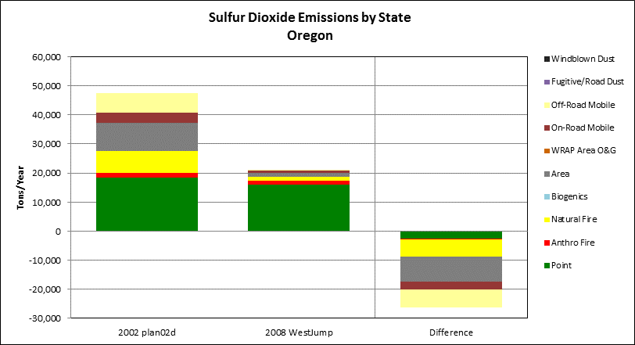

Table 24 Oxides of Nitrogen Emissions by Category

|  |  |  |  |
| --- | --- | --- | --- |
| **Source Category** | **Oxides of Nitrogen Emissions (tons/year)** | | |
| **2002**  **(Plan02d)** | **2008**  **(WestJump2008)** | **Difference**  **(Percent Change)** |
| **Anthropogenic Sources** | | | |
| Point | 26,160 | 23,548 | -2,612 |
| Area | 14,740 | 24,121 | 9,381 |
| On-Road Mobile | 111,646 | 98,399 | -13,247 |
| Off-Road Mobile | 53,896 | 23,463 | -30,434 |
| Area Oil and Gas | 85 | 0 | -85 |
| Fugitive and Road Dust | 0 | 0 | 0 |
| Anthropogenic Fire | 6,292 | 9,923 | 3,630 |
| **Total Anthropogenic** | **212,819** | **179,453** | **-33,366 (-16%)** |
| **Natural Sources** | | | |
| Natural Fire | 27,397 | 8,521 | -18,876 |
| Biogenic | 16,527 | 5,560 | -10,967 |
| Wind Blown Dust | 0 | 0 | 0 |
| **Total Natural** | **43,924** | **14,081** | **-29,843 (-68%)** |
| **All Sources** | | | |
| **Total Emissions** | **256,744** | **193,534** | **-63,209 (-25%)** |

2002 and 2008 Emission and Difference Between Emission Inventory Totals, for Oxides of Nitrogen by Source Category

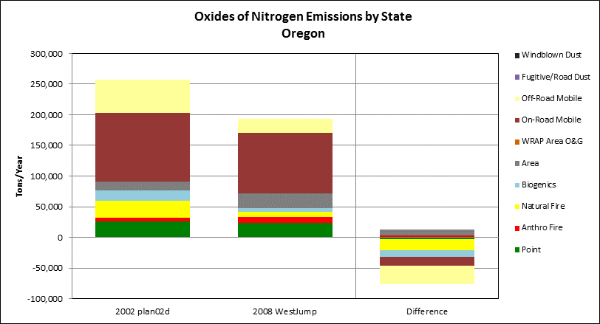

Table 25 Ammonia Emissions by Category

|  |  |  |  |
| --- | --- | --- | --- |
| **Source Category** | **Ammonia Emissions (tons/year)** | | |
| **2002**  **(Plan02d)** | **2008**  **(WestJump2008)** | **Difference**  **(Percent Change)** |
| **Anthropogenic Sources** | | | |
| Point | 919 | 255 | -664 |
| Area | 45,591 | 43,814 | -1,777 |
| On-Road Mobile | 3,263 | 1,668 | -1,594 |
| Off-Road Mobile | 39 | 27 | -12 |
| Area Oil and Gas | 0 | 0 | 0 |
| Fugitive and Road Dust | 0 | 0 | 0 |
| Anthropogenic Fire | 1,211 | 6,900 | 5,690 |
| **Total Anthropogenic** | **51,022** | **52,665** | **1,643 (3%)** |
| **Natural Sources** | | | |
| Natural Fire | 6,132 | 5,907 | -225 |
| Biogenic | 0 | 0 | 0 |
| Wind Blown Dust | 0 | 0 | 0 |
| **Total Natural** | **6,132** | **5,907** | **-225 (-4%)** |
| **All Sources** | | | |
| **Total Emissions** | **57,154** | **58,571** | **1,418 (2%)** |

Figure 14 2002 and 2008 Emission and Difference Between Emission Inventory Totals, for Ammonia by Source Category

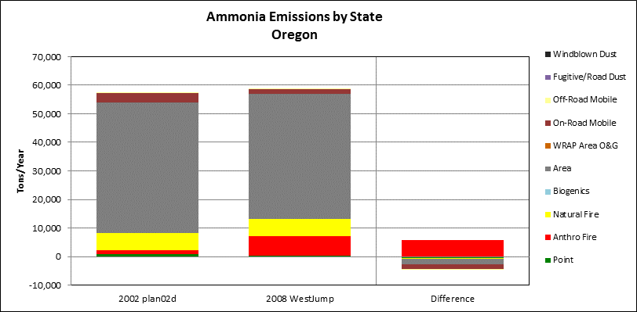

Table 26 Volatile Organic Compound Emissions by Category

|  |  |  |  |
| --- | --- | --- | --- |
| **Source Category** | **Volatile Organic Compound Emissions (tons/year)** | | |
| **2002**  **(Plan02d)** | **2008**  **(WestJump2008)** | **Difference**  **(Percent Change)** |
| **Anthropogenic Sources** | | | |
| Point | 28,762 | 8,554 | -20,208 |
| Area | 245,649 | 63,741 | -181,908 |
| On-Road Mobile | 88,784 | 39,649 | -49,135 |
| Off-Road Mobile | 39,516 | 33,308 | -6,208 |
| Area Oil and Gas | 34 | 0 | -34 |
| Fugitive and Road Dust | 0 | 0 | 0 |
| Anthropogenic Fire | 9,939 | 9,639 | -300 |
| **Total Anthropogenic** | **412,685** | **154,891** | **-257,793 (-62%)** |
| **Natural Sources** | | | |
| Natural Fire | 60,336 | 9,023 | -51,314 |
| Biogenic | 1,148,266 | 339,630 | -808,636 |
| Wind Blown Dust | 0 | 0 | 0 |
| **Total Natural** | **1,208,602** | **348,653** | **-859,950 (-71%)** |
| **All Sources** | | | |
| **Total Emissions** | **1,621,287** | **503,544** | **-1,117,743 (-69%)** |

Figure 15 2002 and 2008 Emission and Difference Between Emission Inventory Totals, for Volatile Organic Compounds by Source Category

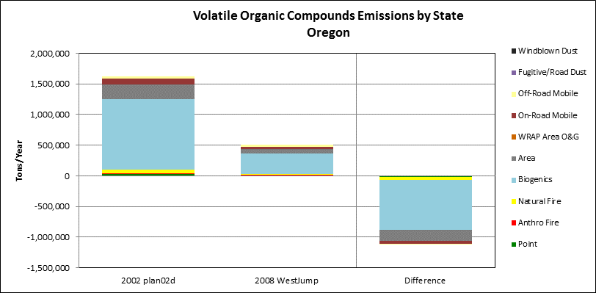

Table 27 Primary Organic Aerosol Emissions by Category

|  |  |  |  |
| --- | --- | --- | --- |
| **Source Category** | **Primary Organic Aerosol Emissions (tons/year)** | | |
| **2002**  **(Plan02d)** | **2008**  **(WestJump2008)** | **Difference**  **(Percent Change)** |
| **Anthropogenic Sources** | | | |
| Point* | 1,445 | 88 | -1,358 |
| Area | 22,281 | 10,459 | -11,822 |
| On-Road Mobile | 1,009 | 2,314 | 1,305 |
| Off-Road Mobile | 1,323 | 1,005 | -318 |
| Area Oil and Gas | 0 | 0 | 0 |
| Fugitive and Road Dust | 298 | 617 | 319 |
| Anthropogenic Fire | 10,937 | 19,073 | 8,136 |
| **Total Anthropogenic** | **37,293** | **33,555** | **-3,738 (-10%)** |
| **Natural Sources** | | | |
| Natural Fire | 81,047 | 17,462 | -63,585 |
| Biogenic | 0 | 0 | 0 |
| Wind Blown Dust | 0 | 0 | 0 |
| **Total Natural** | **81,047** | **17,462** | **-63,585 (-78%)** |
| **All Sources** | | | |
| **Total Emissions** | **118,340** | **51,017** | **-67,323 (-57%)** |

*Point source data includes only oil and gas and regulated CEM sources. More comprehensive point source data were not available at the time this report was prepared but will be made available through the WRAP TSS (<http://vista.cira.colostate.edu/tss/>).

2002 and 2008 Emission and Difference Between Emission Inventory Totals, for Primary Organic Aerosol by Source Category

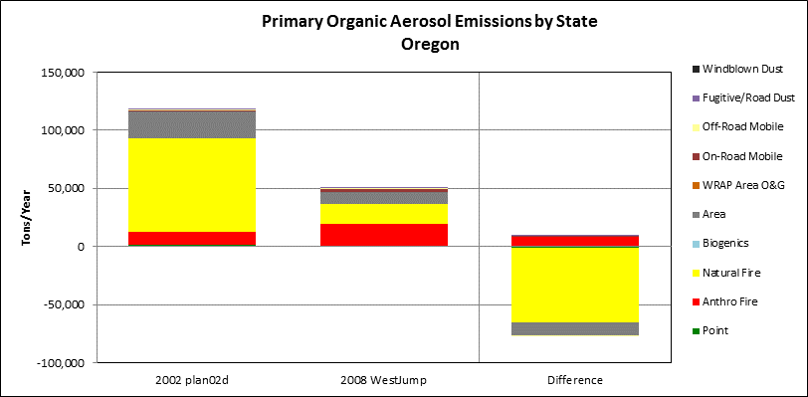

Table 28 Elemental Carbon Emissions by Category

|  |  |  |  |
| --- | --- | --- | --- |
| **Source Category** | **Elemental Carbon Emissions (tons/year)** | | |
| **2002**  **(Plan02d)** | **2008**  **(WestJump2008)** | **Difference**  **(Percent Change)** |
| **Anthropogenic Sources** | | | |
| Point* | 45 | 103 | 59 |
| Area | 4,121 | 1,533 | -2,588 |
| On-Road Mobile | 1,166 | 4,041 | 2,876 |
| Off-Road Mobile | 3,038 | 1,199 | -1,839 |
| Area Oil and Gas | 0 | 0 | 0 |
| Fugitive and Road Dust | 21 | 21 | 0 |
| Anthropogenic Fire | 1,935 | 2,872 | 938 |
| **Total Anthropogenic** | **10,325** | **9,769** | **-556 (-5%)** |
| **Natural Sources** | | | |
| Natural Fire | 16,403 | 2,448 | -13,955 |
| Biogenic | 0 | 0 | 0 |
| Wind Blown Dust | 0 | 0 | 0 |
| **Total Natural** | **16,403** | **2,448** | **-13,955 (-85%)** |
| **All Sources** | | | |
| **Total Emissions** | **26,728** | **12,218** | **-14,510 (-54%)** |

*Point source data includes only oil and gas and regulated CEM sources. More comprehensive point source data were not available at the time this report was prepared but will be made available through the WRAP TSS (<http://vista.cira.colostate.edu/tss/>).

Figure 16 2002 and 2008 Emission and Difference Between Emission Inventory Totals, for Elemental Carbon by Source Category

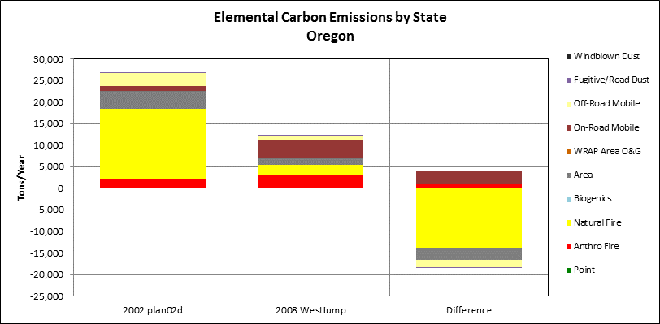

Table 29 Fine Soil Emissions by Category

|  |  |  |  |
| --- | --- | --- | --- |
| **Source Category** | **Fine Soil Emissions (tons/year)** | | |
| **2002**  **(Plan02d)** | **2008**  **(WestJump2008)** | **Difference**  **(Percent Change)** |
| **Anthropogenic Sources** | | | |
| Point* | 5,728 | 430 | -5,298 |
| Area | 15,295 | 5,038 | -10,256 |
| On-Road Mobile | 606 | 394 | -212 |
| Off-Road Mobile | 0 | 70 | 70 |
| Area Oil and Gas | 0 | 0 | 0 |
| Fugitive and Road Dust | 5,022 | 9,364 | 4,342 |
| Anthropogenic Fire | 1,483 | 6,972 | 5,490 |
| **Total Anthropogenic** | **28,133** | **22,269** | **-5,864 (-21%)** |
| **Natural Sources** | | | |
| Natural Fire | 6,090 | 6,396 | 305 |
| Biogenic | 0 | 0 | 0 |
| Wind Blown Dust | 11,586 | 8,499 | -3,087 |
| **Total Natural** | **17,676** | **14,894** | **-2,782 (-16%)** |
| **All Sources** | | | |
| **Total Emissions** | **45,809** | **37,163** | **-8,645 (-19%)** |

*Point source data includes only oil and gas and regulated CEM sources. More comprehensive point source data were not available at the time this report was prepared but will be made available through the WRAP TSS (<http://vista.cira.colostate.edu/tss/>).

Figure 17 2002 and 2008 Emission and Difference Between Emission Inventory Totals, for Fine Soil by Source Category

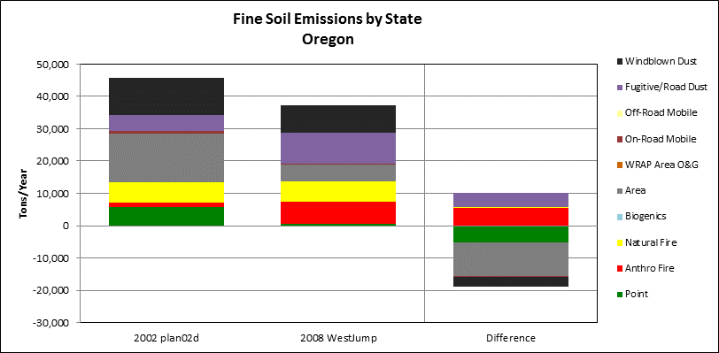

Table 30 Coarse Mass Emissions by Category

|  |  |  |  |
| --- | --- | --- | --- |
| **Source Category** | **Coarse Mass Emissions (tons/year)** | | |
| **2002**  **(Plan02d)** | **2008**  **(WestJump2008)** | **Difference**  **(Percent Change)** |
| **Anthropogenic Sources** | | | |
| Point* | 10,211 | 2,067 | -8,145 |
| Area | 3,546 | 597 | -2,949 |
| On-Road Mobile | 618 | 4,295 | 3,677 |
| Off-Road Mobile | 0 | 116 | 116 |
| Area Oil and Gas | 0 | 0 | 0 |
| Fugitive and Road Dust | 33,999 | 63,599 | 29,600 |
| Anthropogenic Fire | 1,282 | 3,648 | 2,365 |
| **Total Anthropogenic** | **49,657** | **74,321** | **24,664 (50%)** |
| **Natural Sources** | | | |
| Natural Fire | 17,036 | 3,326 | -13,709 |
| Biogenic | 0 | 0 | 0 |
| Wind Blown Dust | 104,272 | 76,489 | -27,783 |
| **Total Natural** | **121,307** | **79,815** | **-41,492 (-34%)** |
| **All Sources** | | | |
| **Total Emissions** | **170,964** | **154,136** | **-16,828 (-10%)** |

*Point source data includes only oil and gas and regulated CEM sources. More comprehensive point source data were not available at the time this report was prepared but will be made available through the WRAP TSS (<http://vista.cira.colostate.edu/tss/>).

Figure 18 2002 and 2008 Emission and Difference Between Emission Inventory Totals, for Coarse Mass by Source Category

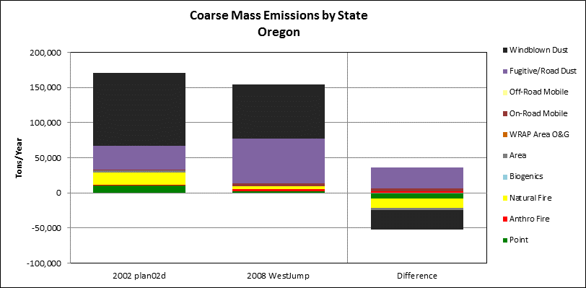

## 3.5 Assessment of Current Monitoring Strategy

#### 40 CFR 51.308 (g) (7)

#### 40 CFR 51.308 (h)

The state is required in this report to review the visibility monitoring strategy and discuss any modifications to the strategy as necessary. The primary monitoring network for the measurement and characterization of the contributors to regional haze, both nationwide and in Oregon, is the IMPROVE network. The IMPROVE network documents the visual air quality in wilderness areas and national parks throughout the United States. Given that IMPROVE monitoring data from 2000-2004 serve as the baseline for the regional haze program and for tracking progress, the regional haze monitoring strategy must necessarily be based on, or directly comparable to, the IMPROVE program. The IMPROVE measurements provide the only long-term record available for tracking visibility improvement or degradation. Therefore, Oregon intends to rely on the continued availability of quality assured data collected through the IMPROVE network to comply with regional haze monitoring requirement in the Regional Haze rule.

The IMPROVE sites in Oregon provide sufficiently representative data sufficient to support demonstrations of reasonable further progress. The WRAP has analyzed, reduced and provided information on relative contributions to visibility impairment using the data reported by the IMPROVE program. Oregon has and will continue to use the regional technical support analysis tool found at the Visibility Information Exchange Web System and WRAP’s TSS, as well as other analysis tools and efforts sponsored by the WRAP. The State will continue to participate in the regional analysis activities of the WRAP to collectively assess and verify the progress toward reasonable progress goals, as the Regional Haze rule continues to be implemented.

Oregon concludes that no modifications to Oregon’s visibility monitoring strategy are necessary at this time. Each of the IMPROVE monitoring locations in the state are sufficient for a monitoring strategy that is representative to provide coverage of all Class I areas in the State. Oregon is committed to continue using the IMPROVE monitoring network. If economic challenges are faced by the IMPROVE monitoring program, Oregon commits to working with federal agencies as a team to try to resolve the situation.

## 3.6 Electrical Generating Unit Emission Summary

As described in previous sections, differences between the baseline and progress period inventories presented here do not necessarily represent changes in actual emissions because numerous updates in inventory methodologies have occurred between the development of the separate inventories. Also, the 2002 baseline and 2008 progress period inventories represent only annual snapshots of emissions estimates, which may not be representative of entire 5-year monitoring periods compared. To better account for year-to-year changes in emissions, annual emission totals for Oregon electrical generating units (EGU) are presented here. EGU emissions are some of the more consistently reported emissions, as tracked in EPA’s Air Markets Program Database for permitted Title V facilities in the state (<http://ampd.epa.gov/ampd/>). RHR implementation plans are required to pay specific attention to certain major stationary sources, including EGUs, built between 1962 and 1977.

Figure 19 presents a sum of annual NOX and SO2 emissions as reported for Oregon EGU sources between 1996 and 2014. While these types of facilities are targeted for controls in state regional haze SIPs, it should be noted that many of the controls planned for EGUs in the WRAP states had not taken place yet in 2010, while other controls separate from the RHR may have been implemented. The chart shows several periods of increases and decreases for both SO2 and NOX.

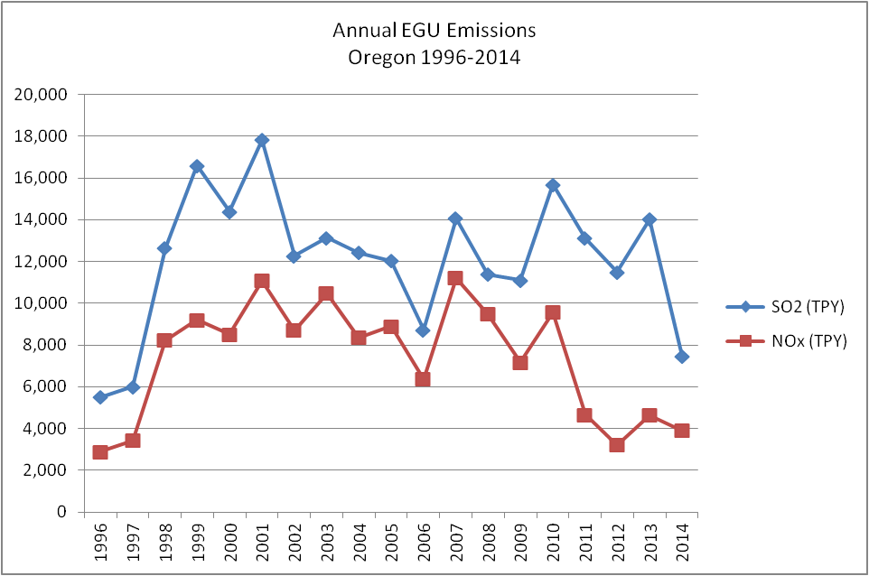

Figure Electrical Generating Unit Emissions of SOx and NOx, 1996 - 2014

## 3.7 Oregon’s Impact on Nearby Class I Areas

The Regional Haze Plan detailed the closest Class I areas in other states that could be impacted by emissions originating in Oregon based on review of PSAT and WEP source apportionment data on the WRAP TSS website focusing on the 20% worst day impacts. These included Mt Rainier National Park and the Goat Rocks Wilderness in Washington state, the Sawtooth Mountain Wilderness in Idaho, Jarbridge Wilderness in Nevada and Lava Beds National Monument and Redwood National Park in California. In none of those areas were Oregon emissions considered to represent a sizeable contribution.

For Washington state, Nevada and Idaho Class I areas, the largest pollutant contribution category was SO2 point sources. Much of this impact can be attributed to the PGE Boardman coal-fired power plant in NE Oregon. Starting July 1, 2018 a more stringent BART SO2 emission limit is required that will significantly reduce emissions with corresponding visibility benefits. Oregon emissions affecting California Class I areas are also very low with impacts from SO2 point sources and NOx mobile source emissions representing the largest source categories. While we will track this during the next stage regional haze plan development we expect further reductions from mobile sources due to vehicle turnover among heavy and light duty vehicles to lower emission vehicles. An anticipated evaluation of non-BART industrial sources may identify further opportunities for improvement in sulfur oxide emissions.

## 3.8 Analysis of Impediments to Progress

Significant steps have been taken in Oregon to implement controls on anthropogenic sources of visibility impairing pollutants. These steps are in addition to the visibility improvements that have come from federal actions taken on on-road and non-road vehicles and equipment as well as benefits from international treaties reducing emissions from ocean going vessels. The improvements in deciview values and light extinction for most of the IMPROVE monitoring locations in Oregon is evident in for both least and most impaired visibility days. As these locations are showing progress toward visibility improvements, the analysis of impediments focuses on the one location that whose trend is not as positive. The one exception is represented at monitor THSI1 for worst 20% visibility days, the site tracking conditions for three Class I areas in central Oregon, Mt. Jefferson, Mt. Washington and Three Sisters wilderness areas.

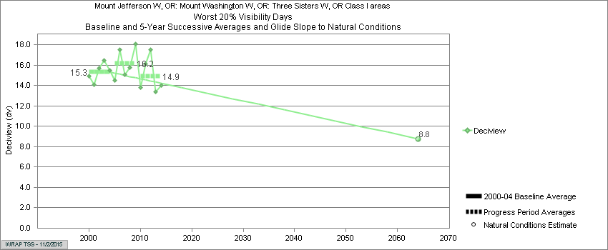

While any impediment to progress can be a cause for concern and deserving of analysis, Figure 20 shows that, even so, overall progress is being made through the latest progress period. The figure does show the extensive variability that underlies the progression toward natural conditions. The major factor accounting for that variability is also the largest contributor to haze conditions at this location, particulate organic mass aerosol (Figure 20).

Figure 20 Trend line for Worst 20% Visibility Days, THSI1

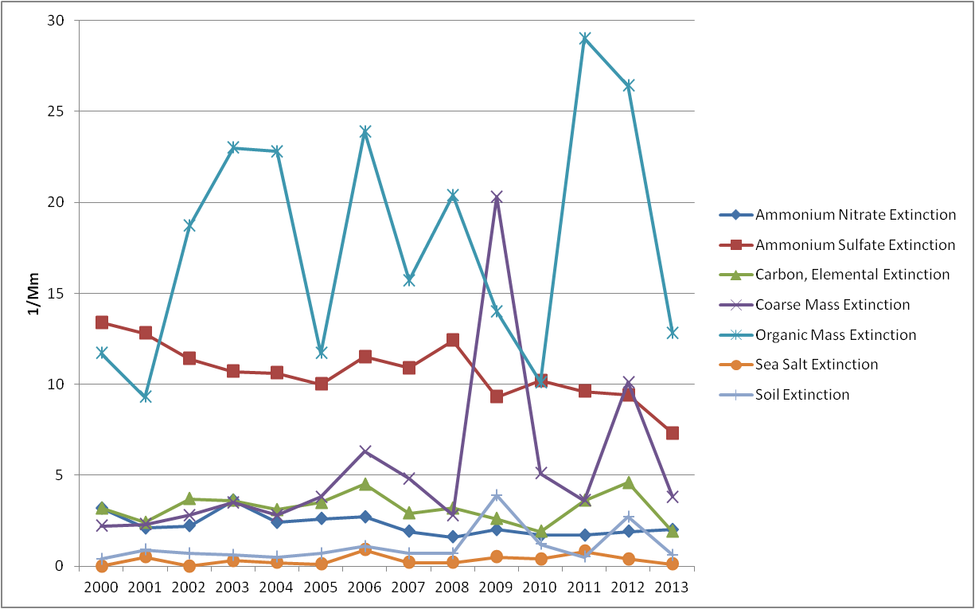

Figure 21 shows the close correspondence between light extinction attributable to organic mass and elevated deciview readings in 2011 and 2012, the two most recent years adversely contributing to visibility trends. Area sources can be a contributor to organic mass aerosols but in this case the resulting visibility impact was caused by wildfire. Areas sources, as exemplified by woodstoves, tend not to be episodic and neither were they likely to be a significant source in mid September, as indicated in Figure 21. By mid-September 2011, there were 16 fires active across Washington (2), Oregon (8), Idaho (4), and Montana (2). Across the region, temperatures were above average and precipitation was below average during the first half of the month, which lowered fuel moistures of all sizes (10-hour, 100-hour, and 1,000-hour fuel moistures) and increased the [fire danger](http://www1.ncdc.noaa.gov/pub/data/cmb/images/fire/2011/09/fd-class-20110915.png) and [Keetch-Byram](http://www1.ncdc.noaa.gov/pub/data/cmb/images/fire/2011/09/kbdi-20110915.png) Drought Index values. The 2011 fires potentially impacting the THSI1 monitor included the Mother Lode (2,661 acres), Shadow Lake (10,000 acres) and the High Cascades (108,154 acres) fires. In 2012 numerous wildfires developed in the 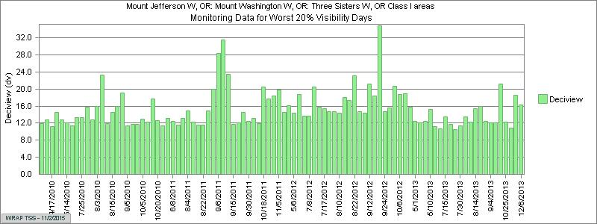Cascade Mountains as a result of lightning strikes. The Pole Creek fire charred over 26,000 acres near Sisters, Oregon. The wildfire impacted air quality for residents as well as nightly inversions trapped the smoke in the valley. Each of these fire events were responsible to the impairment recorded at the THSI1 monitor. As Figure 8 showed, there has been an unfortunate trend towards in the number of acres burned in Oregon as a result of wildfires over the past five years. While wildfires are not considered anthropogenic sources, efforts to control these fires through smoke management efforts such as prescribed burning, could increase the amount of short-term burning that could occur near the Class I areas. As increasing numbers of wildfires occur, continued progress to achieving visibility goals will be challenged should this trend continue.

Deciview

Organic Mass

Figure Recent Deciview and OM Extinction at THSI1 on Worst Days

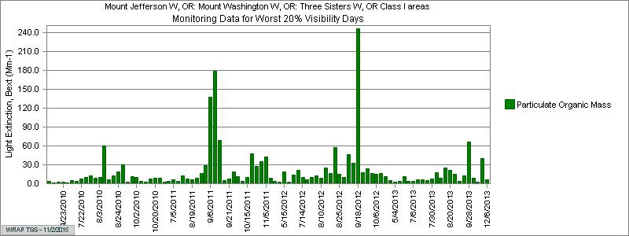

Climate change is a global phenomenon resulting from increasing levels of heat trapping gases. The expression of the consequences of this varies by region. In the Pacific Northwest an expected climate outcome is increased precipitation in the winter, falling as rain not snow, and in the summer as well, in the form of more frequent downpours. From a regional haze perspective, we can expect to see an increase in relative humidity, which adversely impacts visibility by increasing light scattering by water soluble particles, such as sulfates and nitrates. Generally relative humidity is lower in western states as a starting point and along with continued reductions in anthropogenic emissions of water soluble particles, the net impact may not be large. Multiple efforts to reduce climate forcing factors in Oregon are underway but a complete solution will require larger scale efforts from regional, national and international sources that place it outside the scope of regional haze planning efforts.

Windblown dust also contributes to visibility impairment by light scattering. This is not a major source of concern from sources in Oregon. Although large scale dust storms have originated in Asia with enough force and volume to reach the continental United States, these sources of pollution represent a lesser pollution source than local sources. While we can continue to track this source of light scattering pollution, effective control is beyond the scope of regional haze plans.

In the original Regional Haze Plan (2009) the greatest reductions from anthropogenic sources were addressed. Some of the strategies included the BART requirements for the PGE Boardman plant and “on the books” federal mobile source regulations. Other anthropogenic sources, such as other non-BART sources, prescribed burning, and open burning are not sources determined to be “significant” contributors to Class I visibility impairment; therefore it may be more challenging to meet the 2064 goal of natural conditions even with additional controls or regulations.

# 4. Determination of Adequacy, Procedural Requirements and Conclusions

#### 40 CFR 51.308 (g) (6)

The final report will include a discussion of coordination efforts with tribal governments and federal land managers and comments from public participation as summarized in Appendices C and D.

Oregon is making adequate progress in improving visibility as a result of actions taken outlined within the State Implementation Plan as well as actions taken by adjoining states, the federal government and driven by compliance with international treaty. The trends for Worst Days averages show improvement at most every monitoring location. The central Oregon Cascades location shows a slight decrement that can be understood to be affected by wildfires and is otherwise trending positively for other visibility impairing pollutants. Current best day visibility at all locations is lower than Reasonable Progress Goals (see ).

Oregon continues to strengthen existing control measures due to the severity of the air quality problem. Oregon is currently implementing SIPs for the 35 ug/m3 daily PM2.5 and is working with additional communities to implement PM Advance Plans for areas in danger of violating federal health standards. In addition, smoke emissions from California wildfires sometimes impacted Oregon Class 1 Area monitors. Oregon has determined that absent these natural wildfire smoke impacts, visibility is improving sufficiently due to reduction of anthropogenic emissions, in-state and out-of-state.

Oregon staff also meets routinely with state and federal land management agencies (FLMs) to review visibility progress, to share technical and research information, and to discuss policies leading to air quality improvement. This occurs at the staff level throughout the year at smoke management advisory committee meetings and through senior management meetings of DEQ, ODF, and FLM. DEQ provided the draft Progress Report to the FLMs sixty days in advance of the public notice of the hearing on the Progress Report, for their review and comments. Appendix D includes their written comments and the responses from DEQ staff.

With the reductions in anthropogenic emissions in Oregon and the resulting improvement in visibility at the Class I area IMPROVE monitors, DEQ determines that the current regional haze plan strategies are sufficient for Oregon and its neighboring states to meet their 2018 reasonable progress goals. Additionally, in accordance with the requirements of the Regional Haze Rule 40 CFR 51.308(h), Oregon has determined that no further substantive revision of the Regional Haze Plan is necessary at this time to achieve the 2018 goals for visibility improvement.

1. The COGO1 site was discontinued in 2010.
2. See Appendix C – Visibility Basics for background discussion on Best Available Retrofit Technology and other elements of regional haze planning.
3. The COGO1 IMPROVE site was discontinued in 2011.
4. See Appendix C – Visibility Basics for further background on reasonable progress goals, uniform rates of progress and other elements of regional haze planning.
5. Estimated emissions based on modeling
6. Estimated emissions based on modeling
7. The COGO1 IMPROVE site was discontinued in 2011.
8. Annual trends were calculated for the years 2000-2009, with a trend defined as the slope derived using Theil statistics. Trends derived from Theil statistics are useful in analyzing changes in air quality data because these statistics can show the overall tendency of measurements over long periods of time, while minimizing the effects of year-to-year fluctuations which are common in air quality data. Theil statistics are also used in EPA’s National Air EPA’s National Air Quality Trends Reports (<http://www.epa.gov/airtrends/>) and the IMPROVE program trend reports (<http://vista.cira.colostate.edu/improve/Publications/improve_reports.htm>)
9. The significance of the trend is represented with p-values calculated using Mann-Kendall trend statistics. Determining a significance level helps to distinguish random variability in data from a real tendency to increase or decrease over time, where lower p-values indicate higher confidence levels in the computed slopes.
10. Detailed inventory descriptions for development of the WRAP Base02b, plan02c and plan02d inventories are available on the WRAP TSS website http://vista.cira.colostate.edu/TSS/Results/Emissions.aspx and archived on the original WRAP website <http://www.wrapair.org/forums/ssjf/pivot.html>.
11. Detailed inventory descriptions for development of the WRAP WestJump08 inventory are available on the WRAP project page <http://wrapair2.org/WestJumpAQMS.aspx>.
12. Annual EGU emissions for each state were obtained from EPA’s Air Markets Program Database for permitted Title V facilities (<http://ampd.epa.gov/ampd/>).
13. EPA’s 2008 NEI inventory estimates are available at <http://www.epa.gov/ttn/chief/net/2008inventory.htm>.
14. Additional phase II oil and gas inventory descriptions are archived on the original WRAP website <http://www.wrapair.org/forums/ogwg/documents/2007-10_Phase_II_O&G_Final)Report(v10-07%20rev.s).pdf>.
15. Additional details regarding fire inventory descriptions for development of the DEASCO3 inventory are available on the WRAP project page <http://www.wrapfets.org/deasco3.cfm>.