DELETE THIS PAGE BEFORE PUBLISHING THESE RULES TO THE PUBLIC
If your rules include tables, please follow this example as a template of how to format your rules. If your rules do not have tables, you can ignore this example.

Table Title
Additional Title
Even More Info, Date
Subheading 1 |  | Subheading 2
Data | Data | Data | Data
Data | Data | Data | Data

Rule Formatting Standards -OAR 166-500-0055
- Microsoft Word
- Single spaced
- Left justified
- 12 point, Times New Roman font
- One extra (blank) line (carriage return) between each rule segment
- No auto numbering/auto numbering turned off
- Tables formatted according to DEQ standard
- If you are not familiar with creating or formatting tables, ask rules group lead or agency rules coordinator for help
- Keep Track Changes function turned on
- Only make edits on SharePoint version of rules
ONLY THE RULES GROUP LEADER OR AGENCY RULES COORDINATOR MAY ADD RULES TO THIS TEMPLATE
BEFORE EDITING THESE RULES, THE EDITOR SHOULD:
-CHECK THE DOCUMENT OUT OF SHAREPOINT
-CHECK TO MAKE SURE TRACK CHANGES IS TURNED ON
-CHECK THE DOCUMENT BACK IN TO SHAREPOINT WHEN DONE
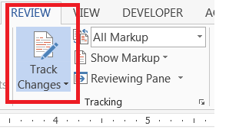
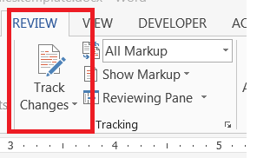
TRACK CHANGES OFF TRACK CHANGES ON


Key to Identifying Changed Text:
Deleted Text
New/inserted text
Text deleted from one location - and moved to another location

DEPARTMENT OF ENVIRONMENTAL QUALITY

XXX-XXX-XXXX

