Medford Carbon Monoxide

Limited Maintenance Plan

By: Oregon Department of Environmental Quality

June, 2015



Last Updated: 12/16/14

By: Jane Doe

DEQ 03-??-###

DEQ Environmental Solutions
Air Quality Program
811 SW 6th Avenue
Portland, OR 97204
Phone: (503) 229-5519
(800) 452-4011
Fax: (503) 229-5675
Contact: Dave Nordberg
www.oregon.gov/DEQ

DEQ is a leader in restoring, maintaining and enhancing the quality of Oregon’s air, land and water.

State Implementation Plan Revision
Medford Carbon Monoxide Limited Maintenance Plan

A Limited Maintenance Plan
for Carbon Monoxide
The Medford Urban Growth Boundary

State of Oregon Clean Air Act Implementation Plan

Opened for public comment
August 14, 2015

State of Oregon
Department of Environmental Quality
811 SW Sixth Avenue
Portland, OR 97204-1390

Table of Contents

Acknowledgments ii
Executive Summary iii
Plan Structure iv
1. Introduction 1
2. Geographic Area 1
3. History of CO Problem in Medford 2
4. Limited Maintenance Plan Option 5
5. Emission Inventory 6
6. Continuing Control Measures 8
7. Verification of Continued Attainment 9
8. Contingency Plan 10

Table of Figures

Figure 1. Medford UGB 2
Figure 2. Medford Carbon Monoxide Trend 2nd highest 8-hour average, 1980-2005 4
Figure 3. 2008 Medford Annual CO Emissions 7
Figure 4. 2008 Medford Seasonal CO Emissions 8

Table of Tables
Table 1. Medford Carbon Monoxide Concentrations 1977-2009 4
Table 2 Medford UGB 2008 CO Annual and Seasonal Emissions Inventory 6

Appendices

Appendix 1: EPA 1995 Paisie Memo
Appendix 2: Medford 2008 Emission Inventory
Appendix 3: EPA 2012 Approval Letter for removal of the CO monitor
Appendix 4: Inventory Preparation and Quality Assurance Plan

Acknowledgments

Principal Author: Dave Nordberg, DEQ Air Quality Planning

Principal Contributors:

Oregon Department of Environmental Quality

David Collier Air Quality Planning Manager
Brian Finneran Air Quality Planning
Anthony Barnack Air Quality Planning
Jeffrey Stocum Air Quality Technical Services Manager
Wes Risher Air Quality Technical Services
Chris Swab Air Quality Technical Services
Brandy Albertson Air Quality Technical Services
Tom Carlson Sierra Research, Inc.

Environmental Protection Agency

Claudia Vaupel EPA Region X

Bob Kotchenruther EPA Region X

Medford

Dan Moore Rogue Valley Council of Governments
Jonathan David Rogue Valley Council of Governments

Executive Summary

Medford, Oregon violated the national air quality standard for carbon monoxide in the 1970s and 1980s. Conditions have progressively improved and Medford has not violated the carbon monoxide (CO) standard since 1991. In 2001 Oregon submitted a ten-year CO Maintenance Plan to EPA and requested that Medford be redesignated to attainment. EPA approved the request as a revision to the State Implementation Plan (SIP) September 23, 2002.

Oregon has now prepared this second ten-year CO Maintenance Plan that indicates how Medford will continue to maintain the CO standard through September 23, 2022--the end of the second maintenance plan period. Once adopted by the Oregon Environmental Quality Commission this plan will be submitted to the EPA as a further revision of the SIP.

High levels of CO have been traditionally caused by motor vehicles emissions. The improvement of CO concentrations over previous decades is largely due to modern vehicle emission control systems which have reduced CO emissions dramatically. Ambient CO concentrations in Medford declined to such low levels that the CO measurement equipment was removed after 2009. Because CO is so low this plan qualifies to use a Limited Maintenance Plan (LMP which streamlines requirements for SIP approval. This technique is available to maintenance areas that have a design value of no higher than 7.65 ppm which is 85 percent of the 8-hour CO standard. By comparison Medford has a design value of 2.4 ppm or 27 percent of the standard.

All maintenance plans including LMPs need to establish the relationship between CO emissions and measured ambient CO concentrations. To speed development of this plan, the Rogue Valley Council of Governments contracted with Sierra Research to assemble much of the Medford CO Emissions Inventory. DEQ and Sierra Research began with the EPA’s 2008 National Emission Inventory (NEI) to quantify CO emissions in the Medford area.

This plan retains the control and contingency measures from the first CO maintenance plan. The primary control measure has been the emission standards for new motor vehicles under the Federal Motor Vehicle Control Program. Another significant measure that continues is the New Source Review Program with Best Available Control Technology (BACT).

Another requirement for a LMP is to maintain a method of determining if an area’s air quality degrades to the point where a violation could occur. Because the Medford CO monitor has been removed, DEQ will use an alternate method to verify that the area continues to attain the CO standard. This will be done by DEQ tracking CO emissions every three years through the Statewide Emission Inventory, which is submitted to EPA for inclusion in the National Emission Inventory. DEQ will evaluate any emissions increase to determine if it will trigger measures in the Contingency Plan. These include resuming ambient CO monitoring in Medford, and if needed, forming an advisory committee to develop new strategies to prevent or correct any violation of the CO standard.

Plan Structure

This SIP revision includes the compliance history for Medford and describes how the
area met and will continue to meet the standard. This document is organized as follows:

Section 1 – Introduction. Describes the purpose of this second maintenance plan, and summary on the CO standard.

Section 2 – Geographic Area. Describes the geographic area covered by the maintenance plan,

Section 3 – History of the Carbon Monoxide Problem. Summarizes Medford CO compliance history and past CO monitoring data and trends.

Section 4 – Limited Maintenance Plan Option. Describes the criteria an area must meet to qualify for this option and how Medford qualifies.

Section 5 – Emission Inventory. Includes historical information on the most significant CO emission categories from the original maintenance plan and an updated inventory on these categories.

Section 6 – Continuing Control Measures. Lists the measures that were in the original CO maintenance plan, and how these measures will be continued under this LMP.

Section 7 – Verification of Continued Attainment. Describes how compliance will be tracked and confirmed.

Section 8 – Contingency Plan. Describes the contingency measures that apply should a violation occur in the future.

Appendices – Supporting documentation for this LMP.

1. Introduction

This State Implementation Plan revision documents that the area within the Medford Urban Growth boundary will continue to meet the National Ambient Air Quality Standard (NAAQS) for CO through 2022. This plan also describes steps that must be taken if the area’s carbon monoxide concentrations deteriorate to an actionable level. This plan is a “limited maintenance plan” developed in accordance with the federal Clean Air Act and the policies of the U.S. Environmental Protection Agency (EPA). See the 1995 “Paisie Memo provided in Appendix A.

The Clean Air Act requires EPA to set air quality standards to protect public health for six common air pollutants, including carbon monoxide. In 1971 EPA set the national ambient air quality standard for carbon monoxide. Carbon monoxide is a colorless, odorless gas that decreases the oxygen carrying capacity of the blood. High concentrations can severely impair the function of oxygen-dependent tissues, including the brain, heart, and muscle. Prolonged exposure to even low levels can aggravate existing conditions in people with heart disease or circulatory disorders. Motor vehicles are the primary source of CO in Oregon.

EPA established the national ambient air quality standard for CO at 35 parts per million (ppm) for a 1-hour average and 9 ppm for an 8-hour average. Two exceedances within one calendar year constitute a violation. Like most areas of the country that failed to meet the CO standard, Medford failed to meet the 8-hour portion of the standard.

2. Geographic Area

The City of Medford is located in southwestern Oregon, West of the Cascade Mountains in the Rogue River Valley. The city is approximately 26 square miles in area, and the population in 2013 was 77,677. The surrounding hills can trap air pollution under stable meteorological conditions (inversions). These conditions exist most frequently during the winter and were associated with the majority of past carbon monoxide violations.

Figure 1 shows the Medford Urban Growth Boundary which is also the geographic area subject to this limited maintenance plan.

Figure 1. Medford Urban Growth Boundary
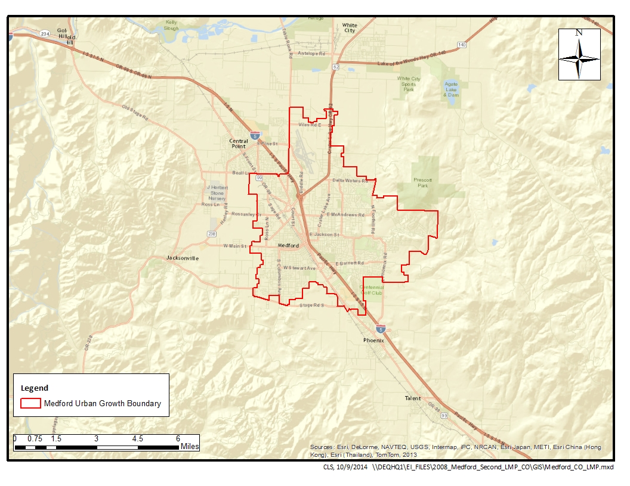

3. History of CO Problem in Medford

History of CO in Medford Area/Design Values

The Medford portion of the Medford-Ashland AQMA was designated by the Environmental Protection Agency (EPA) as a nonattainment area for carbon monoxide (CO) March 3, 1978. On June 20, 1979 DEQ submitted a CO Control Strategy and requested an extension beyond 1982 to attain the CO standard. At that time the design value was 13.8 parts per million (ppm). EPA approved DEQ's 1979 plan and the extension, giving the Department until December 31, 1987 to bring the Medford area into compliance. An updated control strategy was submitted in 1982 which was revised in 1985 to include a state-operated vehicle inspection program.

Following adoption of the 1990 Clean Air Act Amendments, EPA classified Medford as a moderate CO nonattainment area with a design value of 12.1 ppm. The CO nonattainment boundary was defined as the Medford, Oregon Urban Growth Boundary (UGB) used for comprehensive land use planning under state law. In 2001, DEQ demonstrated that Medford had attained the 8-hour CO standard with a design value of 7.5 ppm and submitted a maintenance plan showing how the area would continue to meet the CO standard into the future. EPA approved the maintenance plan and redesignated Medford to attainment for CO effective September 23, 2002.

Since then, CO concentrations continued to improve and CO monitoring was ended after 2009 with EPA’s approval. Now DEQ is submitting a second CO maintenance plan with a design value of 2.4 ppm CO based on ambient monitoring from 2008 and 2009. This second CO plan is based on EPA guidance for limited maintenance plans as detailed by a memo from Joe Paisie dated October 6, 1995 and an email from Meg Patulski dated October 4, 2005.

Historically, several carbon monoxide monitoring sites in the Medford nonattainment area exceeded the 8-hour NAAQS for CO. Exceedances were recorded for approximately half of the year in the late 1970s. However, because the control measures in the State Implementation Plan (SIP) were effective at reducing CO emissions, Medford air quality has met the CO standard since 1992. This is consistent with CO emission inventories from 1993 and 2008 which show that CO emissions in Medford continued to decline.

Table 1. Medford Carbon Monoxide Concentrations 1977-2009

 | 8-hour CO Averages
Year | Maximum | 2nd Highest
1977 | 21.8 | 17.3
1978 | 19.8 | 18.3
1979 | 16.2 | 13.8
1980 | 19.2 | 15.7
1981 | 14.9 | 14.5
1982 | 14.3 | 13.2
1983 | 15.8 | 12.6
1984 | 15.2 | 12.4
1985 | 16.9 | 16.3
1986 | 12.7 | 12.6
1987 | 12.9 | 9.7
1988 | 12.2 | 10.8
1989 | 12.2 | 12.1
1990 | 9.2 | 9.0
1991 | 11.9 | 10.5
1992 | 7.4 | 7.4
1993 | 8.5 | 7.5
1994 | 7.4 | 6.7
1995 | 6.1 | 6.0
1996 | 6.7 | 6.6
1997 | 7.3 | 5.7
1998 | 5.5 | 5.3
1999 | 6.8 | 6.1
2000 | 4.8 | 4.7
2001 | 4.8 | 4.6
2002 | 5.9 | 5.5
2003 | 5.0 | 4.7
2004 | 4.0 | 4.0
2005 | 4.4 | 3.8
2006 | 2.9 | 2.8
2007 | 3.1 | 2.7
2008 | 2.6 | 2.4
2009 | 2.4 | 2.4
(When multiple monitors operated in a given year, values shown are from the CO monitor with the highest second-high measurement.)

Figure 2. Medford Carbon Monoxide Trend 2nd highest 8-hour average, 1977-2009
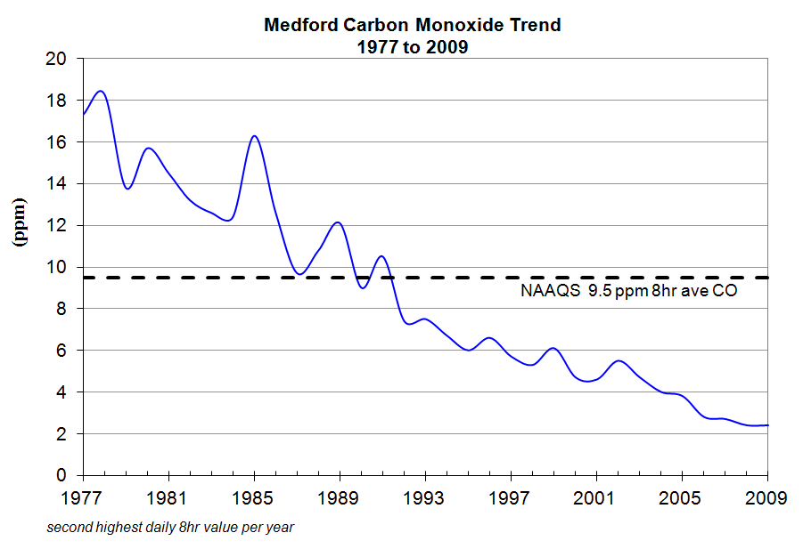

4. Limited Maintenance Plan Option

EPA developed the Limited Maintenance Plan (LMP) option for areas with little risk of re-violating the carbon monoxide standard (see 1995 Paisie Memo, Appendix A). EPA allows states to use this policy to prepare the required second 10-year maintenance plans, if the monitoring data show the design value is at or below 85 percent of the 8-hour CO standard, or 7.65 ppm. Determining the design value in this case is based on the higher of the two annual second highs in a two year calendar period. The Medford 8-hour design value is 2.4 ppm, based on the two most recent years of data (2008 and 2009). This is 27 percent of the 8-hour standard and far below the 85 percent level at which an area is eligible for the LMP option.

The LMP approach does not require future year emission projections or a maintenance demonstration. A LMP must include an attainment inventory, provisions for verification of continued attainment, a contingency plan and a statement regarding conformity determinations. Due to the low measured CO values in Medford over the past 22 years, DEQ does not anticipate that CO levels will approach levels that would exceed or violate the 8-hour CO standard, and as noted above, has never exceeded the 1-hour CO standard.

5. Emission Inventory

The Medford Carbon Monoxide (CO) Maintenance Area has met the National Ambient Air Quality Standards (NAAQS) for carbon monoxide. On September 23, 2002 EPA redesignated the area to attainment and approved Medford’s CO Maintenance Plan submitted in 2001. This current limited maintenance plan inventory is for 2008, and is provided as part of a new maintenance plan showing that the area will continue to comply with published EPA requirements. The principal components for development and documentation that have been addressed in this inventory include stationary point sources, stationary area sources, non-road sources, on-road mobile sources, quality assurance implementation, and emissions summaries. The geographic focus for this 2008 emission inventory is the Medford CO Maintenance Area, which is defined as the Medford Urban Growth Boundary (UGB).
The following table summarizes contributions by source category for annual and seasonal CO emissions within the Medford UGB for 2008.

Table 2. Medford UGB 2008 CO Annual and Seasonal Emissions Inventory
During the average CO season 2008 day, on-road mobile sources contribute 35% of the total carbon monoxide (CO) air emissions in the Medford UGB. Gasoline vehicles contribute 97% of the CO emissions within the on-road mobile category, whereas diesel vehicles contribute 3% of the on-road mobile category.
Stationary area sources comprise 37% of the total CO air emissions in the Medford UGB on a CO season day. Within the area source category, residential wood combustion accounts for 49% of the emissions. Wood combustion in non-certified woodstoves and inserts accounts for 28% of the total area source emissions. Prescribed burning accounts for 47% of the total area source emissions on a CO season day.
Non-road mobile sources contribute 12% of the total CO on an average winter day. Within this category, 4-cycle engines comprise 79% of the total emissions.
Permitted stationary point sources comprise 16% of the CO air emissions in the Medford UGB on an average CO season day. This category includes permitted stationary sources with both federal Title V and state Air Contaminant Discharge Permits. There are 37 point sources within the Medford UGB and a 25-mile buffer zone around the UGB.
Emissions summaries for CO have decreased for both annual and season day as compared to the 1993 attainment year EI. Annual emissions have decreased 24%, and seasonal emissions have decreased 27% compared to the 1993 attainment year EI.
Details of the Oregon 2008 Medford UGB CO Limited Maintenance Plan Emission Inventory from point, area, non-road, and on-road mobile sources are presented in the full emission inventory included as Appendix B. The relative percentage of annual and seasonal CO emissions from stationary point, stationary area, non-road mobile, and on-road mobile sources are shown in Figures 3 and 4.
A detailed breakdown of the 2008 CO emission inventory is provided in Appendix B.

Figure 3. 2008 Medford Annual CO Emissions

Figure 4. 2008 Medford Seasonal CO Emissions

6. Continuing Control Measures

To qualify for the LMP option, the control measures from the first CO maintenance plan must remain in place and unchanged. The primary control measure has been the emission standards for new motor vehicles under the Federal Motor Vehicle Control Program. Other control measures have been the Motor Vehicle Inspection program, New Source Review program and a Woodstove Curtailment program.

Federal Motor Vehicle Emission Control Program

This limited maintenance plan continues to rely on federal emission standards for new motor vehicles. These requirements include the federal Tier II emission standards for new light and medium duty cars and trucks as well as standards for heavy duty on-road and non-road vehicles.

As noted in Table 2 above, on-road mobile sources are responsible for the highest annual CO concentrations in Medford. That is because cars and trucks moving through an area can assemble in significant numbers at areas of heavy traffic. The highest CO concentrations typically occur in a small region near a congested intersection as CO dissipates quickly as it moves away from its point of emission.

Emission reductions mandated by the Federal Motor Vehicle Emission Control Program have been primarily responsible for the large decrease in ambient CO concentrations in the past. Before CO emissions were regulated, a typical car of the 1950s emitted approximately 87 grams of CO per mile. Since then, federal rules have lowered CO emissions to the point where today’s federal Tier II requirements limit cars to no more than 3.4 grams CO per mile - a 95% reduction of CO. This program will continue to be an effective control for on-road mobile source emissions in the future.

Major New Source Review

Under this limited maintenance plan, the emission control requirement for new or expanding major industry in Medford area will continue to require Best Available Control Technology (BACT). BACT technology provides a high level of control while allowing some flexibility and consideration of the cost effectiveness of different control options.

Wood smoke Curtailment

As noted in the previous section, residential wood combustion is a leading source of CO emissions from stationary area sources. As shown in Table 2, stationary area sources represent 21 percent of the total annual and 37 percent of seasonal CO emissions in Medford. Wood smoke emission control efforts have significantly reduced emissions through emission certification standards for new stoves, woodstove change-out programs to encourage removal of non-certified stoves, and a local voluntary curtailment program to reduce wood burning during stagnant weather periods. These efforts will be continued under this limited maintenance plan, and are expected to provide modest reductions in CO emissions in Medford.

Conformity requirements

Federal transportation conformity rules (40 CFR 51.390 and 93.100 et. seq.) and general conformity rules (40 CFR 51.851 and 93.150 et. seq.) continue to apply under a limited maintenance plan. However, as noted in the Paisie Memo these requirements are greatly simplified. Under a LMP vehicle emissions are not considered to be constraining so a Motor Vehicle Emissions Budget is not required. During future transportation conformity determinations, regional emissions analyses are not required (including modeling) as vehicle emissions are assumed to comply.

7. Verification of Continued Attainment

As described in this plan, CO levels in the Medford UGB have declined progressively since 1991. CO concentrations are not expected to increase significantly or threaten compliance with the CO standard. Given that the Medford CO monitor was removed after 2009, another method of verifying continued attainment with the CO standard is needed.

DEQ will calculate CO emissions every three years as part of the Statewide Emission Inventory, which is submitted to EPA for inclusion in the National Emission Inventory (NEI). DEQ will review the NEI estimates to identify increases over the 2008 emission levels and report on them in the annual network plan for the applicable year. Because on-road motor vehicles and stationary area sources emit the most CO in Medford, these categories will be the focus of this review. Any increase in CO emissions will be evaluated by DEQ to verify it is not due to a change in emission calculation methodology, an exceptional event, or other factor not representative of an actual emissions increase. DEQ will consider a 10 percent increase over 2008 emission levels to be a “significant” emission increase for the purpose of triggering the Contingency Plan described in Section 8. Emission categories to be assessed for a significant increase are the total annual emissions, total seasonal emissions, annual or seasonal on-road emissions plus annual or seasonal area source emissions.

8. Contingency Plan

Section 175(A) of the Clean Air Act requires a maintenance plan to include contingency measures necessary to ensure prompt correction of any future violation of the air quality standard. The first Medford maintenance plan contained contingency measures that would be implemented based on monitoring data--if CO concentrations exceeded 90 percent of the 8-hour standard (8.1 ppm) or if a violation of the standard were to occur. Since the Medford CO monitor was removed in 2009, these contingency measures are no longer applicable. Other contingency measures are needed that are appropriate for areas such as Medford that are at low risk of violating the CO standard.

This LMP has three phases of contingency measures typically have several steps for action depending on the severity of air quality conditions. The following apply to this limited maintenance plan:

Phase 1. If DEQ’s three-year periodic review of CO emissions shows a significant increase in emissions, as described in Section 8 of this plan, DEQ will resume monitoring ambient CO in Medford.

Phase 2. If the highest measured 8-hour CO concentration in a given year in Medford exceeds 7.65 ppm (the level at which an area is eligible for a Limited Maintenance plan), DEQ will evaluate the cause of the CO increase, and consider forming an advisory committee to recommend corrective strategies. Within 6 months of the validated 7.65 ppm or higher CO concentration, DEQ will prepare a list of strategies to prevent or correct a violation of the 8-hour CO standard. This list is to facilitate a choice of strategies that might be implemented to reduce ambient CO concentrations.

The contingency strategies that will be considered include, but are not limited to:

- Improvements to parking and traffic circulation
- Aggressive signal retiming program
- Increased transit funding
- More stringent vehicle Inspection/Maintenance requirements, and
- Accelerated bicycle and pedestrian improvements.

DEQ (and the advisory group if needed) may also choose to conduct further evaluation, to determine if other strategies are necessary, or to take no further action if the problem was caused by an exceptional event.

Phase 3. If a violation of the CO standard occurs, and is validated by DEQ, in addition to Phase 2 above, DEQ will replace the requirement for new and expanding industry to apply Best Achievable Control Technology (BACT) with the requirement to apply Lowest Achievable Emission Rate (LAER) technology. In addition, DEQ will reinstate the requirement for new and expanding industry to offset any new CO emissions. More CO emission reduction measures identified in the evaluation of contingency Phase 2 may also be considered. Committing to further study in this way gives DEQ flexibility in choosing an appropriate approach should the need arise.

Appendix 1
EPA 1995 Paisie Memo
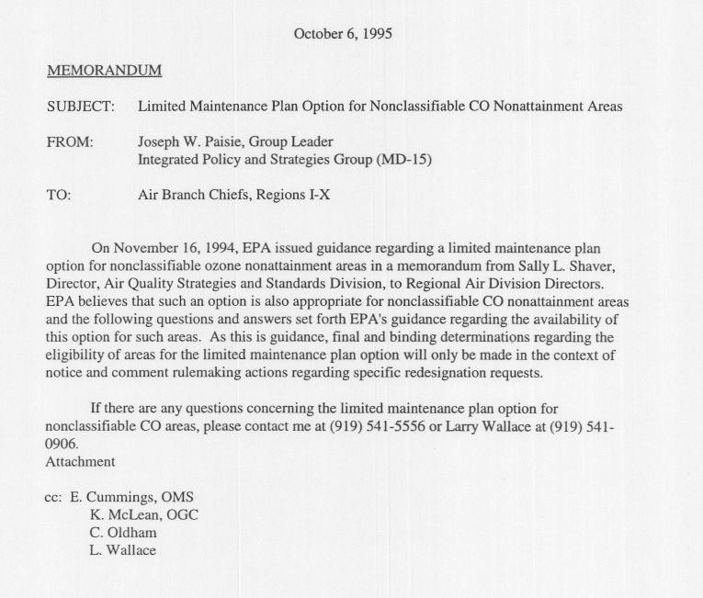

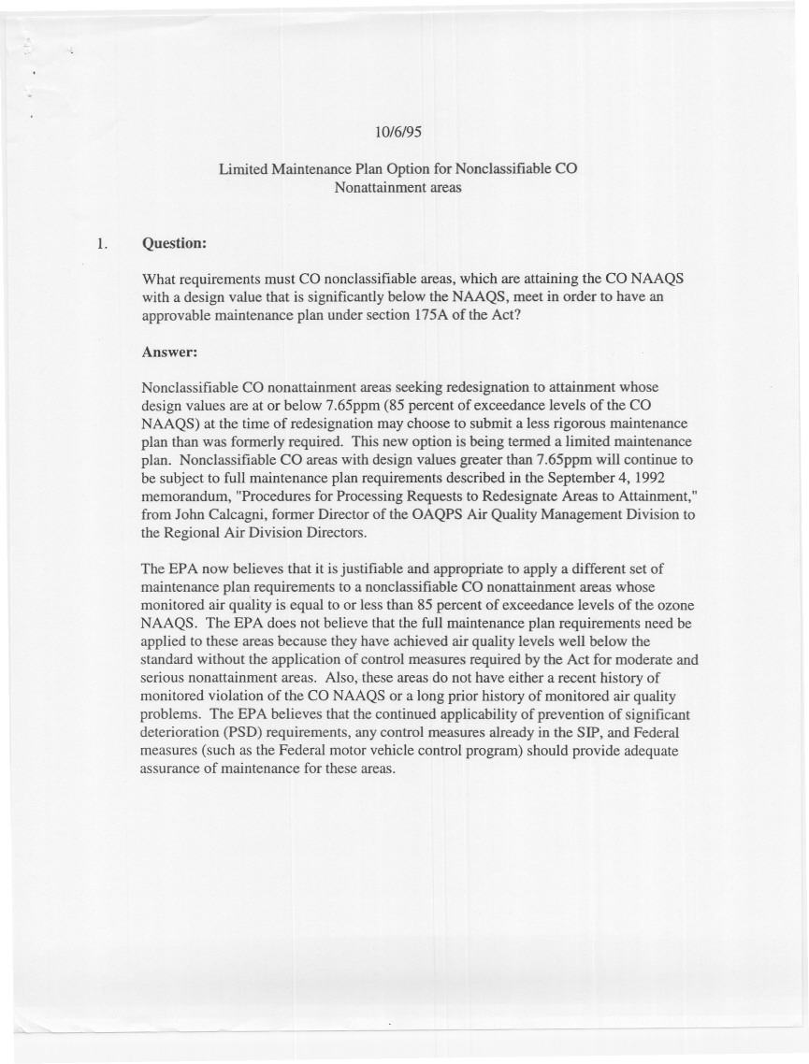
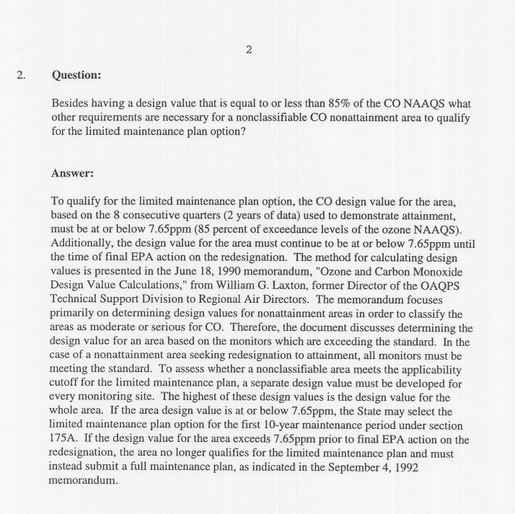

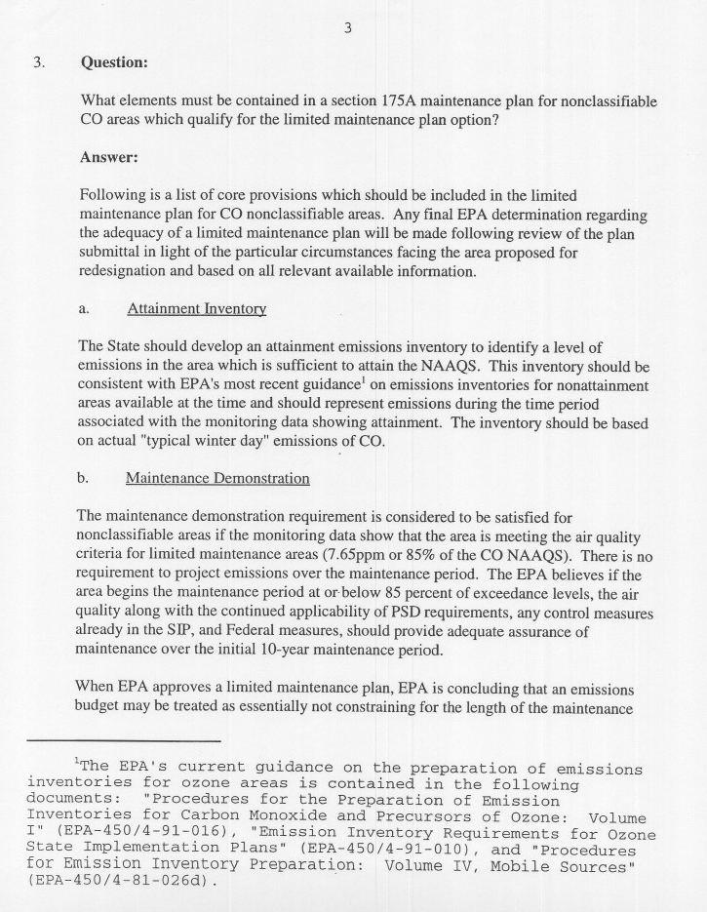
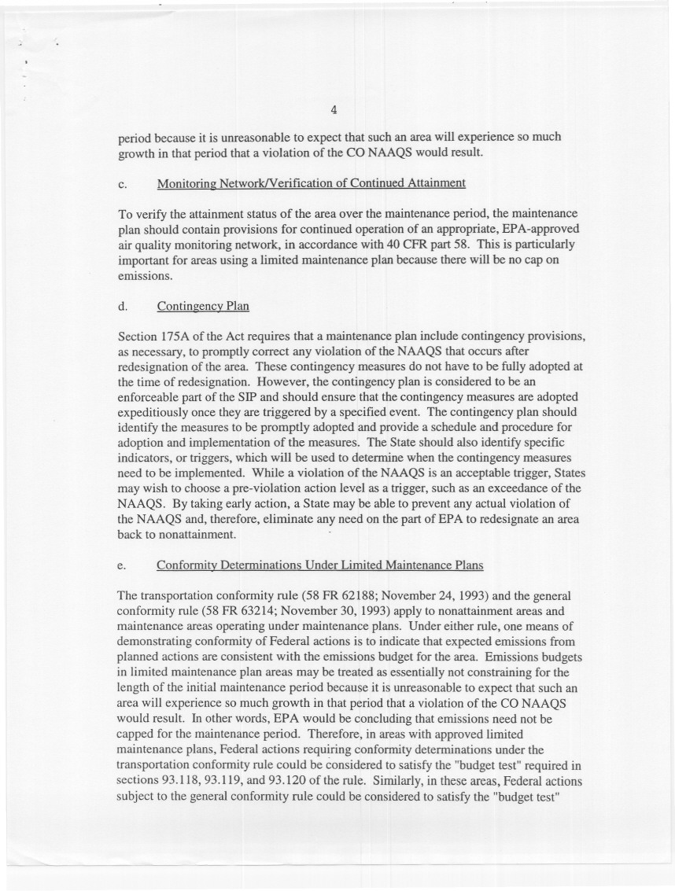

Appendix 2
Medford 2008 Emission Inventory

2008 Year Emission Inventory
For Carbon Monoxide (CO)
Medford Urban Growth Boundary

June 2015

Oregon Department of Environmental Quality
Environmental Solutions Division
Air Quality Technical Services Section
811 SW 6th Avenue
Portland, Oregon 97204

Table of Contents
Table of Contents ii
Table of Figures v
Table of Tables vi
1 Executive Summary 1
2 Introduction 6
2.1 Purpose of the Report 6
2.2 Inventory Time Frame and Area Covered 6
2.3 Report Contents 9
2.4 Automated Systems 10
2.5 Sources Not Inventoried 10
2.6 Guidance Documents 10
2.7 Contact Personnel 11
3 Medford Carbon Monoxide Attainment Area Inventory 13
3.1 Inventory Area Maps and Descriptions 13
3.1.1 Inventory Area Maps 13
3.1.2 Legal Descriptions 17
3.1.2.1 Legal Description of Medford Urban Growth Boundary / CO Inventory Area 17
3.1.2.2 Legal Description of Open Burning Control Areas 18
3.1.2.3 Legal Description of Medford Area Woodstove Curtailment Ordinance / Critical PM10 Control Area 19
3.1.2.4 Legal Description of the Medford-Ashland Air Quality Maintenance Area / Vehicle Inspection Program Boundary 19
3.2 Summary of Emissions Data 20
3.3 Stationary Permitted Point Sources 23
3.3.1 Introduction 23
3.3.2 Geographic Area and Sources Included 23
3.3.3 Point Source Determination 23
3.3.3.1 2008 Point Source Determination 24
3.3.4 Methodology and Approach 25
3.3.4.1 Data Collection 25
3.3.4.2 Emission Basis 25
3.3.4.3 Activity Data 25
3.3.4.4 Plant Site Emission Limits (PSELs) 26
3.3.4.5 Annual Emissons Calculations 26
3.3.4.5.1 Emissions Estimation Methodologies for TV Sources 26
3.3.4.5.2 Emissions Estimation Methodlogies for ACDP Sources 26
3.3.4.6 Seasonal Emissions Calculations 27
3.3.4.6.1 Seasonal Adjustment Factors 27
3.3.4.6.2 Season Day Emissions Calculations 27
3.3.5 Summary of Stationary Point Source Emissions 29
3.3.6 Control Efficiency (CE) and Rule Effectiveness (RE) 30
3.4 Stationary Nonpoint (Area) Sources 31
3.4.1 Introduction and Scope 31
3.4.2 Methodology and Approach 31
3.4.2.1 Source Category Identification and General Methodology Overview 31
3.4.2.2 Reconciliation with Point Source Emissions (double count prevention) 32
3.4.3 Discussion of Area Source Categories 32
3.4.3.1 Waste Disposal, Treatment and Recovery 32
3.4.3.1.1 Incineration 32
3.4.3.1.1.1 Industrial Incineration 32
3.4.3.1.1.2 Commercial/Institutional Incineration 33
3.4.3.1.1.3 Residential Incineration 33
3.4.3.1.2 Open Burning 33
3.4.3.1.2.1 Industrial Open Burning 33
3.4.3.1.2.2 Commercial/Institutional Open Burning 33
3.4.3.1.2.3 Residential Open Burning (back yard burning) 34
3.4.3.2 Small Stationary Fossil Fuel and Wood Use 35
3.4.3.2.1 Fuel Oil Combustion 35
3.4.3.2.2 Natural Gas (NG) and Liquified Petroleum Gas (LPG) 36
3.4.3.2.3 Coal and Biomass Combustion 37
3.4.3.3 Residential Wood Combustion 38
3.4.3.4 Miscellaneous Area Sources 38
3.4.3.4.1 Forest Wildfires 38
3.4.3.4.2 Prescribed Burning 38
3.4.3.4.3 Structure Fires 39
3.5 Nonroad Vehicles and Equipment 55
3.5.1 Introduction and Scope 55
3.5.2 Nonroad Vehicles and Equipment 55
3.5.2.1 Vehicle Categories 55
3.5.2.2 Methodology 55
3.5.3 Aircraft and Airport Operations Emissions 56
3.5.4 Waterborne Vessels 56
3.5.5 Rail 56
3.6 On-Road Mobile Sources 72
3.6.1 Introduction and Scope 72
3.6.2 Spatial and Temporal Allocation of 2008 NEI Data 72
3.6.2.1 Spatial Allocation 72
3.6.2.2 Temporal Allocation 72
3.6.3 Summary of On-Road Mobile Source Emissions 72
4 Quality Assurance and Quality Control 78
4.1 Introduction 78
4.2 Organization and Personnel 78
4.3 Data Collection and Analysis 79
4.3.1 Data Collection and Analysis 79
4.4 DATA HANDLING 79
4.5 Data Coding and Recording 79
4.6 Data Tracking 79
4.7 QA/QC Procedures - Checking and Correcting 80
4.7.1 Checking Data 80
4.7.1.1 Inventory Completeness 80
4.7.1.2 Missing Data 80
4.7.1.3 Incorrect Calculations 80
4.7.1.4 Incorrect Information 81
4.7.1.5 Reasonableness 81
4.7.1.6 Emissions Summary Reasonableness 81
4.8 Data Reporting 81
5 References 82
6 Appendices to the Emission Inventory 84

Table of Figures
Executive Summary, Figure 1: 2008 Medford UGB annual CO emissions, percentage by source category 3
Executive Summary, Figure 2: 2008 Medford UGB CO season day emissions, percentage by source category 3
Executive Summary, Figure 3: Medford UGB Annual CO Emissions Estimates, 1993 vs. 2008 4
Executive Summary, Figure 4: Medford UGB Season Day CO Emissions Estimates, 1993 vs. 2008 5

Figure 1: Medford Urban Growth Boundary 7
Figure 2: 2008 Medford CO LMP, 25-mile buffer and permitted point source locations 8
Figure 3: Open Burning Control Areas and Rogue Basin Open Burning Control Area 14
Figure 4: Woodstove Curtailment Ordinance Area / Critical PM₁₀ Control Area 15
Figure 5: Medford-Ashland Air Quality Maintenance Area / Vehicle Inspection Program Boundary 16
Figure 6: Distribution of 2008 Annual CO Emissions 21
Figure 7: Annual CO Emissions by Percentage 22
Figure 8: Distribution of 2008 Season Day CO Emissions 22
Figure 9: Season Day CO Emissions by Percentage 22
Figure 10: 2008 Commercial Open Burning Locations 36
Figure 11: 2008 Residential Open Burning Locations 37
Figure 12: Area Source Annual Emissions by Percentage 42
Figure 13: Area Source Season Day Emissions By Percentage 42
Figure 14: Distribution of Medford UGB Annual Nonroad Source CO Emissions, 2008 60
Figure 15: Percentage of Medford Annual Nonroad CO Source Emissions, 2008 60
Figure 16: Distribution of Medford CO Season Day Nonroad Source Emissions, 2008 61
Figure 17: Percentage of Medford UGB CO Season Day Nonroad Source Emission, 2008 61
Figure 18: Percentage of 2008 Medford Annual Onroad CO Source Emissions, by Vehicle Type 75
Figure 19: Percentage of 2008 Medford Season Day Onroad CO Source Emissions, by Vehicle Type 75
Figure 20: Percentage of 2008 Medford Annual Onroad CO Source Emissions, by Roadway Type 76
Figure 21: Percentage of 2008 Medford Season Day Onroad CO Source Emissions, by Roadway Type 76

Appendix A, Figure A- 1: 2008 Medford CO LMP Permitted Point Source Locations 88

Appendix B, Figure B- 1: Wildfire and Prescribed Burn Location and Date 94

Table of Tables
Executive Summary, Table 1 Medford UGB 2008 Estimated CO Emissions Contribution by Source Category. 1

Table 2.1: Summary of 2008 CO Emissions Data 22

Table 2.3. 1: 1993 Attainment Year Inventory List of Permitted Point Sources 24
Table 2.3. 2: Medford UGB CO Season: Summary of Point Source Emissions by SIC 29
Table 2.3. 3: Medford UGB CO Season, Summary of Top 5 :Point Source Emitters 30

Table 2.4. 1: Medford 2008 CO EI Summary of Estimation Procedures for Area Sources 41
Table 2.4. 2: Medford 2008 CO EI Summary of Emissions Estimates for Area Sources 41
Table 2.4. 3: Area Source Emissions From Fuel Oil Use 42
Table 2.4. 4: Area Source Emissions From Natural Gas (NG) Use 43
Table 2.4. 5: Area Source Emissions From Liquified Petroleum Gas (LPG) Use 45
Table 2.4. 6: Area Source Emissions From Residential Wood Combustion 47
Table 2.4. 7: Area Source Emissions From Wildfires 48
Table 2.4. 8: Area Source Emissions From Prescribed (RX) Burning 49
Table 2.4. 9: Area Source Emissions From Structure Fires 50
Table 2.4. 10: Area Source Emissions From Residential Open Burning 51
Table 2.4. 11: Area Source Emissions From Industrial Open Burning 52
Table 2.4. 12: Area Source Emissions From Commercial/Institutional Open BUrning 52
Table 2.4. 13: Area Source Emissions From Coal Use 53
Table 2.4. 14: Area Source Emissions From Biomass Burning 54

Table 2.5. 1: Medford UGB 2008 CO Summary of Emissions from Nonroad Sources 60
Table 2.5. 2: Medford UGB 2008 CO, Summary of Emissions from Nonroad Gasoline Vehicles * Equipment, 2-Cycle 61
Table 2. 5. 3. 2008 Medford UGB CO: Summary of Emissions from Nonroad Gasoline Vehicles and Equipment, 4-Cycle 63
Table 2. 5. 4. 2008 Medford UGB CO: Summary of Emissions from Nonroad CNG/LPG Vehicles and Equipment 65
Table 2. 5. 5. 2008 Medford UGB CO: Summary of Emissions from Nonroad Diesel Vehicles and Equipment 67
Table 2.5. 6. 2008 Medford UGB CO: Summary of Emissions from Aircraft and Airport GSE 69
Table 2.5. 7. 2008 Medford UGB CO: Summary of Emissions from Railroads 71

Table 2.6. 1. 2008 Medford UGB CO: Summary of On-Road Mobile Emissions by Vehicle Type 75
Table 2.6. 2. 2008 Medford UGB CO: Summary of On-Road Mobile Emissions by Road Type 77

Appendix A, Table A- 1: Stationary Point Source Determination for 2008 CO Inventory 87
Appendix A, Table A- 2: Exclusion of 1993 and some 2008 Facilities from CO Emission Inventory 87
Appendix A, Table A- 3: Stationary Point Source Emission Estimation Details 89

Appendix B, Table B- 1: GIS Allocation Results: Josephine County Zones, County-Wide and by UGB 93

Executive Summary
The Medford Carbon Monoxide (CO) Maintenance Area has met the National Ambient Air Quality Standards (NAAQS) for carbon monoxide. In accordance with the 1990 Federal Clean Air Act Amendments, the area has been redesignated to attainment status through the development of a Redesignation Request / Maintenance Plan. This limited maintenance plan inventory is for 2008, and is provided as part of the maintenance plan package to show compliance with published EPA requirements. The principal components for development and documentation that have been addressed in this inventory include stationary point sources, stationary area sources, non-road sources, on-road mobile sources, quality assurance implementation, and emissions summaries. The geographic focus for this 2008 emission inventory is the Medford CO Maintenance Area, which is defined as the Medford Urban Growth Boundary (UGB).

The following table summarizes contributions by source category for annual and seasonal CO emissions within the Medford UGB for 2008.

Executive Summary, Table 1 Medford UGB 2008 Estimated CO Emissions Contribution by Source Category.
 | Annual |  | CO Season
Source Type | tpy | % of Category | lbs/day | % of Category
Stationary Point Sources | 2,376.1 | 15% | 13,159 | 16%
Stationary Area Sources | 3,333.1 | 21% | 30,399 | 37%
Non-Road Mobile Sources | 4,488.2 | 28% | 10,061 | 12%
On-Road Mobile Sources | 5,730.0 | 36% | 28,731 | 35%
Total within Medford UGB | 15,927.4 | 100% | 82,350 | 100%

During the average CO season 2008 day, on-road mobile sources contribute 35% of the total carbon monoxide (CO) air emissions in the Medford UGB. Gasoline vehicles contribute 97% of the CO emissions within the on-road mobile category, whereas diesel vehicles contribute 3% of the on-road mobile category.

Stationary area sources comprise 37% of the total CO air emissions in the Medford UGB on a CO season day. Within the area source category, residential wood combustion accounts for 49% of the emissions. Wood combustion in non-certified woodstoves and inserts accounts for 28% of the total area source emissions. Prescribed burning accounts for 47% of the total area source emissions on a CO season day.
Non-road mobile sources contribute 12% of the total CO on an average winter day. Within this category, 4-cycle engines comprise 79% of the total emissions.

Permitted stationary point sources comprise 16% of the CO air emissions in the Medford UGB on an average CO season day. This category includes permitted stationary sources with both federal TV and state ACDP permits. There are 37 point sources within the Medford UGB and a 25-mile buffer zone around the UGB.

Emissions summaries for CO have decreased for both annual and season day as compared to the 1993 attainment year EI. Emissions have decreased 24% annually, and 27% for a season day as compared to the 1993 attainment year EI.

Details of the Oregon 2008 Medford UGB CO Limited Maintenance Plan Emission Inventory from point, area, non-road, and on-road mobile sources are presented in the following document. The relative percentage of annual and seasonal CO emissions from stationary point, stationary area, non-road mobile, and on-road mobile sources are shown in the Executive Summary Figures 1 through 4

Executive Summary, Figure 1: 2008 Medford UGB annual CO emissions, percentage by source category

Executive Summary, Figure 2: 2008 Medford UGB CO season day emissions, percentage by source category

Executive Summary, Figure 3: Medford UGB Annual CO Emissions Estimates, 1993 vs. 2008
Executive Summary, Figure 4: Medford UGB Season Day CO Emissions Estimates, 1993 vs. 2008ntroduction

Purpose of the Report
The Clean Air Act Amendments (CAAA) of 1990 authorized the U.S. Environmental Protection Agency (EPA) to designate nonattainment areas with respect to the National Ambient Air Quality Standards (NAAQS). Under the 1990 CAAA, pre-enactment carbon monoxide nonattainment areas were classified according to the severity of nonattainment. Each state was required to submit a list designating nonattainment areas within the state.

Oregon submitted a list of areas that were in nonattainment to EPA on 15 March 1991. The area within the Medford Urban Growth Boundary was listed as nonattainment for carbon monoxide (Medford UGB / NAA). The nonattainment area had a design value of 7.5 parts per million (ppm) for carbon monoxide, and exceeded the NAAQS in the period 1977 through 1991. The NAAQS limit is 9 ppm, but it must reach 9.5 ppm to be considered an exceedance. The highest recorded CO value measured in Medford was 21.8 ppm at the Brophy building site in 1977. Previous nonattainment boundaries included the entire Medford Air Quality Maintenance Area (AQMA) under former Governor Straub in 1978. Due to hot spot problems within the downtown region of Medford in 1982, the nonattainment area was revised to include only the central business district. The nonattainment area was again modified in 1992 when the Federal Register promulgated the designation of the Medford UGB / NAA as nonattainment for CO on November 30, 1992 by letter from Governor Roberts.

The emission inventory area for the Medford CO nonattainment area was delineated as the Medford UGB in the Inventory Preparation Plan (IPP) submitted September 15, 1997. The Oregon CO IPP was approved by EPA Region X on June, 10, 1998 by letter from Joan Cabreza. This document fulfills the EPA requirements for preparing the limited maintenance plan 2008 year emission inventory, specified in the provisions of the 1990 CAAA, and EPA guidance documents.

Inventory Time Frame and Area Covered

The 2008 limited maintenance plan inventory covers carbon monoxide emissions for the Medford Urban Growth Boundary (UGB) maintenance area. 2008 was chosen as the base year because it is the most recent National Emission Inventory (NEI) year for which the DEQ has PM2.5 monitoring data for the Medford area. Emissions are reported in this inventory for two representative time periods: Annual Emissions (in units of “tons per year”) and Seasonal Emissions (in units of “pounds per day”). Annual emissions represent CO emissions generated over the 2008 Maintenance Year. Seasonal emissions represent CO emissions generated on an average day in a three-month period - called the CO season - when ambient CO accumulations are typically the highest. For the Medford UGB, the CO Season is defined as the period of three consecutive months: December through February.

The geographic area of the Medford UGB is shown in Figure 1. Figure 2 shows boundaries used for the permitted point source section of the 2008 emission inventory. As in the 1993 attainment year inventory, a 25-mile buffer zone is the starting point for point source boundary definition. The 25-mile extension to the UGB area includes incorporated and unincorporated Jackson County and a part of Josephine County. Populated areas within the 25 mile buffer included in this inventory are Medford, Rogue River, Grants Pass, and White City.

Figure 1: Medford Urban Growth Boundary

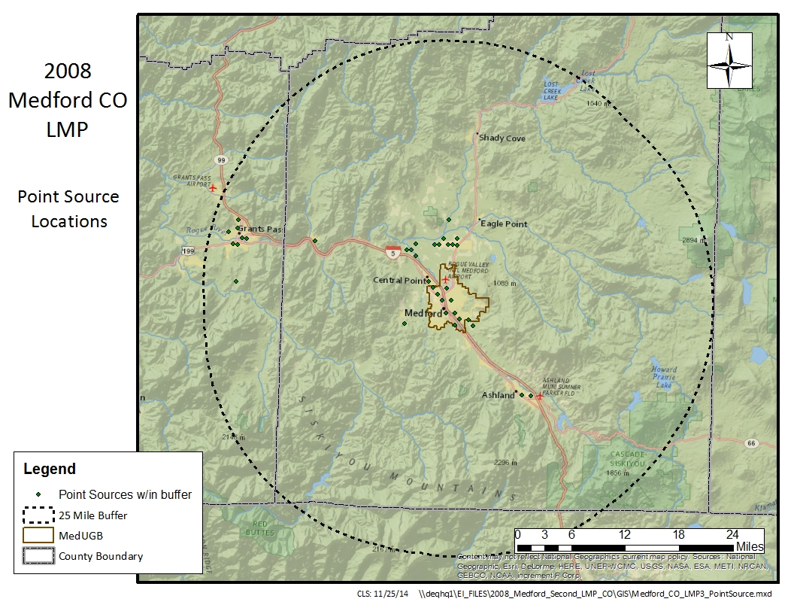
Figure 2: 2008 Medford CO LMP, 25-mile buffer and permitted point source locations

Report Contents
The Report is divided into the following components:

Part 1: Introduction to the Report
Part 2: Medford CO 2008 Limited Maintenance Plan Emission Inventory
Part 3: Quality Assurance and Quality Control
Part 4: References
Part 5: Appendices

- Part 1 provides an introduction to this Report and its purpose. Contents of the Report are briefly described. Information concerning automated systems is included. Sources not inventoried for the inventory are described along with a rationale for the exclusions. EPA procedure and guidance documents used in preparing the inventory are described. Finally, information on the personnel responsible for the preparation of the inventory is outlined.
- Part 2 describes in detail the methodologies and approaches taken to estimate emissions in the Medford UGB for the 2008 Limited Maintenance Plan inventory. Part 2 is divided into sections describing the inventory process and the types of emission sources that are addressed in the inventory, as follows:
- Section 1.0 provides maps of open burning control areas and the Medford-Ashland Air Quality Maintenance Area / Vehicle Inspection Boundary. These maps are included for consistency with the 1993 Medford CO Attainment Year Inventory. This section also provides legal descriptions of the inventory and open burning control areas, as well as the AQMA/VIP boundary.

- Section 2.0 contains summary tables for stationary point, stationary area, non-road mobile, and on-road mobile sources in the Medford UGB.

- Section 3.0 contains a discussion of the stationary point source emission category methodology and emissions estimate approach. Tables summarizing point source emissions estimates follow the discussion.

- Section 4.0 addresses stationary area sources and contains a discussion of the approaches used in estimating emissions. Each area source category inventoried is described in detail, including the methodology used in making the calculations. Tables summarizing stationary area source emissions estimates follow the discussion.

- Section 5.0 provides a discussion of the approach and methodology used in evaluating emissions from non-road mobile sources. Tables summarizing non-road mobile source emissions estimates follow the discussion.
- Section 6.0 provides a description of the approach and methodology used in evaluating emissions from on-road mobile sources. Tables summarizing on-road mobile source emissions estimates follow the discussion.
- Part 3 describes the quality assurance procedures utilized in preparing the 2008 inventory.
- Part 4 contains an extensive list of references utilized for the Medford CO emission inventory.
- Part 5 contains Appendices with supplemental data used to estimate emissions.

Tables and figures for each emission category are located at the end of the discussion section for that category. For example, summary emission tables for all stationary point source types in the Medford UGB are located at the end of Part 2, Section 3. Please note that some references listed in the tables are numbered as ‘DEQ master references’ (See Part 5 for this classification at the end of each entry).

Automated Systems
The inventory has been assembled by the staff of the Technical Services Section, Air Quality Division, of the Oregon Department of Environmental Quality (DEQ), and by Sierra Research, a consulting firm specializing in air quality and pollution control. The point source emissions are specifically drawn from the DEQ Tracking Reporting and Administration of Air Contaminant Sources (TRAACS) database. The TRAACS data is used for tracking compliance with plant site emission limits and for reporting compliance status to the EPA EIS system. TRAACS is also used to store actual emission data also reported to EIS. TRAACS contains annual emission levels for each permitted point source as well as, emission factors, and annual activity levels (fuel use and production levels). Nonpoint emissions, except where indicated, were extracted from the EPA Emission Inventory System (EIS) EIS Gateway. The EPA EIS database houses National Emissions Inventory (NEI) data that includes submittals from states.

Sources Not Inventoried
For consistency, the 1993 attainment year emission inventory was used as a reference, and all sources in the 1993 inventory are addressed in the 2008 inventory. Calculations and methodology for sources emitting 0 emissions during a typical CO season day are included in the 2008 inventory as well.

Guidance Documents
For consistency, DEQ and Sierra followed the format and outline of the 1993 Medford UGB CO Attainment Year Emission Inventory¹. For those sources inventoried by DEQ, inventory methodology followed applicable EPA procedure and guidance documents. Two primary documents utilized were Procedures for the Preparation of Emission Inventories for Carbon Monoxide and Precursors of Ozone, Volume I³, and Emission Inventory Requirements for Carbon Monoxide State Implementation Plans².

Contact Personnel
Due to existing workload and staffing commitments, DEQ entered into an agreement with the Rogue Valley Council of Governments (RVCOG) and Sierra Research for assistance with the Medford CO LMP emission inventory (please see Appendix C for the work proposal from Sierra).

The work breakdown was as follows:
- DEQ
  - Permitted point sources
  - Open burning
  - Wildfires and prescribed burning
- RVCOG/Sierra Research
  - Small, stationary fuel combustion (non-permitted)
  - Residential wood combustion
  - Structure fires
  - Aircraft and airport related
  - Locomotives
  - Recreational marine
  - Nonroad vehicles & equipment
  - On-road mobile (exhaust)

The abbreviated list of those conducting this Medford 2008 Limited Maintenance Plan emission inventory is shown below:

DEQ
Wendy Wiles
Environmental Solutions Division Administrator

Jeffrey Stocum,
Air Quality Technical Services Manager
Emission Inventory
Christopher Swab, Senior Emission Inventory Analyst
Brandy Albertson, Emission Inventory Analyst
Miyoung Park, Emission Inventory Specialist
Wayne Kauzlarich, ACDP Permit Writer
Dana Bailey, Permit Coordinator
Quality Assurance
Wesley Risher, Emission Inventory Analyst
David Collier,
Air Quality Planning Manager
Dave Nordberg, Air Quality Planner

Sierra Research
Tom Carlson, Principal Scientist
Wenxian Zhang, Associate Engineer

Starcrest Consulting Group, LLC
Wayne Elson, Air Quality Planner and Mobile Source Emissions Expert

Rogue Valley Council of Governments
Dan Moore, Planning Coordinator, AICP

Medford Carbon Monoxide Attainment Area Inventory

Inventory Area Maps and Descriptions

Inventory Area Maps
The following maps are presented here for consistency with the Medford CO 1993 Attainment Year SIP Emissions Inventory¹:
- Figure 1 (previous): Medford UGB Carbon Monoxide Attainment Area
- Figure 2 (previous): Medford UGB with 25-mile point source buffer zone
- Figure 3: Open Burning Control Areas as defined in (OAR) 340-264-0078(1) and Rogue Basin Open Burning Control Area as defined in 340-264-0078(3)
- Figure 4: Woodstove Curtailment Ordinance Area / Critical PM₁₀ Control Area
- Figure 5: Medford-Ashland Air Quality Maintenance Area / Vehicle Inspection Program Boundary

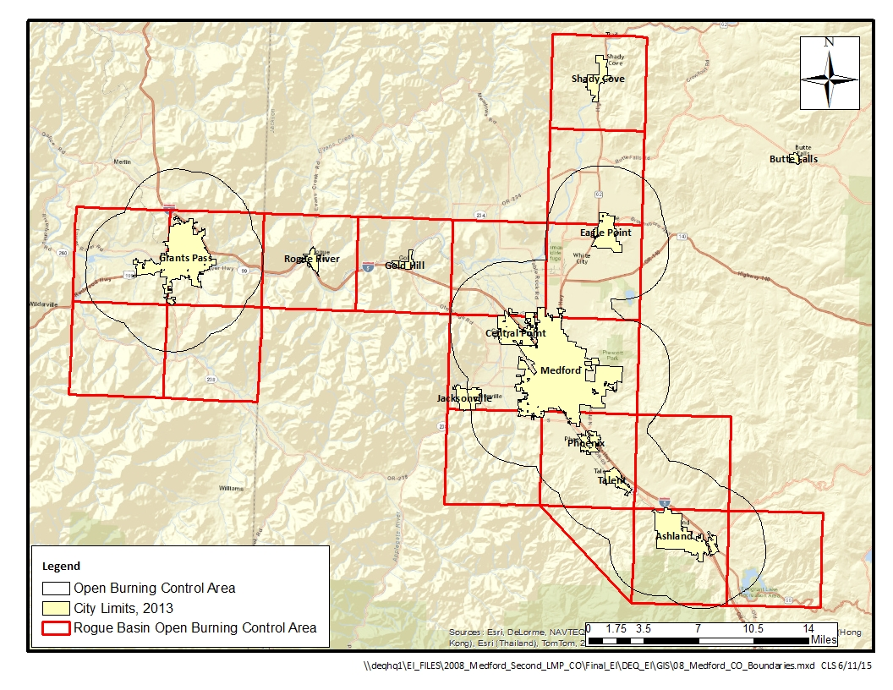
Figure 3: Open Burning Control Areas and Rogue Basin Open Burning Control Area
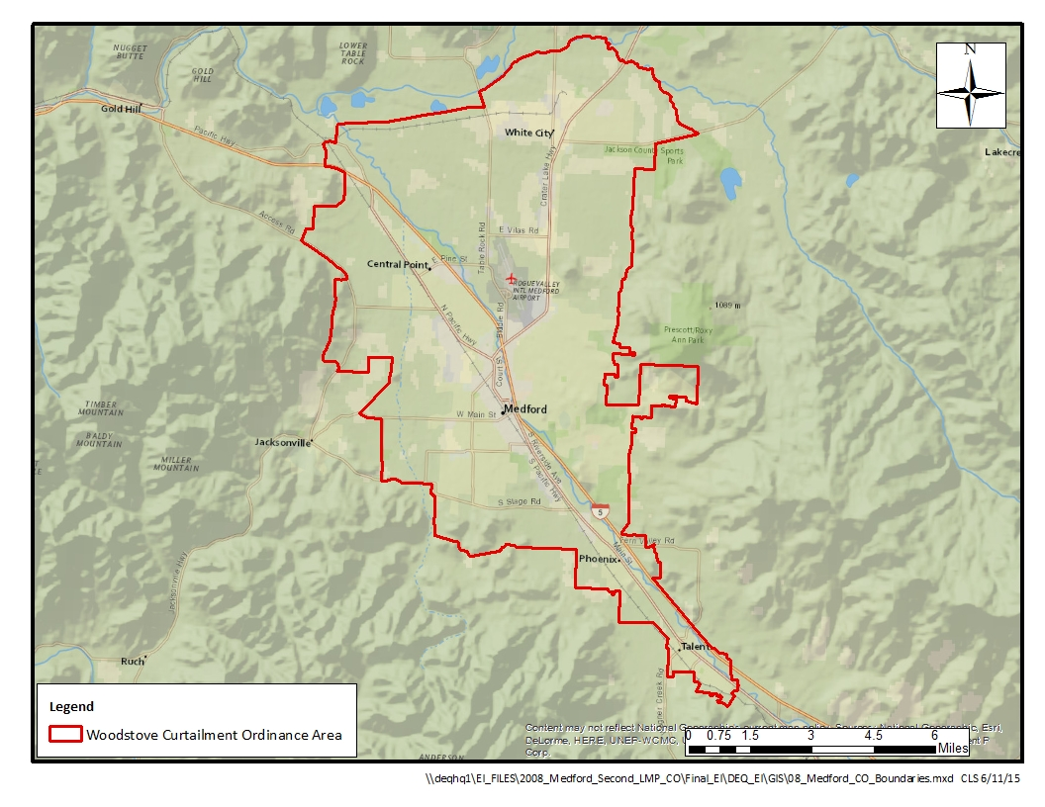
Figure 4: Woodstove Curtailment Ordinance Area / Critical PM₁₀ Control Area
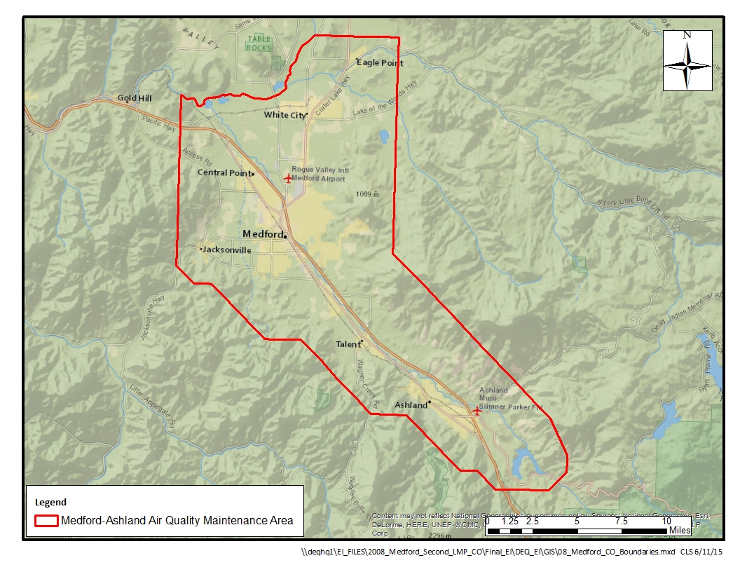
Figure 5: Medford-Ashland Air Quality Maintenance Area / Vehicle Inspection Program Boundary

Legal Descriptions

Legal Description of Medford Urban Growth Boundary / CO Inventory Area
Legal description of the Medford Urban Growth Boundary Attainment Area as adopted by Oregon DEQ define the boundaries as shown in Figure 1 and can be found in the Oregon Administrative Rules (OAR) 340-204-0010(12):

(12) “Medford UGB” means the area beginning at the line separating Range 1 West and Range 2 West at a point approximately 1/4 mile south of the northwest corner of Section 31, T36S, R1W; thence west approximately 1/2 mile; thence south to the north bank of Bear Creek; thence west to the south bank of Bear Creek; thence south to the intersection with the Medford Corporate Boundary; thence following the Medford Corporate Boundary west and southwesterly to the intersection with Merriman Road; thence northwesterly along Merriman Road to the intersection with the eastern boundary of Section 10, T36S, R2W; thence south along said boundary line approximately 3/4 mile; thence west approximately 1/3 mile; thence south to the intersection with the Hopkins Canal; thence east along the Hopkins Canal approximately 200 feet; thence south to Rossanely Drive; thence east along Rossanely Drive approximately 200 feet; thence south approximately 1200 feet; thence west approximately 700 feet; thence south approximately 1400 feet; thence east approximately 1400 feet; thence north approximately 100 feet; thence east approximately 700 feet; thence south to Finley Lane; thence west to the end of Finley Lane; thence approximately 1200 feet; thence west approximately 1300 feet; thence north approximately 150 feet; thence west approximately 500 feet; thence south to Highway 238; thence west along Highway 238 approximately 250 feet; thence south approximately 1250 feet to a point even with the end of Renault Avenue to the east; thence east approximately 2200 feet; thence south approximately 1100 feet to a point even with Sunset Court to the east; thence east to and along Sunset Court to the first (nameless) road to the south; thence approximately 850 feet; thence west approximately 600 feet; thence south to Stewart Avenue; thence west along Stewart Avenue approximately 750 feet; thence south approximately 1100 feet; thence west approximately 100 feet; thence south approximately 800 feet; thence east approximately 800 feet; thence south approximately 1000 feet; thence west approximately 350 feet to a point even with the north-south connector street between Sunset Drive and South Stage Road; thence south to and along said connecting road and continuing along South Stage Road to Fairlane Road; thence south to the end of Fairlane Road and extending beyond it approximately 250 feet; thence east approximately 250 feet; thence south approximately 250 feet to the intersection with Judy Way; thence east on Judy Way to Griffin Creek Road; thence north on Griffin Creek Road to South Stage Road; thence east on South Stage Road to Orchard Home Drive; thence north on Orchard Home Drive approximately 800 feet; thence east to Columbus Avenue; thence south along Columbus Avenue to South Stage Road; thence east along South Stage Road to the first road to the north after Sunnyview Lane; thence north approximately 300 feet; thence east approximately 300 feet; thence north approximately 700 feet; thence east to King’s Highway; thence north along King’s Highway to Experiment Station Road; thence east along Experiment Station Road to Marsh Lane; thence east along Marsh Lane to the northern boundary of Section 6, T38S, R1W; thence east along said boundary approximately 1100 feet; thence north approximately 1200 feet; thence east approximately 1/3 mile; thence north approximately 400 feet; thence east approximately 1000 feet to a drainage ditch; thence following the drainage ditch southeasterly approximately 500 feet; thence east to the eastern boundary of Section 31, T37S, R1W; thence south along said boundary approximately 1900 feet; thence east to and along the loop off of Rogue Valley Boulevard, following that loop to the Southern Pacific Railroad Line (SPRR); thence following SPRR approximately 500 feet; thence south to South Stage Road; thence east along South Stage Road to SPRR; thence southeasterly along SPRR to the intersection with the west fork of Bear Creek; thence northeasterly along the west fork of Bear Creek to the intersection with U.S. Highway 99; thence southeasterly along U.S. Highway 99 approximately 250 feet; thence east approximately 1600 feet; thence south to East Glenwood Road; thence east along East Glenwood Road approximately 1250 feet; thence north approximately 1/2 mile; thence west approximately 250 feet; thence north approximately 1/2 mile to the Medford City Limits; thence east along the city limits to Phoenix Road; thence south along Phoenix Road to Coal Mine Road; thence east along Coal Mine Road approximately 9/10 mile to the western boundary of Section 35, T37S, R1W; thence north to the midpoint of the western boundary of Section 35, T37S, R1W; thence west approximately 800 feet; thence north approximately 1700 feet to the intersection with Barnett Road; thence easterly along Barnett Road to the southeast corner of Section 27, T37S, R1W; thence north along the eastern boundary line of said section approximately 1/2 mile to the intersection with the 1800 foot contour line; thence east to the intersection with Cherry Lane; thence following Cherry Lane southeasterly and then northerly to the intersection with Hillcrest Road; thence east along Hillcrest Road to the southeast corner of Section 23, T37S, R1W; thence north to the northeast corner of Section 23, T37S, R1W; thence west to the midpoint of the northern boundary of Section 22; T37S, R1W; thence north to the midpoint of Section 15, T37S, R1W; thence west to the midpoint of the western boundary of Section 15, T37S, R1W; thence south along said boundary approximately 600 feet; thence west approximately 1200 feet; thence north approximately 600 feet; thence west to Foothill Road; thence north along Foothill Road to a point approximately 500 feet north of Butte Road; thence west approximately 300 feet; thence south approximately 250 feet; thence west on a line parallel to and approximately 250 feet north of Butte Road to the eastern boundary of Section 8, T37S, R1W; thence north approximately 2200 feet; thence west approximately 1800 feet; thence north approximately 2000 feet; thence west approximately 500 feet; thence north to Coker Butte Road; thence east along Coker Butte Road approximately 550 feet; thence north approximately 1250 feet; thence west to U.S. Highway 62; thence north approximately 3000 feet; thence east approximately 400 feet to the 1340 foot contour line; thence north approximately 800 feet; thence west approximately 200 feet; thence north approximately 250 feet to East Vilas Road; thence east along East Vilas Road approximately 450 feet; thence north approximately 2000 feet to a point approximately 150 feet north of Swanson Creek; thence east approximately 600 feet; thence north approximately 850 feet; thence west approximately 750 feet; thence north approximately 650 feet; thence west approximately 2100 feet; thence on a line southeast approximately 600 feet; thence east approximately 450 feet; thence south approximately 1600 feet; thence west approximately 2000 feet to the continuance of the private logging road north of East Vilas Road; thence south along said logging road approximately 850 feet; thence west approximately 750 feet; thence south approximately 150 feet; thence west approximately 550 feet to Peace Lane; thence north along Peace Lane approximately 100 feet; thence west approximately 350 feet; thence north approximately 950 feet; thence west approximately 1000 feet to the western boundary of Section 31, T36S, R1W; thence north approximately 1300 feet along said boundary to the point of beginning.

Legal Description of Open Burning Control Areas
In addition to the UGB, DEQ has specific rules that address commercial, demolition, construction and industrial open burning. The rules are identified for densely populated locations in the state, including cities over 4,000 people in population and within three miles of the corporate city limits of these cities. The boundaries defined by the rules are termed Open Burning Control Areas. The rules pertaining to the Medford area may be found in the Oregon Administrative Rules (OAR) 340-264-0078, summarized below.

Generally, areas around the more densely populated locations in the state and valleys or basins that restrict atmospheric ventilation are designated "Open Burning Control Areas". The practice of open burning may be more restrictive in open burning control areas than in other areas of the state. The specific open burning restrictions associated with these open burning control areas are listed in OAR 340-264-0100 through 340-264-0170 by county. The open burning control areas of the state are defined as follows:

(1) All areas in or within three miles of the incorporated city limit of all cities with a population of 4,000 or more.

(3) The Rogue Basin Open Burning Control Area is located in Jackson and Josephine Counties with boundaries as generally depicted in Figure 4 Rogue Basin Open Burning Control Area. The area is enclosed by a line beginning at a point approximately 4-1/2 miles NE of the City of Shady Cove at the NE corner of T34S, R1W, Willamette Meridian, thence south along the Willamette Meridian to the SW corner of T37S, R1W; thence east to the NE corner of T38S, R1E; thence south to the SE corner of T38S, R1E; thence east to the NE corner of T39S, R2E; thence south to the SE corner of T39S, R2E; thence west to the SW corner of T39S, R1E; thence NW along a line to the NW corner of T39S, R1W; thence west to the SW corner of T38S, R2W; thence north to the SW corner of T36S, R2W; thence west to the SW corner of T36S, R4W; thence south to the SE corner of T37S, R5W; thence west to the SW corner of T37S, R6W; thence north to the NW corner of T36S, R6W; thence east to the SW corner of T35S, R1W; thence north to the NW corner of T34S, R1W; thence east to the point of beginning.

Legal Description of Medford Area Woodstove Curtailment Ordinance / Critical PM10 Control Area
In order to strengthen overall woodstove strategies in the Medford AQMA, local ordinances in the Medford area were unified in 1998, resulting in a Woodstove Curtailment Ordinance Area, also known as the Critical PM₁₀ Control Area. The unified ordinance applies in Jackson County, as well as the cities of Ashland, Central Point, Jacksonville, Medford, Phoenix, and Talent. The legal description is as follows:

Beginning on I-5 and Tolo Road, crossover north on Tolo Road to Old Hwy 99. East on Old Hwy 99 to Kirtland Road. Northeasterly on Kirtland Road to Tablerock Road. North on Tablerock Road to the Rogue River. Northeasterly along the southern bank of the Rogue River to the mouth of Little Butte Creek. Northeasterly along Little Butte Creek to Antelope Creek. Southeasterly along Antelope Creek to Dry Creek. Southeasterly on Dry Creek to Hwy 140. Southwesterly on Hwy 140 to Kershaw Road. South on Kershaw Road to Corey Road. West on Corey Road to Foothill Road. South on Foothill Road to Medford Urban Growth Boundary (UGB) (near Delta Waters Road). Follow eastern UGB south to North Phoenix Road. South on North Phoenix Road to Phoenix UGB. Follow eastern UGB south to I-5. Southeasterly on I-5 to Talent UGB. Follow the eastern, southern, and western UGB until intersection with Southern Pacific Railroad Track (which became Union Pacific / Central Oregon & Pacific Railroad in 1994). Southern Pacific Railroad track north to Hartley Lane (Road). West on Hartley Lane (Road) to Talent-Phoenix Road (Colver Road). North on Talent-Phoenix Road (Colver Road) to Phoenix UGB. West along southern boundary of Phoenix UGB to Camp Baker Road. West on Camp Baker Road to Coleman Creek Road. North on Coleman Creek Road to Carpenter Hill Road. West on Carpenter Hill Road to Pioneer Road. Northwest on Pioneer Road to Griffin Creek Road. North on Griffin Creek Road to Medford UGB. North along Medford UGB to South Stage Road. West on South Stage Road to Arnold Lane. North on Arnold Lane to Jacksonville Hwy. West on Jacksonville Hwy to Hanley Road. Northeast on Hanley Road to Ross Lane. West on Ross Lane to Redwood Drive. South on Redwood Drive to LaPine Avenue (which becomes Wendt Road). West on LaPine Avenue (Wendt Road) to Old Stage Road. North on Old Stage Road to Old Military Road. North on Old Military Road to Old Stage Road. Northwest on Old Stage Road to Scenic Avenue. Northwest on Scenic Avenue to Tolo Road. North on Tolo Road to Willow Springs Road. East on Willow Springs Road to Ventura Lane. North on Ventura Lane to I-5. Northwest on I-5 to crossover of Tolo Road.

Legal Description of the Medford-Ashland Air Quality Maintenance Area / Vehicle Inspection Program Boundary
Vehicle owners residing within the Medford-Ashland Air Quality Maintenance Area are subject to DEQ vehicle inspection per OAR 340-256-0300(2) and (3). The legal description of the Medford – Ashland air quality maintenance area is as follows:

340-204-0010(10) “Medford-Ashland Air Quality Maintenance Area” (AQMA) means the area defined as beginning at a point approximately two and quarter miles northeast of the town of Eagle Point, Jackson County, Oregon at the northeast corner of Section 36, Township 35 South, Range 1 West (T35S, R1W); thence South along the Willamette Meridian to the southeast corner of Section 25, T37S, R1W; thence southeast along a line to the southeast corner of Section 9, T39S, R2E; thence south-southeast along line to the southeast corner of Section 22, T39S, R2E; thence South to the southeast corner of Section 27, T39S, R2E; thence southwest along a line to the southeast corner of Section 33, T39S, R2E; thence West to the southwest corner of Section 31, T39S, R2E; thence northwest along a line to the northwest corner of Section 36, T39S, R1E; thence West to the southwest corner of Section 26, T39S, R1E; thence northwest along a line to the southeast corner of Section 7, T39S, R1E; thence West to the southwest corner of Section 12, T39S, R1W, T39S, R1W; thence northwest along a line to southwest corner of Section 20, T38S, R1W; thence West to the southwest corner of Section 24, T38S, R2W; thence northwest along a line to the southwest corner of Section 4, T38S, R2W; thence West to the southwest corner of Section 6, T38S, R2W; thence northwest along a line to the southwest corner of Section 31, T37S, R2W; thence North and East along the Rogue River to the north boundary of Section 32, T35S, R1W; thence East along a line to the point of beginning.

Summary of Emissions Data
Summary tables of emission data that are presented here include stationary point sources, stationary area sources, non-road mobile sources, and on-road mobile sources. Summary emissions are expressed as charts in Figures 6 through 8. Table 2.1 provides a summary of the 2008 emissions estimates.

Figure 6: Distribution of 2008 Annual CO Emissions

Figure 7: Annual CO Emissions by Percentage

Figure 8: Distribution of 2008 Season Day CO Emissions

Figure 9: Season Day CO Emissions by Percentage

Table 3.1: Summary of 2008 CO Emissions Data

 | Annual |  | CO Season
Source Type | tpy | % of Category | lbs/day | % of Category
Stationary Point Sources | 2,376.1 | 15% | 13,159 | 16%
Stationary Area Sources | 3,333.1 | 21% | 30,399 | 37%
Non-Road Mobile Sources | 4,488.2 | 28% | 10,061 | 12%
On-Road Mobile Sources | 5,730.0 | 36% | 28,731 | 35%
Total within Medford UGB | 15,927.4 | 100% | 82,350 | 100%

Stationary Permitted Point Sources

Introduction
The following section is an overview and summary of the 2008 CO Point Source Emission Inventory developed for the Medford CO Limited Maintenance Plan (LMP) due in 2015. The 2008 CO inventory is an update to the original 1993 Attainment Year inventory¹. However, 1993 and 2008 emission results were not compared because of discrepancies caused by a significant lapse in time between inventories and the change in point source determination methodology. This inventory includes both annual and seasonal emission estimates that establish both short and long term CO trends from industrial sources during 2008. This write up details the steps used to develop the 2008 Medford Point Source Emission Inventory and is a discussion of the results.

Geographic Area and Sources Included
The geographic focus for this inventory is the former Medford CO nonattainment area which is the Urban Growth Boundary (UGB) for the city. The UGB is represented by the red outline above in Section 1, Figure 1. A 25-mile buffer zone was also added to Medford’s UGB to include industrial sources from other cities such as White City, Central Point, Ashland, Grants Pass, and Rogue River. Section 1, Figure 2 shows the UGB and 25-mile buffer zone as the inventory boundary.
Grants Pass industrial sources were not included in the Medford 1993 inventory because they were already inventoried for the 1993 Grants Pass State Implementation Plan⁹. The 1993 inventory for the Grants Pass SIP was updated in July 2014. Industrial sources from Grants Pass will be included in the 2008 CO inventory for Medford.

Point Source Determination
Point sources within the Medford UGB and 25-mile buffer zone include both industrial and non-industrial sources. Industrial sources are included under Part 2.3 Stationary Point Sources of this inventory and non-industrial sources are covered under Part 2.4 Stationary AREA Sources. This is a discussion on the point source determination for industrial sources included in both the 1993 Attainment Year Inventory and the 2008 Point Source CO Inventory for Medford.

Point sources for the 1993 Attainment Year Inventory were defined as stationary industrial sources that emitted more than 100 tons CO within the Medford UGB and a 25-mile buffer zone. Smaller stationary industrial sources that emitted less than 100 tons were included with non-industrial sources under Part 2.4 Stationary AREA Sources in the 1993 inventory.

Table 2.3.1 is the original list of large stationary industrial sources included in the 1993 inventory. See Reference 618, Appendix A, Point Source Data and Table A-1 Individual Stationary Point Source Determinations.
Table 2.3. 1: 1993 Attainment Year Inventory List of Permitted Point Sources
Source Number | Source Name | Permit Type | CO PSEL | Current Operating Status | SIC
15-0004 | Boise Cascade Corporation | TV | 2974 | Active | 2436
15-0012 | U.S. Forest Industries | ACDP | 99 | Active | 2435
15-0014 | Medite Corporation | ACDP | 99 | Active | 2436
15-0020 | Boise Cascade Corporation | TV | 796 | Active | 2436
15-0025 | Timber Products Company | TV | 237 | Active | 2436
15-0041 | Dyno Polymers Incorporated | ACDP | 1900 | Closed | 2861
15-0048 | Medford Corporation | ACDP | 947 | Closed | 2493
15-0058 | Royal Oak Enterprises, Inc. | ACDP | 613 | Closed | 2861
15-0073 | Medford Corporation | TV | 235 | Active | 2493
15-0159 | Biomass One, L.P. | TV | 570 | Active | 4961

Three facilities have since closed and the other seven operated in 2008 so they were added to the 2008 Medford CO EI.

2008 Point Source Determination
Point sources included in the 2008 CO Inventory are defined as stationary industrial sources that have a state or federal air operating permit and are located within the UGB and 25-mile buffer for Medford. These stationary industrial sources would fall under one of two permit programs that DEQ administers:
- Air Contaminant Discharge Permit (ACDP): a state operating permit for small industrial sources that emit 99 tons or less per year of any criteria pollutant, or
- Title V Permit (TV): a federal operating permit for large industrial sources that emit 100 tons or greater per year of any criteria pollutant.

One major change for the 2008 inventory was to include ACDP sources, reported as Area Sources in 1993, with the TV sources. DEQ has better data now to estimate CO emissions from ACDP sources.

The conditions used in 1993 for point source determination no longer apply and so the new conditions for inclusion in the 2008 inventory are as follows:
- Sources are located within the UGB and 25-mile buffer,
- Sources had an active ACDP or Title V permit in 2008
- Sources operated in 2008,
- Sources actually emit CO emissions

All ACDP and TV sources in Jackson and Josephine Counties were mapped using ArcGIS 10 in order to eliminate sources located outside the UGB and 25-mile buffer zone. The remaining ACDP and TV sources that fell within the inventory boundary were compared against the other conditions listed above to determine if they would be included in the 2008 CO EI for Medford. The list was narrowed down to 28 ACDP and 9 TV sources that met all the conditions above. Table A-1 is the final list of 37 sources by source number, name, site location, permit types, operating status, CO PSEL, and standard industrial classification codes (SIC) included in the 2008 inventory. Section 1, Figure 2 provides the geographical locations for the Medford sources included in 2008 CO inventory.

Appendix A, Table A-1.1 provides a list of 37 sources that were excluded from the 2008 inventory because they did not meet one or more of the conditions listed above. Ten sources were not included because, although they had a CO PSEL in their permit, they did not actually operate equipment that emits CO. This is fairly common with General ACDPs because they list all possible emission units and processes based on a source category and assign a facility based on the type of business they operate. An example of this is when a source is assigned to a General permit for millwork and the emission units/processes identified in the permit are boilers, veneer dryers, kilns, cyclones, target boxes, etc. The source may only operate cyclones and target boxes and nothing else in the list that may emit CO emissions.

27 sources were closed sometime between 1993 and 2008; therefore, they were not included in the 2008 CO EI for Medford

Methodology and Approach
The Medford inventory was developed using existing TV emissions data submitted by DEQ to EPA’s 2008 National Emission Inventory (NEl) and by putting together estimates for ACDP sources where no data was readily available. Since ACDP sources are typically reported to the NEI as Area Sources by county and source classification, CO emission estimates needed to be calculated down to individual source levels. The following is the methodology and approach used to develop the 2008 Medford Point Source CO Emission inventory.

Data Collection
Data collection is necessary to gather information used to calculate both annual and seasonal emissions. Information such as a source’s emission basis, activity/throughput data, operating schedules, and Plant Site Emission Limits (PSELs) were collected for the inventory. This data was collected from 2008 annual reports, permits, or retrieved electronically from a permitting database. Most emissions and compliance information for TV sources is already stored in DEQ’s Tracking Reporting and Administration of Air Contaminant Sources (TRAACS) permitting database. However, some information for ACDP sources such as emission basis and emission estimates are stored in an external database.

Emission Basis
Emission basis details the emission units and processes permitted at a source. The basis is developed by using information from emission detail sheets found in permits or permit review reports. For TV sources emission basis is organized in a workbook, a delivery mechanism for importing data into TRAACS. The workbook contains emission source and process descriptions, activity data, emission factors or other data used in estimating emissions, and potential to emit emissions used to develop Plant Site Emission Limits (PSELs). The workbook imports the emission basis into TRAACS where this information is used in preparing emission inventories. Further, the emission basis and emissions are submitted to EPA’s EIS database annually.

ACDP emission basis is collected and stored by inventory project in an MS Access database, known as Final ACDP EI database. This database stores the same type of information as TRAACS such as the emission units/process descriptions, emission factors, and other data necessary for calculating emissions. The information is obtained from ACDP permits and/or annual reports.

Activity Data
Activity data, also called throughput, was collected from 2008 annual reports for Title V and ACDP sources. Activity data consists of fuel use, production activity, or other annual throughput types used to estimate emissions. Sources must fulfill permit conditions for annual reporting by submitting annual activity information, emissions factors, and emission estimates for criteria air pollutants. The activity data is used to verify existing emissions estimates from the reports as well as to calculate emissions not typically reported by the sources themselves

Plant Site Emission Limits (PSELs)
PSELs were found in the DEQ TRAACS database (see Section 1.4) or permits

Annual Emissions Calculations
Point source annual emissions were estimated at the process level for each source. Emission basis and activity data used to estimate process level emissions were collected from ACDP and TV permits and 2008 annual reports. Below are the estimation methodologies used to prepare TV source annual emissions for the 2008 NEI and ACDP source emissions for the Medford inventory.

Emissions Estimation Methodologies for TV Sources
Emissions for this inventory were estimated 1 of 2 ways using:
- emission factors, or
- Continuous Emissions Monitoring System (CEMS)

Emission factors, the most common methodology, are derived by the source and permit writer to determine PSELs and compliance. Emission factors are developed using such resources as AP-42, industry standards, or by source testing. Emission factors relate the quantity of a pollutant to its activity such as lb. of pollutant per gallon of fuel oil. Emission factors may be based on assumptions or conversions not likely defined in the permit or emission detail sheets. These assumptions include capture efficiencies, control efficiencies, conversion constants, %LEL (lower explosive limit), and transfer efficiency.

Most of the CO emission estimates were developed using emission factors from permits and activity from 2008 annual reports. The following formula was used to estimate annual CO emissions:
2008 Annual CO Emissions (tpy) = (2008 Activity * Emission Factor)/2000 lbs/ton

Some CO emission estimates were derived via CEMS which is the most accurate representation of emissions at a source. Permit conditions may require direct measurement of stack emissions and recordkeeping for reporting hourly or daily CO emitted at a facility. Emission factors and CEMS are the most common estimation methodologies used to develop large industrial point source emissions for the 2008 CO inventory.

Emissions Estimation Methodologies for ACDP Sources
Emissions from ACDP sources are generally not reported as point sources to the NEI but as AREA sources at the county-level and source classification code (SCC). Since ACDP sources were reported on a county-level to the 2008 NEI, emission estimates had to be developed for each individual source for this inventory.
CO emission estimates were developed using emission factors from permits and activity from 2008 annual reports. The following formula was used to estimate annual CO emissions:
2008 Annual CO Emissions (tpy) = (2008 Activity * Emission Factor)/2000 lbs/ton

See Appendix A, Table A-2 Stationary Point Source Emission Estimation Details. The table provides annual emission details down to process-level for both ACDP and TV sources. This table includes emission unit level information such as annual activity, emission factors, and operating details. The 2008 annual emissions for both ACDP and TV sources were used next to calculate seasonal emissions.

Seasonal Emissions Calculations
Emissions are generally not static and fluctuate during different times of the year for various reasons such as changes in source activity or temperature. For example, CO emissions may peak during winter months in urban areas due to incomplete combustion of carbon-based fuels (i.e. automobiles, woodstove, open-burning, fuel combustion of industrial boilers, etc.). The winter months of December through February is defined as the CO season, the period for which emissions are more likely to peak. The reason for this is cooler temperatures during these months prevent complete combustion of the fuel which may result in excess CO emissions trapped near the ground by atmospheric inversions.

2008 annual CO emissions were temporally allocated from annual to seasonal emissions for the CO season. Typical Season Day (TSD) emissions are average daily CO emissions calculated over the CO season and recorded in pounds per day (lbs/day). To complete seasonal emission estimates data components such as annual emissions (tpy), seasonal adjustment factors, and annual activity days are required. The following is the allocation and development methods and data components needed to calculate seasonal emissions.

Seasonal Adjustment Factors
Seasonal Adjustment Factors (SAF) were calculated using temporal files of peak season activity by source classification code (SCC) from EPA’s Sparse Matrix Operator Kernal Emissions (SMOKE) modeling program. The data components from these files are used in the following equation to calculate SAF:
SAF =
((Sum of Peak Season Activity) (12 months)) / ((Annual Activity) (Peak Season Activity Months))

An example of how this calculation works is:
Use SCC 10200502,
Determine the peak season months and % activity for the peak season months:
Peak Season Activity Months: | % Activity During Peak Season Months
December | 83
January | 83
February | 83
Total Annual Activity: | 996
Insert information into pertinent components of SAF calculation:
SAF = ((83+83+83) (12 months)) / ((996) (3 months)) = 1.00

Both ACDP and TV sources required SAFs to complete seasonal calculations. See Appendix B, Table B-1: Seasonal Adjustment Factors by SCC Used for 2008 CO Inventory.

Season Day Emissions Calculations
Typical Season Day (TSD) emissions are average daily CO emissions calculated over the CO season (i.e. December 1st through end of February the following year). The following data components are needed to calculate TSD emissions:
- 2008 Annual CO Emissions (AE)
- SAF
- Activity Days (AD)
TSD emissions = (AE*SAF*2000 lb./ton) / (AD)

The following is an example calculation for natural gas fuel combusted in a veneer dryer. In order to complete the TSD calculation 2008 annual CO emissions, seasonal adjustment factor by SCC and annual activity days are needed. This formula breaks the annual emissions down to lbs/day over the CO season.

Dryer Emissions (SCC 30700716):
- AE = 140 tons
- SAF = 1.00
- AD = 365 days/yr.
TSD Emissions = (140*1.00*2000) / (365) = 767 lbs/day

TSD emission calculations were performed for all 37 ACDP and TV sources. TSD emission estimates for TV and ACDP sources cannot be calculated nor stored in TRAACS. TV and ACDP seasonal emissions were calculated and housed in MS Access Final_SIP_MP_PSD_EITool database. Appendix A, Table A-2 Stationary Point Source Emission Estimation Details also provides TSD emission estimates down to the process-level for both ACDP and TV sources.

Summary of Stationary Point Source Emissions
Inventory results were organized into tables summarizing 2008 annual and seasonal CO emissions by source industrial classification (SIC) and at source and process levels. Appendix C, Tables 2.3.1, 2.3.2, and 2.3.3 summarize stationary point source CO emissions for the 2008 Medford inventory. See Figures 8 through 11 for how stationary point source annual and season day emissions are distributed amongst the other source categories of the inventory.

Total 2008 annual and seasonal CO emissions for industrial sources located within the Medford UGB and 25-mile buffer are 2,376.1 tons per year and 13,159 lbs per day, respectively. The major industries permitted in Medford and the surrounding cities are wood products manufacturing, concrete production, steam supply for operating processes or heating dwellings, sewer systems, crematories, and landfills.

Table 2.3.2 summarizes 2008 CO annual and seasonal emissions by SIC for the Medford UGB and 25-mile buffer area. The table reveals three industrial classifications that contribute over 96% of total point source CO emissions in 2008.

Table 2.3. 2: Medford UGB CO Season: Summary of Point Source Emissions by SIC
 |  | (1) | (2)
 |  | CO Emissions
SIC Code | SIC Name | Annual and TSD Emissions
 |  | tpy | lbs/day
2048 | OTHER PREPARED FEEDS | 0.1 | 1
2421 | SAWMILLS AND PLANING MILLS | 2.4 | 20
2431 | MILLWORK | 1.2 | 9
2434 | WOOD KITCHEN CABINETS | 0.2 | 1
2435 | HARDWOOD VENEER AND PLYWOOD | 22.4 | 123
2436 | SOFTWOOD VENEER AND PLYWOOD | 1803.6 | 9943
2439 | STRUCTURAL WOOD MEMBERS | 0.3 | 2
2493 | RECONSTITUTED WOOD PRODUCTS | 36.3 | 207
2951 | PAVING MIXTURES AND BLOCKS | 12.3 | 74
3272 | OTHER CONCRETE PRODUCTS | 5.2 | 37
3861 | PHOTOGRAPHIC EQUIPMENT & SUPPLY | 3.8 | 21
4952 | SEWERAGE SYSTEMS | 10.7 | 59
4953 | REFUSE SYSTEMS | 211.1 | 1160
4961 | STEAM SUPPLY | 266.6 | 1501
 | Pollutant Total | 2376.1 | 13159

Softwood veneer and plywood (SIC 2436) contributes 75.9% while steam supply (SIC 4961) and refuse systems (SIC 4953) only emit 11.2% and 8% of total CO emissions, respectively. This leaves a wide margin between softwood veneer and plywood products manufacturing and other industrial classifications.

Further evaluation required identification of sources in each SIC. Table 2.3.3 in Appendix C, is a list of sources with annual and seasonal CO emissions for each SIC. This table reveals which sources are contributing significantly to CO emissions in the three primary SIC’s listed above. A 100 tpy annual emissions cut-off was applied to these sources to determine the top emitters of CO emissions for this inventory.

Table 2.3.3 lists five sources that contribute the most CO emissions within the Medford UGB and 25-mile buffer. These five sources emit together 88% of the total annual and seasonal CO emissions. Boise Cascade Wood Products, L.L.C. (15-0004) produces over half the 2008 CO emissions out of the five sources. CO emissions for these sources occur because of fuel combustion activities such as the operation of boilers, landfill engines, and veneer dryers. All other source contributions to 2008 annual and seasonal CO emissions are considered minimal.

Table 2.3. 3: Medford UGB CO Season, Summary of Top 5 Point Source Emitters
 |  |  |  | (1) | (2)
 |  |  |  | CO Emissions
Emission Year | SIC Code | Source Number | Source Name | Annual Emissions | Typical Season Day
 |  |  |  | tpy | lbs/day
2008 | 2436 | 15-0004 | Boise Cascade Wood Products, L.L.C. | 1087.6 | 5943
2008 | 2436 | 15-0020 | Boise Cascade Wood Products, L.L.C. | 513.1 | 2812
2008 | 4961 | 15-0159 | Biomass One, L.P. | 232.7 | 1278
2008 | 4953 | 15-0026 | Dry Creek Landfill, Inc. | 162.6 | 891
2008 | 2436 | 17-0030 | TP Grants Pass, LLC | 111.4 | 598
 |  |  | Pollutant Total | 2,107.4 | 11,521
- And (2), see Appendix A, Table A-2

In summation, wood product companies (Boise Cascade (15-0004) and (15-0020)) and TP Grants Pass L.L.C (17-0030) account for 81% of total CO emissions during 2008. Biomass One, L.P. (15-0159) and Dry Creek Landfill (15-0026) only account for 19% of the industrial source CO emissions in 2008. These sources contributed 2107.4 tpy out of 2376.1 tpy and 11521 lbs/day out of 13159 lbs/day over the CO season. All these sources are still in operation today.

Control Efficiency (CE) and Rule Effectiveness (RE)
EPA requires control efficiency and rule effectiveness to be calculated for SIPs. According to EPA’s Air Emissions Reporting Requirements (AERR) rule (40 CFR Part 51) these concepts are defined as:
- Control Efficiency (CE): the capture and reduction efficiency of primary control devices
- Rule effectiveness (RE): a generic term for identifying and estimating the uncertainties in emission control programs. Rule effectiveness adjusts the control efficiency from what could be realized under ideal conditions to what is actually emitted in practice due to less than ideal conditions. It is a measure of the extent to which a rule actually achieves its desired emission reductions.

The 1993 baseline control efficiencies were zero and rule effectiveness did not apply because no CO controls were installed back then for any source. No controls for CO have been installed since 1993 for any source; therefore, control efficiency and rule effectiveness also do not apply in the 2008 inventory.

Stationary Nonpoint (Area) Sources

Introduction and Scope
This section describes the development of the emissions inventory for carbon monoxide for stationary area sources located in the Medford UGB in 2008. Area sources included in this inventory are stationary and collectively represent relatively small and numerous individual sources within the inventory area. Included in the area source category are three groups of distinct area source emission contributors: Waste disposal, treatment and recovery (including residential, industrial, and commercial open burning); Small stationary fuel and wood use (including residential, industrial, and commercial combustion); and Miscellaneous (forest fires, structural fires, and slash burning). A fourth group of sources, small permitted point sources, originally included in the 1993 attainment year inventory, are included in the permitted point source inventory (Section 2.3) for this emission inventory.

All tables referred to in this section of the report are shown at the end of the section.

Table 2.4.1 lists the procedures used to develop the emission estimates for the various categories of area source CO emissions included in the Medford UGB inventory. Estimated area source emissions represented in this inventory occur on an average weekday during the three-month CO season of January 1 through February 28, and December 1through December 31, 2008.

Stationary area sources are currently referred to as nonpoint sources by EPA, however the term area sources is used in this document for consistency with the 1993 attainment year EI.

Methodology and Approach

Source Category Identification and General Methodology Overview
Discussion of guidance documents and broad methodology used to calculate stationary area source emissions can be found in Part I. The list of stationary area sources included in the inventory was based on the EPA Procedures Document³ and the Emissions Inventory Requirements for CO¹. These area sources were compared to sources evaluated in the 1993 Attainment Year CO SIP Emission Inventory⁶¹⁸, and the annual inventory of point source categories.

The starting point for emissions estimates for many area source categories was the EPA 2008 National Emission Inventory. All data from the 2008 NEI was retrieved from the EPA EIS Gateway (See Part 1, Section 1.4 of this report). The 2008 NEI CO emissions estimates consist of data generated by both DEQ and EPA, depending upon source category. The DEQ data for specific categories, such as Residential Wood Combustion, were submitted to EPA through the EIS CERS XML process as required by the Air Emissions Reporting Rule (AERR). Data and documentation for the 2008 NEI may be found at the following website: http://www.epa.gov/ttnchie1/net/2008inventory.html

For DEQ generated emission estimates, emission factors were taken from the EPA Procedures Document², the FIRE Version 5 SCC’s and Emission Factors¹⁰, the Compilation of Air Pollution Emission Factors (AP-42)¹¹, various EPA Surveys, and local studies conducted by the Oregon Department of Environmental Quality or environmental consulting firms. Errors in estimated emissions could occur in the multiplier values used, in the accuracy of calculations, or in mistakes in the construction of equations. Therefore, estimated emissions were checked for reasonableness by a number of approaches: 1) using alternative multiplier values when possible; 2) comparing estimates with the results of earlier area source inventories; and 3) performing independent checks on the accuracy of the multiplier values, the methodologies, and the emission calculations.

Seasonal activity factors were taken from the EPA Procedures Document² or were derived by DEQ and based upon season specific activity levels following guidelines in the Procedures Document. All sources were considered to be uncontrolled with the exception of open burning; for details on how controls were incorporated into the open burning categories, please see Section 2.4.3.1.2 and associated tables.

Reconciliation with Point Source Emissions (double count prevention)
Double counted emissions were removed from area source fuel combustion emissions by subtracting emissions from point source fuel burning processes, broken down by the specific type of fuel, as shown in Appendix A, Table A-2. However, point source emissions to be removed were selected with the following two parameters:
- ACDP source emissions only, since the 2008 TV source double-count was resolved by the DEQ for the 2008 NEI submittal.
- Jackson County sources only, excluding those sources inventoried in the Grants Pass area, since area sources inventoried were for the Medford UGB only

Discussion of Area Source Categories
Each of the major area source categories is comprised of area source types. Detailed descriptions of the emission estimation methodology for each source type are included in Tables 2.4.3 through 2.4.14 and in Appendix B. The applicable appendix table number is included in the annotations, which accompany the summary table. Discussion of data sources, emission factors, seasonal adjustment factors, and activity levels which affect the area source are included for each area source type. Applicable state regulations affecting a specific area source emission category are included in the notes on each category summary table. If specific area source type emissions were affected by state regulations during the inventory year, control efficiency, rule effectiveness, and rule penetration have been applied^{1, 3}. Example calculations for emissions estimates are included on individual spreadsheets. The following sections describe these major categories; subsections corresponding to individual area source types are included.

Summary charts and tables, along with emissions estimates tables by category, are shown following this section.

Waste Disposal, Treatment and Recovery
This category includes disposal, treatment, recovery and cleanup of solid and liquid wastes by incineration and open burning.

Incineration
This category consists of the disposal of solid waste, infectious waste, or crematory incinerator waste from industrial and commercial/institutional sources by combustion. Combustion occurs in a structure or furnace for the purpose of reduction in volume or weight of the waste material.

Industrial Incineration
The Medford UGB does not contain any industrial incineration sources and as such this category has not been inventoried

Commercial/Institutional Incineration
The 1993 attainment year emission inventory considered this category (given as “Commercial/Institutional On-Site Incineration) as an Area source. In 2008 this category was treated under point sources; Please see Part 2.3 of this document for point source methodology.

Residential Incineration
Residential on-site solid waste incineration activity is assumed to be zero. DEQ rules outlining structural requirements, source tests, and continuous emission monitoring, as well as associated permit costs, preclude individual residential construction of incineration devices. Destruction of solid waste and yard debris at residential sites is included in residential open burning calculations.

Open Burning
This category includes waste material disposal from industrial, commercial / institutional, and residential sources in open outdoor fires, burn barrels or incinerators which do not meet DEQ emission limits, or burn in a manner in which combustion air is not effectively controlled and combustion products do not vent through a stack or chimney.

Industrial Open Burning
Industrial open burning is prohibited in the Medford UGB except by special letter permit issued by DEQ’s Western Region Office. No industrial open burning was permitted within the Medford UGB in 2008 ^{945, 946}. Industrial Open Burning emissions estimates are detailed in Table 2.4.11.

Commercial/Institutional Open Burning
This category is specific to the clearing of land for new construction and the burning of organic material (i.e. trees, shrubs and other vegetation). Jackson County Commercial and Institutional Open Burning emissions are from the EPA 2008 National Emissions Inventory (NEI) database. Using Jackson County land use zoning acreage, GIS allocations were created to approximate both the location and magnitude of emissions, see Appendix B, Table B-1. Annual CO Medford UGB Emissions were estimated by multiplying the county emissions by the GIS allocation (%) for the appropriate land use zoning classification (ID #8: Commercial Lawn & Garden: Commercial Zones).

Burn permits and complaints were provided by the DEQ Medford office^{12, 14} and City of Medford Fire District^{13, 15}, and burn days and type of burn were based on the information.
Latitude and longitude data obtain from the permits were used in Google earth to determine which burn locations were inside the UGB area. Figure 10 shows all commercial open burning location from permits and complaints within Medford UGB area.
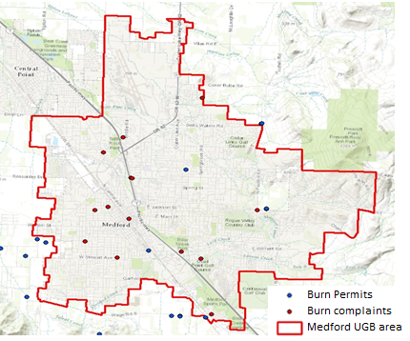

Figure 10: 2008 Commercial Open Burning Locations

There were no CO emission in the CO season because there were no permitted commercial burns and no record of illegal burns.

Residential Open Burning (back yard burning)
Residential open burning includes the outdoor burning of wood, leaves, land clearing debris, and household waste. Household waste often referred to as residential municipal solid waste (MSW), is a term for nonhazardous refuse produced by households (e.g. paper, plastics, metals, wood, glass, rubber, leather, textiles, and food wastes).

Jackson County residential open burning emissions are from the EPA 2008 National Emissions Inventory (NEI) database.
Using Jackson County land use zoning acreage, GIS allocations were created to approximate both the location and magnitude of emissions, see Appendix B, Table B-1. Annual CO Medford UGB emissions were estimated by multiplying the county emissions by the GIS allocation (%) for the appropriate land use zoning classification (ID #9: Residential Lawn & Garden: Residential Zoning).

Burn permits and complaints were provided by the DEQ Medford office^{12, 14} and City of Medford Fire District ^{13, 15}, and burn days and type of burn were based on the information.
Latitude and longitude data obtain from the permits were used in Google earth to determine which burn locations were inside the UGB area. Figure 11 shows all residential open burning location from permits and complaints within Medford UGB area.
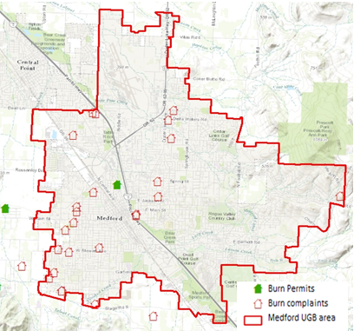
Figure 11: 2008 Residential Open Burning Locations

Weekly activity values use based on EPA’s document¹⁶. Open burning can be expected to take place seven days a week. Typical Season Day emissions were calculated by multiplying the UGB annual emissions tons by the Seasonal Adjustment Factor (SAF), which includes burning complaints (violations record) and permitted burning during peak Season and total burning days annual activity, divided by activity days per week, multiplied by 52 weeks per year using the following formula:

CO Typical Season Day (lbs/day) = (Annual UGB Emissions (tons/year) *2000 (lb./ton)* SAF)/ (Activity (days/wk.) * 52 (wk./year))

Residential Open Burning emissions estimates are detailed in Table 2.4.10

Small Stationary Fossil Fuel and Wood Use
This category includes small furnaces, heaters, heating units, and cooking devices that emit fewer than 100 tons of CO per year. Four main types of fuel are used within the Medford UGB by industrial, commercial/institutional, and residential sources: fuel oils, natural gas, liquefied petroleum gas (LPG), and wood. Wood fuel use is evaluated only for residential sources, where wood use is primarily in fireplaces, wood stoves, furnaces, and for cooking; fossil fuel use by residential sources is evaluated for space heating or cooking purposes only. Use of these fuels by industrial and commercial sources for other purposes is included in the point source inventory.

Fuel Oil Combustion
Fuel oil emissions from industrial/commercial/institutional sources are from fuel consumption in large or small boilers, furnaces, heaters, and other heating devices. Residential fuel oil emission sources are primarily from fuel consumption in furnaces, heaters, and other heating devices. For this inventory, industrial and commercial fuel oil use includes residual oil, distillate oil, and kerosene use; residential fuel oil consumption includes distillate and kerosene use only.

Jackson County emissions for fuel oil combustion are from the EPA 2008 NEI database. Since industrial and commercial fuel use emissions were not inventoried in the 2008 NEI, the respective 2011 NEI emissions were used. EPA county-wide industrial and commercial emissions were allocated to the Medford UGB using the 2008 employee population data from the US Census Bureau and developing a ratio of UGB employees to county employees. The 2008 US Census employee population was downloaded from the following location: http://www.census.gov/econ/cbp/index.html. Two zip codes were used to represent the Medford UGB: 97501 and 97504. The residential emissions were allocated to the UGB by a ratio of the 2010 Medford UGB population to the county-wide population. The Medford UGB population was determined by mapping the census blocks with population and housing unit counts to the Medford UGB boundary using the GIS spatial analysis tool. The census block data with population and housing unit counts are from the 2010 Tiger/Line shapefiles. This type of shapefile is released every 10 years, so the 2010 shapefile was selected as the closest to year 2008. The following formula was used for spatial allocation:

Annual UGB emissions, tpy = Annual Jackson County Emissions (tons/year) * (UGB employee or population / Jackson County employee or population)

The employee data were used to allocate industrial and commercial fuel use, and the population data were used to allocate residential fuel use. Weekly activity and the SAF were taken from the 1993 EI.³ Typical Season Day emissions were calculated by multiplying the UGB annual emissions tons by the SAF, divided by activity days per week, multiplied by 52 weeks per year, using the following formula.

CO Typical Season Day Emission (lbs/day) = (Annual UGB Emissions (tons/year) * 2000 (lb./ton) *SAF)/ (Activity (days/wk.) *52 (weeks/yr.))

Area source fuel combustion emissions were reconciled with permitted point source emissions by subtracting emissions from point source fuel burning processes, broken down by the specific type of fuel, as shown in Appendix A, Table A-2. However, point source emissions to be removed were selected with the following two parameters:
- ACDP source emissions only, since the 2008 TV source double-count was resolved by the DEQ for the 2008 NEI submittal.
- Jackson County sources only, excluding those sources inventoried in the Grants Pass area, since area sources inventoried were for the Medford UGB only

Fuel Oil Combustion emissions estimates are detailed in Table 2.4.3.

Natural Gas (NG) and Liquefied Petroleum Gas (LPG)
Natural Gas (NG) and Liquefied Petroleum Gas (LPG) emissions from industrial and commercial sources are from fuel consumption in large or small boilers, furnaces, heaters, and other heating devices. Residential NG/LPG emission sources are primarily from fuel consumption in furnaces, heaters, and other heating devices.

Jackson County emissions for NG and LPG were first extracted from the EPA 2008 NEI database. Since industrial and commercial NG/LPG use emissions were not inventoried in the 2008 NEI, the respective 2011 NEI emissions were used. EPA county-wide industrial and commercial emissions were allocated to the Medford UGB using the 2008 employee population data from the US Census Bureau and developing a ratio of UGB employees to county employees. The residential emissions were allocated to the UGB by the ratio of the 2010 Medford UGB population data divided by the county-wide population. The UGB population was determined using the same method and data described in section 2.4.3.3.1. The following formula was used for spatial allocation:

Annual UGB emissions, tpy = (Annual Jackson County Emissions (tons/year)) * (UGB employee or population / Jackson County employee or population)

The employee data were used to allocate industrial and commercial NG/LPG use, and the population data were used to allocate residential NG/LPG use. Typical Season Day emissions were calculated by multiplying the UGB annual emissions tons by the SAF, divided by activity days per week, and multiplied by 52 weeks per year. Weekly activity and SAFs were taken from the 1993 EI.³

CO Typical Season Day Emission (lbs/day) = (Annual UGB Emissions (tons/year) * 2000 (lb./ton) *SAF)/ (Activity (days/wk.) *52 (weeks/yr.))

Area source fuel combustion emissions were reconciled with permitted point source emissions by subtracting emissions from point source fuel burning processes, broken down by the specific type of fuel, as shown in Appendix A, Table A-2. However, point source emissions to be removed were selected with the following two parameters:
- ACDP source emissions only, since the 2008 TV source double-count was resolved by the DEQ for the 2008 NEI submittal.
- Jackson County sources only, excluding those sources inventoried in the Grants Pass area, since area sources inventoried were for the Medford UGB only

NG and LPG emission estimates are detailed in Table 2.4.4 and Table 2.4.5.

Coal and Biomass Combustion
Jackson County emissions for coal and biomass were extracted from the EPA 2011 NEI since they were not inventoried in the 2008 NEI. EPA county-wide industrial and commercial emissions were allocated to the Medford UGB using the 2008 employee population data from the US Census Bureau and developing a ratio of UGB employees to county employees. The following formula was used for spatial allocation:

Annual UGB emissions, tpy = (Annual Jackson County Emissions (tons/year)) * (UGB employee / Jackson County employee)

The employee data were used to allocate industrial and commercial coal and biomass use. Typical Season Day emissions were calculated by multiplying the UGB annual emissions tons by the SAF, divided by activity days per week, and multiplied by 52 weeks per year. Weekly activity and SAFs were not provided in the 1993 EI³, so the same values as the fuel oil use were used.

CO Typical Season Day Emission (lbs/day) = (Annual UGB Emissions (tons/year) * 2000 (lb./ton) *SAF)/ (Activity (days/wk.) *52 (weeks/yr.))

Coal and biomass emission estimates are detailed in Table 2.4.14 and Table 2.4.15.

Residential Wood Combustion
Wood is an important residential space-heating source in Oregon. As a heating source, wood contributes a significant percentage of pollutants to an airshed when compared to fuel oil and NG/LPG. Because the CO season in Medford occurs during the winter months when residential wood combustion is at its height, emissions from residential wood burning are considered, and have been estimated, to be significant in the UGB.

Jackson County emissions for Residential Wood Combustion were extracted from the EPA 2008 NEI database. Annual UGB emissions were estimated by multiplying county-wide emissions by the ratio of the UGB population to county population. The UGB population was determined using the same method and data described in section 2.4.3.3.1. The following formula is used for spatial allocation:

Annual UGB emissions, tpy = Annual Jackson County Emissions (tons/year) * (UGB population / Jackson County population)

Typical season day emissions were calculated by multiplying the UGB annual emissions tons by the SAF, divided by activity days per week, and multiplied by 52 weeks per year. The SAFs were obtained from the 1993 EI.¹ Weekly activity is 7 days per week based on the need for heating from this fuel source, which is consistent with the 1993 EI.¹

Residential Wood Combustion emissions estimates are detailed in Table 2.4.6.

Miscellaneous Area Sources
The area sources described in this section are combustion sources and include forest wildfires, prescribed burning, and structural fires.

Forest Wildfires
DEQ staff analyzed EPA 2008 NEI fire event data^{17,} to determine wildfire emissions for the Medford UGB and a 10-mile buffer around the UGB. The 10-mile buffer was chosen because it captured most of the northern valleys in the area that might drain towards Medford. Since EPA NEI fire event emission data is specific to date, direct estimation of annual and seasonal emissions is possible without relying on an SAF from other reference sources. Seasonal emissions were determined to be 0 lbs/day. Forest wild fire emissions estimates and references are detailed in Table 2.4.7.

Prescribed Burning
By definition, “prescribed burning” means forest debris or woody vegetation to be burned under the Oregon Smoke Management Plan administered by the Oregon Department of Forestry pursuant to OAR 477.515. To estimate prescribed burning emissions, DEQ staff analyzed EPA 2008 NEI fire event data^{17,} for the Medford UGB and a 10-mile buffer around the UGB. The 10-mile buffer was chosen because it captured most of the northern valleys in the area that might drain towards Medford. Since EPA NEI fire event emission data is specific to date, direct estimation of annual and seasonal emissions is possible without relying on an SAF from other reference sources.

Use of the EPA data resulted in a significant increase in prescribed burning emissions estimates - two orders of magnitude larger than the estimate for the 1993 attainment year plan. However, emission inventory staff for the attainment year plan did not have access to the considerably more exact prescribed burning data currently available from EPA for 2008. Prescribed burning emission estimates and details are found in Table 2.4.8.

Structure Fires
Josephine County structure fires emissions are from DEQ’s 2008 county-wide emissions submitted to the EPA National Emissions Inventory (NEI).

Annual CO Medford UGB emissions are estimated by multiplying county-wide emissions by the ratio of the 2008 UGB population to county population (population data taken from the US Census Bureau) using the following formula:

Annual UGB emissions, tpy = UGB Emissions (tons/year) * (UGB population / Josephine county population)
The Seasonal Adjustment Factors (SAF) was estimated from Oregon Fire Marshal data specific to Medford. Weekly activity are taken from the EPA procedures document². Typical Season Day emissions were calculated by multiplying the UGB annual emission tons by the SAF, divided by activity days per week, multiplied by 52 weeks per year using the following formula:

CO Typical Day Emissions (lb./day) = (Annual UGB Emissions (tons/year) *2000 (lb./ton)* SAF)/ (Activity (days/wk.) * 52 (wk./year))

Structure Fires emissions estimates are detailed in Table 2.4.9.

Area Source Emissions Summaries and Estimates

Figure 12: Area Source Annual Emissions by Percentage

Figure 13: Area Source Season Day Emissions By Percentage

Table 2.4. 1: Medford 2008 CO EI Summary of Estimation Procedures for Area Sources
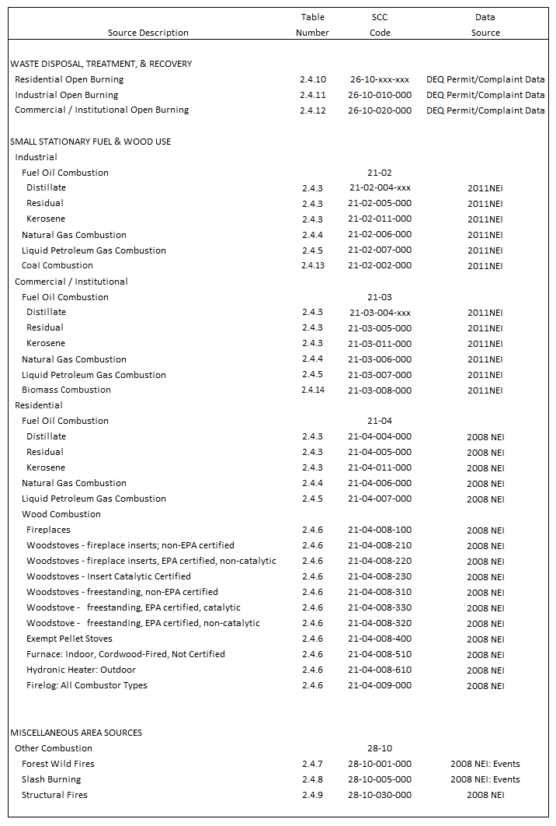
Table 2.4. 2: Medford 2008 CO EI Summary of Emissions Estimates for Area Sources
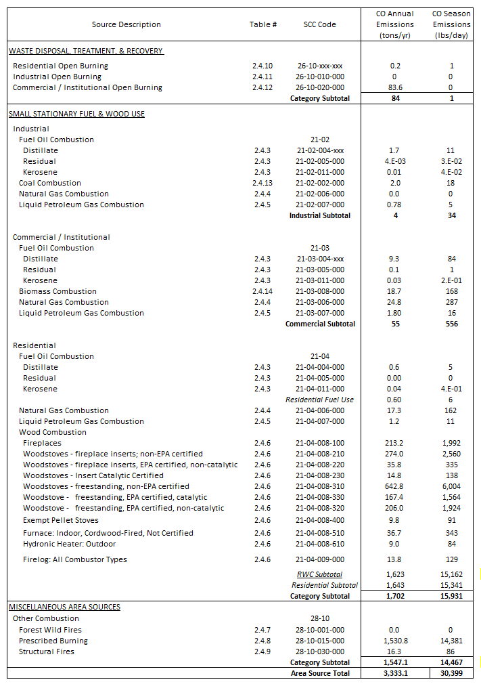
Table 2.4. 3: Area Source Emissions From Fuel Oil Use
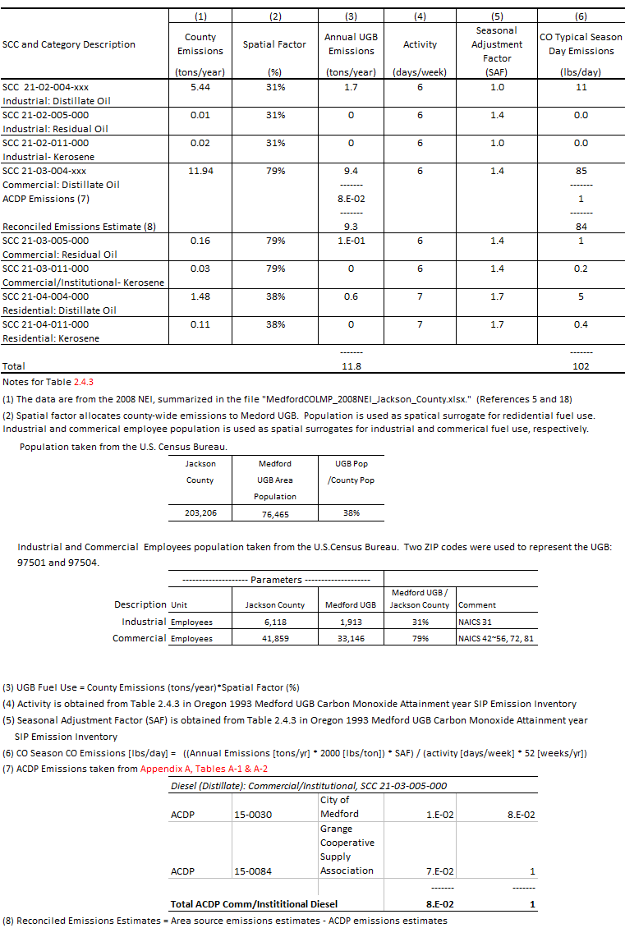
Table 2.4. 4: Area Source Emissions From Natural Gas (NG) Use
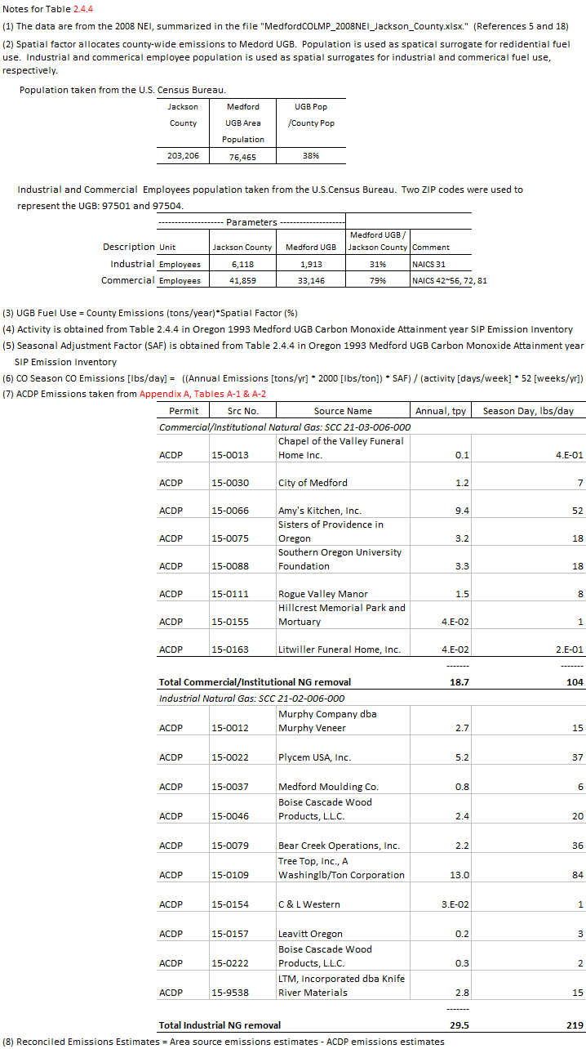
Table 2.4. 5: Area Source Emissions From Liquefied Petroleum Gas (LPG) Use
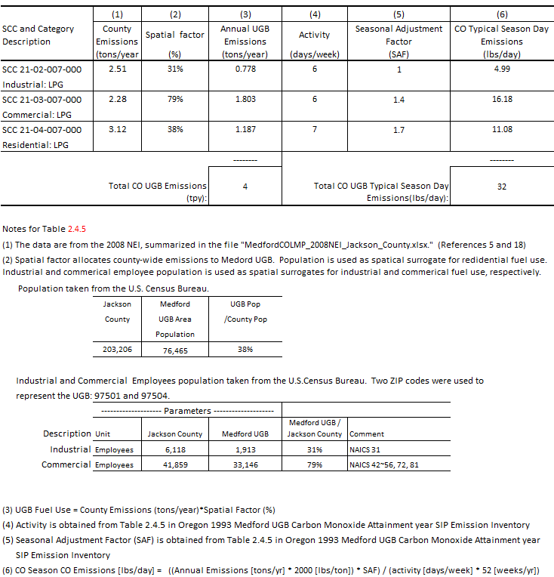

Table 2.4. 6: Area Source Emissions From Residential Wood Combustion
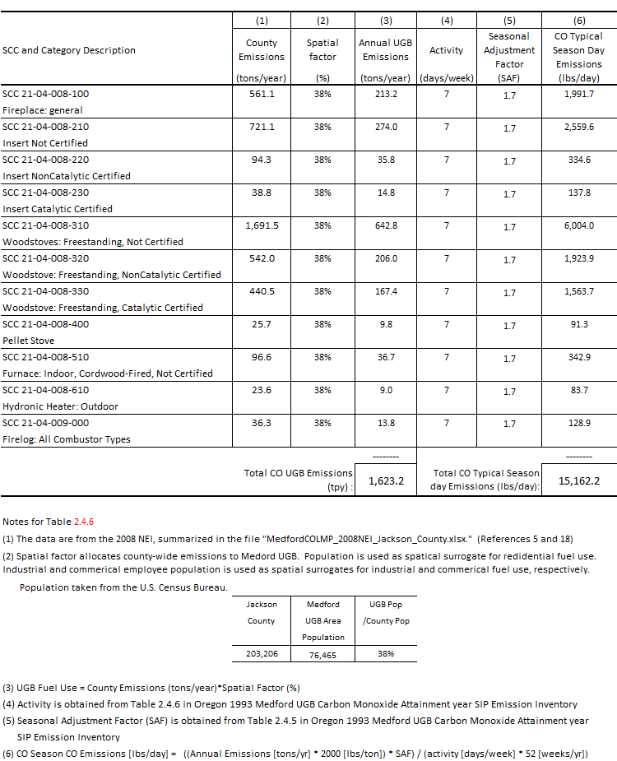

Table 2.4. 7: Area Source Emissions From Wildfires
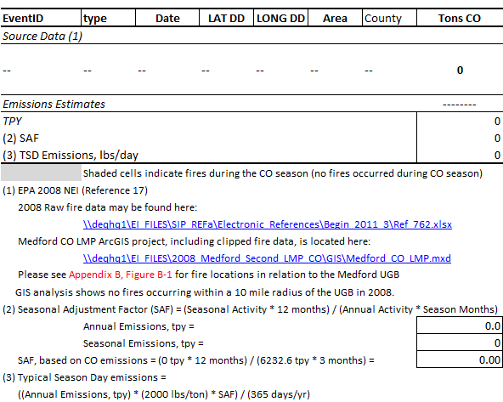

Table 2.4. 8: Area Source Emissions From Prescribed (RX) Burning
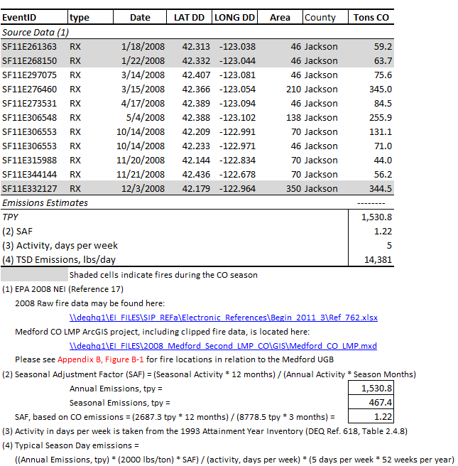

Table 2.4. 9: Area Source Emissions From Structure Fires
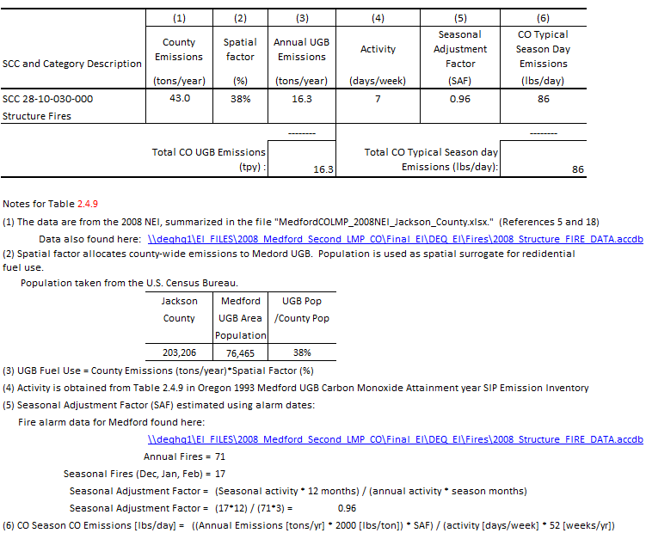

Table 2.4. 10: Area Source Emissions From Residential Open Burning
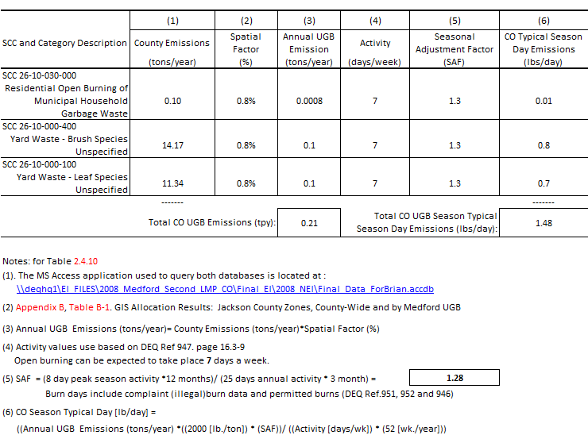

Table 2.4. 11: Area Source Emissions From Industrial Open Burning
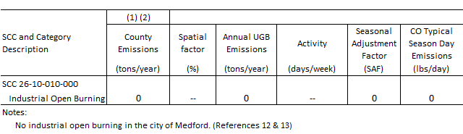

Table 2.4. 12: Area Source Emissions From Commercial/Institutional Open Burning

Table 2.4. 13: Area Source Emissions From Coal Use
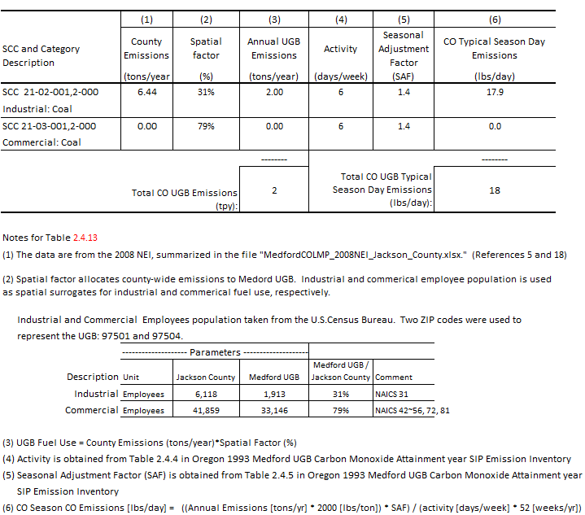

Table 2.4. 14: Area Source Emissions From Biomass Burning
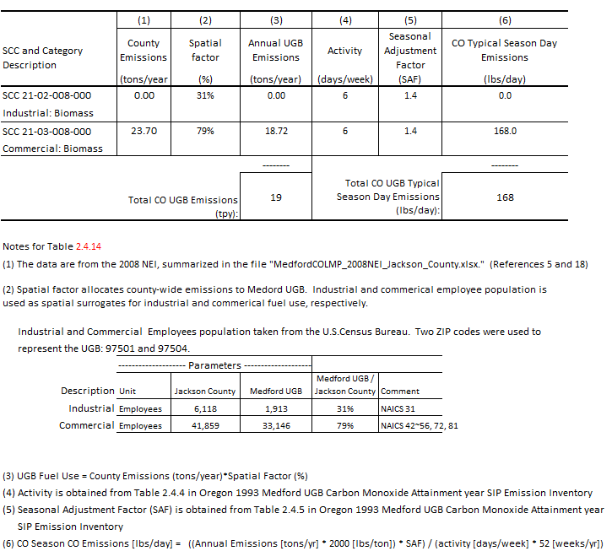

Nonroad Vehicles and Equipment

Introduction and Scope
This section describes the development of the emission inventory for carbon monoxide for nonroad mobile sources located in the Medford UGB in the 2008 CO Limited Maintenance Plan year. Sources inventoried within the nonroad mobile sector include off-road gasoline and diesel-powered vehicles and equipment, aircraft, and railroads as well as recreational and commercial waterborne vessels.

As with most of the area source categories, emissions within the Medford UGB were developed by applying SCC-specific spatial and temporal scaling factors to county-wide estimates of annual emissions for Jackson County from the 2008 NEI pursuant to the methodology outlined in the IPP.

Table 2.5.1 summarizes the nonroad mobile source emission inventory for the major nonroad source categories in terms of both annual and daily emissions (adjusted for activity during the CO season). Figures 2-1 through 2-4 compare emissions of the nonroad emission subcategories.

Nonroad Vehicles and Equipment
This category encompasses 2-stroke gasoline, 4-stroke gasoline, Compressed Natural Gas (CNG) / Liquefied Petroleum Gas (LPG), and diesel vehicles and equipment. Each of the sub-categories includes the following vehicle categories: Recreational Equipment, Construction Equipment, Industrial Equipment, Lawn/Garden Equipment, Agricultural Equipment, Light Commercial Equipment, and Logging Equipment.

Vehicle Categories
The nonroad vehicles and equipment category includes the following gasoline, CNG/LPG, and diesel sources:
SCC: 22-xx-001-xxx: Recreational Equipment
SCC: 22-xx-002-xxx: Construction Equipment
SCC: 22-xx-003-xxx: Industrial Equipment
SCC: 22-xx-004-xxx: Lawn / Garden Equipment
SCC: 22-xx-005-xxx: Agricultural Equipment
SCC: 22-xx-006-xxx: Light Commercial Equipment
SCC: 22-xx-007-xxx: Logging Equipment

Methodology
The starting point for emissions estimates for sources in this category was the county-wide, annual CO emissions from the EPA 2008 NEI. Using Jackson county land use zoning acreage,⁷ GIS-based spatial allocation factors were created to estimate the fraction of county-wide emissions from each of the vehicle types (Appendix A, Table A-1) occurring within the Medford UGB. Annual Medford UGB emissions were estimated by multiplying the county-wide emissions by the spatial factor (%) for the appropriate zoning ID. The following formula was used for spatial allocation:

Annual UGB emissions [tpy] = Annual Jackson County Emissions (tons/year) * Spatial Allocation Factor

Typical CO Season Day emissions were calculated by multiplying the UGB annual emissions tons by the SAF) divided by 365 days per year. SAFs were taken from the 1993 EI.³ The activity is assumed to be 7 days per week across all vehicle types to be consistent with the 1993 EI.³

CO Typical Season Day Emission [lbs/day] = (Annual UGB Emissions (t/yr.) * 2000(lb./ton) *SAF)/ (365 days/yr.))

Nonroad vehicle and equipment emissions are detailed in Tables 2.5.2 through 2.5.5.

Aircraft and Airport Operations Emissions
The aircraft and airport operation emission source categories inventoried include commercial and military aircraft, general aviation, air taxi, airport auxiliary power unit, and airport ground service equipment (GSE). Annual Jackson County CO emissions from aircraft and airport operation were obtained from the 2008 NEI. Annual Medford UGB CO emissions were estimated by multiplying the county-wide emissions by appropriate spatial allocation factors. Spatial factors for general aviation and air taxi were calculated by dividing the total aircraft-related emissions by those of the Jackson County. The military and commercial aircraft, auxiliary power unit, and GSE were assigned a 100% spatial allocation factor since all these sources occur at the Rouge Valley International Medford Airport located within the UGB, which is the sole commercial airport operating in Jackson County. The details of these calculations and a summary of aircraft and airport emissions are given in Table 2.5.6.

Waterborne Vessels
Waterborne vessels fall under two categories: commercial/military marine vessels and recreational pleasure craft. Although pleasure craft emissions occur in other areas of Jackson County, neither category of waterborne vessel has any activity within the Medford UGB due to lack of sufficient water bodies and inland location to support such activity. As such, waterborne vessel emissions within the Medford UGB were set to zero.

Rail
Railroad emissions encompass both locomotive operation and railway maintenance as shown by individual SCC category below.

SCC: 22-85-002-007: Locomotives: Line-Haul
SCC: 22-85-002-010: Locomotives: Yard

County-wide annual emissions for railroads were taken from the EPA 2008 NEI database. Jackson County annual emission estimates for locomotive emissions were allocated using only active track miles within the Medford UGB and locating railroad yard activity within the Medford UGB using the railway GIS shapefiles in the 2008 NEI supporting data.

The 2008 NEI had no railway maintenance emissions for Jackson County; therefore, emissions for these SCC categories were set to zero for the Medford UGB.

Typical Season Day emissions were calculated by multiplying the UGB annual emissions tons by the SAF, divided by 365 days per year. To be consistent with the 1993 EI,³ seasonal activity is assumed to be uniform and the SAF is equal to 1.0.

CO Typical Season Day Emission [lbs/day] = (Annual UGB Emissions (t/yr.) * 2000(lb./ton) *SAF)/ (365 days/yr.))

Railroad emission estimates are detailed in Table 2.5.7.

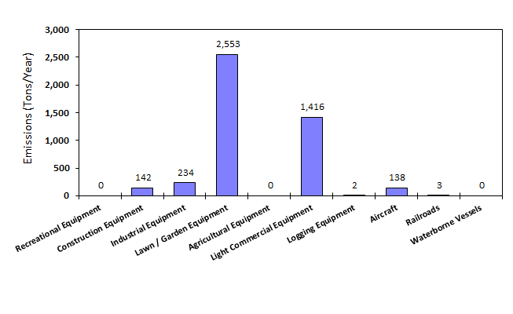
Figure 14: Distribution of Medford UGB Annual Nonroad Source CO Emissions, 2008

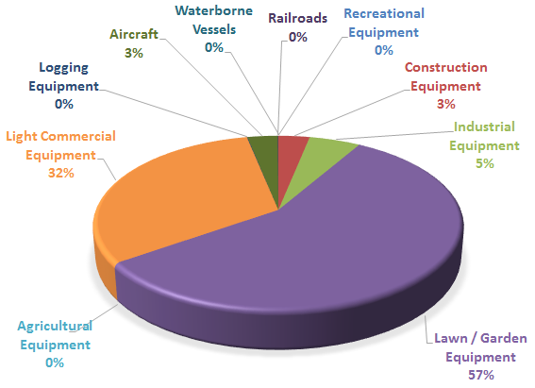
Figure 15: Percentage of Medford Annual Nonroad CO Source Emissions, 2008
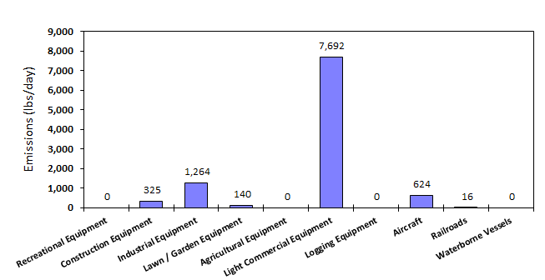
Figure 16: Distribution of Medford CO Season Day Nonroad Source Emissions, 2008

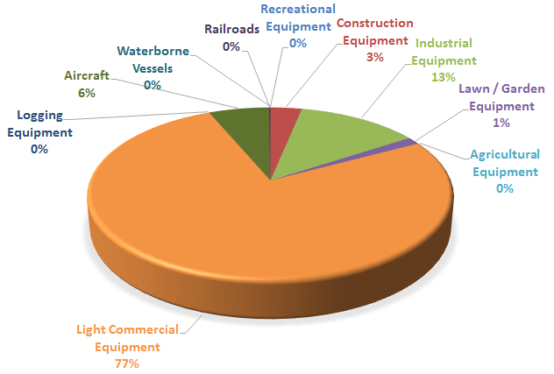
Figure 17: Percentage of Medford UGB CO Season Day Nonroad Source Emission, 2008

Table 2.5. 1: Medford UGB 2008 CO Summary of Emissions from Nonroad Sources

Table 2.5. 2: Medford UGB 2008 CO, Summary of Emissions from Nonroad Gasoline Vehicles * Equipment, 2-Cycle

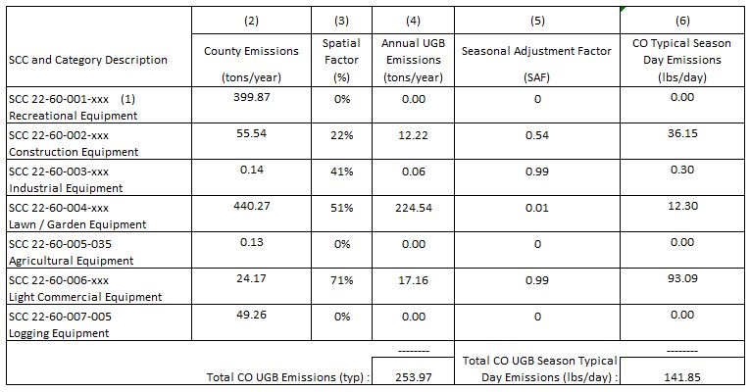

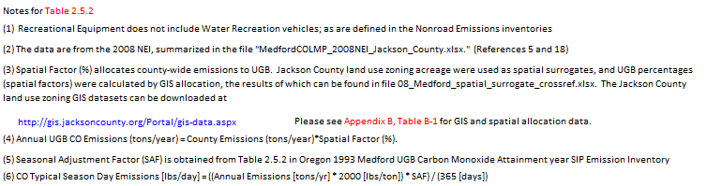

Table 2. 5. 3. 2008 Medford UGB CO: Summary of Emissions from Nonroad Gasoline Vehicles and Equipment, 4-Cycle
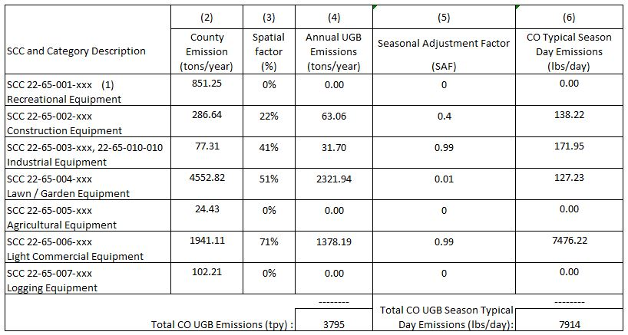

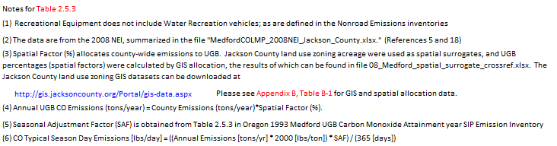

Table 2. 5. 4. 2008 Medford UGB CO: Summary of Emissions from Nonroad CNG/LPG Vehicles and Equipment
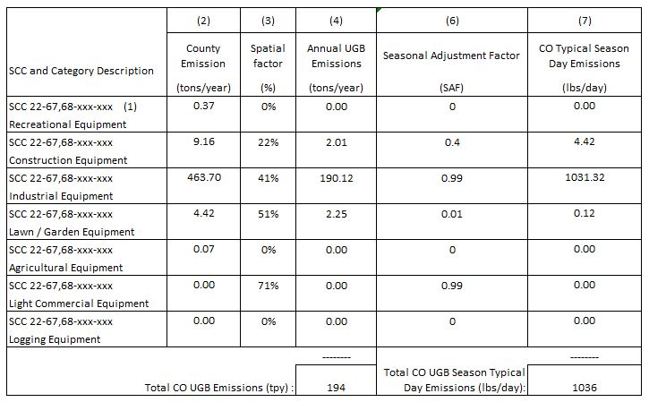

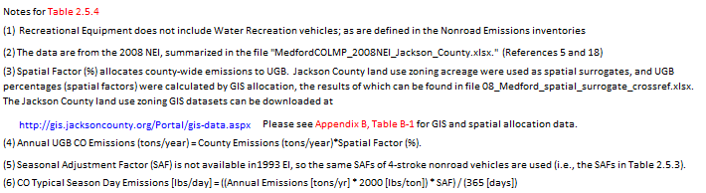

Table 2. 5. 5. 2008 Medford UGB CO: Summary of Emissions from Nonroad Diesel Vehicles and Equipment
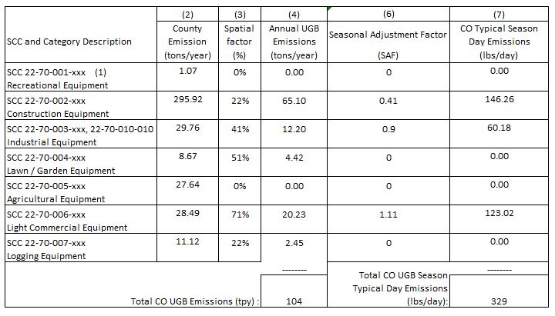

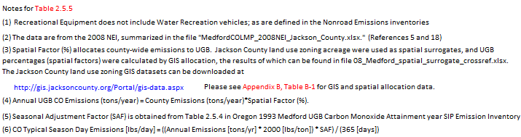

Table 2.5. 6. 2008 Medford UGB CO: Summary of Emissions from Aircraft and Airport GSE
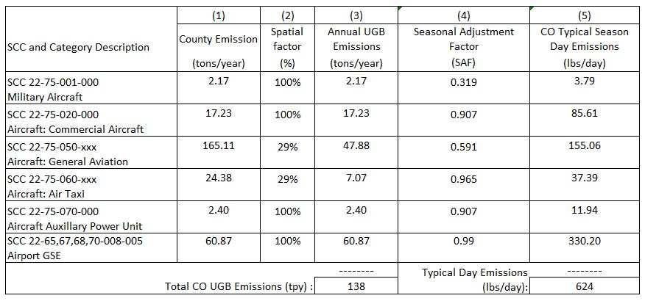

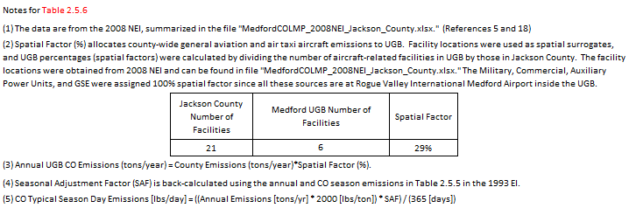

Table 2.5. 7. 2008 Medford UGB CO: Summary of Emissions from Railroads

On-Road Mobile Sources

Introduction and Scope
This section describes the development of the emission inventory for CO from on-road mobile sources in the Medford UGB for the 2008 CO LMP analysis year. On-road emission estimates from Version 3 of the 2008 NEI database were used to represent countywide emissions. (The on-road emission estimates in Version 3 of the 2008 NEI were developed using EPA’s MOVES2010b vehicle emissions model.) On-road sources included in this inventory were grouped by both vehicle type and road type. Separate sets of on-road CO emissions categorized by vehicle type and by road type were estimated and reported.

Spatial and Temporal Allocation of 2008 NEI Data

Spatial Allocation
County-wide 2008 on-road exhaust emissions from the 2008 NEI were allocated to the Medford UGB using spatial surrogates based on vehicle miles traveled (VMT). The spatial factor was calculated by dividing the Medford UGB annual VMT by the Jackson County annual VMT in 2008. Medford UGB annual VMT was calculated from the model output of the RVMPO “Models Version 3.0” travel demand model.⁸ Jackson County annual VMT was calculated from the monthly VMT provided in the 2008 NEI supporting “4c” archive file database for transportation activity. Table 2.6.1 and Table 2.6.2 detail spatial allocation of data for on-road mobile sources. The following formula was used for spatial allocation:

Annual UGB emissions, tpy = Annual Jackson County Emissions (tons/year) * (UGB Annual VMT / Jackson County Annual VMT)

Temporal Allocation
Typical Season Day CO emissions were calculated by multiplying the UGB annual emissions tons by the SAF, divided by 365 days per year. The SAFs for on-road emissions grouped by vehicle type were calculated using the values in Table 2.6.5 in the 1993 EI.¹ The SAFs for on-road emissions grouped by road type were taken from Table 2.6.3 in the 1993 EI,¹ and the weekly adjustment factors were taken from Table 2.6.4 in the 1993 EI¹. The following formula was used for temporal allocation:

CO Typical Season Day Emission (lbs/day) = (Annual UGB Emissions (tons/year) * 2000 (lb./ton) *SAF)/ (365 days/year)

Summary of On-Road Mobile Source Emissions
On-road mobile emissions have been summarized by vehicle type and roadway type for annual and season day emissions in Figures 19 through 21, and Tables 2.6.1 and 2.6.2 respectively.

The CO Season daily emissions are nominally different in Tables 2.6.1 and 2.6.2 because of the SAFs, which were taken from the 1993 Attainment Year EI¹. Although these SAFs gave the same CO Season daily emissions in respective tables in the 1993 EI, they result in slightly different CO season daily emissions when applied to the 2008 NEI.
Figure 18: Percentage of 2008 Medford Annual Onroad CO Source Emissions, by Vehicle Type

Figure 19: Percentage of 2008 Medford Season Day Onroad CO Source Emissions, by Vehicle Type

Figure 20: Percentage of 2008 Medford Annual Onroad CO Source Emissions, by Roadway Type

Figure 21: Percentage of 2008 Medford Season Day Onroad CO Source Emissions, by Roadway Type

Table 2.6. 1. 2008 Medford UGB CO: Summary of On-Road Mobile Emissions by Vehicle Type
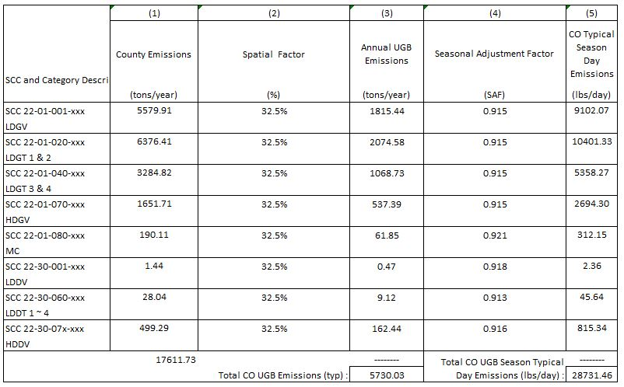

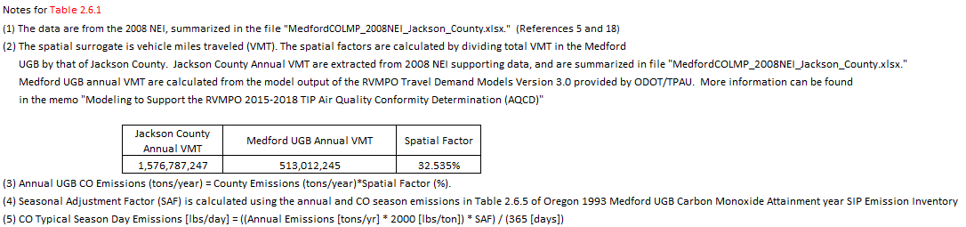

Table 2.6. 2. 2008 Medford UGB CO: Summary of On-Road Mobile Emissions by Road Type
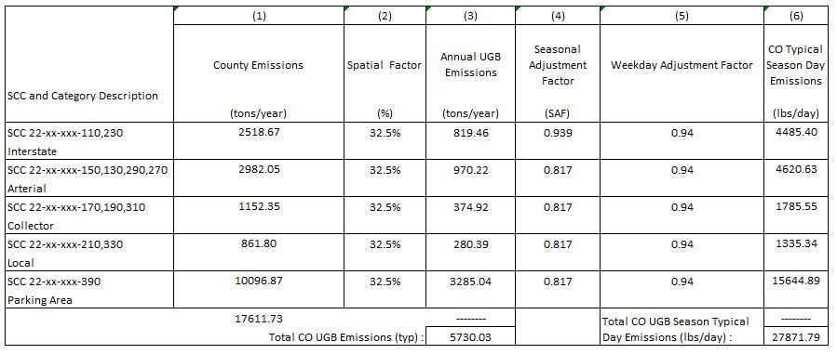

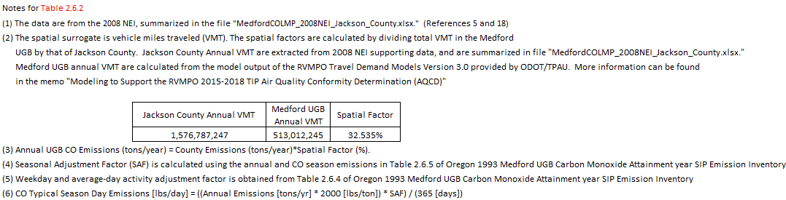

Quality Assurance and Quality Control

Introduction
The Oregon DEQ is responsible for overall quality and accuracy of this inventory of Carbon Monoxide (CO) sources and emissions for the Medford urban growth boundary (UGB) for the 2008 Limited Maintenance Plan. As presented in the IPP delivered to EPA in November 2014, DEQ used existing data that has already been quality checked. DEQ staff performed quality assurance for accuracy, completeness, and representativeness on the spatial and temporal allocation of emissions from the existing inventory. DEQ and Sierra Research used EPA county database estimates from the 2008 NEI v.3 generated using MOVES2010b modeled emissions rates.^{5,18}

Organization and Personnel
Wesley Risher, an emission inventory analyst at the DEQ, was appointed Quality Assurance Coordinator. DEQ staff Brandy Albertson, Christopher Swab, and Miyoung Park, along with Wenxian Zhang at Sierra Research, performed the bulk of the required source calculations. The abbreviated organizational hierarchy for carrying out the Quality Assurance Program is shown below.

Oregon Department of Environmental Quality
Air Quality Division

Wendy Wiles, Administrator – Environmental Solutions Division
Jeffrey Stocum, Manager – Air Quality Technical Services Section
Emission Inventory
Christopher Swab, Senior Emission Inventory Analyst
Brandy Albertson, Emission Inventory Analyst
Miyoung Park, Emission Inventory Specialist
Quality Assurance
Wesley Risher, Emission Inventory Analyst

David Collier,
Air Quality Planning Manager
Dave Nordberg, Air Quality Planner

Sierra Research
Tom Carlson, Principal Scientist
Wenxian Zhang, Associate Engineer

Data Collection and Analysis

Data Collection and Analysis
To ensure the comprehensive nature of the emission inventory, a source listing from the 1993 attainment year inventory was used as a starting point¹. The listing of sources in the 1993 inventory was generated using EPA's Quality Assurance Plan guidance document¹ and EPA’s Procedures for the Preparation of Emissions for Carbon Monoxide And Precursors Of Ozone² were used. The inventoried sources are marked under the appropriate pollutant category. Only those sources that had been determined to operate in the inventory areas were included

Inventory source categories were divided into Stationary Point Sources, Stationary Area Sources, Non-Road Mobile and On-Road Mobile Sources, the details of which are discussed in Parts 2.3 through 2.6 of this report. Permitted stationary point source information is maintained by DEQ for sources with annual emissions of at least 5 tons per year, so a questionnaire/survey was not necessary to identify stationary area and point sources. Emissions from permitted point sources were calculated on the basis of 2008 production levels and the best available emission factors (from TV source tests or from the permits). Point sources considered in this inventory are listed in Appendix A, Table A-1.

The majority of the area and nonroad source emissions data at annual, county-wide levels were taken from previously compiled EPA and DEQ estimates that were subjected to QA/QC protocols⁵. Many of the stationary area sources and non-road mobile sources were allocated to UGB by applying a spatial surrogate developed using ArcGIS and zoning shapefiles. Zoning and railway line GIS work was reviewed for completeness and accuracy by DEQ staff familiar with the Medford UGB region and activity. Population, fuel use, and employee data was reviewed by DEQ staff as part of the QA/QC protocols outlined here. Additionally, in all cases, the source of the information and validation for its use was documented in the calculation spreadsheets and checked at the time of QC for reliability and appropriateness.

DATA HANDLING
Data handling by DEQ staff included: 1) data tracking, and 2) QA/QC (which included data checking, data correcting, and handling corrected data). Specific additional procedures included checking data after conversion to the inventory format, checking for missing data, and reviewing the estimates.

Data Coding and Recording
No air dispersion modeling was performed for this SIP so coding the source emissions for entry into the model was not necessary.

Data Tracking
Information obtained from source files, other divisions of the DEQ, other State, Federal, and local agencies, and private companies used in compiling the emission inventories were recorded in reference files, in appendices, and documented on the calculation spreadsheets. The appendices and calculation spreadsheets were also stored electronically. All emission factors, throughputs, seasonal adjustment factors, and activities were documented on the calculation spreadsheets in both hard copy and electronic copy. All of the above mentioned information is kept at DEQ Headquarters.

QA/QC Procedures - Checking and Correcting
The QC of all source category emissions included:
- Checking input data for inventory completeness, missing data, incorrect calculations, incorrect information, and reasonableness, and
- Correcting the calculation sheets, summary sheets, and Appendices where needed.

The QA of the emission estimates include:
- Reviewing the emission summary for reasonableness, and
- Ensuring that the data transferred between agencies and consultants was intact.

Checking Data

Inventory Completeness
Completeness of the inventory was determined by checking against the EPA QA Plan guidance source listings and the 1993 attainment year inventory. Double counting of sources was reviewed to ensure that source categories included in stationary point source category were not also included in area or non-road mobile categories. Double-count removal is detailed in Tables 2.4.3 and 2.4.4 of this document.

Missing Data
In order to ensure that all the necessary data was submitted for each stationary point source, forms were created to identify all the data elements required by EPA to be reported for each stationary point source. Any parameter left blank during the initial completion of the form was considered a missing data element. Further review of the source files and, as necessary, contact with facility personnel were procedures used to obtain the missing information. If these steps did not result in supplying a missing data element, estimates were made based on similar point sources or from information contained in EPA publications. Written documentation of the source of the data were recorded in the Emission Inventory notebook on the Data Error Report and Correction form as well as in the Audit Trail notebook.

Missing data for stationary area sources and non-road mobile sources can usually be identified by the inability to calculate emissions. If the appropriate data was missing, a reasonable effort was made to acquire it. If this was unsuccessful, estimates were made based on data of recent years or on information contained in EPA documents. Missing data were recorded on the QC area and non-road mobile correction forms.

Incorrect Calculations
In order to ensure that all the calculations were done correctly, the calculations were first reviewed to ensure that they were used correctly, followed by review of electronic equations in order to make sure that they were entered correctly. Any improperly used or incorrect calculations were noted on the calculation sheet.

Incorrect Information
In order to ensure that the information on summary sheets, calculations sheets, and Appendices for this report are correct, all the explanations, titles, and reference were checked for accuracy and clarity. Any changes were documented either directly on the sheet.

Reasonableness
A reasonableness check was performed on the estimated emissions, activity levels, and emission factors using the 1993 Medford Attainment Year CO SIP emission inventory¹ as a background comparison.

Stationary point source estimated emissions associated with the Air Contaminant Discharge Permit, Title V Permit, or Title V draft for each identified point source were reviewed in relation to similar sources. In addition, the stationary point source production levels source tests, and permitted emission factors were rechecked. The source’s current operational status was also reviewed using notices of construction, permit addendums, and DEQ source inspector information. Stationary area source and non-road mobile estimated emissions were compared, when possible to the 1993 Medford Attainment Year CO SIP emission inventory¹. The references from which the emission factors and activity levels were taken were confirmed for the appropriateness of their use. Any reasonableness errors were documented in the correction forms.

Emissions Summary Reasonableness
Emissions summaries were reviewed against the 1993 attainment year, as shown in Executive Summary Figures 3 and 4 of this document.

Data Reporting
An electronic copy of this report will be provided to EPA Region X in June 2015. Electronic copies of the summary and calculations spreadsheets will be made available to EPA upon request.

References

- State of Oregon 1993 Attainment Year SIP Emission Inventory: Medford UGB Carbon Monoxide, Appendix D3-4. Air Quality Division, Oregon Department of Environmental Quality, Portland, OR, March 9, 2001. (DEQ AQ-TS Ref. 618)

- Procedures Document for National Emission Inventory, Criteria Air Pollutants 1985-1999, EPA-454/R-01-006, U.S. EPA, Research Triangle Park, NC. March 2001. (DEQ AQ-TS Ref. 2)

- Emission Inventory Requirements for Carbon Monoxide State Implementation Plans, EPA-450/4-91-011, U.S. EPA, Research Triangle Park, NC. March 1991. (DEQ AQ-TS Ref. 1a)

- Inventory Preparation Plan/Quality Assurance Plan for the Medford Urban Growth Boundary 2008 Carbon Monoxide (CO) Limited Maintenance Plan, Oregon Department of Environmental Quality, February 2015: Please see Appendix C.

- http://www.epa.gov/ttnchie1/net/2008inventory.html.

- 2008 National Emissions Inventory, Version 3, Technical Support Document, Draft, U.S. EPA, Research Triangle Park, Sep 2013.

- The Jackson County zoning data were downloaded from http://gis.jacksoncounty.org/Portal/gis-data.aspx.

- Technical Memorandum: Modeling to Support the RVMPO 2015-2018 TIP Air Quality Conformity Determination (AQCD), prepared by Jin Ren with ODOT/TPAU, June 2014.

- Grants Pass SIP Appendices for Carbon Monoxide. Appendix D4-4: Grants Pass UGB and CO NAA: 1993 Base Year and 2015 Forecast Year Emission Inventory and Forecast. Oregon DEQ. September 13, 2002. (DEQ AQ-TS Ref. 933)

- Internet: http://www.epa.gov/ttnchie1/software/fire/index.html

- Compilation of Air Pollutant Emission Factors, Fifth Edition and Supplements, AP-42, U.S. EPA, Research Triangle Park, NC. January 1995. (DEQ AQ-TS Ref. 8).

- Email from Wayne Kauzlarich, DEQ WR Medford, AQ Permit Writer/Inspector to Miyoung Park. City of Medford burn information (2008year). November 28, 2014 (DEQ AQ-TS Ref. 945).

- Email from Greg G. Kleinberg, City of Medford , Deputy Chief - Fire Marshal, Medford Fire-Rescue to Miyoung Park. City of Medford burn Information (2008 year). November 25, 2014 (DEQ AQ-TS Ref. 946).

- Email from Meghan Fagundes, DEQ WR Medford, AQ Permit Writer/Inspector to Miyoung Park. Complaint open burning locations for Jackson County in 2008. March 12, 2015 (DEQ AQ-TS Ref. 951).

- Email from Greg G. Kleinberg, City of Medford , Deputy Chief - Fire Marshal, Medford Fire-Rescue to Miyoung Park. City of Medford, illegal burn information (2008 year). March 12, 2015 (DEQ AQ-TS Ref. 952).

- Open Burning Emission factor: Emission Inventory Improvement Program (EIIP), EPA, Office of Air Quality Planning and Standards, Emission Factor and Inventory Group, Research Triangle Park, NC. Volume III: Chapter 16 (DEQ AQ-TS Ref. 947)

- E-mail from Venkatesh Rao (EPA) to C. Swab. EPA 2008 Oregon/California prescribed burning and wildfire emissions estimates, EIS event format. August 3, 2011. (DEQ AQ-TS Ref. 762)

- E-mail from Wenxian Zhang to C. Swab. Medford UGB 2008 CO LMP - Draft Emission Inventory. April 27, 2015. (DEQ AQ-TS Ref. 961).

Appendices to the Emission Inventory

APPENDIX A: STATIONARY PERMITTED POINT SOURCES

- Figure A-1: Point Source Locations
- Table A-1: Stationary Point Source Determination for 2008 CO Inventory Determination
- Table A-2: Exclusion of 1993 and some 2008 Facilities from CO Emission Inventory
- Table A-3: Stationary Point Source Emission Estimation Details

Appendix A, Figure A- 1: 2008 Medford CO LMP Permitted Point Source Locations

Appendix A, Table A- 1: Stationary Point Source Determination for 2008 CO Inventory
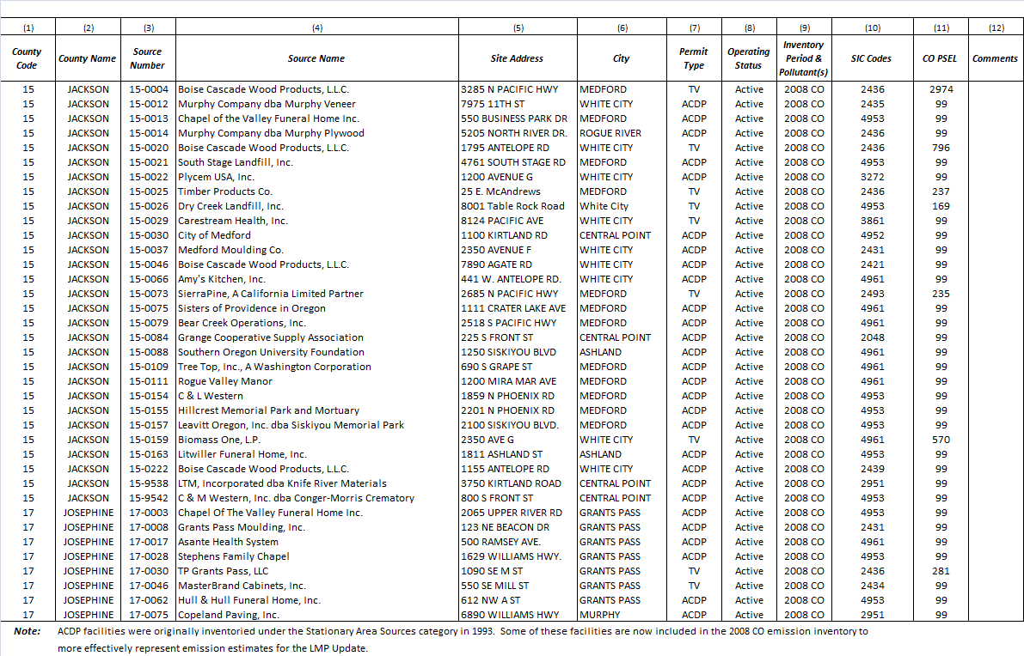

Appendix A, Table A- 2: Exclusion of 1993 and some 2008 Facilities from CO Emission Inventory
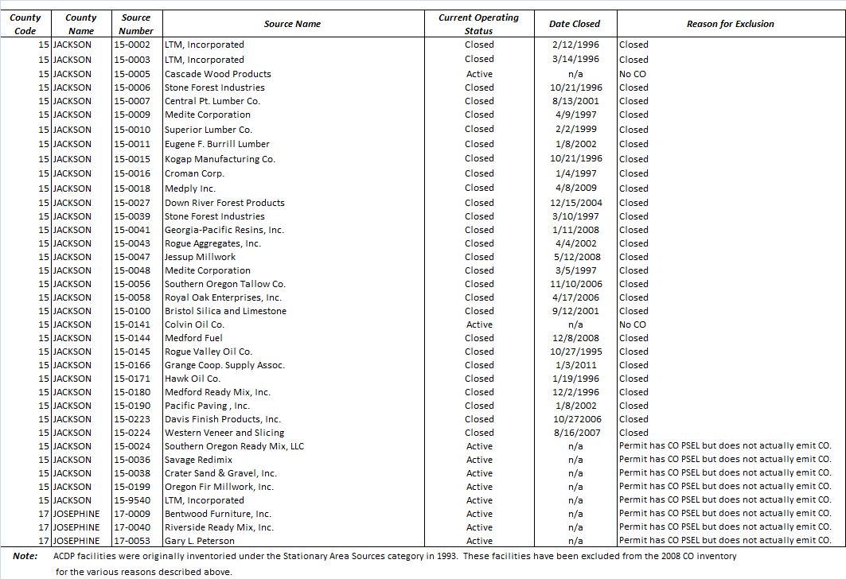
Appendix A, Table A- 3: Stationary Point Source Emission Estimation Details
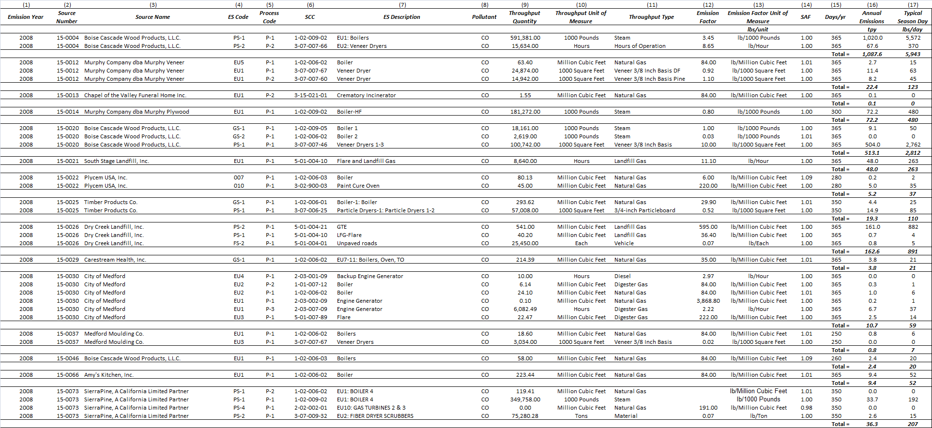
(cont’d on next page)

Appendix A, Table A-3 Continued
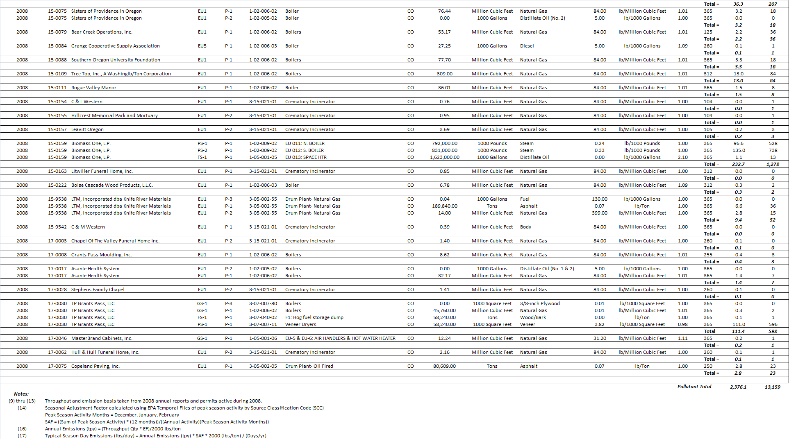
APPENDIX B: STATIONARY AREA SOURCES

- Figure B-1: Wildfire and Prescribed Burning Locations
- Table B-1: GIS Allocation Results: Josephine County Zones, County-Wide and by UGB

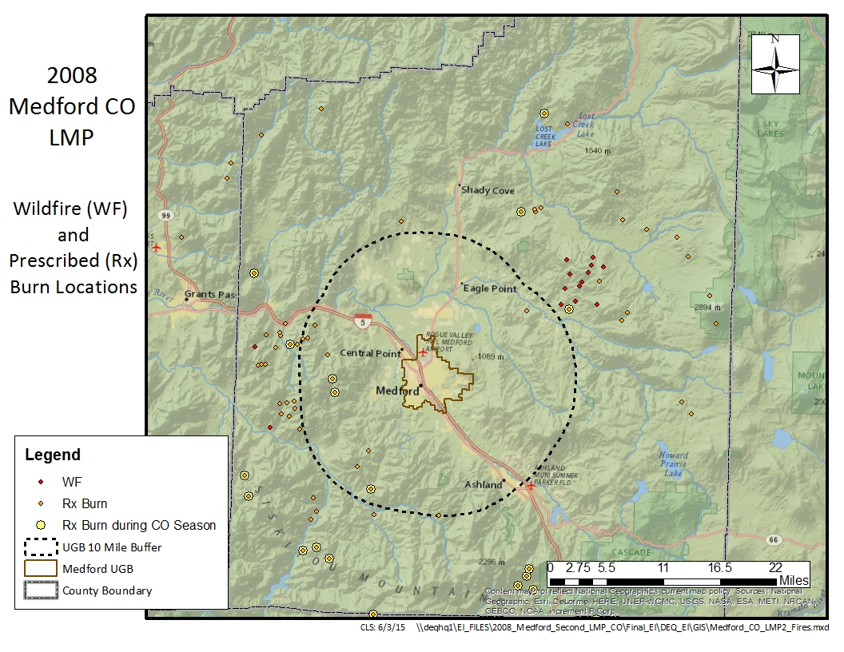
Appendix B, Figure B- 1: Wildfire and Prescribed Burn Location and Date
Appendix B, Table B- 1: GIS Allocation Results: Josephine County Zones, County-Wide and by UGB
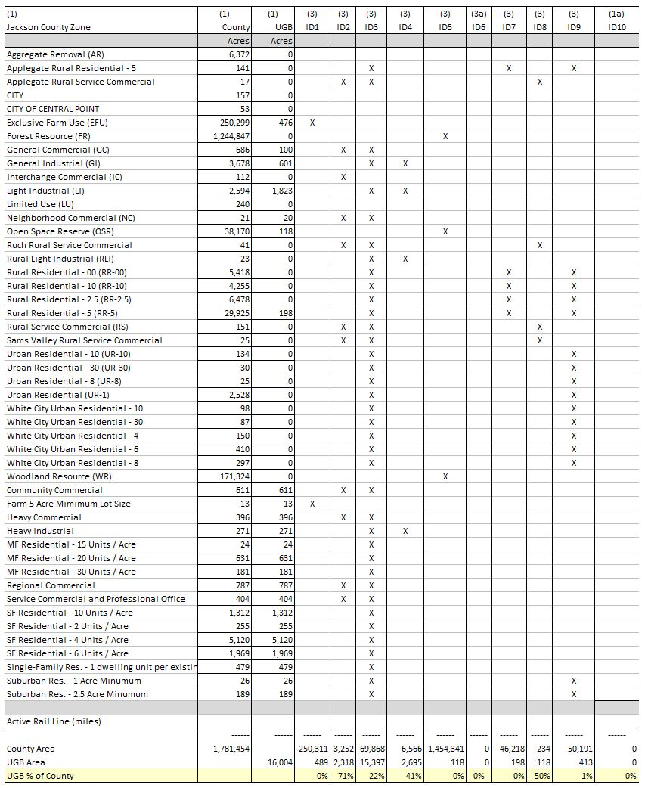

Notes for Table B-1
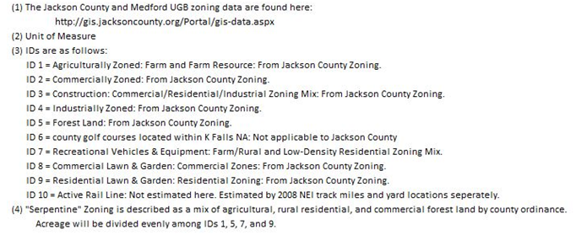

Appendix 3
EPA 2012 Approval Letter for removal of the CO monitor

Appendix 4
Inventory Preparation and Quality Assurance Plan

Oregon Department of Environmental Quality
Air Quality Division – Technical Services Section

Inventory Preparation and
Quality Assurance Plan
for the
Medford Urban Growth Boundary
2008
Carbon Monoxide (CO)
Limited Maintenance Plan

February 2015
Oregon Department of the Environmental Quality
Inventory Preparation Plan/Quality Assurance Plan
for the
Medford Urban Growth Boundary
2008
Carbon Monoxide (CO)
Limited Maintenance Plan

© Oregon Department of the Environmental Quality
Environmental Solutions Division, Technical Services Section
811 SW Sixth Avenue
Portland, Oregon 97204
Phone 503-229-5359 • Fax 503-229-5675
TABLE OF CONTENTS
1 INTRODUCTION 1
Geographic Area 1
Temporal Resolution 3
2 INVENTORY DEVELOPMENT 3
2.1 Data Categories 4
Emission Sectors 4
3 SPATIAL ALLOCATION METHODS 5
4 TEMPORAL ALLOCATION METHODS 7
4.1 Permitted Point 7
4.2 Aircraft and Locomotives 7
4.3 Nonpoint (area) and Nonroad Vehicles & Equipment 7
4.3.1 Open Burning 7
4.3.2 Small Stationary Fossil Fuel Combustion 7
4.3.3 Residential Wood Combustion 7
4.3.4 Wildfires and Prescribed Burning 8
4.3.5 Structure Fires 8
4.3.6 Nonroad Vehicles & Equipment Excluding Aircraft and Locomotives 8
4.4 On-Road Mobile: Vehicle Exhaust 8
5 QUALITY ASSURANCE AND QUALITY CONTROL 8
6 EXTERNAL AUDITS 8
7 PERSONNEL 8
8 SCHEDULE 9

TABLE OF FIGURES
Figure 1-1. Medford UGB and CO Maintenance Area 2
Figure 1-2. Medford 25 Mile Buffer for CO Sources >100 tons/year 3

TABLE OF TABLES
Table 2.1. 1993 CO Season Day Emissions by Category 4
Table 2.2. 1993 CO Season Day Emissions by Source Category 4
Table 3.1. Data Sources, Spatial Surrogates and Boundaries 6

INTRODUCTION
Medford Oregon was designated a nonattainment area for carbon monoxide (CO) in 1978 and classified as moderate upon enactment of the 1990 Clean Air Act Amendments (CAAA). The highest 8-hour carbon monoxide concentration recorded in Medford occurred in 1977 at level of 21.8 ppm. Due to hot spot problems within the downtown region of Medford in 1982 the nonattainment area was revised to include only the central business district. Following the CAAA, the nonattainment area was modified to the Medford Urban Growth Boundary (UGB) as recommended by Governor Roberts’s March 15, 1991 letter to the EPA (57 FR 56762, November 30, 1992). By the late 1980’s, maximum levels were closer to the standard level, and the last exceedances of the standard were in 1990.

The area was redesignated to attainment for the 8-hour CO standard in September 23, 2002, when EPA approved Oregon’s redesignation request and the first maintenance plan designed to maintain compliance with the 8-hour CO standard through the year 2015 (67 FR 48388, July 24, 2002). This plan addresses the second 10-year maintenance period required under section 175A(b) of Act. Once approved by EPA, the second maintenance plan will fulfill the 20-year maintenance planning requirements of Clean Air Act section 175A. This Inventory Preparation Plan is in support of the development of the required second CO maintenance plan.

The maintenance area is the Medford UGB (Figure 1.1). Similar approach is recommended for the second maintenance plan. One of two CO monitors was located at the Brophy building location in downtown Medford. Measured CO levels were so low that the monitor was removed with EPA approval at the end of 2009. Because on-road mobile vehicle emissions are the primary source of CO in Medford (about 50%), Oregon DEQ has been tracking any increase in emissions for CO in Medford.

The Medford second maintenance plan qualifies for the Limited Maintenance Plan (LMP) approach because it satisfies all the requirements outlined in the Limited Maintenance Plan Option for Nonclassifiable CO Nonattainment Areas (Paisie memo, 1995). For the 8-hour CO, in the most recent two years of data, the maximum value of 2.6 ppm was recorded on January 18, 2008 and the second maximum value of 2.4 ppm was recorded on December 6, 2008. The risk to the community of exceeding the CO standard is low.

Oregon DEQ proposes using existing information from the EPA 2008 National Emission Inventory (NEl) to create the emissions inventory for CO sources in Medford. This document describes the planned approach to the Medford CO LMP EI and the basis for selecting that approach.

Geographic Area
The geographic area of the Medford UGB is shown in Figure 1-1. The 25-mile extension to the UGB area is shown in Figure 1-2; includes incorporated and unincorporated Jackson County and a part of Josephine County. Populated areas within the 25 mile buffer with large point sources included in this inventory are Medford, Rogue River and White City. The city is approximately 28 sq. miles in area, and the US Census 2008 population was 77,667. The elevation of the city is approximately 422 meters (1384 ft.).

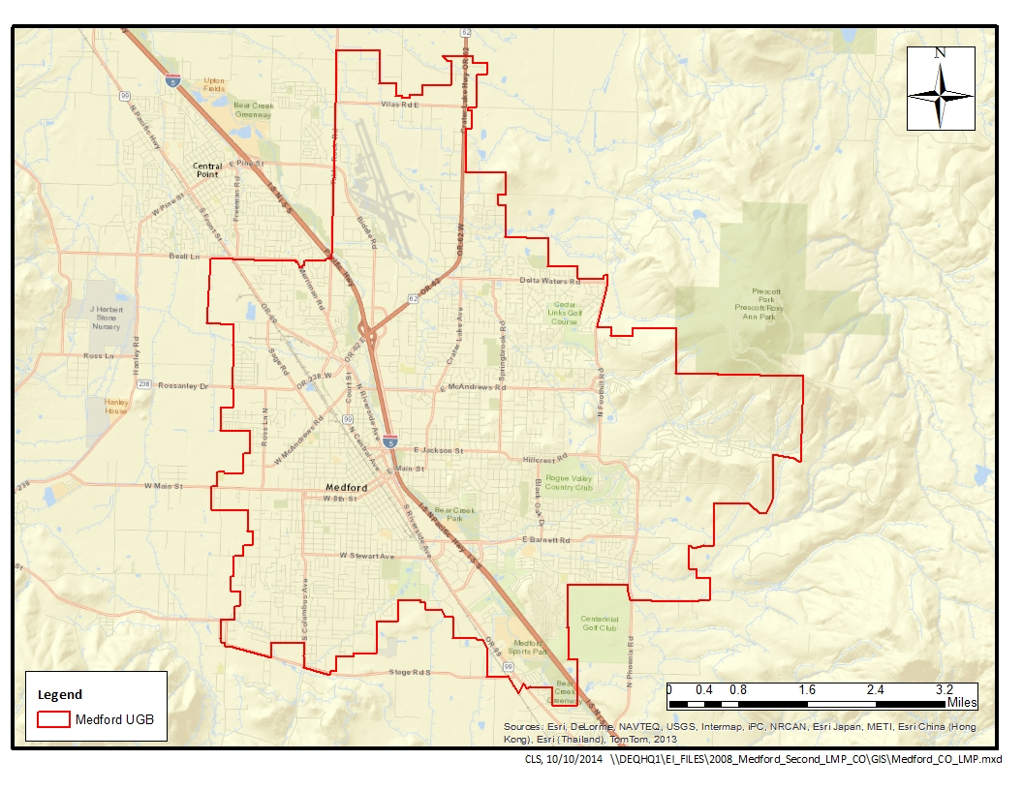
Figure 1-1. Medford UGB and CO Maintenance Area

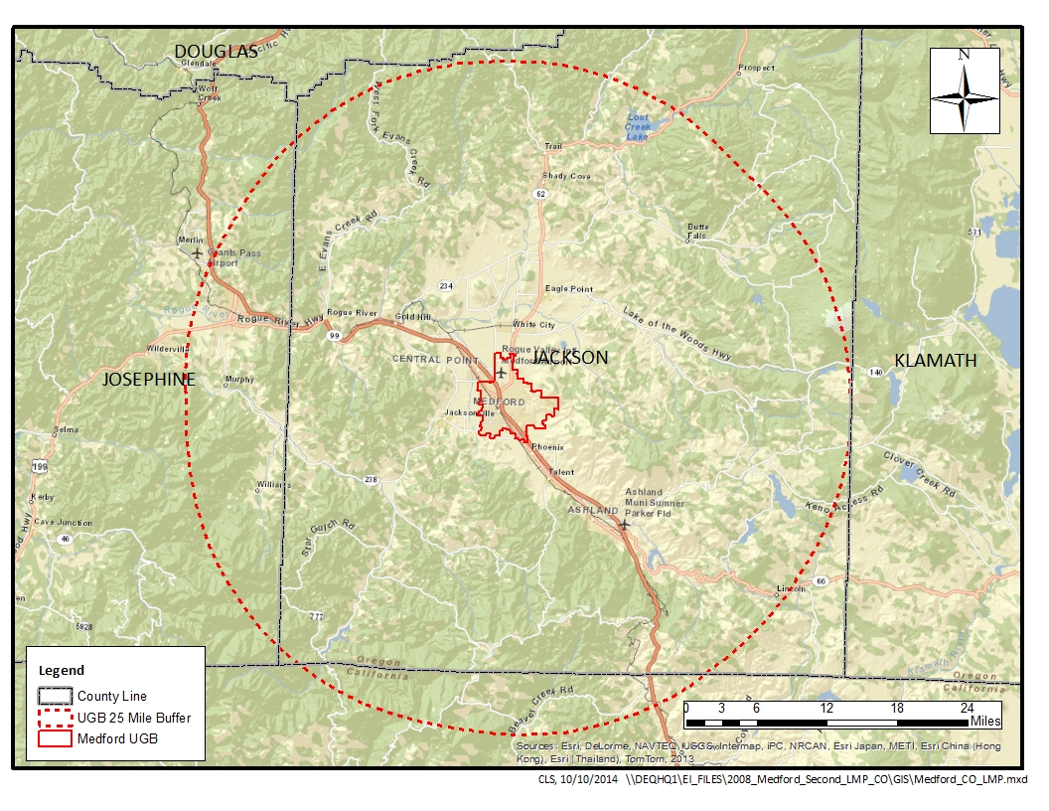
Figure 1-2. Medford 25 Mile Buffer for CO Sources >100 tons/year

Temporal Resolution
The CO season is defined as three consecutive months, December 1st through the end of February. As such, winter season day emissions will be included in the inventory. The unit of measure for winter season day emissions will be pounds per day (lb./day).

INVENTORY DEVELOPMENT
The DEQ will develop an emission inventory using EPA 2008 National Emissions Inventory (NEI) data for Jackson County. We will temporally allocate the EI data to CO season, and spatially allocate the county-wide NEI data to the Medford UGB, or to buffers around the UGB, depending on emissions category. All data sources and allocation methods will be documented. The emission inventory will be consistent with the 1993 inventory.

Data Categories
From the base year (1993) emission inventory for the maintenance plan, the most significant categories of CO emissions in the Medford UGB are on-road mobile vehicle exhaust, stationary area sources, permitted point sources, and nonroad vehicles and equipment. Table 2.1 shows the breakdown by category for CO Season day emissions in 1993.
Table 2.1. 1993 CO Season Day Emissions by Category
Emission Inventory Category | Emissions per Day (lb./day) | Percent of Daily Emissions
On-Road Mobile Sources | 57,342 | 51%
Stationary Point Sources | 28,516 | 25%
Stationary Area Sources | 19,748 | 18%
Non-Road Mobile Sources | 6,536 | 6%
 | ------- | -------
Total | 112,143 | 100%

Emission Sectors

We propose 11 emission inventory source sectors be included in this LMP for the Medford UGB maintenance area. The sectors are based on a review of emission sectors listed in the 1993 maintenance plan, and an analysis of 2008 NEI data. Table 2.2 shows the breakdown by source category of average daily CO emissions in 1993 inventory; DEQ will use the same source categories as in the 1993 inventory with the exception of the small point sources which will be combined with the Permitted Point Sources category.

Table 2.2. 1993 CO Season Day Emissions by Source Category
Emission Source Category | Emissions per Day (lb./day) | Percent of Worst-Case Day Emissions
Permitted Point Sources | 28,516 | 25.43%
Small Point Sources | 13 | 0.01%
Open Burning | 495 | 0.44%
Small Stationary Fossil Fuel Combustion^{(a)} | 390 | 0.35%
Residential Wood Combustion | 18,648 | 16.63%
Wildfires & Prescribed Burning | 183 | 0.16%
Structure Fires | 19 | 0.02%
Aircraft & Airport Related | 2,773 | 2.47%
Locomotives | 17 | 0.01%
Recreational Marine | 0 | 0.00%
Nonroad Vehicles & Equipment | 3,747 | 3.34%
Onroad Mobile: Exhaust | 57,342 | 51.13%
 | ------- | --------
Total | 112,143 | 100%
- Non-permitted stationary residential, industrial, commercial, and institutional fuel use

SPATIAL ALLOCATION METHODS
For emissions sources with specific coordinates, emissions will be mapped to either the UGB or other boundary, depending on emissions source category. For sources without specific coordinates, spatial surrogates will be used to approximate both the location and magnitude of emissions. Spatial surrogates are typically used to approximate emissions inside smaller boundaries from larger boundaries. For sources without specific coordinates, county-wide emissions will be spatially allocated to UGB using the formula:

E_{UGB} = E_{COUNTY} * Surrogate_{UGB} / Surrogate_{COUNTY}

Where E_{UGB} = emissions in UGB,
E_{COUNTY} = county-wide emissions
Surrogate_{UGB} = surrogate activity in UGB
Surrogate_{COUNTY} = surrogate activity in county

Data sources, spatial surrogates or boundaries used for each category of emissions are detailed in Table 3-1.

Table 3.1. Data Sources, Spatial Surrogates and Boundaries
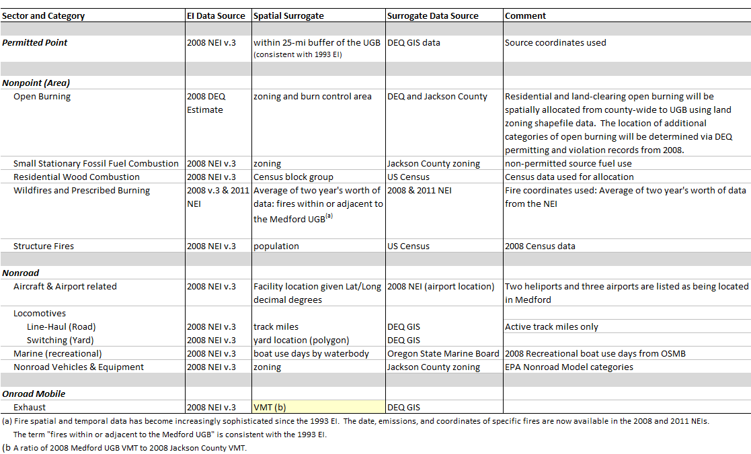

TEMPORAL ALLOCATION METHODS
Annual emissions will be adjusted from tons per year to lbs per season day for each source category. Methods for each category are described below, and all methods are consistent with the 1993 EI.

Permitted Point
Typical day emissions estimates will be calculated from annual emissions utilizing facility operating schedules taken from source permits. Seasonal adjustment may also be estimated from source annual reports, and DEQ point source emissions estimation reports.

Aircraft and Locomotives
Aircraft and locomotive activity will be considered uniform throughout the year. Annual emissions will be divided by 365 days to estimate season day emissions.

Nonpoint (area) and Nonroad Vehicles & Equipment
For nonpoint (area) and nonroad vehicles and equipment (excluding aircraft and locomotive), temporal allocation to season will follow the formula:

Annual to Typical Season Day = (Annual Emissions * SAF) / (weekly activity * 52 weeks/yr.)
Where SAF = Seasonal Adjustment Factor =
= (Season Activity * 12 months) / (Annual Activity * Season Months)
(Reference: EPA-450/4-91-016, p. 5-22)

Open Burning
Open burning will be temporally allocated using SAF values and activity in days per week; DEQ may either verify the SAF values used in the 1993 EI or develop new SAF values based on the 2008 permitting and complaint data. Regardless, the method will be consistent with the 1993 EI.

Small Stationary Fossil Fuel Combustion
Annual emissions from small stationary fossil fuel combustion will be temporally allocated using SAF values and activity in days per week taken from the 1993 EI. SAF values for these sources in the 1993 EI were taken directly from EPA-450/4-91-016, Table 5.8-1, p. 5-18.

Residential Wood Combustion
Annual emissions from residential wood combustion will be temporally allocated using SAF values and activity in days per week taken from the 1993 EI. SAF values for these sources in the 1993 EI were taken directly from EPA-450/4-91-016, Table 5.8-1, p. 5-18.

Wildfires and Prescribed Burning
As wildfires and prescribed burning are date-specific events, DEQ will temporally allocate emissions from these sources using fire date data, available from the EPA National Emission Inventory (NEI). SAF values will be calculated using annual and seasonal fire dates.

Structure Fires
As structure fires are date-specific events, DEQ will temporally allocate emissions from these sources using fire date data. Fire data used by DEQ to estimate structure fire emissions for the NEI is supplied by the state fire marshal. A seasonal adjustment factor (SAF) will be estimated using annual and seasonal fire dates.

Nonroad Vehicles & Equipment Excluding Aircraft and Locomotives
Sources of emissions covered by the Nonroad model include the following categories:
- Recreational marine • Railway maintenance
- Agricultural • Lawn & garden
- Construction • Industrial
- Light commercial • Logging
- Airport Ground Support Equipment (GSE)
Emissions from these categories will be temporally allocated to season using SAFs and weekly activity taken from the 1993 emission inventory.

On-Road Mobile: Vehicle Exhaust
EPA provides 2008 on-road NEI data by month, allowing for calculation of an on-road seasonal adjustment factor for typical season day estimation.

QUALITY ASSURANCE AND QUALITY CONTROL
DEQ will be using existing data that has already been quality checked. DEQ staff will perform quality assurance for accuracy, completeness, and representativeness on the spatial and temporal allocation of emissions from the existing inventory. DEQ will be using EPA county database estimates from the 2008 NEI v.3 generated using MOVES2010b modeled emissions rates.

EXTERNAL AUDITS
DEQ is willing to be audited by the EPA, and make changes to this inventory preparation and quality assurance plan if warranted.

PERSONNEL
DEQ personnel responsible for the Medford CO Limited Maintenance Plan inventory include:

Wendy Wiles, DEQ Environmental Solutions Division Administrator
Jeffrey Stocum, Air Quality Technical Services Section Manager, 503-229-5506
Emission Inventory and Air Quality Information Systems
Christopher Swab, Senior Emission Inventory Analyst, 503-229-5661
Brandy Albertson, Emission Inventory Analyst, 503-229-6459
Wesley Risher, Emission Inventory Analyst, 503-229-5092
Miyoung Park, Emission Inventory Specialist, 503-229-5178
Quality Assurance
Anthony Barnack, Air Monitoring Coordinator, 503-229-5713
David Collier, Air Quality Planning & Development Manager, 503-229-5177
Dave Nordberg, Air Quality Planner, 503-229-5519

SCHEDULE

Medford CO 2008 Limited Maintenance Plan
Draft Inventory Preparation Plan to EPA Oct. 2014
Fast Track Checklist to EPA Feb. 20, 2015
Final IPP with Schedule to EPA Feb. 20, 2015
Draft Emissions Inventory to ODEQ May 1, 2015
Draft Maint. Plan w/o E.I. to EPA May 20, 2015
Final E.I. to ODEQ June 16, 2015
EPA Comments on Draft Maint. Plan to ODEQ June 22, 2015
Maintenance Plan with E.I. to EPA July 1, 2015
EPA Comments on Plan & E.I. to ODEQ (if possible) July 22, 2015
Public Comment Period Begins (email notice) Aug. 17, 2015
Public Hearing (in Medford) Sept. 17, 2015
Close of Comment Period Sept. 21, 2015
Rule Adoption Staff Report to Director’s Office Oct. 29, 2015
Environmental Quality Commission Meeting Dec. 9, 2015
ODEQ Submits SIP Rule Update to SOS Dec. 14, 2015
Submit SIP Revision to EPA Dec. 22, 2015
EPA Approves Adequacy Determination Mar. 30, 2016

40CFR part 50.8 states that standards defined in parts per million should be compared “in terms of integers with fractional parts of 0.5 or greater rounding.” This led to an interpretation by EPA that any 8-hour CO concentration of less than 9.5 ppm would be equivalent to attainment. Therefore, concentrations at or above 9.5 ppm represent an exceedance of the standard. Two exceedances in one calendar year constitute a violation.
See Paise Memo in Appendix A for additional information on conformity requirements.
Aircraft and airport operations have traditionally been classified within the Nonroad Mobile Source sector. Although their SCC classifications have not changed, EPA grouped them within the Point Source sector beginning with the 2008 NEI. To maintain consistency with previous Medford air quality plans and emission inventories, these emissions continue to be reported within the Nonroad sector.
Railroad have traditionally been classified within the Nonroad Mobile Source sector. Although their SCC classifications have not changed, EPA grouped them within the Non-Point (Area) Source sector beginning with the 2008 NEI. To maintain consistency with previous Medford air quality plans and emission inventories, these emissions continue to be reported within the Nonroad sector.
ftp://ftp.epa.gov/EmisInventory/2008v3/doc.

